Welsh Government guidance on vulnerable groups:
Based on what we know about Coronavirus (COVID-19), doctors have advised that the group of people identified in the lists below are at an increased risk of severe illness from Coronavirus (COVID-19). Please read the risks before attending your appointment.
People in the extremely vulnerable group include:
- Solid organ transplant recipients
- People with specific cancers:
- People with cancer who are undergoing active chemotherapy or radical radiotherapy for lung cancer
- People with cancers of the blood or bone marrow such as leukemia, lymphoma or myeloma who are at any stage of treatment
- People having immunotherapy or other continuing antibody treatments for cancer
- People having other targeted cancer treatments which can affect the immune system, such as protein kinase inhibitors or PARP inhibitors
- People who have had bone marrow or stem cell transplants in the last 6 months, or who are still taking immunosuppression drugs
- People with severe respiratory conditions including all cystic fibrosis, severe asthma and severe Chronic Obstructive Pulmonary Disease (COPD)
- People with severe single organ disease (e.g. Liver, Cardio, Renal, Neurological).
- People with rare diseases and inborn errors of metabolism that significantly increase the risk of infections (such as Severe Combined Immunodeficiency (SCID), homozygous sickle cell).
- People on immunosuppression therapies sufficient to significantly increase risk of infection.
- Adults with Down’s syndrome.
- Pregnant women with significant heart disease, congenital or acquired.

Those at an increased risk of severe illness from Coronavirus (COVID-19):
- aged 70 or older (regardless of medical conditions)
- under 70 with an underlying health condition listed below (ie anyone instructed to get a flu jab as an adult each year on medical grounds):
- chronic (long-term) respiratory diseases, such as asthma, chronic obstructive pulmonary disease (COPD), emphysema or bronchitis
- chronic heart disease, such as heart failure
- chronic kidney disease
- chronic liver disease, such as hepatitis
- chronic neurological conditions, such as Parkinson’s disease, motor neurone disease, multiple sclerosis (MS), a learning disability or cerebral palsy
- diabetes
- problems with your spleen – for example, sickle cell anaemia or if you have had your spleen removed
- a weakened immune system as the result of conditions such as HIV and AIDS, or medicines such as steroid tablets or chemotherapy
- being seriously overweight (a body mass index (BMI) of 40 or above)
- those who are pregnant.

Physiotherapy Walk-In Clinic,
Port Talbot Resource Centre,
Moor Road, Port Talbot, SA12 7BJ

You have received this information because you have booked to see a Physiotherapist in the Port Talbot Resource Centre. Please note, in booking and attending this appointment you have given your consent to the COVID-19 risks as expressed below. Please read the following information carefully:

The Physiotherapy Walk-In Clinic at Port Talbot Resource Centre (SA12 7BJ) is a self-booking service which has been carefully planned to reduce the risk of COVID-19 transmission as much as possible. There will be clearly designated waiting areas, social distancing enforced and hand sanitiser available. Your Physiotherapist will be wearing appropriate PPE and following all recommended infection control guidelines. By coming to the appointment you also agree to follow Welsh Government guidelines as appropriate. Despite this, there is always a risk and COVID-19 transmission cannot be completely avoided. If you fall under the high risk category (see above) or would like to discuss the risk/reward of assessment, please contact the PhysioDirect phone line (01792 487453). We can discuss you concerns over the phone and offer advice or place you on a waiting list as necessary.

Please DO NOT attend if you have:
- a high temperature:
- a new, continuous cough: (if you usually have a cough, it may be worse than usual)
- a loss, or change, to sense of smell or taste:
- not currently awaiting a COVID-19 test result
- been in contact with anyone with COVID-19 symptoms or confirmed COVID-19 within last 14 days.

Remember:
- You need to be wearing a face covering on entering the building, unless you are medically exempt
- Do not arrive earlier on site than 15 minutes before your appointment time. Please wait in your car or if you’ve arrived by public transport wait outside the building ensuring you adhere to social distancing rules
- Do not arrive more than 5 minutes late. We will not be able to assess you and you will have to rearrange the appointment regardless of the reason. Wasted / unattended appointments cost the NHS £216,000,000 per year
- Please note there is no direct phone access for you to speak to staff in the Walk-In Clinic
- For all Physiotherapy queries please contact the Physiotherapy Department in Neath Port Talbot Hospital on 01639 862043, any queries about the Resource Centre please contact them on 01639 683020 (directions, access, facilities etc.)
- Attend the appointment on your own if possible
- You have the right at any point to withdraw consent for a face to face consultation or treatment.
- Be aware there are currently no refreshment facilities in the Walk-In Clinic.

Prior to arrival:
- The Walk-In Clinic room can be found on the ground floor next to the dental suite at the back of the building
- Contact the Physiotherapy Department if you have any queries or concerns relating to your treatment
- An assessment form is included in this email for you to give as much information as possible to help our assessment. If possible before you attend please print and complete that form bringing it with you. If that is not possible there will be blank copies available in the waiting area for you to complete. Please allow enough time to do this before to the start time of your appointment

On arrival:
- Please use the main entrance of the Resource Centre by the car park. If you are attending by bus please make your way to the front entrance (the bus stop is at the back of the centre).
- Use hand sanitiser situated on entrance to the building and before taking any paperwork from the trolley outside the Walk-In Clinic room.
- Do not enter the Walk-In Clinic waiting area until a maximum of 10 minutes prior to your appointment time.
- There is no receptionist at the Walk-In Clinic. Please sit down on the chairs unless it is uncomfortable to do this. If you are in less pain standing please obey social distancing rules in the waiting area.

During your consultations:
- Your physiotherapist will be wearing personal protective equipment (PPE), this will include a facemask, visor/goggles, gloves and an apron.
- When not requiring hands on treatment or assessment please try to keep 2m away from your physiotherapist.
- If at any time you feel uncomfortable or wish to withdraw from treatment, please make your physiotherapist aware

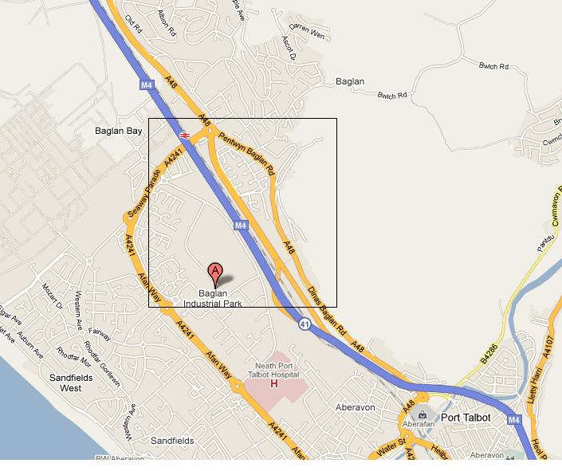
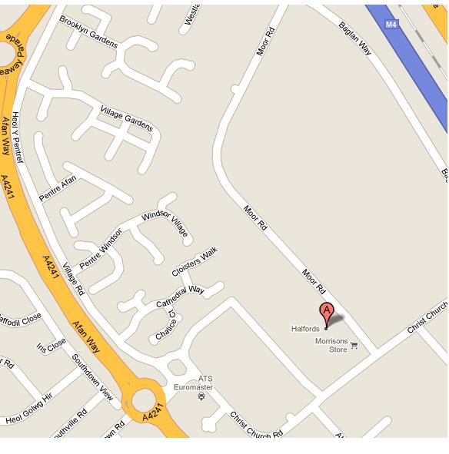
Port Talbot Resource Centre

