Patient Name: Address:  D.O.B:  Hosp. No.:  Tel. No.: |  | N.O.K & contact details: | Medically Fit for D/C | ☐
Patient Name: Address:  D.O.B:  Hosp. No.:  Tel. No.: |  |  | Pt Consented to ESD | ☐
Patient Name: Address:  D.O.B:  Hosp. No.:  Tel. No.: |  |  | Family aware? | ☐
Patient Name: Address:  D.O.B:  Hosp. No.:  Tel. No.: |  |  | Physio Agree d/c | ☐
Patient Name: Address:  D.O.B:  Hosp. No.:  Tel. No.: |  |  | OT agree D/c | ☐
Patient Name: Address:  D.O.B:  Hosp. No.:  Tel. No.: |  |  | Transport Arranged? | ☐
Date of Admission: |  | GP Details:
Hospital/Ward:
Home Situation:
Access: |  |  |  |  |  |  |  | Key safe: |  |  | Y ☐ Required ☐
Stairs: | Y ☐ Rails ☐ |  |  |  |  |  |  | Life Line: |  |  | Y ☐ Required ☐
Bed: | ↑ / ↓ |  |  |  |  |  |  | Bathroom: |  |  | ↑ / ↓
Bed on d/c: | ↑ / ↓ |  |  |  |  |  |  | Toilet access on d/c
Lives: | Alone/with spouse/with family/other |  |  |  |  |  |  | Domestic Support: |  |  | ☐ Required ☐
Evening support? (Bed / chair transfers? Support at night?)
Medical and Functional Information:
Reason for Admission: |  |  | Relevant Past Medical Hx: |  |  |  | Relevant Medication Hx: |  |  |  |  |  | Follow up Required?
 |  |  |  |  |  |  |  |  |  |  |  |  | DNs/ACT/Virtual ward?
 |  |  |  |  |  |  | Self-medicating?:
 |  |  |  |  |  |  | ☐
Rookwood Clinical Frailty scale |  | 1 ☐ |  | 2☐ | 3☐ | 4☐ |  |  | 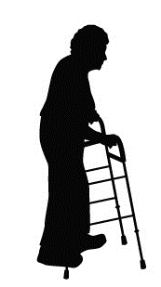5☐ | 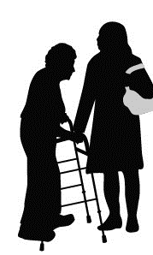6☐ |  | 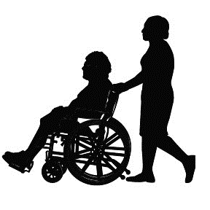 7☐ |  | 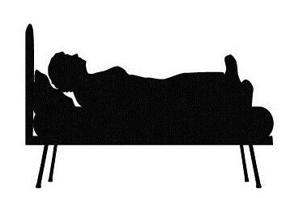8☐ | 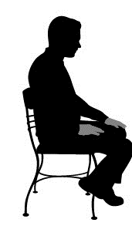 9☐
Patient identified rehab goals :
BARTHEL SCORE |  | Scoring |  |  |  |  |  |  |  | Pre-admission | On  D/C |  | Post ESD | Comments
Feeding |  | 0=unable / 5=needs help /10=independent
Bathing |  | 0=dependent / 5= independent
Grooming |  | 0=needs help / 5 independent
Dressing |  | 0=dependent 5=needs help can do ½ / 10 independent
Bowels |  | 0=incontinent / 5=occasional incident 10=continent
Bladder |  | 0=incontinent / 5=occ incident/10=continent
Toilet Use |  | 0=dep /5-needs help /10 independent
Transfers |  | 0=unable /5=major help/ 10=minor help / 15 independent
Mobility |  | 0=immobile /5=Wheelchair /10=with 1 /15 independent
Stairs |  | 0=unable / 5-needs help / 10 independent
 |  | Barthel Total
Cognition / Mood | MCI ☐ Dementia ☐  Low mood ☐ Fatigue ☐ Low Motivation ☐ |  |  |  |  |  |  | Communication |  |  | Speech Impaired?☐ Hearing Impaired?☐ Understanding Impaired?☐  Vision Impaired?☐
Falls history |  |  | History of falls in past 12 months |  |  | ☐ | Relevant Details:
Referrer: |  |  |  |  |  | Designation: |  |  |  |  |  | Date/Time of referral:
Accepted by ESD: |  |  |  | ☐ | ESD Team Member: |  |  |  |  |  |  | Date/ Time of D/C
NEATH PORT TALBOT
EARLY SUPPORTED DISCHARGE (ESD) TEAM REFERRAL

BARTHEL SCORE | Scoring | Pre-admission | Current | Final | Comments
Feeding | 0=unable / 5=needs help /10=independent
Bathing | 0=dependent / 5= independent
Grooming | 0=needs help / 5 independent
Dressing | 0=dependent 5=needs help can do ½ / 10 independent
Bowels | 0=incontinent / 5=occasional incident 10=continent
Bladder | 0=incontinent / 5=occ incident/10=continent
Toilet Use | 0=dep /5-needs help /10 independent
Transfers | 0=unable /5=major help/ 10=minor help / 15 independent
Mobility | 0=immobile /5=Wheelchair /10=with 1 /15 independent
Stairs | 0=unable / 5-needs help / 10 independent
 | Bartels Total
TOCALS: EARLY SUPPORTED DISCHARGE (ESD) TEAM REFERRAL

