

Risks of opioid and gabapentinoid medicines

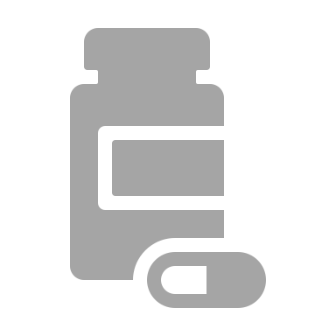
What are opioids?

- Opioids are medicines like codeine, tramadol and morphine
- They are known as ‘strong painkillers’ and used to reduce pain e.g. after you have hurt yourself or if you have arthritis

What are gabapentinoids?

- Gabapentinoid is another way of talking about gabapentin
and pregabalin
- They are medicines used for ‘nerve pain’
- Nerve pain might feel like burning or an electric shock


What is the problem with these medicines?

- They do not work very well for all types of pain
- They only work at all for 4 out of 10 people
- They have lots of side-effects that can cause other health problems


These medicines, on their own or when taken together can cause:


Tiredness, falling asleep
Changes in mood and emotions
Dry mouth
Problems having sex or wanting sex
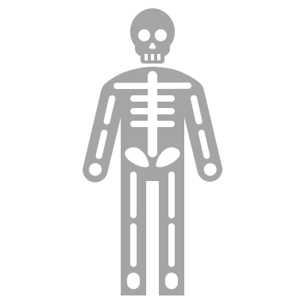
Weight gain


Increased infections
Falling and breaking bones

Problems going to the toilet
Feeling sick, vomiting, upset stomach

- Taking the two types of medicines together can
cause accidental overdose
- It can make breathing difficult
- In some cases people might die


How do I know if the medicines are right for me?
- Do you have less pain now?
- Can you do more now you are taking the medicines?

If you answer ‘NO’ to either question, then the medicines are not working
- It would be safer to slowly reduce and stop the medicines

- Your doctor or pharmacist can help you to do this

What might happen if I reduce my medicines?

- You can have more energy and be able to do more
- Your thinking can be clearer, and it makes you safer to drive

- You can have less pain

- Even if you think the medicines work for you, it is safer to reduce them from time to time to see if you really need them

- There are better and safer ways to live with pain
- Healthcare staff can support you to find what works best
for you
- Things that can help include stretching, walking, relaxation
and pacing yourself and the things you do

How do I reduce the medicines?

- Medicines need to be reduced slowly and carefully
- Make an appointment to talk to the doctor or pharmacist about how to do it

