
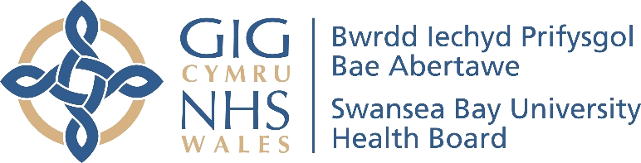
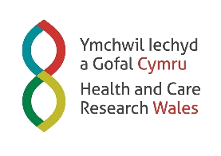
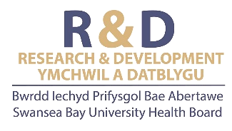



Swansea Bay University Health Board
Research and Development Annual Report 2025-2026

CONTENT

EXECUTIVE LEAD INTRODUCTION 4
SWANSEA BAY UHB R&D PROFILE 6
Who’s Who 6
Organisational Structure 8
Embedding R&D 11
Health and Care Research Wales 13
SUMMARY OF THE YEAR 2025-26 15
CASE STUDY HIGHLIGHTS 17
Case Study 1 17
Case Study 2 18
Case Study 3 19
Case Study 4 20
Case Study 5 21
STAFF SPOTLIGHT 22
Sharon Jones 22
Samantha Rees 24
Dr Amy Case 26
PARTNERSHIP AND COLLABORATION 28
University Partner – Swansea University 28
Swansea University and SB UHB Midwifery Research Collaboration 30
ReconRegen 33
Welsh Centre for Emergency Medicine Research (WCEMR) 36
CanSense 39
Utilising extracellular vesicles for early detection of clinically significant prostate cancer 41
Advancing Heart Failure Research Through Strategic Clinical & Academic Collaboration 42
Driving Research and Innovation in EMRTS & ACCTS 43
Wales Ambulance Services (WAST) 44
Radiotherapy Physics: Research, Innovation and Partnerships 45
Strengthening Research in Occupational Therapy Services 47
Clinical Innovation in Nuclear Medicine: A Partnership with GE Healthcare 48
Establishing a Centre of Excellence in MRI Physics 49
PUBLIC INVOLVEMENT AND ENGAGEMENT 51
Developing co-produced, evidence-based patient resources for adults with blunt chest injuries. 51
Gastroscope study PPI work shortlisted for Moondance cancer awards. 53
First Regional Research & Development Symposium 56
OTHER KEY ACHIEVEMENTS 58
FINANCIAL SUMMARY 59
FORWARD LOOK & CONCLUSION 61
Research & Development Strategy 63
APPENDICES 66
Appendix 1 – Acronyms 66

EXECUTIVE LEAD INTRODUCTION

It is with great pleasure I introduce the Swansea Bay University Health Board (SBUHB) Research and Development Annual Report for 2025-26.

2025-2026 has been an exceptionally busy year for our research teams, presenting significant periods of change, challenge and reward. In our 2024-25 annual report, we were pleased to share the new strategic pillars of research agreed by the Board. During the past year, we have made great progress against the ambitions we set ourselves, notably significantly enhancing the visibility of research at Board level through regular reporting to the Data, Digital, Research and Innovation Committee (DDRI). I’m delighted to confirm we are confident in the continued relevance of the objectives and are working to expand to a three year programme, whilst we move towards offering trials on a regional basis under the oversight of the Regional Joint Board.

We have established a new R&D Governance Group to report into DDRI, replacing the old R&D Committee, strengthening representation from across the Health Board. We have continued to operate our successful medical student placement scheme within the clinical trial delivery teams and are pleased to have implemented FLORENCE, a new electronic system to manage clinical trial files.

We were delighted to deliver on our promise to host a regional R&D symposium event with our partners at Hywel Dda University Health Board (HDD) which took place in October 2025. Equally, we have been strengthening dialogue between our clinicians and academics at Swansea University, developing open door access to clinical forums for research collaboration ideas to be pitched and explored, with several collaborative grant submissions currently being explored.

The strength and breadth of our research activity is also reflected in a growing body of publications produced by our teams over the past year, demonstrating both the quality and impact of work being undertaken across the organisation. We hope the detail which follows provides a clear insight into these achievements, and we invite readers to explore the full publication list available on our website (Publication Lists - Swansea Bay University Health Board) for a comprehensive overview of outputs from 2025–26.


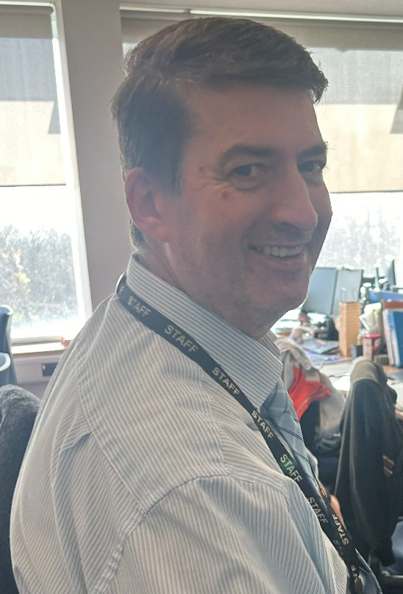
In memory of Mark Simpson

It is fitting that we dedicate this report to Mark Simpson, a dear colleague who sadly passed away on August 5th, 2025, following a bravely fought illness. Mark was appointed as R&D Finance Manager in 2009 and was a core member of the R&D Senior Management Team until his passing. Mark’s expertise, warmth and humour are greatly missed by the team, who are determined to continue championing the importance of research in Mark’s memory.



SWANSEA BAY UHB R&D PROFILE

Who’s Who

Dr Raj Krishnan | Interim Executive Medical Director
 | Dr Raj Krishnan is currently the Interim Executive Medical Director at Swansea Bay University Health Board. He is a Consultant Paediatric Nephrologist, having completed his paediatric training in Liverpool, Birmingham, and Edinburgh, followed by specialist nephrology training in Newcastle, The Hospital for Sick Children in Toronto, and Great Ormond Street Hospital in London.  Dr Krishnan has held several senior management positions, including Associate Medical Director for Patient Safety and Governance at Cardiff and Vale University Health Board prior to his move to Swansea Bay to take up the Deputy Medical Director role. He has also recently served as the Officer for Clinical Standards and Improvement with the Royal College of Paediatrics and Child Health.

Professor Stephen Bain | Associate Medical Director for R&D
 | Professor Steve Bain is the Associate Medical Director for Research & Development and Health and Care Research Wales Speciality Lead for Diabetes.  Professor Bain completed his undergraduate training at St John's College, Cambridge and then was clinically trained at King's College Hospital, London. On qualifying in 1983, he went on to hold junior appointments in London and the Midlands. His research centred on the genetics of type 1 diabetes and he was granted a Medical Research Council Lectureship. In 1993, he became a Senior Lecturer/Honorary Consultant Physician at Birmingham Heartlands Hospital with promotion to Reader in Diabetic Medicine in 1998. Professor Bain became a Fellow of the Royal College of Physicians UK in 1996. He has been Chief Investigator for several multi-centre trials investigating novel therapies for diabetes.  Professor Bain is the Diabetes Lead Clinician for the Swansea Bay University Health Board, chairs the Joint Clinical Research Facility in Swansea and was Clinical Director of the Academic Health Science Collaboration in Wales until September 2015.

Professor Dean Harris | Deputy Associate Medical Director for R&D
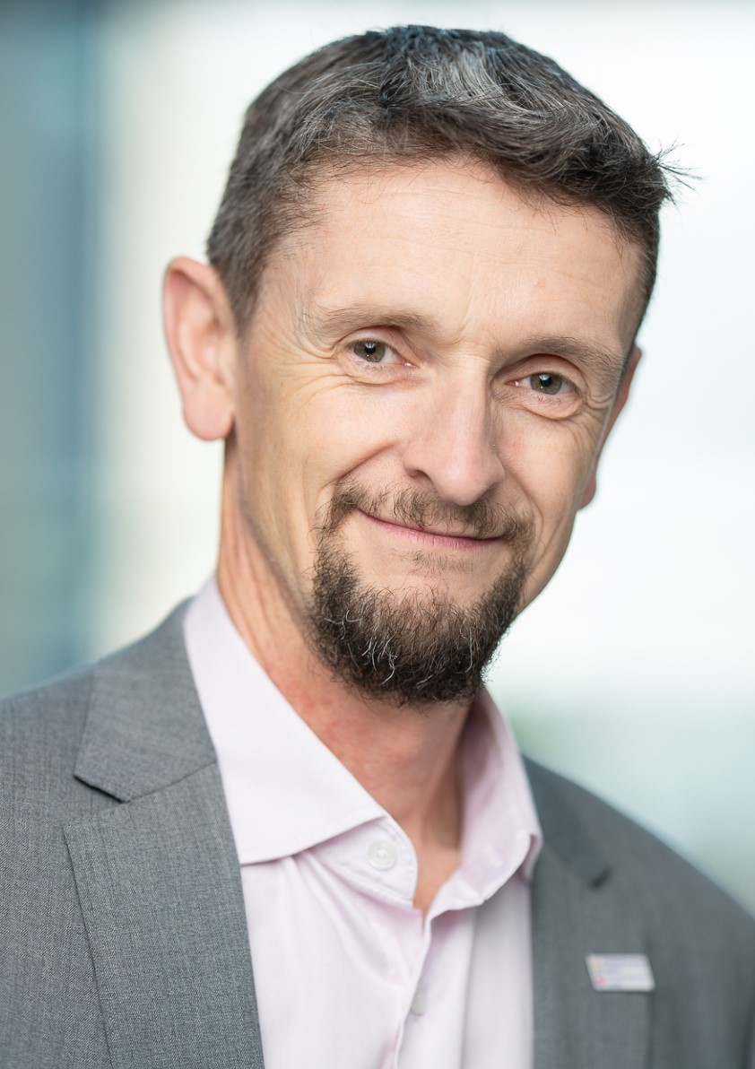 | Professor Dean Harris is the Deputy Associate Medical Director for R&D at Swansea Bay UHB and vice chair of the Joint Study Review Committee. He is a consultant colorectal surgeon providing a tertiary service for advanced rectal cancer. He is Lead Clinician of the Colorectal Cancer MDT (multidisciplinary team) and clinical lead for the Wales Cancer Industry Forum. He is on the NHS Clinical Entrepreneur Programme since 2020 fuelling his interest in MedTech innovation.  In 2013 he became an honorary clinical professor in Swansea University Medical School with research interests in early detection of cancer and personalised cancer treatment and has won over £2M in academic funding towards this.  He is co-founder and clinical director of CanSense, a Swansea University spin-out company, translating a reagent-free colorectal cancer serum diagnostic for the NHS to address cancer inequalities.

Organisational Structure

Research & Development Management Team

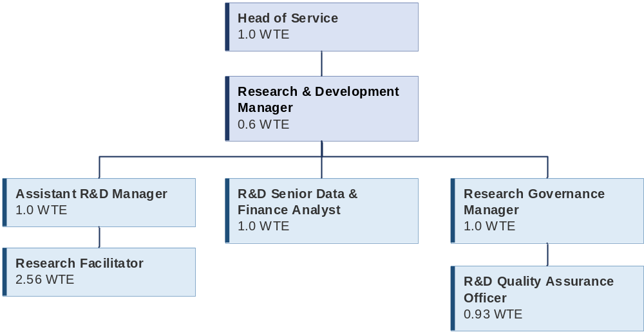

Research & Development Delivery Team
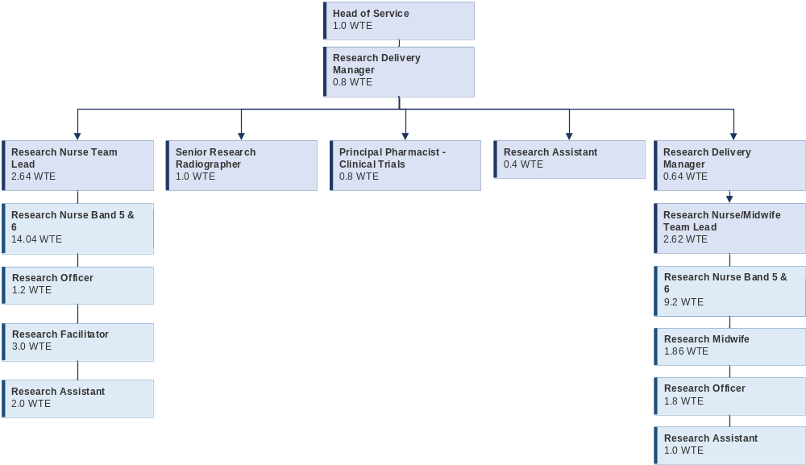

Research & Development Groups

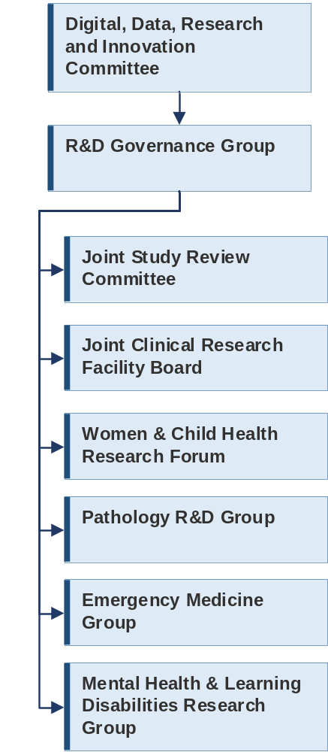

Embedding R&D

R&D is a department within the Executive Medical Director’s Directorate. The function of the department is Health Board wide, supporting and overseeing research across all clinical directorates and structures.

Research Planning: R&D is considered a core quality priority within the Health Board. Consequently, ambitions for research are embedded within the Health Board annual plan and inform clinical services horizon planning. Our 2024-25 research, development and innovation (RD&I) one year bridging strategy has been extended to a 3-year Strategy underpinned with clear objectives intended to create an environment rich in research and fulfilling the 10 pillars of excellence as described within the NHS Research Excellence Framework (2023).

Regional Research: There is consistent evidence that research active NHS organisations report better patient outcomes and staff satisfaction. As such, regional delivery of research has been a long existing dialogue between SBU and HDD with both Health Boards fully committed to the principle of equitable access to clinical trials irrespective of post code boundaries. This requires us to step back and assess how we can design and mobilise our research delivery infrastructure to serve not just Swansea Bay patients but also open access for patients within our regional boundaries of Hywel Dda UHB. Consideration needs to be given to harmonising standard of care pathways, enhancing capacity, contracting and financial risk alongside facilitating and agreeing realistic recruitment numbers with clinical trial Sponsors. This detail requires careful clinical and governance management oversight to ensure what we are seeking out to achieve is achievable with tangible benefits. A stepped change approach is essential with work initially focussed on regional delivery of Oncology. Using funding from Welsh Government, a task and finish group was established to consider how to develop a regional pathway for oncology trials. The initial recommendations were taken through both health boards’ governance structures and discussions are ongoing with Welsh Government as to how to take these forwards.

Annual Plan

A thriving culture of Research, Development and Innovation is a critical factor in the provision of safe, high-quality care and aligns with health boards' Duty of Quality to continually improve the quality of the services they provide. This through a continued two-pronged approach.
- Development of a Regional RD&I strategy with Hywel Dda UHB under the Joint Committee arrangements, recognising the strengths both organisations bring, along with opportunities for wider academic partnerships with Swansea University and University of Trinity St David.

- Further development of its RD&I Strategy for SBUHB pending the establishment of the regional RD&I plan with Hywel Dda UHB.
The Research, Development and Innovation Strategy has been developed to align to the pillars of the NHS Research & Development Framework, supported by a current self-assessment. Underneath each pillar are associated objectives which are supported by a delivery plan, including:
- Visibility of research, development and innovation at board level
- Effective use of research delivery staff
- On-time trial initiation, higher research income and full access for all eligible patients
- Introduce research, development and innovation showcase events
- Introduce modern facilities and equipment
- Introduce pump-prime schemes
- Strengthen access to oncology clinical trials across south-west Wales as the cancer centre for the region, as well as working collaboratively with Velindre Cancer Centre to enhance the offer across Wales
New governance arrangements are an opportunity to define a clear process through which research impact on service development and clinical pathway design is tracked and disseminated, including identification and use of linked research accounts to support innovative service change.

Workforce:
- Joint peer review committee to share learning
- Time recognition in job planning guidance
- Research leads in non-medic roles
- Shadowing links with medical and nursing schools
- Increase number of clinicians with Good Clinical Practice Training
Strategy, Finance and Governance:
- Alignment to organisation strategy and clinical service plan
- Commercial income and grant funding to support further activity and service change
- Board oversight through DDRI Committee, supported by R&D Governance group
Patient and Public Involvement:
- Patient representatives on health board sponsored studies
- Communications Plan
- Plans for patient involvement group with Swansea Trials Unit
Partnership Working:
- Partnership with Swansea University:
  - Co-signed sponsorship model
  - Joint Clinical Research Facility
  - Partnership board to be established
- Monthly surgeries and clinical advisory group with local trials units
- Regional work with Hywel Dda
- Annual showcase events

Health and Care Research Wales

Swansea Bay UHB R&D teams are proud to be part of Wales wide infrastructure of Health and Care Research Wales, working together to deliver the overarching HCRW goal that ‘today’s research makes a difference to tomorrow’s care.’ The research community in Wales is well-connected through the national infrastructure, working together to deliver a research eco-system which places the goal of transforming care for patient benefit as the guiding principle why we do research.

In March 2026, we returned our second formal self-assessment against the NHS R&D Framework, with our continued 3 R&D Strategic Pillars aligned to the 10 Pillars of excellence described within the Framework – What excellence looks like in NHS Wales


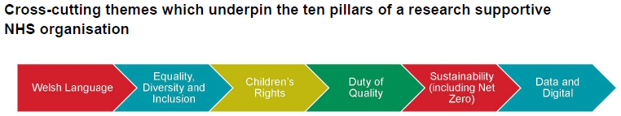

Health and Care Research Wales Speciality Leads
Health and Care Research Wales invest in Specialty Leads to champion and support research delivery by building networks of principal investigators within their specialty and supporting the uptake of studies throughout Wales. They map onto the 31 National Institute for Health Research therapeutic areas and provide strong UK-level engagement for Wales. There are 5 speciality leads within SBUHB.

 | Diabetes  Professor Stephen Bain |  | Stroke  Dr Manju Krishnan
 | Musculoskeletal Disorders  Mr Piers Page |  | Trauma and Emergency Care  Dr Suresh Kumar Gopala Pillai
 | Cardiovascular  Dr Daniel Obaid

SUMMARY OF THE YEAR 2025-26




Top
£
Managing Specialties
by recruitment for
open portfolio
studies
- Cancer
- Neurology
- Reproductive health and childbirth
- Cardiovascular
- Stroke

Contributed to winning over
£1 Million
in new grant funding (as lead or co-applicants), with funding shared across partner organisations.
RECRUITED
2380
Participants into Portfolio studies
2218 Non-Commercial | 162 Commercial
72
Open Non-Portfolio Studies
15
Open Swansea Bay UHB Sponsored studies within the Health Board
40 Open
Commercial Studies
163
Portfolio Studies In Follow Up
118 Non-Commercial
45 Commercial

Joint Study Review
Committee (JSRC)
signed off:
6 New studies
48 Service Evaluations
161
Open Non-Commercial Portfolio
Studies

CASE STUDY HIGHLIGHTS

Case Study 1

Potential impact of oral Semaglutide on coronary artery disease progression following Acute Coronary Syndrome: the Post-ACS study.

The purpose of this study was to find out how effective the drug Semaglutide is at reducing the amount of fatty build-up (plaques) from narrowing blood vessels supplying the coronary arteries of the heart.

The study was part of an educational project and was used to obtain an academic doctoral degree.

The purpose of this study was to find out whether an advanced type of heart scan could be used to track changes in fatty build-up (plaques) in the heart’s arteries after treatment with medication, in people who had recently experienced a heart attack or similar event.

The study was carefully designed as a clinical trial, where patients were randomly given either the treatment or a placebo (a dummy treatment). It focused on understanding how the treatment works in the body, using detailed imaging. This research forms an important part of a wider effort to better predict an individual’s future risk of heart problems.

Some parts of the study were funded by the pharmaceutical company Novo Nordisk. They paid for certain tests (such as blood tests and scans) and provided the study medication (either semaglutide or a placebo). However, the company was not involved in how the study was designed, carried out, analysed, or reported. The research was conducted independently by the academic team.

The study was sponsored by Swansea Bay University Health Board.

The study was conducted and co-ordinated by staff of the Joint Clinical Research Facilities (JCRF), ILS2, Swansea University who funded the research registrar undertaking this project.

The main goal of the study was to see whether treatment with semaglutide could reduce the most harmful type of fatty build-up (plaque) in the heart arteries over 12 months, compared with a placebo (dummy treatment). This was measured using a detailed heart scan.

The study also looked at whether semaglutide could affect:
- The types of plaque in the arteries
- The total amount of plaque in the heart arteries
- Levels of inflammation and other substances in the blood linked to heart disease
- Blood vessel health and stiffness

The study recruited 140 patients between August 2022 and July 2024. Each patient was randomly assigned to receive either semaglutide or a placebo, alongside their usual care, within 30 days of being admitted to hospital with a heart problem.

Patients attended 7 clinic visits over 12 months. During this time, the dose of the study medication was gradually increased:
- Starting with a low dose
- Increased after 4 weeks
- Increased again after 8 weeks, then continued at that level

At the start and end of the study, patients had:
- A heart scan
- A test to measure artery stiffness
- Blood tests to check inflammation and cholesterol

At every visit, their general health was checked, including blood sugar, blood pressure, and weight.

If a patient experienced side effects, they could not tolerate, the dose of the study medication (either semaglutide or placebo) was reduced.

The study data is now being collated and will be reported later this year. Of the 140 subjects recruited 134 completed the study 69 in the Semaglutide arm and 65 in the placebo arm.

Case Study 2

Steps II - The Efficacy of Peroneal Nerve Functional Electrical STimulation (FES) for the Reduction of Bradykinesia in Parkinson’s DiSease: An Assessor Blinded Randomised Controlled Trial

Swansea Bay University Health Board (SBUHB) was one of seven UK recruiting sites participating in the NIHR-funded STEPS II Parkinson’s Disease trial, an assessor-blinded randomised controlled study evaluating peroneal nerve Functional Electrical Stimulation (FES) to reduce bradykinesia , a symptom that causes slowness and difficulty initiating movement, and improve walking in people with Parkinson’s disease. The study at Swansea Bay began in February 2024 and was hosted within Rehabilitation Engineering, part of Medical Physics & Clinical Engineering. Dr Lorna Tasker, Consultant Clinical Scientist, was Principal Investigator. Delivery of the trial was led through a multi-professional model, with healthcare scientists and allied health professionals playing central roles in recruitment, intervention delivery and outcome assessment. Molly Jones, FES Research Physiotherapist, acted as the blinded assessor. Recruitment was completed in March 2026, with 41 participants enrolled. The SBUHB service has more
than 20 years’ experience delivering Functional Electrical Stimulation to people who have had a stroke or have multiple sclerosis, and the findings from STEPS II trial are expected to provide greater insight into its potential benefits for people with Parkinson’s disease, including falls prevention. Two-thirds of participants have continued to use the device following trial completion, with reported improvements in freezing, coordination and overall confidence in walking.

Case Study 3

ABA Feed study - Peer support intervention to improve breastfeeding: UK based, multicentre, parallel group, randomised controlled trial

The objective of the study was to assess the effect of a proactive, peer support infant feeding intervention in addition to usual care on breast feeding rates, formula feeding practices and other outcomes.
Our infant feeding specialist midwife received specific ABA-Feed intervention training to enable her to facilitate training and support of 9 volunteer infant feeding helpers to deliver the community based study intervention of additional infant feeding peer support. The infant feeding helpers were instrumental to the success of delivering the study, demonstrating such commitment to providing support. Swansea Bay were one of 17 participating sites between Jan 2022 and April 2024 and we recruited 186 women into the study.

The findings of the ABA-Feed study were recently published (please see link below). Whilst the peer support intervention did not improve breastfeeding rates compared with usual breastfeeding support, a great deal of positive feedback was received from many mothers who had participated in the study ( Mum's the word as baby feeding trial attracts almost 200 volunteers - Swansea Bay University Health Board). The importance of this positive feedback was something the research team and our infant feeding coordinator felt needed to be recognised in addition to the benefits of utilising the additional knowledge and skills acquired in their role on the study. After further discussions and consultations with senior managers, the decision was made to utilise research generated money to fund a full time, 1yr contract for an infant feeding support worker predominantly within the hospital setting. Two successful candidates were appointed into a job share role. The valuable contribution they have made to both the experience of mothers and infant feeding outcomes is evidenced in the monthly statistics produced by our infant feeding specialist midwife, the positive patient feedback and the reduction in infant feeding related complaints.

Despite the research intervention not demonstrating a benefit to breastfeeding rates overall, supporting the ABA-Feed study in Swansea Bay has made a positive and lasting impact to the infant feeding support our families receive.

https://www.bmj.com/content/392/bmj-2025-086558

Case Study 4

SCC-AFTER - Adjuvant Radiotherapy in Patients with High-risk Primary Cutaneous Squamous Cell Carcinoma AFTER surgery (SCC-AFTER): An Open Label, Multicentre, Two-arm Phase III Randomised trial.

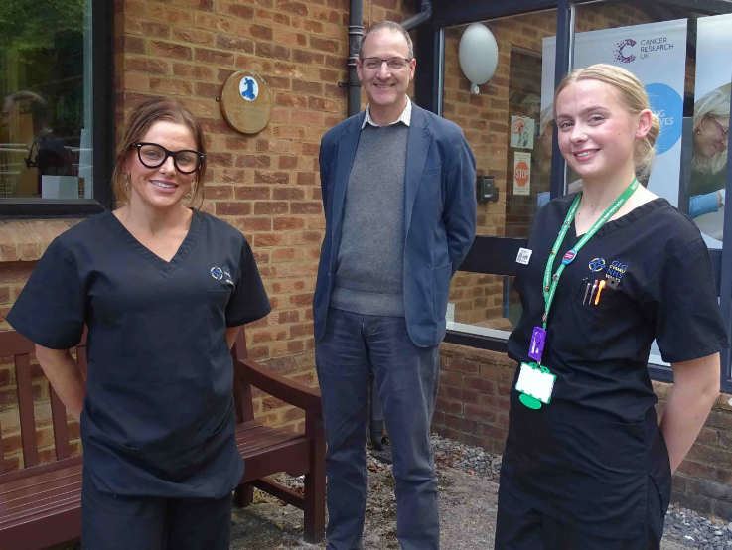
Pictured: Senior research radiographers Victoria Morris (left) and Leigha Yardley with consultant clinical oncologist Martin Rolles

Singleton Hospital in Swansea has become the first in Wales to take part in a UK-wide clinical trial examining treatment approaches for squamous cell carcinoma (SCC), a common form of skin cancer with more than 50,000 new cases diagnosed annually in the UK. The study, known as SCC-AFTER, is being led at the South West Wales Cancer Institute, where three Welsh patients have already been recruited. It focuses on patients who have undergone curative surgery for high-risk SCC, for whom radiotherapy is often routinely given to reduce the risk of recurrence. The trial is investigating whether some patients could instead be safely managed through close monitoring, reserving radiotherapy only if the cancer returns.

The randomised controlled trial will compare outcomes between patients receiving adjuvant radiotherapy (radiotherapy given after initial treatment to lower the risk of cancer coming back) and those under observation, with the aim of identifying cases where treatment can be safely avoided. Reducing unnecessary radiotherapy could spare patients side effects and repeated hospital visits, while also freeing up treatment capacity. Early recruitment at Singleton is among the highest in the UK, and the programme is expected to expand significantly. Alongside its research goals, the trial has already led to improvements in clinical processes, including faster access to pathology results and more streamlined care pathways, supporting wider benefits for cancer services across the region.

Case Study 5

Royal College of Nursing Foundation: CareLeD project
SBU HB lead: Prof Neil James, Consultant Nurse Learning Disability

The Royal College of Nursing Foundation commissioned a project to improve access to urgent and emergency care in times of ill health for people with a learning disability.
This was a UK collaboration that included researchers from Keele University, North Staffordshire Combined Healthcare NHS Trust, Swansea Bay University Health Board, Belfast Health and Social Care Trust, NHS Grampian, and an independent advisor consultant nurse.

The 12-month UCAN (Urgent Care Access Now) project commenced in August 2024 and co-produced a tool to assist people with a learning disability when preparing to access urgent and emergency health care. The project drew upon the experiences of people with lived experience of a learning disability who have recently accessed urgent and emergency health care services. The tool which was co-produced is called careLeD. It has been designed as an educational tool to help people with a learning disability access urgent and emergency health care.

The tool is available at CareLeD tool - Keele University (CareLeD tool - Keele University)

The breadth of research activity demonstrated within our MHLD Service is fantastic to see and is testament to our team's passion and engagement in research & innovation to improve services for patient benefit.

STAFF SPOTLIGHT

Sharon Jones
Lead Research Midwife

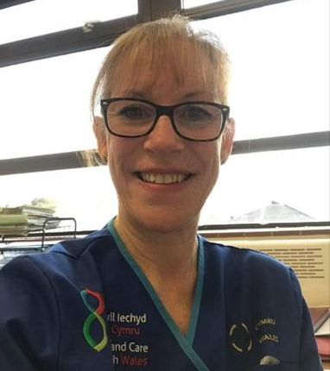
I am Sharon Jones, lead research midwife in Swansea Bay. After qualifying as a registered general nurse in Carmarthenshire, I moved to Cardiff where I trained to become a midwife, completing my midwifery diploma. There was no midwifery degree at this time so I subsequently completed my midwifery degree part time over 2 years. I have been a midwife for 35 years with experience in all areas of clinical practice, midwifery education and clinical research delivery. My clinical practice included many years as a community midwife managing a caseload of women and babies, providing all aspects of care from antenatal booking, intrapartum and post-natal care. During this time, I became a part-time midwifery clinical tutor in Swansea University which provided me with the opportunity to teach, clinically support and mentor midwifery students.
“Together, we are contributing to providing the evidence to improve outcomes and quality of care.”

I had a change to my area of practice when I went on to work in the antenatal day assessment unit (ADAU) providing care for women with high risk pregnancy and complications. It was during my time working in the ADAU that I became aware of a research study which had recently opened in our maternity unit. The research team visited our unit in search of some practical guidance about recruitment strategies for the study. The study was investigating a pregnancy condition which I had a particular interest in and it immediately caught my attention. My interest was acknowledged by the research team and I was offered the opportunity to support the delivery of the trial on a secondment one day a week. Despite having no prior research delivery experience, I jumped at this opportunity in the knowledge that my clinical knowledge and experience would be of value.
My initial one-day secondment gradually increased as I became involved in the set up and delivery of other pregnancy related studies with the support and encouragement of the research delivery team. Fast forward some twelve years later, to my current role as the first lead research midwife for reproductive health and childbirth in Swansea Bay. I manage a small, very enthusiastic and committed team of research midwives. I lead on the set up and coordination of a wide range of research studies including randomised controlled trials, drug trials and observational studies.

Study selection is discussed with appropriate specialist clinicians including obstetricians, midwives, neonatologists, pharmacist and sonographers. The decision to support a study is determined by the purpose and potential benefit to service users in addition to the capacity and capability of both the research team and clinicians required to recruit and follow up participants successfully and safely. Each study has a protocol which must be adhered to in the conduct of all research activity in addition to the requirement for Good Clinical Practice in research certification. The additional requirement to comply with research regulatory standards for example, Human Tissue Act and Medicines and Healthcare products Regulatory Agency is the responsibility of each individual supporting research activity.

My research experience has enabled me to take on the role of Principle Investigator (PI) for several studies in Swansea Bay. This role requires me to have oversight of all research activity required for a particular study and the ability to delegate roles and tasks to appropriately qualified or experienced members of staff. A recent development to promote this role is being supported by the maternity research team, encouraging clinicians to undertake the Associate PI training programme and contribute to building our research capacity.

A key element of my team is to engage staff and participants to support to our research activity and achieve identified recruitment targets. Staff engagement is supported by face-to-face interaction and training opportunities, presentations at induction and mandatory training days. Information boards and posters are on display within the maternity units and we utilise social media via Swansea Bay Maternity Facebook and Intranet. Strategies for approaching and recruiting potential participants vary but are primarily face to face, providing an opportunity to build a professional and trusting relationship. Participants often comment on the benefits of taking part in a research study including having additional information and opportunity to discuss their care or any concerns with the research midwife.

The continued growth of the maternity research portfolio has created new opportunities for additional research midwives. The capacity of the research team has grown over time with an additional permanent research midwife in addition to a fully funded secondment. The maternity research team have an established collaboration with Swansea University and currently support a diverse range of studies.
Recruiting women and babies into a research study is very much a team effort and requires close collaboration with midwives, obstetricians, anaesthetists, neonatologist, pharmacists and Healthcare Support Workers (HCSWs) to identify and recruit women and babies who may be eligible to take part. Together, we are contributing to providing the evidence to improve outcomes and quality of care.

Samantha Rees
Research Facilitator
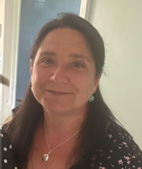
Hello, my name is Samantha Rees, and I work as a Research Facilitator within the Research & Development Department at Swansea Bay University Health Board. I have been part of the Health Service for nearly 41 years.

I began my NHS journey straight from school, joining Morriston Hospital through a work scheme. My early years were spent working across different departments, where I gained a wide range of experience and had the opportunity to work with many colleagues. I started in the Outpatients Department and later moved to Medical Records, supporting a busy hospital and working with a variety of teams.

During my time in Medical Records, I particularly enjoyed being part of a large and hardworking team. My role developed over time, and in my final post I was responsible for providing patient information to solicitors, police departments and other external organisations.

In 1999, after starting my family and moving to part-time work, I was offered the opportunity to set up a Research & Development Department. At the time, there was no central record of research activity within the hospital, so I was tasked with building one. With very little information to start with, I was handed a pile of papers and was asked to create a database of the research activity within the Hospital. I worked across many different locations to identify and document what research was taking place and who was involved, and sometimes working in quite unusual office spaces, including one created from a lift shaft.

At one point, the Complaints Department also became part of our work, which gave me valuable insight into another aspect of patient care.

Over the years and many office moves, the department has grown from a team of one into a well-established service.

My role within R&D has continued to evolve, allowing me to build knowledge and experience within the research environment. I am now part of a small team of Facilitators, supporting the setup and management of studies, ensuring governance requirements are met, maintaining study records, and responding to queries from both internal and external colleagues.
“Working in R&D has shown me how important research is in improving care for patients now and in generations to come.”

I also act as the Health Board’s research archivist, managing records for studies that require long-term off-site storage.

Working in R&D has shown me how important research is in improving care for patients now and in generations to come.

I have always valued learning through experience and working alongside colleagues and look at my time in the Health Service as a way of giving something back, helping to ensure future generations can benefit from new and positive treatments.

I am proud of my time in the NHS and feel that I have played a small part in supporting research that helps improve outcomes for future generations.

Thank you for the opportunity to share my story.

Dr Amy Case
Consultant Clinical Oncologist
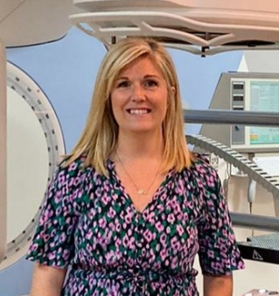
As a Clinical Oncologist, I am committed to practising evidence-based medicine, with clinical trial data the cornerstone of patient-centred treatment decision-making. I use this evidence to guide discussions with patients, working in partnership with them to select treatments that not only aim to optimise prognosis but also prioritise quality of life.

Early in my clinical oncology training, I was inspired by research-active consultants and witnessed first-hand how involvement in clinical trials offers the opportunity to contribute to practice-changing studies, access innovative therapies, and drive meaningful improvements in patient care.

Getting involved with research as a resident
Following completion of my Foundation Programme and Core Medical Training, I obtained a specialty training post in Clinical Oncology in South Wales in 2013. During my training, I was fortunate to work alongside excellent mentors, Professor Richard Adams and Dr Sarah Gwynne, who took me under their wing and provided me with a range of valuable research opportunities.

My experience as Principal Investigator for small, single site trial, ADVANCE (a feasibility study of a point-of-care white cell count device)—enabled me to collaborate with expert staff from the Cardiff University Centre for Trials Research. This experience significantly enhanced my interest in cross-organisational collaboration and multidisciplinary working within clinical trials.

In 2021, I was given the opportunity to join the PICCOS trial team (Pressurised Intraperitoneal Aerosolised Chemotherapy [PIPAC] in the management of cancers of the colon, ovary and stomach: a randomised controlled phase II trial assessing efficacy in peritoneal metastases). I contributed to the development of the gastric arm of the trial protocol, which led to the publication of a systematic review. I have since remained an active member of the Trial Management Group

Out of Programme Research

I was fortunate to obtain an Out of Programme Research Fellowship at the South West Wales Cancer Centre in 2021. Co-funded by the Wales Cancer Research Centre and Swansea Bay University Health Board, this 2-year fellowship provided the opportunity to undertake an MD at Swansea University. Focussed on the role of radiotherapy for inoperable gastric cancer, my research has since become my passion! As well as publishing a systematic review on gastric radiotherapy, I conducted a national survey of oesophagogastric oncologists to explore current patterns of radiotherapy use in the UK, and to establish support in the community for a future trial. I was very lucky to travel to the American Society of Radiation Oncology Annual Meeting, San Diego in 2023 to present an abstract of this work. I also designed and led an exploratory study into interobserver variation in gastric tumour volume delineation using CT plus MRI, presented at the European Society for Radiation oncology Annual Meeting in 2024 (poster), and more recently at the UK and Ireland Oesophagogastric Group Annual Meeting in 2026.
“I am committed to practising evidence-based medicine, with clinical trial data the cornerstone of patient-centred treatment decision-making.”

GastroSCOPE

The work undertaken during my MD has informed the design of GastroSCOPE, proposed to be the first UK clinical trial evaluating the role of high-dose palliative radiotherapy for patients with inoperable gastric cancer. With Dr Sarah Gwynne as Chief Investigator, I have been offered the amazing opportunity to be Co-lead on our funding application, which is co-sponsored by Swansea Bay University Health Board. Developing the trial has allowed me to network with, and learn from, several expert oncologists from across the UK, and alongside the fantastic Cardiff University Centre for Trials Research team, we have developed an exciting, potentially practice-changing trial. It has been both enjoyable and humbling to work alongside patient representatives during the development of GastroSCOPE, with our work awarded “Best Public and Patient Involvement” at the Wales Cancer Research Conference in 2025.

Working as a Consultant and Researcher in SBU

On completion of training, I took up a post as Consultant Clinical Oncologist specialising in Upper Gastrointestinal Cancers, and Stereotactic Ablative Body Radiotherapy in SBU in 2025, and am enjoying integrating with the dynamic, ambitious team at the South West Wales Cancer Centre. With some of my practice covering Hywel Dda University Health Board, I look forward to working with R&D departments across the region to ensure equity of access to clinical trials for patients across South West Wales.

PARTNERSHIP AND COLLABORATION

University Partner – Swansea University

A brief history of our Joint Clinical Research Facility (JCRF)

In 1989, the Clinical Research Unit was established in the New Postgraduate School of Clinical and Health Care Studies based at Morriston Hospital as a self-funding department under the leadership of Prof John Williams and Kathie Wareham. With its mission statement “Dedicated to Excellence in Patient Research”.

As its reputation grew so did the workload and the team. Lasting relationships developed with Pharmaceutical companies and for some we are a preferred site ensuring a diverse portfolio of clinical studies across many disease areas.

Success enabled the development of two purpose built units, the first Clinical Research Unit was established in Morriston hospital in the late 1990’s and followed in 2010 with a second in the Institute of Life Science 2 (ILS2). This was the formation of the Joint Clinical Research Facilities (JCRF) a partnership between the then Abertawe Bro Morgannwg Health Board and Swansea University Medical School.

Today, the JCRF continues to serve the Health Board as our flagship research partnership with SU. This year we’re pleased to confirm JCRF as the only site in Wales afforded preferred site status with Novo Nordisk (12 sites overall in UK), recognising the leading role JCRF operates in the advancement of diabetic medicine. Other areas of excellence include neurology and cardiovascular. Supporting clinicians from across the Health Board, in 2025-26, the team hosted 25 commercial studies recruiting 82 patients.

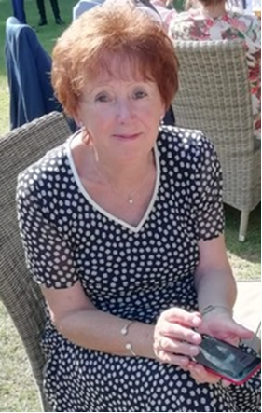
A special mention must be made to Kathie Wareham, who has acted as CRU/JCRF Director since its inception. Kathie’s vision, drive and passion as Director have enabled the unit to grow and her enthusiasm is an example to all that have the pleasure of working with her. After many years of excellent service, Kathie has recently announced her retirement however we are pleased to confirm Kathie continues to offer guidance and leadership through an honorary contract, continuing to support clinicians in completion of specific research programmes.

Picture: Katie Wareham

Swansea University and SB UHB Midwifery Research Collaboration

As part of our University collaboration with Swansea University, the Health Board midwifery team is pleased to be supporting several academic led research initiatives, operating under a service level agreement, these are outlined below. For further information, please do not hesitate to contact us.

GDM- Raman spectroscopy and gestational diabetes
Total number of participants recruited so far: 801

Aim: The purpose of this research study is to compare the Raman spectroscopy test to the glucose tolerance test and to better understand why the universities test might be able to diagnose gestational diabetes.

Our Role: A research midwife approaches women at their routine glucose tolerance test in antenatal clinic and discusses the study. If participants agree to take part, they sign consent forms to provide extra blood (36mls) alongside their routine bloods which then get taken over to Swansea University.

Investigating the effects of climate change on responses of pregnant women in different communities in Wales (INFORMED)
Total number of participants recruited so far: 75 (Recruitment now finished)

Aim: The aim of this research to understand if climate change (heat waves and air pollution) can affect the immune system during pregnancy across different communities in Swansea and Port Talbot.

Our Role: The Research midwives have been screening women based on their estimated due date and approaching women in person when they are attending routine visits. Women were also able to put in expression forms from QR codes from posters that were put around GP surgeries, social media sites and Swansea University. For the participants who were happy to take part, the research midwife would either attend participant’s homes or would see participants in Swansea University. Participants would have 3 appointments overall during a six-week period. During each appointment the research midwife would take participants temperature and blood pressure and then palpate and auscultate the fetal heart. The research midwives would then also collect samples, the participants consent for 3-6 samples to be taken at each appointment including blood, urine, hair, saliva, swear and a nasal sample. During the second appointment air monitors would also be installed into participants homes and a personal health monitor provided to wear for 3 days.

Participants can also consent to give their placenta and umbilical cord blood and to also provide a postnatal saliva sample and a heel prick blood sample from baby.

Relating Environment-use Scenarios in Pregnancy/Infanthood and Resulting airborne material Exposures to child health outcomes – Intensive cohort (RESPIRE-I)
Total number of participants recruited so far: 15.

Aim: The purpose of the study is to better understand how air pollutants may affect your health and that of your child’s during and after pregnancy. With the use of questionnaires, a location diary (e.g. how many hours you spend at home) and pollution monitors we hope to estimate your personal exposure to these pollutants.

Our Role: The research midwives were screening women in antenatal clinic who were coming for their dating scans. The midwife would discuss the study with the woman and provide a PIL to both her and if she had a partner, they would also receive the PIL. If the woman consented to the study a home appointment would be made where a research midwife and university colleague would attend, to take consent from both the participant and their partner and to take hair, blood and nasal samples from the woman as their first trimester samples, while the university colleague set up the at home air monitors. The woman would then have the option to provide the same samples in both her second and third trimester. The research midwife would also then send out first trimester and third trimester questionnaires, and a location diary. If the woman then consents cord blood (9ml) would be collected at birth and handover over to the university team.

Other supported studies

- Immunometabolic adaptation to pregnancy (Recruited=101)
  - Examines how and when the immune system changes during pregnancy through blood samples taken at different stages

  - Midwives recruit participants during antenatal visits and collect additional blood samples alongside routine care

- MAMOL – Maternal, placental and cord blood immune response study (Recruited=7)
  - Investigates immune responses in pregnancy using maternal blood, placenta, and umbilical cord samples

  - Includes collection during elective caesarean pathway, with consent for additional samples at delivery

- MAGENTA – Maternal health and heat exposure (Recruited=47)
  - Explores the impact of heat exposure during pregnancy on maternal health
  - Similar approach to INFORMED, with sampling timed around heatwave periods and pregnancy stage


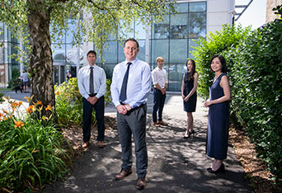
ReconRegen

Picture shows ReconRegen team

Established in 2012, and led by Professor Iain Whitaker, ReconRegen in Swansea University Medical School has developed into the largest single centre reconstructive surgery research group in the UK. In 2020, ReconRegen was awarded £2.5 million to establish the multi-year Scar Free Foundation and Swansea University Programme of Research in Reconstructive and Regenerative Medicine, supported by Health and Care Research Wales. The Programme’s main research projects include:

3D Bioface project (2020 – 2027).
Original award: £1,975,368.
Additional funding awarded 2024/25: £95,500; 2026/27: £20,000

The aim of 3D Bioface is to 3D print durable cartilage implants, using a natural ‘bioink’ combined with the patient’s own cells. If successful, the outcomes could revolutionise our ability to reconstruct form and function in patients affected by facial deformities.

We have developed a high performance, ultra-pure bioink that supports cell growth and that has excellent shape fidelity when used with our novel printing and in situ ‘crosslinking’ process. We have carried out multiple lab experiments to show that our bioink is non-toxic and non-immunogenic and, in 2024, we carried out a first round of animal testing in collaboration with Harvard University that confirmed our lab results. These results were included in our paper Characterisation, biocompatibility, and immunogenicity of tunicate-derived nanocellulose for tissue engineering that was published in the journal Carbohydrate Polymers in November 2025.

Also in November 2025, SBUHB / Swansea University clinical research fellow Dr Cynthia de Courcey was awarded a PhD for her thesis Establishing the effects of Nanocellulose-based bio-inks in an advanced 3D in vitro model for cartilage tissue engineering. Cynthia’s research has played an important part in demonstrating the safety of our bioink.

In March 2026, we were awarded £20,000 for 3D Bioface from Advanced Therapies Wales. We will be using this funding to continue the development of a bioreactor that will be essential for strengthening 3D printed constructs. SBUHB / Swansea University clinical research fellow Dr Parinita Swarnkar is leading on this research.

RESECT project (2020 – 2027).
Original award: £385,610.
Additional funding awarded 2024/25: £58,500; 2026/27: £528,000

The focus of the RESECT project is to develop recommendations for improving efficiency in the skin cancer treatment pathway. We have published multiple studies that evaluate the patient and healthcare burden of skin cancer in Wales, as well as the first ever audit of the environmental impact of non-melanoma skin cancer surgery. We are currently repeating this study to evaluate whether the use of a ‘green’ theatre checklist can make a positive impact on the environmental impact of these procedures. Results of this study will be published later in 2026.

In March 2026, we were awarded £528,000 from the Voluntary Scheme for Branded Medicines Pricing, Access and Growth (VPAG) funding scheme to develop an AI MDT tool with the aim of significantly increasing recruitment of Welsh cancer patients to clinical trials. This 12-month project will focus initially on skin cancer, but we have the future goal of broadening the tool for use in all cancer types.

In April 2026, SBUHB / Swansea University clinical research fellow Dr Manuela Roman was awarded an MD for her thesis Refining our understanding of basal cell carcinoma in Wales to aid service planning.

Swansea - Panzi Alliance for the Reconstruction & Care of victims of conflict related sexual violence (SPARC) (2024- ).
Funding awarded 2024/25: £86,821; 2026/27: £23,950

SPARC is a collaborative initiative between Swansea University and Panzi Hospital, led by Dr Denis Mukwege and Professor Iain Whitaker and with support from Her Royal Highness The Duchess of Edinburgh. SPARC aims to enhance surgical care and develop comprehensive support to alleviate the physical and psychological burden of conflict-related sexual violence (CRSV).

In July 2024, Professor Whitaker led an exploratory visit to Panzi Hospital, which highlighted the urgent need for upskilling in advanced reconstructive techniques. In October 2024, Dr Mukwege and Her Royal Highness The Duchess of Edinburgh visited Swansea University to discuss next steps in the evolution of SPARC, including the ongoing development of our novel ‘ANSWERS’ 3D printed surgical training models, for which we have been awarded £45,000 from the Engineering and Physical Sciences Research Council (EPSRC).

In September 2025, Her Royal Highness The Duchess of Edinburgh hosted a high-level roundtable discussion on CRSV at St James’s Palace, attended by a delegation from SBUHB / Swansea University comprising Professor Whitaker, Consultant Plastic Surgeon Mr Ahmed Emam, Consultant Anaesthetist Ms Claire Ware and Plastic Surgery Specialty Registrar Mr Stephen Ali. Also in September 2025, Panzi surgeon Dr Gloire Byabene visited Swansea for a month-long clinical and research observership to gain vital insight into advanced reconstructive surgery techniques.

In October 2025, Professor Whitaker, Mr Ahmed Emam and Ms Claire Ware visited Panzi Clinic, Kinshasa. During this week-long visit, the surgical team saw over 50 patients in clinic and operated on more than 20, including multiple children with severe burn contractures and a five-year old female rape survivor. Professor Whitaker operated on this little girl alongside Dr Mukwege, Mr Ahmed Emam assisting and Ms Claire Ware leading the anaesthetic team. We were privileged to be joined in theatre by Her Royal Highness The Duchess of Edinburgh, who was visiting DRC at the time. This was covered in a front-page story in The Times on 5 October 2025 and on the Royal Family website: The Duchess of Edinburgh visits the Democratic Republic of Congo | The Royal Family.

In November 2025 our paper, Evaluating the role of the ‘Accessible Novel Solutions for Widespread Emergency Reconstructive Surgery’ (ANSWERS) 3D-printed perineal training model for conflict-related sexual violence injuries, co-authored by Professor Whitaker, Dr Mukwege and HRH The Duchess of Edinburgh was published in the Journal of Plastic, Reconstructive & Aesthetic Surgery (JPRAS).

In early 2026, we were awarded a further £23,950 by the Welsh Government’s Wales and Africa Grant Scheme and have applied for more than £250,000 additional funding from the Children’s Investment Fund Foundation, the BMA Foundation and RCS Edinburgh to continue our work in the SPARC project. Newly appointed SBUHB / Swansea University clinical research fellow, Dr Garikai Kungwengwe, will play a key role in pushing this research forwards in 2026 and 2027.

Our goal is to establish a formal knowledge exchange, enabling Panzi surgeons to learn reconstructive skills in the Welsh Centre for Burns and Plastic Surgery at Morriston Hospital.

Welsh Centre for Emergency Medicine Research (WCEMR)

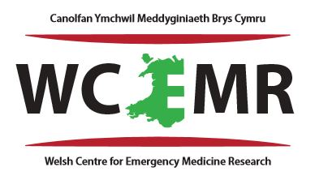
The Emergency Department Research Team has had a productive year, with active recruitment across multiple studies, successful completion of key COPD-related research, and a strong portfolio of upcoming projects. Continued collaboration with other specialties and academic partners has supported both clinical research delivery and academic output, reflected in a growing list of high-quality publications.

The Team

Director  Dr Suresh Pillai | Clinical Research Fellows  Dr Bharath Sundaramoorthy  Dr Muthusankar Sudalaimuthu

Ongoing Studies

TiLLi study- Thromboprophylaxis in Lower Limb Immobilisation (Tilli) study
Randomised Control Trial (RCT) looking into various therapeutic interventions. This project is being carried out along with T&O department. Started recruiting from 2nd March 2026 and recruited 14 participants so far.

CONSEPT trial - CONservative versus Standard carE for primary spontaneous PneumoThorax.
This study is run by Respiratory team and recruited 6 participants from Morriston Hospital Emergency Department reaching recruitment target from this site. However, PI for this study Dr Narendra Chinnappa advised that they need another 4 more and the study is open till September 2026.

Studies completed in 2025

- In-Hospital fibrinogen-level monitoring of COPD patients using microfluidic rheometry - completed recruiting December 2025

- Effects of COPD and treatments on blood clot functionality - completed recruiting March 2025

Studies commencing in 2026

BRAINS-TBI
Recruitment Numbers: ~160
Randomised Control Trial (RCT) looking into biomarkers in head injury.

EDCO-D
Recruitment Numbers: ~1000
Retrospective study ‘Identifying delays in Diagnosis of Carbon Monoxide in the Emergency Department (EDCO-D)’. Expected recruitment.

Liver study
Recruitment Numbers: ~90
Clot microstructure in liver disease is included in the Non-Portfolio section of the Research Directory of HCRW and is undertaken as part of MSc by Research by Bharath with Swansea University.

ToTs trial
Paediatric Emergency Medicine trial investigating Toddler fracture cast vs non-cast

Publications

- Bulpitt A, Hawkins K, Sundaramoorthy B, Sudalaimuthu M, Pillai S, De Guidice F. Experimental viscoelasticity of physiological protein solutions. J. Rheol. 70, 125–138 (2026). https://doi.org/10.1122/8.0001081
- Pillai S, Lawrence M, Zaldua JC, Hawkins K, Morris K, Whitley J, Evans PA. Alterations in clot microstructure in acute exacerbations of COPD. Respir Res. 2025 Nov 18;26(1):323. doi: 10.1186/s12931-025-03405-4. PMID: 41254616; PMCID: PMC12625250.

- Sundaramoorthy B, Sudalaimuthu M, Gopala Pillai SK. Acute Bilateral Lower Limb Ischemia Mimicking Neurological Emergency: A Case of Leriche Syndrome. Cureus. 2025 Nov 8;17(11):e96397. doi: 10.7759/cureus.96397. PMID: 41376759; PMCID: PMC12686743.

- Sudalaimuthu M, Sundaramoorthy B, Gopala Pillai SK. Pulmonary Embolism Following Quadriceps Tendon Repair With Tourniquet Use Despite Adequate Thromboprophylaxis: A Case Report. Cureus. 2025 Oct 16;17(10):e94718. doi: 10.7759/cureus.94718. PMID: 41246719; PMCID: PMC12619567.

- Ellis J, Gopala Pillai SK. Awareness and management of cannabinoid hyperemesis syndrome among staff in emergency departments in Wales. Emerg Med J. 2025 Apr 22;42(5):313-314. doi: 10.1136/emermed-2024-214519. PMID: 40032493.

- Abdulshafea M, Ahmed T, Gopala Pillai SK. Multifocal epithelioid haemangioma of the lower limb bones in a child: an unusual presentation. BMJ Case Rep. 2025 Mar 14;18(3):e262089. doi: 10.1136/bcr-2024-262089. PMID: 40086847.

- Zaldua JC, Watson O, Gregoire DJ, Pillai S, Hellsten Y, Hawkins K, Evans PA. The impact of physical activity and intensity on clot mechanical microstructure and contraction in middle-aged/older habitual runners. BMC Neurol. 2025 Mar 1;25(1):81. doi: 10.1186/s12883-025-04074-y. PMID: 40025415; PMCID: PMC11871672.

Fundings

St David’s Medical Foundation held by Professor Adrian Evans- £6,037.95 (only to be used for clot microstructure studies). £3303.00 used for publishing main AECOPD paper-Alterations in clot microstructure in acute exacerbations of COPD.

Other News

Dr Oliver Watson (previous Clinical Research Fellow)- Awaiting MSc by Research viva with Swansea University.

Dr James Gregoire (previous Clinical Research Fellow)- Awaiting MSc by Research thesis submission.

CanSense

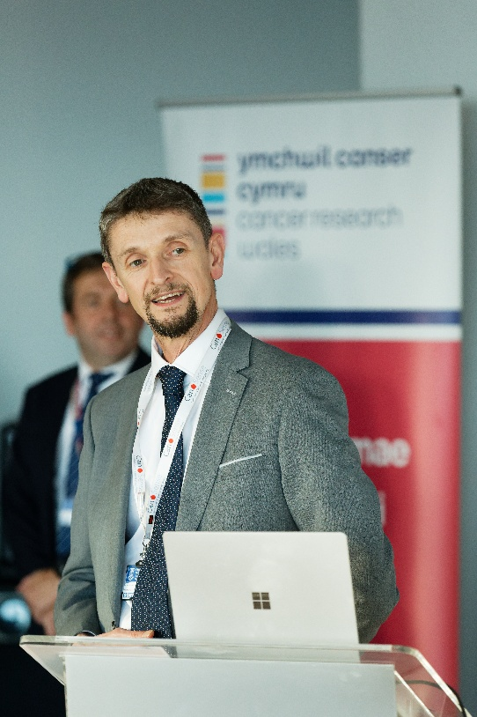
A significant proportion of SBU Sponsored research supports the work of ‘CanSense Ltd.’. CanSense Ltd is a spin-out company from Swansea University arising from academic progress shown through numerous high-profile studies led and sponsored by Swansea Bay UHB. The company is developing a blood-based diagnostic for colorectal(bowel) cancer to address inequalities in early detection and to alleviate pressure on diagnostic pathways for cancer seen throughout NHS practice. The company was incorporated in 2018 and has taken the test from prototype to a fully functional market-ready analyser. The company has won £3M in non-dilutive funding and £1.5M in equity funds. There are heads of terms and business cases with 4 customers in readiness for analyser installation and patient benefit.

The technology developed is now being tested on other cancer types such as breast, lung and ovarian which all require better clinical need for early detection. Early results are extremely promising with the CanSense blood test having the potential to transform the cancer pathway.

Qualitative research undertaken with the GP community reported extremely positive attitudes to the test, with an appetite to see the test introduced into routine practice. The team also undertook a SBRI real world evaluation study 2024/5 which reported the CanSense test can radically improve efficiencies within the current pathway for detecting colorectal cancer, reporting a 55% reduction in false positive rate vs FIT alone, 63.8% patients avoided SCP colonoscopy, £30M per year saving through reduction of unnecessary colonoscopies (NHS Eng & Wales) .

Equally, we have seen that introducing an alternative to the stool test (FIT test) and colonoscopy through a non-invasive blood test which can be delivered in the community, has potential to see improved screening rates amongst ethnic minority groups helping reduce health inequalities.

The test is patented and regulatory ready for roll out within the NHS this year pending UKCA approval, with an NHS business case currently under review. If agreed, anticipated benefit would be 10-day time reduction from referral to test : achieves 85% 28d target compliance (50% fewer diagnostic breaches) and a 25.6% reduction in colonoscopy demand saving £2.7M costs annually at 6.3x ROI.

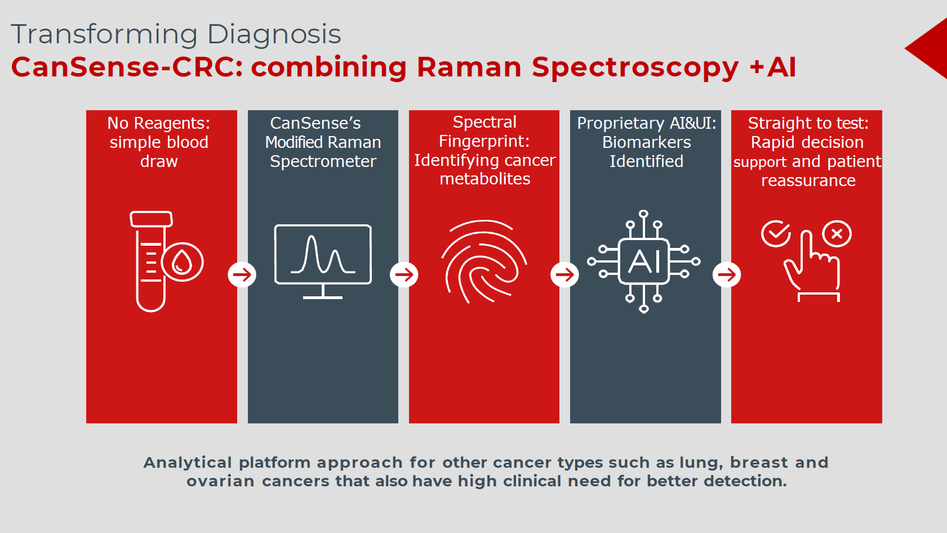

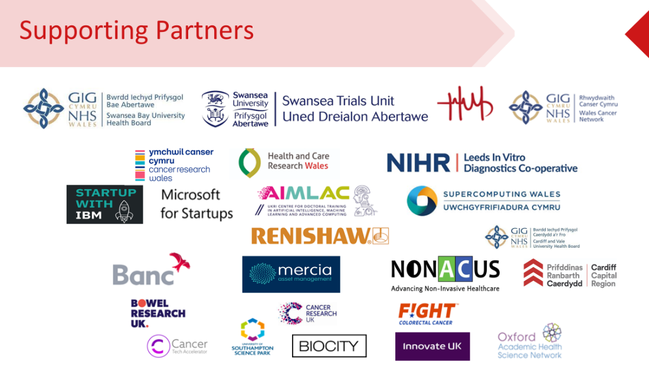

Utilising extracellular vesicles for early detection of clinically significant prostate cancer

In a study co-lead by Dr Jason Webber (Swansea University) and Mr Gokul KandaSwamy (SBUHB), titled Utilising extracellular vesicles for early detection of clinically significant prostate cancer, researchers are seeking to understand why some prostate cancers are more aggressive than others. This information is being used to develop a new blood test to enable early detection of patients with clinically significant, aggressive disease, who require urgent therapy.

Whilst there have been recent advancements in imaging technologies, a lack of diagnostic information that can accurately distinguish between patients with aggressive cancers or slow growing cancers means that many patients still require biopsy. This is invasive, with associated risks, and even when combined with the standard blood test (PSA) lacks absolute reliability for detection of clinically significant disease. Better blood-based tests are therefore required to facilitate prostate cancer diagnosis.

There is much interest in liquid biopsies as minimally invasive means of diagnosing patients. Extracellular vesicles (EVs), present within patient blood, carry many markers associated with the cell of origin. Changes in sugars (glycans) present within prostate cancer cells have been linked to disease progression. We have therefore developed a test that can detect sugars present on prostate cancer-derived EVs within patient blood. We have successfully recruited more than 350 patients, undergoing prostate cancer diagnosis within the Swansea Bay University Health Board, with further recruitment ongoing. Patients are supplying blood (serum) and urine samples which we are using to evaluate the test. The results, to date, are extremely promising and suggest our test can successfully discriminate between patients with clinically significant, aggressive, disease or clinically insignificant disease. We are now looking to assess the test in a larger number of patient samples to confirm its utility for accurate diagnosis. We are also exploring additional applications of the test, such as monitoring of disease following therapy. Overall, this project highlights successful collaboration between Swansea University and the Swansea Bay University Health Board strengthening links between the two institutions whilst delivering research aimed at improving the lives of patients with prostate cancer.

Advancing Heart Failure Research Through Strategic Clinical & Academic Collaboration

There is a well-established, active collaboration between clinical teams at Swansea Bay University Health Board (SBUHB) and clinical researchers within Dr Emma Rees’ group at the Faculty of Medicine, Health and Life Sciences, Swansea University. Collaborative research spans investigator-led and commercial work, with SBUHB staff contributing to the whole research cycle.

At the research design phase, cardiologists, heart failure (HF) nurses, and pharmacists are contributing to IMPROVE-HF, an NIHR Application Development Award which is developing a programme grant of applied research to improve HF outcomes and services across Wales. IMPROVE-HF work has comprised a national sandpit event to define the variation and challenges in heart failure services across health boards in Wales, a systematic review of the evidence based for interventions to improve HF outcomes, and a Delphi consensus work package to determine the interventions and outcome measures which will be used in a programme grant application.

The Acute Clinical Teams in SBUHB are contributing to the delivery of research in patient homes through the FOCUS-HF study (funded by HCRW). This programme of work aims to support clinical teams to make better first-line decisions during home visits of older people with acute breathlessness. Research phases have included mapping the current HF diagnostic pathway for older people in Wales using electronic health record data; training advanced practice nurses to perform focused hand-held ultrasound of the heart and lungs with careful assessment of accuracy and reproducibility; a feasibility study of adding the scan to the current patient pathway during home visits (Neath team); and a forthcoming trial of comparative diagnostic accuracy and decision-making impact (Swansea team).

In relation to commercial research, Dr Rees’ group have been supporting an American med-tech start-up company to develop a novel ‘self-driving’ ultrasound machine which aims to improve newborn screening for congenital heart defects. The device is designed to be used in remote and low-resource settings. As the prototype nears the threshold for clinical investigation, Dr Rees has collaborated with neonatal/paediatric consultants and healthcare scientists in SBUHB to scope and plan the protocol for an initial feasibility study at Singleton Hospital. This proposal is currently being reviewed by MHRA and NHS HRA.

The collaborative teams are also building for the future, working together to shape proposals for incubator that seeks to improve HF outcomes through building research capacity and capability in primary and community care settings.

Driving Research and Innovation in EMRTS & ACCTS

The Emergency Medical Retrieval and Transfer Service (EMRTS) and Adult Critical Care Transfer Service (ACCTS) deliver a highly specialised model of pre-hospital and interhospital critical care across Wales, providing advanced clinical decision-making and interventions for patients with life or limb-threatening conditions. The service is designed to ensure equitable access to critical care, enabling early specialist intervention and direct transfer to appropriate treatment centres, thereby improving patient outcomes and system efficiency.

The service is developing a diverse portfolio of research and innovation. This includes clinical topics such as novel use of Cold stored platelets, airway management techniques, and Stroke Care, through to the use of artificial intelligence, and drones supporting delivery of healthcare.
Academic Partnerships
EMRTS and ACCTS maintain strong collaborative relationships with academic institutions, including Swansea University, Warwick University, Cardiff University, and Bristol University. These partnerships support a diverse programme of research that extends beyond traditional clinical studies.
A key highlight is the collaboration with Warwick University, which utilises applied linguistics and behavioural science to examine communication, decision-making, and risk negotiation within critical care teams. This work is highly innovative within emergency and retrieval medicine and provides valuable insights into how clinicians make complex, time-critical decisions under pressure.
Findings from this research is supporting policy and training as well as allowing the study of complex decision making, which is key to delivery of the services offered across EMRTS and ACCTS.
NHS and Clinical Partnerships
The service works in close collaboration with other NHS partners, including the Welsh Ambulance Services University NHS Trust, Welsh Blood Service and the South Wales Trauma Network.
These partnerships not only enable coordinated clinical delivery but also play a critical role in facilitating research and innovation. Through access to real-world clinical environments, shared datasets, and multidisciplinary expertise, partners contribute to the development and evaluation of research in areas such as pre-hospital interventions, blood product use, and trauma care pathways.
This collaborative infrastructure supports the translation of research into practice, ensuring that innovations are tested, implemented, and scaled within routine care, ultimately improving patient outcomes and service effectiveness
Industry Collaboration and Technological Innovation
The service also has a unique collaborative partnership with industry working closely with Tactical Wireless Ltd. This collaboration has enabled the development and implementation of cutting-edge technologies that enhance both clinical care and operational capability.
Key areas of innovation include:
- Telemedicine solutions, enabling real-time remote specialist support
- Remote ultrasound, improving diagnostic capability in pre-hospital environments
- 360-degree immersive clinical support systems, supporting both patient care and training
- Advanced satellite communication technologies, enhancing connectivity in rural and remote settings
This work also includes engagement with the European Space Agency (ESA). Through revenue share agreements this also has facilitated income generation which is used to undertake further projects.

More about the EMRTS various projects can be found on their website (https://emrts.nhs.wales/research/ )

Wales Ambulance Services (WAST)

RESPOND Research Programme

The 999RESPOND1 and 999RESPOND2 studies aim to explore communication and decision-making practices in relation to dispatching Enhanced Critical Care Teams. Both projects are sponsored by the Welsh Ambulance Services University NHS Trust and are delivered in collaboration with Swansea Bay University Health Board Emergency Medical Retrieval and Transfer Service, Wales Air Ambulance Charity, University of Warwick, and University of Bristol. 999RESPOND2 includes all these collaborators and additionally Imperial College Health Care NHS Trust, Clarach Economics and West Midlands Ambulance Service University NHS Trust.
999RESPOND1 examined how emergency medical dispatch decisions for critical care teams are made within ambulance control rooms. It analysed real-world data including 999 audio, written sequence of events records and a policy document to identify points of information loss and communication practices that affect decision making. 999RESPOND2 aims to build on this work to evaluate how introducing Video Consultation as an additional information source affects communication, risk assessment and dispatch decisions compared to traditional audio calls. It aims to analyse 999 audio and video calls and policy documents as well as undertake focus groups and interviews to build a Theory of Change framework to support improved decision making.
Swansea Bay University Health Boards/WASTs involvement in this project includes the extraction, anonymisation and sharing of 999 Audio and Video calls (where a critical care team was dispatched) for analysis by the research team. Involvement also includes participants for interviews and focus groups and support to create the Theory of Change framework.

Radiotherapy Physics: Research, Innovation and Partnerships

Radiotherapy Physics continues to play a central role in advancing research, innovation, and service development across the organisation. Through strong academic collaborations, strategic industry partnerships, and active involvement in clinical trials, the department ensures that cutting-edge developments are translated directly into improved patient care.

Academic Collaboration and Workforce Development
The department maintains a well-established and highly productive partnership with Swansea University, supporting both education and research. Staff contribute to postgraduate teaching on the MSc in Medical Radiation Physics and the MSc in Clinical Science programmes, helping to train the future clinical workforce.

In addition, Radiotherapy Physics provides supervision for several Clinical Radiotherapy MSc research projects each year, supporting applied research aligned to clinical priorities. At doctoral level, the department currently supervises a PhD student in Clinical Radiotherapy. This work has delivered tangible outputs, including two peer-reviewed publications within the last year, with the student recently submitting their thesis.

The collaboration is further strengthened through a joint Associate Professor post with Swansea University, reinforcing the integration of academic research and clinical practice and enabling direct translation of innovation into patient benefit.

Industry Partnerships and Technological Innovation
Radiotherapy Physics continues to build strong partnerships with leading industry providers to support the development and implementation of advanced technologies.
The department holds a Centre of Excellence agreement with C-Rad, a supplier of Surface Guided Radiotherapy (SGRT) systems. This collaboration supports the optimisation of treatment delivery, enhances patient safety, and enables access to the latest technological developments.

In addition, there are two active research agreements with Elekta, one of the world’s leading radiotherapy equipment and software manufacturers. These projects focus on:

- The development of advanced patient pathway software to improve efficiency and patient experience
- The exploration of automated and AI-based treatment planning solutions to enhance accuracy, consistency, and productivity
These partnerships ensure the department remains at the forefront of innovation and contributes to the wider advancement of radiotherapy practice.

Clinical Trials Activity
Radiotherapy Physics provides specialist support to a broad portfolio of clinical trials. This includes expertise in treatment planning, imaging, dosimetry, and quality assurance, ensuring safe and effective implementation of trial protocols. This activity enables patient access to new and innovative treatments while supporting the generation of high-quality clinical evidence.

Research Outputs and Impact
The department has maintained a strong publication record over the reporting period, with five peer-reviewed papers published across a range of radiotherapy topics. These include:
- National guidance on the use of 3D printing in radiotherapy (IPEM topical report)
- Evaluation of patient time spent in radiotherapy departments pre-, mid-, and post-COVID-19
- Assessment of dose uncertainty related to CBCT imaging on Elekta systems
- Evaluation of dental dose to inform pre-radiotherapy decision-making in head and neck cancer
- Investigation of geographic variation (“postcode lottery”) in access to breast radiotherapy
Additional work has also focused on the optimisation of imaging protocols to reduce unnecessary radiation exposure while maintaining image quality.

These outputs demonstrate the department’s commitment to improving treatment quality, efficiency, and equity of access for patients.

Research Funding
Radiotherapy Physics has achieved notable success in securing research funding. During the reporting period, the department secured over £100,000 in direct R&D funding. In addition, staff contributed as co-applicants on successful bids totalling approximately £600,000 in collaboration with Velindre Cancer Centre.

This level of funding highlights the department’s strong research capability and its contribution to regional and national research initiatives.

Strengthening Research in Occupational Therapy Services
Over the past year, Occupational Therapy, an Allied Health Profession service in Swansea Bay have continued to strengthen research capacity and capability. This has been supported by a growing network of research-active and research-interested staff, led by the Research Lead Occupational Therapist and in regular collaboration with the R&D department.
Key achievements include successful participation in the FIRST hand tendon trial, with 33 participants recruited and 12-month follow-up assessments completed by Burns and Plastic Surgery therapy staff, supported by the R&D delivery team. This involvement enabled professional development opportunities, including completion of the NIHR PI Associate Scheme by an Occupational Therapist, who was then also invited to join the Data Monitoring Committee for the ongoing SCOOTT trial.
R&D support also facilitated establishment of the Health Board as a Participant Identification Centre, enabling progression of a portfolio-adopted PhD study on Occupational Therapy evaluation methods in primary care. Led by the Research Lead Occupational Therapist, the study has completed qualitative stakeholder interviews and produced two publications currently under peer review.
Several service evaluations have progressed during the year. These include an evaluation of an Occupational Therapy-led intergenerational burn prevention programme, accepted for poster presentation at the British Burns Association conference. In addition, prior R&D pathway to portfolio support enabled completion of a UK-wide survey exploring virtual working in primary care Occupational Therapy, with findings submitted to the British Journal of Occupational Therapy.
A service evaluation examining Occupational Therapy provision within Older People’s Mental Health Primary Care was completed in June 2025, supported by Elizabeth Casson Trust funding. Findings were presented at the HCRW Support and Delivery Day 2025. A further evaluation is ongoing, exploring the impact of an Occupational Therapy-led care home training programme on personal care practices.
Finally, several staff are contributing to national research as stakeholders, including work on a scoping review of Occupational Therapy in substance misuse and a primary care occupational therapy study using realist methods.

Clinical Innovation in Nuclear Medicine: A Partnership with GE Healthcare

Nuclear Medicine has a very good industry partnership with GE Healthcare. We purchased the UK’s first GE StarGuide solid detector 3D SPECT/CT scanner from GE. We are working closely with GE Healthcare in the developmental aspects of the clinical implementation of this scanner, particularly as it concerns:
- Calculation of coronary flow reserve (this is a measure of the heart’s ability to increase its blood supply to meet an increased need for oxygen, such as when you exercise or are stressed.

- CT head scans as part of our Parkinson’s Disease diagnosis (this makes the diagnostic accuracy more specific as it combines molecular function with anatomy)
- Calcium scoring to assess coronary artery disease (having a sense of to what extent calcium deposits have narrowed your arteries)

- Contrast CT as part of parathyroid imaging (our next development) (helping us the locate parathyroid disease to within a few millimetres)
We are furthermore in the process of purchasing new detectors for this scanner from the same supplier (a UK / global first) which would enable us to look at dosimetry and higher energy radionuclides when scanning patients on the GE StarGuide scanner.

Establishing a Centre of Excellence in MRI Physics

The MRI Physics Group was established in April 2020 with just one member. Since then, we have grown to a team of 8 including clinical scientists and trainees. The expansion of our service provision across most of NHS Wales has led to the creation of a new section within the Medical Physics and Clinical Engineering (MPCE) department. Led by Dr Jonathan Phillips, a consultant clinical scientist and honorary associate professor in Medical Imaging at Swansea University (Dr Jonathan Phillips - Swansea Bay University Health Board), the mission of the group is to develop a centre of excellence for clinical and research MRI in Wales.

So far this year, a major highlight has been getting ethical approval for a study funded by Swansea Bay Health Charity, investigating the use of MRI in radiotherapy pathways. Together with clinical colleagues Drs Owen Nicholas and Claire Brunner at the South West Wales Cancer Centre, we will be investigating ways of improving visualisation of tumours and organs at risk across different anatomical regions, focussing on novel tumour sites and assessing the clinical impact of MRI-CT Integration in the radiotherapy pathway. We will also be identifying, developing and undertaking pilot studies for MRI-adapted radiotherapy for selected tumour sites and identifying pilot studies assessing MRI protocols which can act as (structural and functional) imaging biomarkers. We are about to begin this with a healthy volunteer study. The MRI examinations will be performed on the 3T research scanner in Swansea University.

We are also working in partnership with the maxillofacial prosthetics department at Morriston Hospital led by Peter Llewelyn Evans to investigate MRI safety aspects of patients with certain prostheses to see if they can have MRI scans safely without having their prosthetics removed, which can cause delays.

Another project, led by our Senior Principal MRI Physicist Dr Maria Yanez Lopez (Dr Maria Yanez Lopez - Swansea Bay University Health Board) has just resulted in a paper being submitted. This collaborative work with other UK imaging centres, provides recommendations on best practices for the implementation of MRI protocol development within a clinical setting. This is key to ensuring the most optimised MRI images are consistently achieved and in the shortest possible examination times – helping the patient experience and increasing patient throughput.

We are also about to publish our work on the introduction of a new pathway to scan patients with ‘effectively MR Conditional’ cardiac implanted electronic devices (e.g. pacemakers) – a move which has improved workflows and allows more patients access to MRI scanning earlier and without the need for individual risk assessments to be performed. This project has been in collaboration with colleagues in Hull, Newcastle and the Christie, Manchester.

Looking forward, Siwan Evans (Siwan Haf Evans - Swansea Bay University Health Board), a Principal MRI Physicist in the team will be leading a major project investigating the barriers to, and methods to support, safe equitable MRI access for patients with cardiac implanted electronic devices. This will involve the co-development of decision-support interventions with referrers and patients to improve MRI safety knowledge, support shared decision-making and promote patient advocacy for appropriate MRI access.

PUBLIC INVOLVEMENT AND ENGAGEMENT

Effective engagement and building partnerships with the public as stakeholders in our research is fundamental to developing trust and enabling advancements in healthcare. From participating in studies through to sitting on oversight groups, the involvement of patients and public enables our staff to explore new treatments and service models.
During the past year, we’ve seen some excellent examples of effective PPI models in research. Below are two such examples which showcase PPI at its best:

Developing co-produced, evidence-based patient resources for adults with blunt chest injuries.

SB UHB Lead Prof. Ceri Battle, Consultant Physiotherapist

Why did we complete this work?

Blunt chest injuries are commonly sustained by adults as a result of falls, road traffic collisions, assaults and sporting injuries. Injuries range in severity from simple bruising to the chest wall, through to life-threatening multiple rib fractures and damage to the underlying organs. For people with blunt chest injuries, delayed complications are common, so patient education and self-management are key components of care. There are no universally accepted patient advice resources and, as a result, there is inconsistency in the advice provided, even on a local or regional level in the UK. People with blunt chest injuries say that they find the patient resources provided unhelpful and lacking the necessary guidance to assist with their recovery. Until recently, most patient resources have been traditionally developed by healthcare providers without the input of people with lived experience of blunt chest injuries. The aim of this study was to design, develop and evaluate co-produced, evidence-based patient resources for adults with blunt chest injuries.

What did we do?

Two workshops were run using a co-production approach, facilitated by one physiotherapist and one patient with lived experience of blunt chest injuries. This method was used to remove any professional or organisational boundaries, so that all study members actively participated in the work. The first face to face workshop was attended by 18 diverse participants; eight adults with lived experience of chest injury, two family members and eight healthcare professionals from across the multi-disciplinary team. Through the various activities undertaken in the workshop, a comprehensive list of topics was collated by the study facilitators, which participants felt were the important components of the recovery process following a chest injury. This list would form the content of the patient resources being developed. The second phase of the development and design of the resource involved the study participants reconvening for an online workshop. The aim of the second workshop was to finalise the content proposed in the first workshop and then discuss the format of the patient resource. The final stage of the development and design of the resource involved feedback sessions either via face to face or via electronic communication.

What did we achieve?

Following the two workshops, two different patient education resources were developed;

1) a double-sided A4 patient advice sheet to be printed and given to the patient in paper format This was also produced in three additional formats;
a) Welsh language,
b) easy read and
c) screen reader and/or digital Braille software compatible.
The advice sheet was a concise 2-sided paper resource, using a traffic light format with icons and minimal text, to guide the reader through the stages of recovery. This included information on what to expect, what activities the patient should or should not do, and when and where to seek help. On the reverse side was a free text section in which the healthcare professional managing the patient could include personalised care plan information on specific injuries sustained and instructions, co-morbidities management, medication specifics and contact details for local available services.

2) a five-minute animation which provides additional, in-depth, supportive information to the patient, with a voiceover and subtitles (and is recorded with Welsh language subtitles and voiceover, and a British Sign Language version). This can be accessed by the patient / carer using a QR code on the paper advice sheet. The animation can be viewed here: https://youtu.be/vS_3zE8WMi4

What have our resources achieved so far?

These patient resources have been introduced into Swansea Bay University Health Board and made available for use by the South Wales Trauma Network. They have been endorsed by the British Trauma Society and added to their website. They are also currently being translated into Ukrainian, for use there.

- CID5382(a) Chest Injuries Advice and Recovery Easy Read Guide for Patients (Welsh) (New - April 2026)
- CID5382(b) Chest Injuries Advice and Recovery Easy Read Guide for Patients (English) (New - April 2026)
- CID5384(a) Chest Injuries Infographic for Patients (Welsh) (New - April 2026)
- CID5384(b) Chest Injuries Infographic for Patients (English) (New - April 2026)

What did the patients say about it?

Evaluation of the co-production process showed that participants felt that they were valued and treated as equal members, with their opinions heard and respected. Using a healthcare professional and patient with lived experience as equal facilitators throughout the study, also contributed to the reported positive co-production process. By the end of the process, participants reported that final resources developed were a true reflection of their experiences and feedback. Feedback regarding the resources highlighted that the use of an animation to support the paper resource was very useful and provided a more personalised approach to self-management following hospital discharge.

Gastroscope study PPI work shortlisted for Moondance cancer awards.

SB UHB Lead – Dr Sarah Gwynne, Consultant Oncologist.

Gastroscope is a UK-wide clinical trial developed by clinicians in Swansea, in partnership with the Centre for Trials Research (Cardiff), a national multidisciplinary clinical team, and patient partners from across the UK. The study explores whether higher-dose radiotherapy can better control inoperable stomach cancer, delay distressing symptoms, and improve quality of life compared with current standard care.
The trial has progressed to the final stage of the CRUK clinical trial funding scheme and has received positive internal and external reviews. The funding outcome is expected in May 2026, with alternative funding routes identified should CRUK funding not be secured.

This nomination specifically recognises the depth, breadth, and impact of patient and public involvement (PPI) in the development of GastroSCOPE.

Background and Rationale

Surgery is the only curative treatment for stomach cancer, yet only around one third of patients are eligible. For patients with inoperable disease, treatment options are limited and may not adequately prevent symptoms such as bleeding, obstruction, and pain. Radiotherapy is currently used at low doses to help relieve symptoms once they occur. However, emerging evidence suggests that higher-dose radiotherapy may offer better cancer control and prevent symptom development, though this has not been tested in a definitive randomised controlled trial.

Trial Design

GastroSCOPE is a randomised controlled trial aiming to recruit 446 patients across 28 UK centres. Patients with inoperable stomach cancer that has not spread beyond the stomach are allocated to one of two groups, depending on whether they are able to receive chemotherapy. Participants will receive either standard care or standard care plus high-dose radiotherapy.

Optional exploratory studies include MRI-based treatment planning, tumour tissue analysis, blood samples, and additional endoscopy in selected patients, to improve understanding of treatment response.

Patient and Public Involvement

PPI partners have been integral to the study from its earliest stages, shaping the research question, trial design, and acceptability of interventions and assessments. Two online and one in-person facilitated focus groups were held, involving patients treated for oesophageal or gastric cancer, carers, and experienced PPI contributors from diverse demographic and geographic backgrounds. Discussions focused on trial design, endpoints, radiotherapy schedules, imaging, and biological sample collection.
Feedback demonstrated strong support for the trial’s aims and design, including the addition of MRI and translational research components. Travel burden for radiotherapy emerged as a key concern, particularly for patients in South West Wales where average travel distances are greater. In response, the trial has incorporated virtual follow-up visits wherever possible, flexible completion of quality-of-life questionnaires (online or by post), and reimbursement of travel costs in line with CRUK guidance. A SWAT (Study Within A Trial) addressing barriers to recruitment is also planned.

The quality and impact of this work was recognised with the Best PPI Involvement Award at the Wales Cancer Research Conference (March 2025).

A Patient Advisory Group (PAG), including patient representatives, public contributors, and a GUTS UK representative, will meet regularly throughout the trial. The PAG will review patient-facing materials, advise on trial conduct and dissemination, and help ensure findings are communicated clearly to patients and the public. Patient representatives are embedded within the Trial Management Group and Trial Steering Committee, and PPI costs are fully funded.

Impact

If GastroSCOPE demonstrates benefit, it could change national and international treatment guidelines for inoperable stomach cancer, expanding treatment options for a group of patients with significant unmet need. Trial results will be reported in line with the AllTrials initiative and shared with patients, professional audiences, partner charities, and the wider public

First Regional Research & Development Symposium

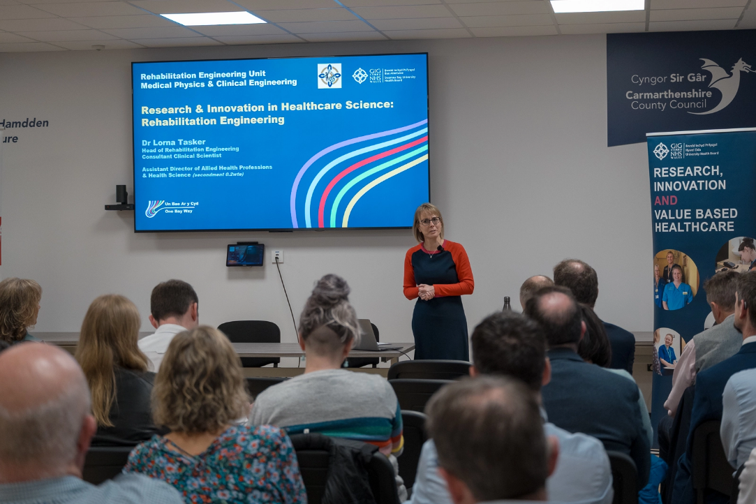
Pictured: Dr Lorna Tasker, Consultant Clinical Scientist, Head of Rehabilitation Engineering and Assistant Director of Allied Health Professions and Health Science, Swansea Bay Health Board.

Following a successful local Research and Development (R&D) showcase in September 2024, Swansea Bay University Health Board partnered with Hywel Dda University Health Board to host their first joint regional event in October 2025. The event marked an important step towards developing a coordinated regional approach to research, innovation and excellence, while celebrating ongoing work across both organisations.

The day, led by the Executive Medical Directors, began with staff presentations highlighting a wide range of research activity. Topics included lymphoedema, midwifery, rehabilitation engineering, emergency medicine, artificial intelligence and cancer research in primary care, alongside work focused on evidence generation and value within the NHS. In the afternoon, regional universities shared examples of collaborative projects, demonstrating the importance of cross-sector partnerships in supporting high-quality, sustainable healthcare. Contributions from industry partners, including CGI, further showcased the growing role of digital innovation and artificial intelligence in healthcare delivery.

The event concluded with breakout sessions, where participants explored regional priorities, barriers to innovation and opportunities to strengthen partnerships. Insights gathered from these discussions are now being collated to inform the development of a regional programme of work in research and innovation.

Senior leaders from both health boards highlighted the strong link between research activity and improved patient outcomes, as well as the importance of innovation in responding to future healthcare challenges. They also recognised the unique mix of rural and urban communities across south-west Wales and the opportunity this presents to expand access to clinical research, test new approaches to care and strengthen regional collaboration.

OTHER KEY ACHIEVEMENTS

  NIHR Healthcare Science Innovation Fellowship awarded to Rehabilitation Engineering |   Appointment of lead Research Pharmacist |  |   Seven UK-wide commercial studies open with SB UHB Chief Investigators
  Top recruiting sites over the year for studies:  CRAFFT, PACIFIC, Awake Prone, BACHb, MATRIX-2, PETNECK 2, SCC-After |   Multiple studies conducted at SBUHB published in medical journals.  Including 8 in highest ranking journals - 4 The New England Journal Of Medicine, 2 The Lancet, 2 Annals of Oncology |  |   Oncology research awarded investment of over £400k  Awarded from the Voluntary Scheme for Branded Medicine Pricing, Access and Growth (VPAG)
  Study run in SB UHB DESTINY-09 was highlighted at ASCO 2025 as the first trial in over a decade to show a meaningful outcome improvement for first-line HER2-positive metastatic breast cancer patients. |  |     Continued provision of research placements for medical and physician associate students, supported by a new handbook, with positive feedback highlighting valuable insight into NHS clinical trials.
  Dr Manju Krishnan receives national recognition for leading stroke research, winning the Local Clinical Research Investigator Award from the British and Irish Association of Stroke Physicians. |  |   SB UHB wellbeing programme lead by Dr Zoe Fisher has been scaled across Wales and adapted for students, delivering proven improvements and earning Bevan Commission Exemplar status.

FINANCIAL SUMMARY

Research Income | Current Year | Previous Year
Research Delivery Funding | £2,471,744 | £2,329,425
Excess Treatment Costs | £209,568 | £136,777
VPAG funding | £219,261 | £36,196
Non-Commercial Income | £899,510  (All non-commercial income receipted in 25-26) | £134,424  (Only included HCRW related grant income)
Commercial Research Income | £1,967,825 | £1,700,000
TOTAL INCOME | £5,767,908 | £4,336,822

Definitions:

Research Delivery Funding
Funding provided by Welsh Government R&D Division to SBUHB to support the set-up and delivery of research studies, including the staffing and infrastructure required to deliver research.

Excess Treatment Costs (ETCs)
These are the additional costs associated with research studies taking place within SBUHB, identified using the UK AcoRD (Attributing the Costs of health and social care Research & Development) framework. ETCs are defined as the difference between the cost of the treatment provided as part of a research study and the cost of the existing standard treatment (or care) that would otherwise be provided. These costs are reimbursed by Welsh Government.

VPAG Funding
Funding arising from the Voluntary Scheme for Branded Medicines Pricing, Access and Growth (VPAG), a UK-wide agreement where pharmaceutical companies rebate a proportion of their profit to UK government. These funds are used to support NHS sustainability and investment, including an allocated amount to enhance NHS commercial clinical trial infrastructure.

Non-Commercial Income
Income received from publicly funded or charity-supported research (e.g. NIHR, HCRW, universities or charities).

Commercial Income
Income received from industry (e.g. pharmaceutical or biotech companies).

FORWARD LOOK & CONCLUSION

Thank you for taking the time to read our Annual Report 2025–26. We hope it has provided a meaningful insight into the breadth, depth and impact of research activity taking place across Swansea Bay University Health Board (SBUHB). Our research community continues to grow in strength and ambition, and this report highlights the commitment of our teams to improving patient care through innovation and evidence-based practice.

The Health Board would like to extend its sincere thanks to our research collaborators, funders and partners whose continued support enables our work to thrive. We are particularly grateful to our academic partners, industry collaborators and regional stakeholders who help us to deliver high-quality research at scale. Most importantly, we would like to recognise and thank the patients and members of the public who generously provide their time and consent to participate in research. Their contribution is invaluable and underpins our ability to make meaningful improvements to the care of tomorrow.

As we look to the future, and following discussion with Welsh Government, we have agreed to three clear action points for the forthcoming year, namely:

- Action 1: Develop a clear, action focused communications plan to demonstrate, showcase and maximise the impact and value of research, including how this impact is translated into practice across the organisation.

- Action 2: Medical Directors and R&D Directors across Swansea Bay UHB and Hywel Dda Health Board will jointly develop a clear implementation plan to enable delivery of the recommendations of the Cancer Research Pathways project.

- Action 3: Establish a Clinical Academics Group jointly with Swansea University with a clear purpose, defined priorities, and a focus on delivering tangible outcomes, including the development of future joint posts.

With the continued engagement and support of our Board, the above action points compliment the following three identified internal priority areas that will shape our research direction:

- Opening oncology trials on a regional basis
We aim to expand access to oncology trials across the region, ensuring that patients benefit from equitable opportunities to participate in cutting-edge treatments closer to home. By developing a regional model for oncology trials, we intend to establish a framework that can be replicated across other clinical pathways, supporting a more integrated and collaborative approach to research delivery at scale.

- Re-establishing a Partnership Board and Memorandum of Understanding (MOU) with Swansea University (SU)
Strengthening our strategic partnership with Swansea University is a key priority. By re-establishing a formal Partnership Board and renewing our MOU, we will create a robust governance structure to support the development of clinical academic careers. This will enable us to increase capacity, foster innovation, and ensure a sustainable pipeline of clinician-researchers who can bridge the gap between research and frontline care.

- Developing local metrics to measure research success
To better understand and demonstrate the value of research within SBUHB, we will develop and implement a suite of locally relevant metrics. These will go beyond traditional measures, capturing the full impact of research across patient outcomes, workforce development, income generation and system-wide improvements. This will allow us to monitor progress, inform decision-making and clearly articulate the benefits of research to our stakeholders.

Our Three Pillar Bridging Strategy will evolve into a comprehensive three-year strategy, setting out a clear and ambitious vision for research within SBUHB. At its core, this strategy will emphasise collaboration - locally, regionally and nationally - to maximise impact and ensure sustainability. A key element of this will be working closely with Hywel Dda University Health Board to develop and deliver a shared regional research strategy, strengthening our collective ability to innovate and improve outcomes for the populations we serve.


Together, these priorities position us to build on our successes and continue to embed research as a core component of high-quality healthcare delivery across Swansea Bay and beyond.

Research & Development Strategy

The Three Pillars Strategy

Pillar 1: Research, Development, and Innovation Culture

Strategic Aim: To create a vibrant learning culture with research and innovation fully embedded into health and care services.

Objective 1.1
Ensure visibility of research and development at board level, by providing reports to the Digital Data, Research, and Innovation Committee, to ensure research and development visibility.

Objective 1.2
Support staff to develop necessary skills, by using NIHR associate principal investigator scheme, to ensure that staff are skilled in research, development and innovation.

Objective 1.3
Embed skills within teaching and clinical training, by collaborating with Swansea University Medical school for student placements, to ensure the longevity of clinical researchers.

Objective 1.4
Embed specific tariff in job planning guidance, by promoting tariff in job planning, to ensure protected time for clinicians.

Objective 1.5
Monitor and promote engagement via PDR process, through peer mentorship and departmental leads, to increase staff engagement.

Objective 1.6
Promote link between research, innovation, and quality improvement, by supporting staff with regulatory navigation and IP protection, to ensure increased activity from service evaluation.

Objective 1.7
Increase awareness of health and wealth benefits, through positive communication and media engagement, to increase public and staff awareness.

Objective 1.8
Re-launch the Local Innovation Panel, through a partnership with ARCH to advise on potential new innovations.

Objective 1.9
Advocate for Non-Medical Principal Investigators to encourage non-medics to lead research studies to aid the expansion of Principal Investigator skills.

Pillar 2: Research, Development and Innovation Support

Strategic Aim: To create an enabling environment for high-quality research, development, and innovation.

Objective 2.1
Effective use of research delivery staff, through equitable allocation of resources, to ensure access to expertise and facilities.

Objective 2.2
Maintain recruitment to time and target performance, through efficient capacity and capability process, to ensure timely research program starts.

Objective 2.3
Regional partnership working, through sustainable investment in key departments, enabling local and regional clinical trial delivery.

Objective 2.4
Introduce modern facilities and equipment, using commercial income and capital investment to provide state-of-the-art research facilities.

Objective 2.5
Introduce pump-prime schemes by funding small schemes through development grants.

Objective 2.6
More efficient procurement processes by developing a collaborative approach with stakeholders to ensure better value for money contracts and quicker procurement times.

Pillar 3: External Relationships

Strategic Aim: To adopt an open and collaborative approach with multi-sectoral partners.

Objective 3.1
Increase the number of Chief and Principal Investigators, by collaborating with universities for joint appointments, to ensure the availability of Principal / Chief Investigators.

Objective 3.2
Develop regional models of research development with Hywel Dda, with initial focus on oncology trials, through strategic deployment of VPAG monies, for more equitable trials access.

Objective 3.3
Develop collaborative sponsorship with Swansea University providing a memorandum of understanding and co-sponsorship agreements to ensure an efficient study setup process.
Objective 3.4
Continue to support Health and Care Research Wales 'One Wales' approach by acting as lead site and permitting health board sponsored studies to be set up as One Wales studies for the efficiency of setup processes.

Objective 3.5
Continue to support Joint Clinical Research Facility, by maintaining preferred site status, for a sustainable pipeline of commercial studies coming into the health board.

Objective 3.6
Collaborative working to share learning by partnering with Health and Care Research Wales, to attract research into Wales, such as through collaborative grants and regional commercial feasibilities.

Objective 3.7
Effective approach to public and patient involvement and communication outreach, by engaging with Health and Care Research Involvement and Engagement Alliance and Communication Alliance groups for greater awareness of clinical trials and potential for participation.

Objective 3.8
Develop influencing, motivational, and resilience skills for innovation, by delivering leadership programs with Swansea University to ensure staff have skills to support embedding of new innovations within services.

Objective 3.9
Introduce research, development and innovation showcase events, by introducing regular presentations and showcases to share learning from innovation and new ideas regionally and internationally, encourage investigation and horizon scanning ideas that identify best practice to inform service delivery.

Objective 3.10
Support innovators through programs, such as the Bevan Commission Exemplars and develop in-house programmes, such as an Innovation Fellowship with Swansea University to create space for safe to fail experimental testing.

Objective 3.11
Maximise the benefits of National Programmes and events for supporting innovation by making the most of national programmes and events for supporting innovation, such as the Welsh Health Hack to ensure learning is shared and applied.

Objective 3.12
Lead, influence and contribute to the Welsh Innovation Agenda through influencing national activities and maintaining a network, to ensure successful innovations spread across Swansea Bay and the rest of Wales.

APPENDICES

Appendix 1 – Acronyms

ACCTS – Adult Critical Care Transfer Service Cymru
AcoRD - Attributing the Costs of health and social care Research & Development
ACS – Acute Coronary Syndrome (heart attack or similar condition)
AI – Artificial Intelligence
ARCH - A Regional Collaboration for Health
ASCO - American Society of Clinical Oncology
BMA – British Medical Association
BMJ – British Medical Journal
COPD – Chronic Obstructive Pulmonary Disease
CRSV – Conflict-Related Sexual Violence
CRUK – Cancer Research UK
CT – Computed Tomography (a type of scan)
DDRI – Data, Digital, Research and Innovation Committee
EMRTS - Emergency Medical Retrieval and Transfer Service
EPSRC – Engineering and Physical Sciences Research Council
ESA - European Space Agency
ETCs – Excess Treatment Costs
EVs – Extracellular Vesicles
FES – Functional Electrical Stimulation
FIT – Faecal Immunochemical Test (bowel screening test)
GP – General Practitioner
HCRW – Health and Care Research Wales
HCSW - Healthcare Support Worker
HDD – Hywel Dda University Health Board
HF – Heart Failure
ILS2 – Institute of Life Science 2
IP – Intellectual Property
JCRF – Joint Clinical Research Facility
JSRC - Joint Study Review Committee
MD – Doctor of Medicine degree
MDT – Multidisciplinary Team
MHLD - Mental Health and Learning Disabilities
MOU - Memorandum of Understanding
MPCE - Medical Physics and Clinical Engineering
MRI – Magnetic Resonance Imaging
MSc - Master of Science
NHS – National Health Service
NIHR – National Institute for Health and Care Research
PAG - Patient Advisory Group
PhD – Doctor of Philosophy degree
PI – Principal Investigator
PIPAC - Pressurised Intraperitoneal Aerosolised Chemotherapy
PIL – Patient Information Leaflet
PPI – Patient and Public Involvement
PSA – Prostate-Specific Antigen (blood test)
QR – Quick Response (barcode)
R&D – Research and Development
RCT – Randomised Controlled Trial
RD&I - Research, Development and Innovation
ROI - Return on Investment
SBU/SBUHB – Swansea Bay University Health Board
SCC - Squamous Cell Carcinoma
SGRT - Surface Guided Radiotherapy
SU – Swansea University
SWAT - Study Within A Trial
T&O - Trauma and Orthopaedics
UHB – University Health Board
VPAG – Voluntary Scheme for Branded Medicines Pricing, Access and Growth
WAST – Welsh Ambulance Services Trust
WCEMR – Welsh Centre for Emergency Medicine Research
WTE - Whole Time Equivalent

