

Gynaecological Oncology Surgery

Public Engagement Documentation

The Future Provision of Gynaecological-Oncology Surgery for the Population of South, Mid and West Wales: A Discussion Document

Cardiff & Vale University Health Board
Swansea Bay University Health Board

Contents

Introduction 3
Glossary of Terms (jargon buster) 4
What is Gynaecological Cancer? 5
What is Gynaecological Oncology Surgery? 5
Who needs these services? 5
How are services currently provided? 6
What are the challenges facing services? 6
Vision for the Future 6
Proposed Service Model 6
How can you get involved? 7
What happens next? 7

Introduction

This document is being shared with you, as service users, to start a conversation about how gynaecological-oncology surgery is provided in the future. It aims to share information and gain your views about:

- How gynaecological-oncology services are currently provided
- The challenges facing gynaecological-oncology services
- The options we have started to consider for how we could respond to these challenges
- A preferred way for organising services
- What the advantages and disadvantages may be of any future changes.

-----

Please complete our survey to share your views, thoughts and ideas with us.

Paper copy – please complete and return to the outpatient department.

Online – please us the QR code below which will take you to an online form.

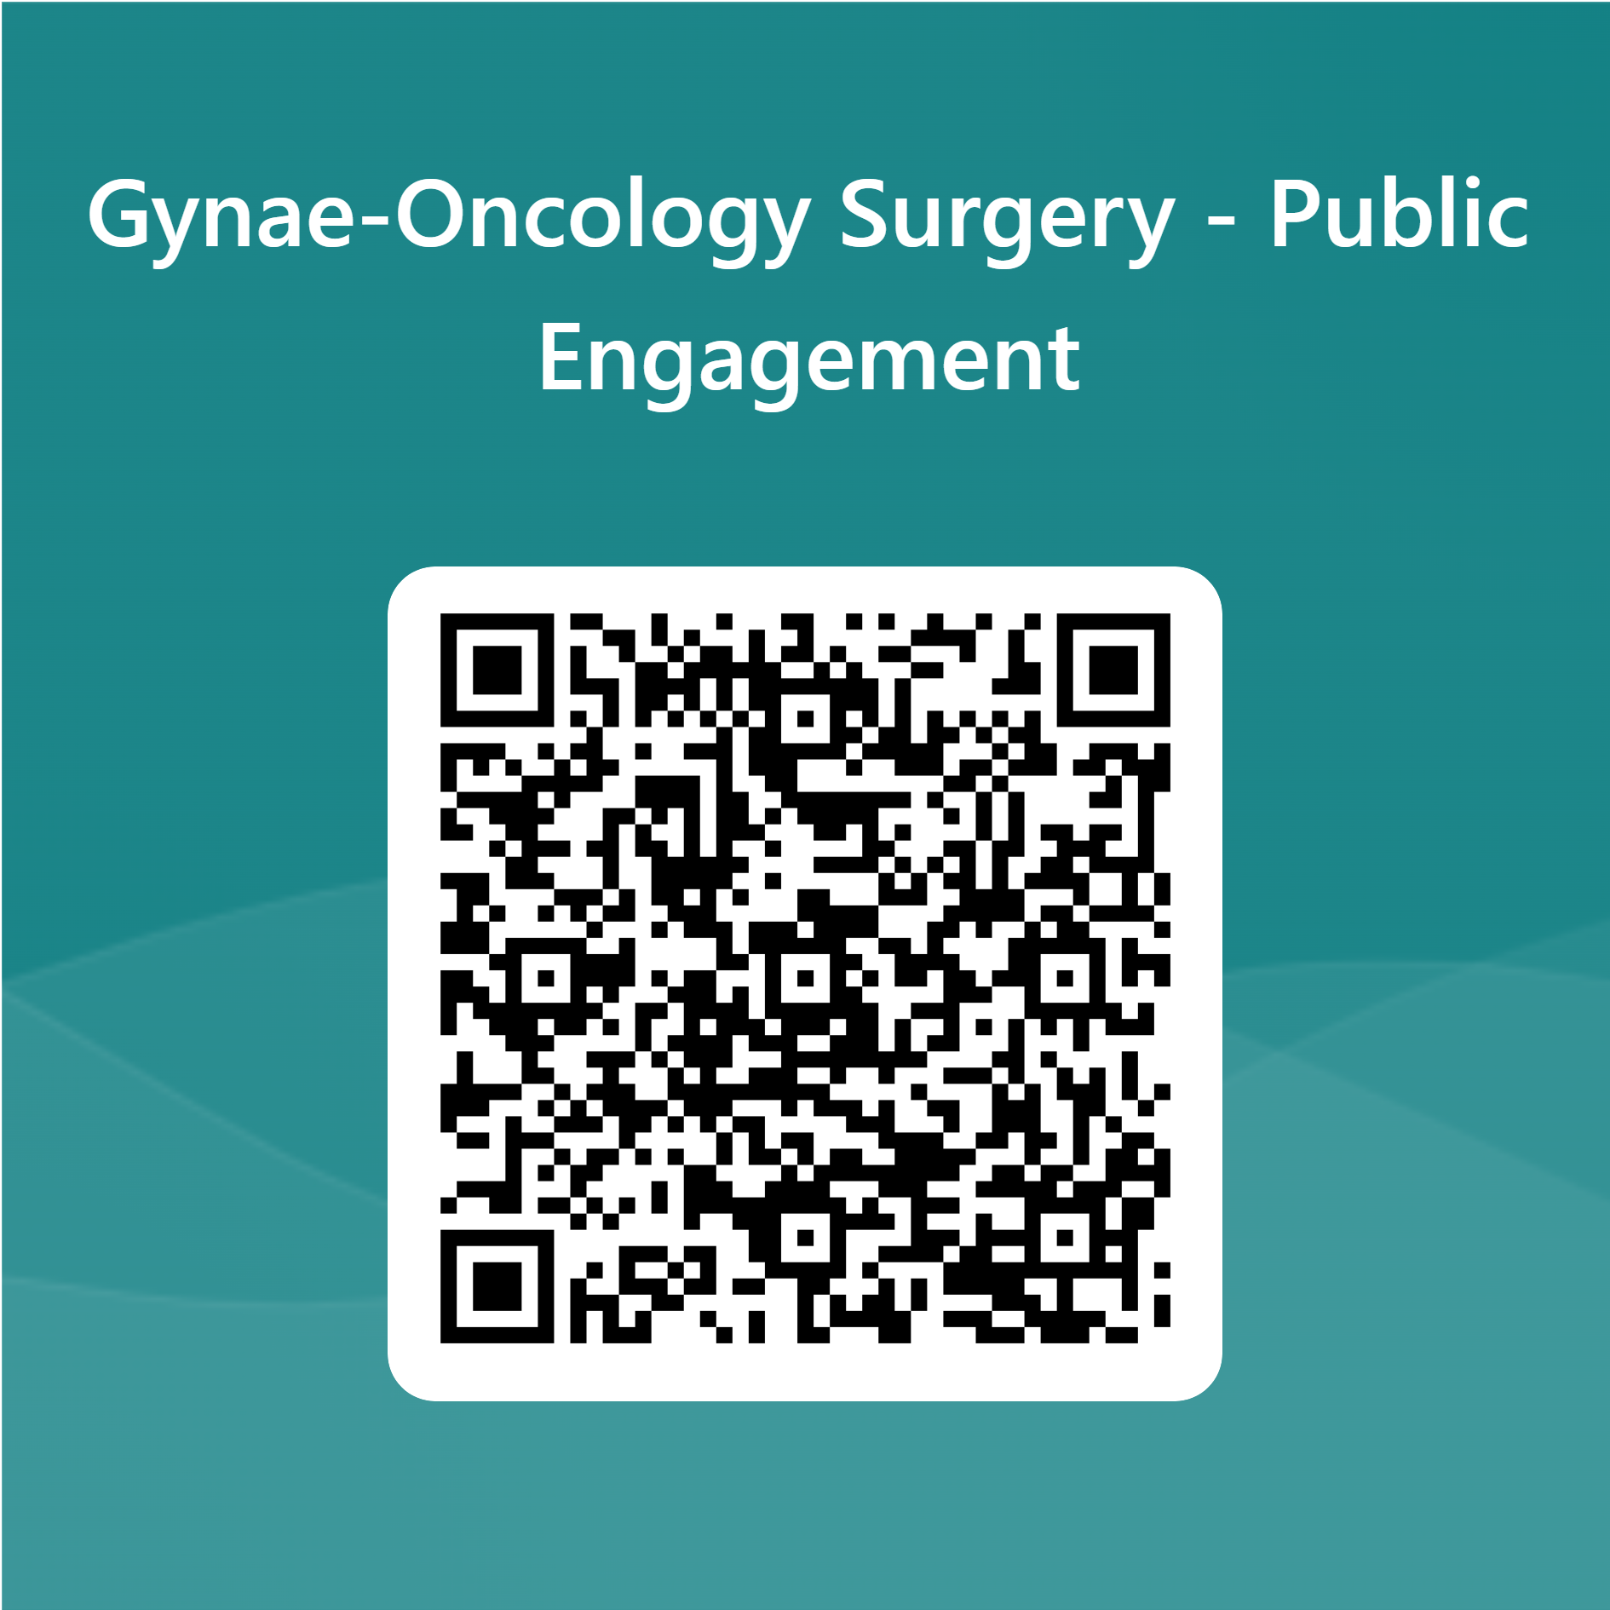

Your response needs to be with us by Monday 9th February 2026.

You can also respond by:
Email: SBU.Engagement@wales.nhs.uk

Your feedback will help us to ensure services meet your needs.

------

If you would like an Easy Read version of this survey or a version in another language, please ask your specialist nurse who can request this.

We recognise that this document will have some medical terms associated with gynaecological-oncology surgery within it. We have added a ‘Glossary of Terms’ to help with this.

We are committed to ensuring that changes do not disadvantage any group. An Equality Impact Assessment is being carried out to understand how the proposal may affect people differently based on age, gender, disability, ethnicity, and other factors. We will use this information to shape services that are fair and inclusive.

Glossary of Terms (jargon buster)
This page explains specialist terms used in the engagement document to help everyone understand the content more easily.
Gynaecological Oncology Surgery - Specialist surgery to treat cancers in the female reproductive system (e.g. womb, ovaries, cervix).

Gynaecological Cancer - Cancer that starts in parts of the female reproductive system.

Subspecialist - A doctor who has trained in a very specific area of medicine beyond general practice.

Multidisciplinary Team (MDT) - A group of healthcare professionals from different specialties who work together to plan and deliver patient care.

Oncologist - A doctor who specialises in treating cancer.

Radiologist - A doctor who interprets medical scans like X-rays and MRIs.

Pathologist - A doctor who examines tissues and samples to diagnose diseases.

Professions Allied to Medicine - Healthcare roles that support doctors and nurses, such as physiotherapists, dietitians, and occupational therapists.

Clinical Trials - Research studies that test new treatments to see how well they work.

Cancer Pathway Targets - NHS goals for how quickly patients should be diagnosed and start treatment for cancer.

Equality Impact Assessment - A review to check how changes might affect different groups of people (e.g. by age, gender, disability).

Centralising Services - Moving services to one main location instead of having them spread across multiple sites.

Sustainable Rotas - Work schedules for staff that are manageable and can be maintained over time.

Seamless Care Pathway - A smooth and coordinated journey through different stages of care, without disruption.

Disaggregated Data - Data that is separated into categories (e.g. by location or patient group) to help understand differences.

Velindre Cancer Centre - A specialist cancer treatment centre in Wales.

Singleton Hospital - A hospital in Swansea, Wales where oncology services and others are provided.

University Hospital of Wales (UHW) - A major hospital in Cardiff, Wales which provides Specialist for the wider population of Wales as well as local services for the population of Cardiff.

What is Gynaecological Cancer?

Gynaecological cancer is a cancer that starts in the female reproductive system. These cancer types can affect women, some transgender men and non-binary people assigned female at birth.
This includes the following cancers:

- Cancer of the womb; the womb is the pear-shaped muscular organ that holds a baby during pregnancy. Most womb cancers start in the lining of the womb. They are also called uterine or endometrial cancer. The endometrium is the lining of the womb.

- Cervical cancer is when abnormal cells in the lining of the cervix grow in an uncontrolled way. The cervix is part of the female reproductive system. It is the opening to the vagina from the womb. The main symptom is unusual bleeding from the vagina. Finding changes in the cells through screening can help to prevent cancer developing.

- Ovarian cancer is when abnormal cells in the ovary, fallopian tube or peritoneum begin to grow and divide in an uncontrolled way. They eventually form a growth (tumour). If not caught early, cancer cells gradually grow into the surrounding tissues. And may spread to other areas of the body. Ovarian cancer can affect women, some transgender men and non-binary people assigned female at birth.

- Vaginal cancer is rare. It starts in the vagina, which is the passage that leads from the neck of the womb (cervix) to the vulva. This is part of the female reproductive system. Vaginal cancer is more common in older women.

- Vulval cancer is a rare cancer. It is sometimes called vulvar cancer. Vulval cancer can start in any part of the vulva. The vulva is the area between a woman’s legs that includes the external sex organs.

The treatment you need depends on how big the cancer is and whether it has spread. The most common treatment is surgery.

What is Gynaecological Oncology Surgery?

- Specialist surgery for cancers in the female reproductive system.
- These surgeries are complex and need highly trained surgeons in specialist centres.
- Because these cancers are uncommon, patients are referred to central locations for the best care.

Who needs these services?

- Anyone diagnosed with gynaecological cancer in Wales (about 1,200 people each year).
- Patients may need a combination of surgery, chemotherapy, and radiotherapy.

You may be waiting for treatment or have already had treatment for a gynaecological cancer.

How are services currently provided?

- There are two main centres: one in Swansea (Swansea Bay University Health Board) and one in Cardiff (Cardiff & Vale University Health Board).
- Other treatments may be given at local hospitals.
- Care is provided by a team of specialists, including surgeons, nurses, oncologists, and other healthcare professionals.

What are the challenges facing services?

- Not enough staff and difficulty recruiting specialists.
- Patients are waiting longer than they should for diagnosis and treatment.
- There are unnecessary differences in how services are provided in the two centres.
- Patients have limited access to clinical trials.

Vision for the Future

- Create a network that delivers safe, effective, and sustainable care.
- Ensure timely and fair access for all patients.

Proposed Service Model

- Centralise specialist surgery at University Hospital Wales in Cardiff.
- Other care (diagnosis, follow-up, chemotherapy) would still be provided locally.
- Local teams would work closely with Cardiff specialists to ensure smooth care for patients.

What options have we considered in response to these challenges?

- Keep services as they are.
- Improve both existing sites.
- Centralise specialist surgery at one site (the preferred option).

Preferred Option (centralise specialist surgery at one site):
Advantages:  - Consistent, high-quality treatment for all patients.  - Shorter waiting times.  - Stronger, more resilient workforce  - Better recruitment and training opportunities.  - More opportunity for patients to join research and clinical trials. | Disadvantages:  - Some patients may have to travel further for surgery.  - Staff roles and locations may change

The information gained through this engagement process to increase our understanding of impact on our community and help us to identify solutions to any issues you raise.

How can you get involved?

We want to hear from you.

You can complete our survey:

Paper copy – please complete and return to the outpatient department.

Online – please us the QR code below which will take you to an online form.

Your response needs to be with us by Monday 9th February 2026.

You can also respond by:

Email: SBU.Engagement@wales.nhs.uk

Your feedback will help us to ensure services meet your needs.

What happens next?

- Public engagement runs until Monday 9th February 2026.
- Feedback will be reviewed and considered
- A final decision will be made by NHS leaders
- If approved, a detailed implementation plan will be developed

