ABMUHB Population Demographics – October 2018

Contents

List of Tables 2
List of Figures 3
1. Background 4
Age 5
Mortality rate 10
Life expectancy and healthy life expectancy at birth. 12
Disability 15
Gender 16
Gender Reassignment 17
Marriage and civil partnership 18
Pregnancy and Maternity 19
Race 20
Religion and Belief (including non-belief) 21
Sexual Orientation 23
Welsh Language 24
Unpaid Carers 25
Socio-economic status 26
Appendix A: List of Most deprived LSOAs in ABMUHB Area 31

List of Tables
Table 1: 2017 Population estimates for ABMU local authorities for residents (ONS Crown Copyright Reserved, from NOMIS on 24 August 2018) 6
Table 2: 2017 Age band as percentage of total local authority. Population estimates for ABMU local authorities for residents (ONS Crown Copyright Reserved, from NOMIS on 24 August 2018). 7
Table 3: Valid Ambulance call outs in ABMUHB area by age of service user 10
Table 4: Life expectancy and Healthy life expectancy at birth by gender and health board, 2010-2014 (Source: StatsWales) 13
Table 5: Life expectancy and Healthy life expectancy at birth by gender and local authority, 2010-2014 (Source: StatsWales) 14
Table 6: Long-term health problem or disability by ABMU Health Board area 15
Table 7: Gender by unitary authorities in ABMU Health Board area 16
Table 8: Births in 2015 by location and number of live births with low birth weight by ABMU Health Board area 19
Table 9: Ethnic group by ABMU Health Board area 20
Table 10: Religion by unitary authorities in ABMU Health Board area 22
Table 11: Sexual orientation by ABMU Health Board area 23
Table 12: Welsh language profile by ABMU Health Board area 24
Table 13: Population density for ABMU Health Board area 27
Table 14: LSOAs in ABMU Health Board area ranked as Most Deprived (0-20%), WIMD 2014 30
Table 15: LSOAs in ABMU Health Board area ranked as Next Most Deprived (20-40%), WIMD 2014 30
Table 16: Most deprived (0-20%) LSOAs in ABMUHB area, WIMD 2014. 31

List of Figures
Figure 1: Population distribution by age (65-84 years) and LSOA in ABMU Health Board area, 2014. 8
Figure 2: Population distribution by age (85 years plus) and LSOA in ABMU Health Board area, 2014. 9
Figure 3: Population projections by age group 9
Figure 4: Under 75 all-cause mortality age-standardised rate per 100,000 persons, 2012-14. (Source: Public Health Wales Observatory) 11
Figure 5: All Ages all-cause mortality age-standardised rate per 100,000 persons, 2012-14. (Source: Public Health Wales Observatory) 12
Figure 6: Welsh Index of Multiple Deprivation, ABM UHB, 2014 29

Background
This document provides an overview of the population of ABMUHB as of October 2018. The demographic data is drawn from a number of sources, with the 2011 Census as the primary source. Mid-year population estimates for 2017 are included sourced from the NOMIS website.

The demographic data is broken down by the nine protected characteristics recognised by the Equality Act 2010:

- Age
- Disability
- Gender
- Gender Reassignment
- Marriage and Civil Partnership*
- Pregnancy and Maternity
- Religion and Belief (including non-belief)
- Race
- Sexual Orientation.

In addition summary data is provided on:

- Welsh language
- Carers**
- Socio-economic status.

The above characteristics are not Protected Characteristics under the Equality Act 2010. However, they are key factors that influence healthy outcomes and underpin ABMUHB’s organisational values. EIAs should therefore, endeavour to explore any potential differential impact in respect of these characteristics alongside the Equality Act protected characteristics.

* Under the Equality Act 2010 protections for the protected characteristic Marriage and Civil Partnership only apply to discrimination in the workplace.

**While Carers are not a protected characteristic, carers of elderly or disabled people are protected by the Equality Act 2010 against direct discrimination or harassment that relates to their caring responsibilities.

Age

Table 1 and Table 2 below provides 2017 population estimates for residents living in the ABMUHB area.

Table 1 shows that within the ABMUHB area Swansea has the largest population of the three local authorities. Table 2 shows that the distribution of the age bands across the three local authorities is very similar. In the ABMU LHB area as whole the bulk of the population is aged between 25 – 64 years (51 per cent), this age range accounts for 52.0% of the population in Neath Port Talbot.

Of the three local authorities Neath Port Talbot has the highest proportion of its population aged 65 years and over (20.6 per cent).

The demographic data in Table 1 shows that for adults aged 65 years plus, there are more women than men in each age band, and this is true for each of the local authorities in the ABMUHB area. Across ABMUHB area (and in Neath Port Talbot separately) women account for 55 per cent of all residents aged 65 years plus.

Table 1: 2017 Population estimates for ABMU local authorities for residents (ONS Crown Copyright Reserved, from NOMIS on 24 August 2018)
Region | Age | Female | Male | Total
Bridgend | Under 1 year | 700 | 800 | 1,500
Bridgend | 1 - 4 years | 3,100 | 3,400 | 6,500
Bridgend | 5 - 14 years | 7,900 | 8,500 | 16,400
Bridgend | 15 - 24 years | 7,300 | 8,300 | 15,600
Bridgend | 25 - 39 years | 13,300 | 13,800 | 27,100
Bridgend | 40 - 54 years | 15,300 | 14,700 | 30,000
Bridgend | 55 - 64 years | 9,400 | 8,900 | 18,300
Bridgend | 65 - 84 years | 13,700 | 11,900 | 25,600
Bridgend | 85 and over | 2,100 | 1,200 | 3,300
Bridgend | Total | 72,800 | 71,500 | 144,300
Neath Port Talbot | Under 1 year | 700 | 700 | 1,400
Neath Port Talbot | 1 - 4 years | 3,000 | 3,100 | 6,100
Neath Port Talbot | 5 - 14 years | 7,700 | 7,900 | 15,600
Neath Port Talbot | 15 - 24 years | 7,400 | 8,400 | 15,800
Neath Port Talbot | 25 - 39 years | 13,200 | 13,200 | 26,400
Neath Port Talbot | 40 - 54 years | 14,500 | 13,900 | 28,400
Neath Port Talbot | 55 - 64 years | 9,700 | 9,400 | 19,100
Neath Port Talbot | 65 - 84 years | 13,600 | 12,000 | 25,600
Neath Port Talbot | 85 and over | 2,400 | 1,200 | 3,600
Neath Port Talbot | Total | 72,200 | 69,800 | 142,000
Swansea | Under 1 year | 1,200 | 1,200 | 2,400
Swansea | 1 - 4 years | 5,000 | 5,500 | 10,500
Swansea | 5 - 14 years | 12,700 | 13,900 | 26,600
Swansea | 15 - 24 years | 16,900 | 20,200 | 37,100
Swansea | 25 - 39 years | 22,700 | 24,300 | 47,000
Swansea | 40 - 54 years | 22,900 | 22,600 | 45,500
Swansea | 55 - 64 years | 15,100 | 13,700 | 28,800
Swansea | 65 - 84 years | 22,400 | 18,800 | 41,200
Swansea | 85 and over | 4,100 | 2,300 | 6,400
Swansea | Total | 123,000 | 122,500 | 245,500
ABMUHB | Under 1 year | 2,600 | 2,700 | 5,300
ABMUHB | 1 - 4 years | 11,100 | 12,000 | 23,100
ABMUHB | 5 - 14 years | 28,300 | 30,300 | 58,600
ABMUHB | 15 - 24 years | 31,600 | 36,900 | 68,500
ABMUHB | 25 - 39 years | 49,200 | 51,300 | 100,500
ABMUHB | 40 - 54 years | 52,700 | 51,200 | 103,900
ABMUHB | 55 - 64 years | 34,200 | 32,000 | 66,200
ABMUHB | 65 - 84 years | 49,700 | 42,700 | 92,400
ABMUHB | 85 and over | 8,600 | 4,700 | 13,300
ABMUHB | Total | 268,000 | 263,800 | 531,800
Source: NOMIS

Table 2: 2017 Age band as percentage of total local authority. Population estimates for ABMU local authorities for residents (ONS Crown Copyright Reserved, from NOMIS on 24 August 2018).
Region | Age | Female | Male | Total
Bridgend | Under 1 year | 1.0% | 1.1% | 1.0%
Bridgend | 1 - 4 years | 4.3% | 4.8% | 4.5%
Bridgend | 5 - 14 years | 10.9% | 11.9% | 11.4%
Bridgend | 15 - 24 years | 10.0% | 11.6% | 10.8%
Bridgend | 25 - 39 years | 18.3% | 19.3% | 18.8%
Bridgend | 40 - 54 years | 21.0% | 20.6% | 20.8%
Bridgend | 55 - 64 years | 12.9% | 12.4% | 12.7%
Bridgend | 65 - 84 years | 18.8% | 16.6% | 17.7%
Bridgend | 85 and over | 2.9% | 1.7% | 2.3%
Bridgend | Total | 100.0% | 100.0% | 100.0%
Neath Port Talbot | Under 1 year | 1.0% | 1.0% | 1.0%
Neath Port Talbot | 1 - 4 years | 4.2% | 4.4% | 4.3%
Neath Port Talbot | 5 - 14 years | 10.7% | 11.3% | 11.0%
Neath Port Talbot | 15 - 24 years | 10.2% | 12.0% | 11.1%
Neath Port Talbot | 25 - 39 years | 18.3% | 18.9% | 18.6%
Neath Port Talbot | 40 - 54 years | 20.1% | 19.9% | 20.0%
Neath Port Talbot | 55 - 64 years | 13.4% | 13.5% | 13.5%
Neath Port Talbot | 65 - 84 years | 18.8% | 17.2% | 18.0%
Neath Port Talbot | 85 and over | 3.3% | 1.7% | 2.5%
Neath Port Talbot | Total | 100.0% | 100.0% | 100.0%
Swansea | Under 1 year | 1.0% | 1.0% | 1.0%
Swansea | 1 - 4 years | 4.1% | 4.5% | 4.3%
Swansea | 5 - 14 years | 10.3% | 11.3% | 10.8%
Swansea | 15 - 24 years | 13.7% | 16.5% | 15.1%
Swansea | 25 - 39 years | 18.5% | 19.8% | 19.1%
Swansea | 40 - 54 years | 18.6% | 18.4% | 18.5%
Swansea | 55 - 64 years | 12.3% | 11.2% | 11.7%
Swansea | 65 - 84 years | 18.2% | 15.3% | 16.8%
Swansea | 85 and over | 3.3% | 1.9% | 2.6%
Swansea | Total | 100.0% | 100.0% | 100.0%
ABMUHB | Under 1 year | 1.0% | 1.0% | 1.0%
ABMUHB | 1 - 4 years | 4.1% | 4.5% | 4.3%
ABMUHB | 5 - 14 years | 10.6% | 11.5% | 11.0%
ABMUHB | 15 - 24 years | 11.8% | 14.0% | 12.9%
ABMUHB | 25 - 39 years | 18.4% | 19.4% | 18.9%
ABMUHB | 40 - 54 years | 19.7% | 19.4% | 19.5%
ABMUHB | 55 - 64 years | 12.8% | 12.1% | 12.4%
ABMUHB | 65 - 84 years | 18.5% | 16.2% | 17.4%
ABMUHB | 85 and over | 3.2% | 1.8% | 2.5%
ABMUHB | Total | 100.0% | 100.0% | 100.0%
Source: NOMIS

Figure 1 and Figure 2 show the population distribution by age across the 327 LSOAs in the ABMUHB area.

Figure 1: Population distribution by age (65-84 years) and LSOA in ABMU Health Board area, 2014.
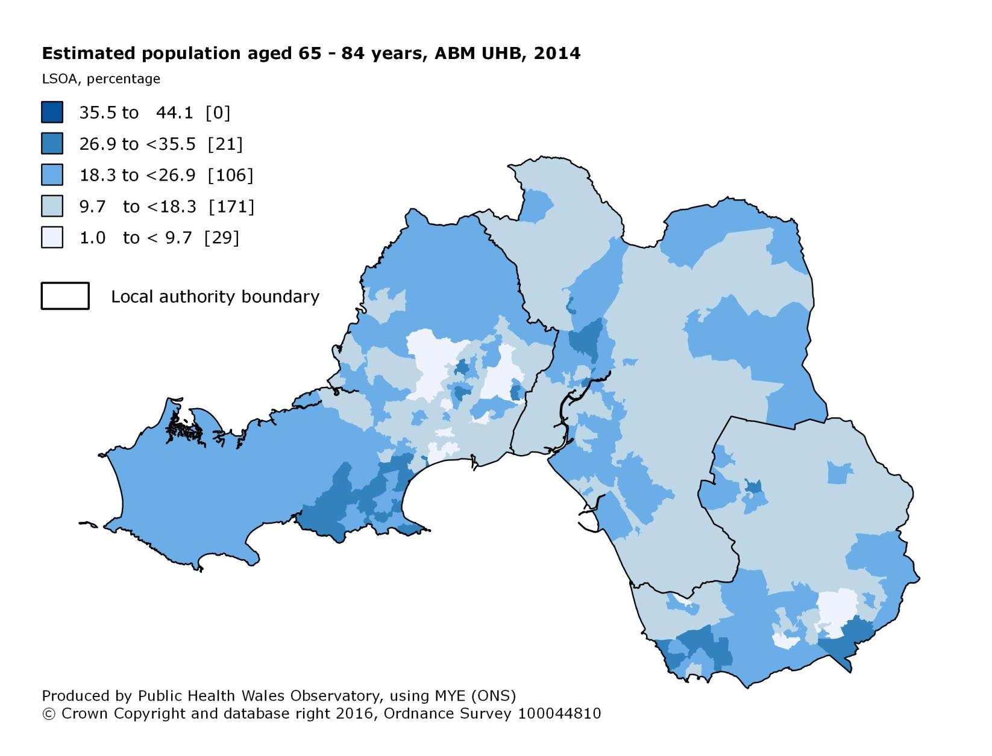

Figure 2: Population distribution by age (85 years plus) and LSOA in ABMU Health Board area, 2014.
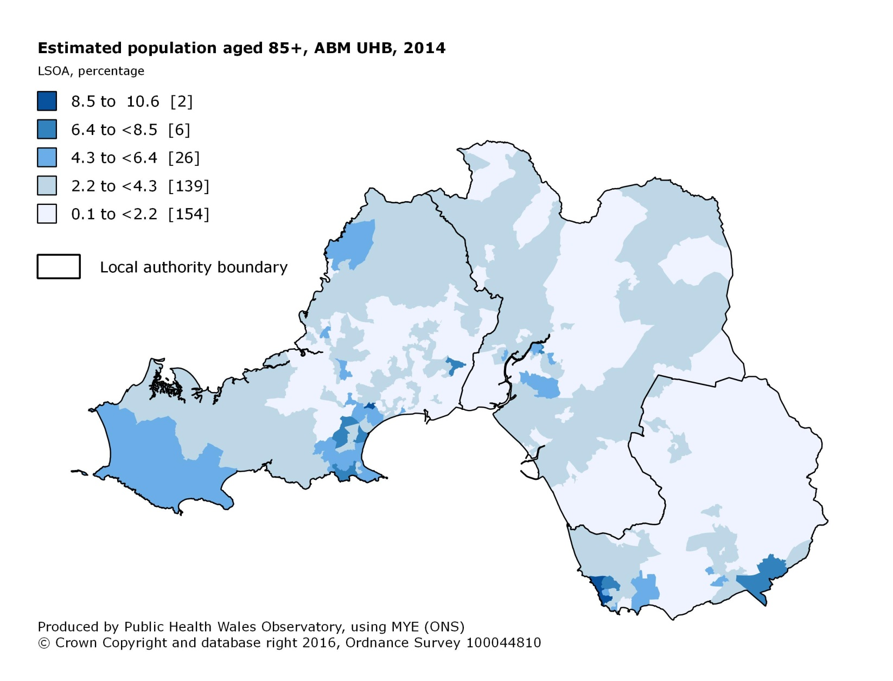

Figure 3: Population projections by age group
Table 2 highlighted that within ABMUHB area the 65 years plus age group accounts for a fifth of the overall population. Figure 3 above shows that this age group is projected to increase by approximately 30 percentage points between 2016 and 2036.

The 85 years plus age group (2.5 per cent of total ABMUHB area population in 2016) is projected to show a percentage change of approximately 120 percentage points between 2016 and 2036. This is the largest percentage change of all age groups.

Demographic changes and improvements in life expectancy mean that there is an expected increase in the overall number of people with dementia. In 2015, approximately 6,979 people in Western Bay had a diagnosis of dementia. By 2030, this is predicted to rise by 48% to 10,295.

There is evidence that the need for healthcare increases disproportionately over the age of 75 years (Capita report 2016). This is supported by analysis of Wales Ambulance Service Trust data on ambulance callouts in Table 3 below.

Table 3: Valid Ambulance call outs in ABMUHB area by age of service user
Quarter | Months | 0 - 64 | 65 and Over | Unknown
Q4 2015 | Oct - Dec | 46.1% | 42.2% | 11.7%
Q1 2016 | Jan - Mar | 43.4% | 45.3% | 11.3%
Q2 2016 | Apr - Jun | 43.8% | 44.8% | 11.4%
Q3 2016 | Jul - Sep | 43.9% | 44.8% | 11.2%
Q4 2016 | Oct - Dec | 42.9% | 46.3% | 10.8%
Q1 2017 | Jan - Mar | 43.6% | 45.9% | 10.5%
Q2 2017 | Apr - Jun | 43.8% | 45.5% | 10.8%
Q3 2017 | Jul - Sep | 44.5% | 43.7% | 11.8%
Q4 2017 | Oct - Dec | 42.4% | 46.4% | 11.2%
Q1 2018 | Jan - Mar | 40.5% | 49.2% | 10.3%
Q2 2018 | Apr - Jun | 44.5% | 43.8% | 11.7%
Source: Wales Ambulance Service Trust, Health Informatics Team

The ambulance call out data shows that while the 65 years and over population in the ABMUHB area is 20% of the total population, it accounted for on average 45% of all valid call outs over the period reported.

Mortality rate
Data produced by Public Health Wales for 2012-14 shows that the ABM ULHB all-cause mortality rate per 100,000 population for under 75s at 407 is higher than the rate for Wales (307), and is the second highest of all the health boards, with Cwm Taf UHB at 439 having the highest (see Figure 4).

The all-cause mortality rate per 100,000 population for under 75s in Neath Port Talbot (428) is the fourth highest in Wales, Bridgend (415) is the fifth highest, and Swansea (389) is the tenth highest.

Figure 4: Under 75 all-cause mortality age-standardised rate per 100,000 persons, 2012-14. (Source: Public Health Wales Observatory)
Figure 5 sets out the position in relation to the all-cause mortality rate in Wales per 100,000 population for all ages. The data shows that for 2012-14 the ABM ULHB all-cause mortality rate per 100,000 population for all ages at 1,096 is higher than the rate for Wales (1,042) and is the second highest among the health boards, with Cwm Taf UHB at 1,184 the highest.

The all-cause mortality rate per 100,000 population for all ages in Bridgend (1,141), is the fourth highest in Wales, Neath Port Talbot (1,134) is the sixth highest, and Swansea (1,050) is the eleventh highest.

Figure 5: All Ages all-cause mortality age-standardised rate per 100,000 persons, 2012-14. (Source: Public Health Wales Observatory)

Life expectancy and healthy life expectancy at birth.
Table 4 and Table 5 below provide a breakdown of the life expectancy and healthy life expectancy estimates for the populations in Wales by health board and local authority. Life expectancy is an estimate of the average number of years newborn babies could expect to live, assuming that current mortality rates for the area in which they were born applied throughout their lives. Healthy life expectancy is an estimate of the average number of years that newborn babies could expect to live in good health, assuming that current mortality rates and levels of good health for the area in which they were born applied throughout their lives.

Life expectancy and healthy life expectancy differ by gender, with females having longer life expectancy and healthy life expectancies than males.

Table 4 shows the life expectancy and healthy life expectancy estimates by gender for each of the health boards in Wales for 2010-2014. The data shows that for both females and males ABMUHB life expectancy and healthy life expectancy are lower than the figure for Wales. Comparing ABMUHB to the other Welsh health Boards, ABMUHB has the second lowest life expectancy and healthy life expectancies amongst the health boards for both females and males.

Table 4: Life expectancy and Healthy life expectancy at birth by gender and health board, 2010-2014 (Source: StatsWales)
Health Board | Female |  | Male
Health Board | Life expectancy* | Healthy life expectancy | Life expectancy* | Healthy life expectancy
ABMUHB | 81.7 | 65.0 | 77.4 | 63.9
Aneurin Bevan UHB | 82.0 | 65.3 | 78.1 | 63.8
Betsi Cadwaladr UHB | 82.4 | 69.2 | 78.7 | 67.6
Cardiff and Vale UHB | 82.9 | 67.6 | 78.6 | 65.7
Cwm Taf UHB | 80.9 | 62.6 | 76.6 | 61.2
Hywel Dda UHB | 82.9 | 67.6 | 79.2 | 66.2
Powys Teaching Health Board | 83.6 | 68.7 | 80.2 | 68.2
Wales | 82.3 | 66.7 | 78.3 | 65.3
* Data is based on a 5 year average and is intended to provide context for the 5 year average on Health life expectancy.

Table 5 describes life expectancy and healthy life expectancy estimates by gender and local authority.

For females, Bridgend has the joint fourth lowest life expectancy (81.2 years), and sixth lowest healthy life expectancy (64.3 years). Neath Port Talbot has the joint fourth lowest life expectancy (81.2 years), and third lowest healthy life expectancy (62.4 years). Swansea has the eleventh lowest life expectancy (82.4 years), and the ninth lowest health life expectancy (66.8 years).

For males, Bridgend has the joint third lowest life expectancy (77 years), and seventh lowest healthy life expectancy (63.4 years). Neath Port Talbot has the joint third lowest life expectancy (77 years), and fifth lowest healthy life expectancy (61.9 years). Swansea has the seventh lowest life expectancy (77.8 years), and the eleventh lowest health life expectancy (65.5 years).
Table 5: Life expectancy and Healthy life expectancy at birth by gender and local authority, 2010-2014 (Source: StatsWales)
Region | Female |  | Male
Region | Life expectancy* | Healthy life expectancy | Life expectancy* | Healthy life expectancy
Isle of Anglesey | 82.9 | 70.9 | 78.6 | 67.7
Gwynedd | 83.5 | 71.1 | 79.3 | 68.2
Conwy | 82.6 | 69.1 | 78.9 | 67.3
Denbighshire | 81.4 | 67.7 | 78.1 | 67.5
Flintshire | 82.4 | 68.9 | 79.0 | 67.7
Wrexham | 81.8 | 67.8 | 78.3 | 66.8
Ceredigion | 83.9 | 69.7 | 80.1 | 67.9
Pembrokeshire | 82.9 | 69.0 | 79.5 | 66.9
Carmarthenshire | 82.6 | 66.0 | 78.6 | 65.0
Swansea | 82.4 | 66.8 | 77.8 | 65.5
Neath Port Talbot | 81.2 | 62.4 | 77.0 | 61.9
Bridgend | 81.2 | 64.3 | 77.0 | 63.4
Vale of Glamorgan | 83.4 | 68.7 | 79.6 | 66.6
Cardiff | 82.7 | 67.1 | 78.2 | 65.3
Rhondda Cynon Taf | 80.9 | 62.9 | 76.5 | 61.2
Merthyr Tydfil | 80.9 | 61.5 | 77.1 | 61.1
Caerphilly | 81.4 | 63.7 | 77.7 | 61.5
Blaenau Gwent | 80.2 | 59.3 | 76.0 | 59.6
Torfaen | 82.0 | 64.4 | 77.9 | 63.1
Monmouthshire | 84.1 | 70.7 | 80.5 | 69.8
Newport | 82.3 | 67.2 | 78.0 | 65.4
Powys | 83.6 | 68.7 | 80.2 | 68.2
Wales | 82.3 | 66.7 | 78.3 | 65.3
* Data is based on a 5 year average and is intended to provide context for the 5 year average on Health life expectancy.

Disability

The disability profile in the ABMUHB area (25%) is higher than the figure for Wales as a whole (23%). The proportion of people in the ABMUHB area categorised as having their ‘Day-to-day activities limited a lot’ is 2% higher in ABMUHB than Wales.

At a local authority level there is noticeable difference between local authorities. Swansea has the lowest levels of people classed as disabled (23%), while Neath Port Talbot has the highest (28%).

Neath Port Talbot has the highest proportion of its population categorised as having their ‘Day-to-day activities limited a lot’ (16%) in Wales. Neath Port Talbot also has the second highest proportion of its population categorised as having their ‘Day-to-day activities limited a little’ (12%) in Wales. Consequently, within Wales Neath Talbot has the smallest proportion of its population categorised as not being disabled i.e. ‘Day-to-day activities not limited’ (72%).

Table 6: Long-term health problem or disability by ABMU Health Board area
Region | Day-to-day activities limited a lot | Day-to-day activities limited a little | Day-to-day activities not limited | Total (%) | Total
ABMUHB | 14% | 11% | 75% | 100% | 518,013
Bridgend | 14% | 11% | 75% | 100% | 139,178
Neath Port Talbot | 16% | 12% | 72% | 100% | 139,812
Swansea | 13% | 11% | 77% | 100% | 239,023
Wales | 12% | 11% | 77% | 100% | 3,063,456
(Source: Table QS303EW 2011 Census, ONS)

At the LSOA level, the percentage of residents whose day-to-day activities are limited a lot or a little by a long-term health problem range from 8% in the Bryntirion, Laleston and Merthyr Mawr areas of Bridgend (Bridgend LSOA 017E) to 42% in the Neath North area of Neath Port Talbot (Neath Port Talbot LSOA 008D).

These are crude percentages only and do not take into account the age structure of the population. The areas with the highest percentages are found in the Castle area of Swansea, Sandfields East, Sandfields West and Neath North areas of Neath Port Talbot and the Caerau area in Bridgend.

The latest disability prevalence estimates for England and Wales (Office for Disability Issues, 2014) show that the prevalence of disability rises with age (16% working age adults and 45% adults over state pension age).

Gender

The gender split (see Table 7). for the ABMUHB area mirrors very closely the gender split for Wales as a whole. Approximately a 50:50 split with slightly more females (50.3%) than males (49.7%). The variation between local authorities within the ABMU Health Board Area is small.

Table 7: Gender by unitary authorities in ABMU Health Board area
Region | Female | Male | Total
ABMU | 50.3% | 49.7% | 531,900
Bridgend | 50.4% | 49.6% | 144,300
Neath Port Talbot | 50.7% | 49.3% | 142,000
Swansea | 50.1% | 49.9% | 245,500
Wales | 50.7% | 49.3% | 3,125,200
(Source: NOMIS Population Estimates/Projections, Local Authority based 1981 to 2017)

As previously noted (see Table 2 above), for the over 65 years age group the proportion of females to males increases as the population ages. 52% of people in ABMUHB area aged 65-69 years are female, while 64.9% of the people aged 85 years plus are female.

Data from the 2011 Census shows that 90% of the lone parent households in Wales are female. Lone parent households experience some of the lowest levels of wealth in Wales. As such any additional travel costs incurred due to service reconfiguration will have significant impact upon service users and staff from this group. The 2011 Census data shows that only 18.3% of female lone parent households in the ABMUHB area are in full-time employment, 32.2% are in part-time employment, and 40.3% are not in employment.

Gender Reassignment

Transgender or trans is an umbrella term used to describe the whole range of people whose gender identity/or gender expression differs from the gender assumptions made at birth.

No data is available on the size of the transgender population in the ABMUHB area.

In ‘It’s just Good Care: A guide for health staff caring for people who are Trans’ 2015-19, trans people must be accommodated in line with their gender expression. This applies to toilet facilities, wards, outpatient departments, accident and emergency or other health and social care facilities, including where these are single sex environments. Different genital or chest appearance is not a bar to this. Privacy is essential to meet the needs of the trans person and other service users. If there are no cubicles, privacy can usually be achieved with curtaining or screens. The wishes of the trans person must be taken into account rather than the convenience of nursing staff. An unconscious patient should be treated according to their gender presentation. Absolute dignity must be maintained at all times. It also states that breaching privacy about a person’s Gender Recognition Certificate or gender history without their consent could amount to a criminal offence. A medical emergency where consent is not possible may provide an exception to the privacy requirements.

The EHRC note in How fair is Britain? that one in seven transgender people who responded to a survey felt that they had been treated adversely by healthcare professionals because of their transgender status.

Research suggests transgender people are likely to experience risk of harassment when attempting to access healthcare. A survey by Press for Change (2007) found 36.8% (277) of trans people (aged 18 to 75) who chose to present their acquired gender permanently, experienced negative comments while out socially, because of their acquired gender. Only 27% of respondents in the survey recorded they had not experienced anything of the above while out in public spaces. This means that 73% of respondents experienced comments, threatening behaviour, physical abuse, verbal abuse or sexual abuse while in public spaces.

Marriage and civil partnership

Under the Equality Act 2010 protections for the protected characteristic Marriage and Civil Partnership only apply to discrimination in the workplace.

Pregnancy and Maternity

Data from the ONS on live births in Wales for 2015 (see Table 8) shows that there were 5,462 births in the ABMUHB area. Hospital births account for the majority of all births in the ABMUHB area (96.0%) and in Wales as a whole (96.9%).

Low birth weight is a key health indicator for early years and is a major cause for infant mortality in developed countries, including the UK. The percentage of births in the ABMUHB area that are low birth weight (i.e. below 2,500 grams) is consistent with the figure for Wales as a whole (6.8%).

Among the Welsh Health Boards Cwm Taf Health Board has the highest proportion of low birth weight births (8.2%). ABMUHB has the second lowest proportion of low birth weight births (6.3%).

At the local authority level there is some variation within the ABMUHB area, with Bridgend (6.9%) having the highest low birth weight rate in the Health Board, and the ninth highest in Wales. Swansea (6.3%) and Neath Port Talbot (5.7%) are ranked 15th and 19th in Wales in terms of low birth weight rates (where rank 1 is the highest low birth weight rate).

Table 8: Births in 2015 by location and number of live births with low birth weight by ABMU Health Board area
Region | NHS hospital birth | At home, non-NHS hospital or elsewhere | Number of live births with birth weight under 2,500 grams | Percentage of live births with birth weight under 2,500 grams | Total
ABMUHB | 5,244 | 218 | 346 | 6.3% | 5,462
Bridgend | 1,405 | 82 | 103 | 6.9% | 1,487
Neath Port Talbot | 1,434 | 44 | 85 | 5.7% | 1,478
Swansea | 2,405 | 92 | 158 | 6.3% | 2,497
Wales | 31,878 | 1,021 | 2,253 | 6.8% | 32,899
(Source: Stats Wales),

Race

The 2011 census data for the Black and Minority Ethnic (BME) population across the Health Board shows an above average BME population in Swansea at 6.0% and lower percentages in Bridgend 2.2% and Neath Port Talbot 1.9% (see Table 9). These proportions have all increased from the 2001 census data as there was evidence that ethnicity was under reported in 2001 and there have been increases in migrant workers within all three areas.

Table 9: Ethnic group by ABMU Health Board area
Region | White | Mixed / Multiple ethnic group | Asian / Asian British | Black / African / Caribbean / Black British | Other ethnic group | Total (%) | Total
ABMUHB | 96.1% | 0.8% | 2.1% | 0.5% | 0.5% | 100% | 518,013
Bridgend | 97.8% | 0.7% | 1.1% | 0.2% | 0.2% | 100% | 139,178
Neath Port Talbot | 98.1% | 0.7% | 1.0% | 0.2% | 0.1% | 100% | 139,812
Swansea | 94.0% | 0.9% | 3.3% | 0.8% | 1.0% | 100% | 239,023
Wales | 95.6% | 1.0% | 2.3% | 0.6% | 0.5% | 100% | 3,063,456
(Source: Table KS201EW Census 2011, ONS)

Where English is not a patient’s first language the ability of patients to receive and communicate about their health care provision in the language of their preference, may be affected. This is a particular issue for older patients with dementia where patients ability to communicate in English with staff may be compromised.

Religion and Belief (including non-belief)

ABMUHB area population profile closely mirrors Wales as a whole, however there are some slight variations. The proportion of Christians in the ABMUHB area (55.7%) is slightly lower than in Wales (57.6%). The population proportion with ‘No religion’, in ABMU (34.7%) is higher than the figure for Wales (32.1%). In general, the ABMU Health Board area and Wales, have high numbers of people who either identify as ‘Christian’ (55.7%) or ‘No religion’ (34.7%), with very low proportions of the other religion categories.

At the local authority level Neath Port Talbot (57.7%) has the highest population proportion categorised as ‘Christian’ – in line with the figure for Wales (57.6%). While Swansea (55.0%) and Bridgend (55.1%) have Christian population proportions lower than Wales.

Swansea (2.3%) has the highest population proportion categorised as ‘Muslim’ in the ABMUHB area, this is the third highest in Wales. While the Neath Port Talbot (0.4%) and Bridgend (0.4%) ‘Muslim’ populations are both below the figure for Wales (1.5%)

Table 10: Religion by unitary authorities in ABMU Health Board area
Region | Christian | Buddhist | Hindu | Jewish | Muslim | Sikh | Other religion | No religion | Religion not stated | Total (%) | Total
ABMUHB | 55.7% | 0.3% | 0.2% | 0.0% | 1.3% | 0.1% | 0.4% | 34.7% | 7.3% | 100.0% | 518,013
Bridgend | 55.1% | 0.3% | 0.2% | 0.0% | 0.4% | 0.0% | 0.4% | 36.7% | 7.0% | 100.0% | 139,178
Neath Port Talbot | 57.7% | 0.2% | 0.1% | 0.0% | 0.4% | 0.1% | 0.4% | 33.8% | 7.3% | 100.0% | 139,812
Swansea | 55.0% | 0.4% | 0.3% | 0.1% | 2.3% | 0.1% | 0.4% | 34.0% | 7.5% | 100.0% | 239,023
Wales | 57.6% | 0.3% | 0.3% | 0.1% | 1.5% | 0.1% | 0.4% | 32.1% | 7.6% | 100.0% | 3,063,456
(Source: Table KS209EW Census 2011, ONS)

Sexual Orientation

Sexual orientation is not asked for by the Census so in order to estimate the Lesbian, Gay and Bisexual (LGB) population in Wales we need to use data from the ONS’s Integrated Household Survey (see Table 11). The Integrated Household Survey does not report findings by local authority, but by regional groupings, and some cells are not reported as they could either identify individuals or they are not sufficiently robust for publication.

From the Integrated Household Survey data, we can see that the majority of the population in Wales and the regions making up the ABMUHB area identify as heterosexual (c.a. 95%). The percentage of the population identifying as LGB is approximately 1.5% in the ABMUHB area, this is higher than the value for Wales as a whole (1%) due to the higher LGB populations in Swansea (2%).
LGBT people are more likely to experience mental disorder, have issues with substance misuse, deliberate self-harm and commit suicide than the general population due to long term issues of discrimination and living in an unsympathetic society.

Table 11: Sexual orientation by ABMU Health Board area
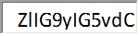  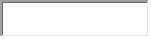  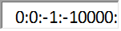  Region | LGB | Hetero-  sexual | No response | Other | Don't know  /Refusal | Total (%) | All people aged 16+
Bridgend and Neath Port Talbot | 1% | 95% | 2% | * | 2% | 100% | 221,500
Swansea | 2% | 95% | 1% | * | 1% | 100% | 193,200
Wales | 1% | 94% | 1% | 0% | 3% | 100% | 2,456,400
(Source: Integrated Household Survey 2012)
* The data item could disclose identity or not sufficiently robust for publication.

Welsh Language

Welsh language skills in the ABMUHB area are lower than in Wales as a whole (see Table 12). While the ABMUHB area is comparable to the Welsh figure for the proportion of the population that can understand spoken Welsh only, (5.4% vs 5.3% for Wales), it is significantly lower than Wales as a whole when considering ‘Can speak Welsh’ (12.0% vs 19.0%) and ‘Can read and write Welsh’ (8.6% compared to 14.6%).

Table 12: Welsh language profile by ABMU Health Board area
Region | Can understand spoken Welsh only | Can speak Welsh | Can speak, read and write Welsh | Total
ABMU | 5.4% | 12.0% | 8.6% | 500,978
Bridgend | 4.1% | 9.7% | 7.3% | 134,545
Neath Port Talbot | 6.4% | 15.3% | 10.8% | 135,278
Swansea | 5.5% | 11.4% | 8.1% | 231,155
Wales | 5.3% | 19.0% | 14.6% | 2,955,841
(Source: Table KS208WA 2011 Census, ONS. All usual residents aged 3 years and over)

At the local authority level there are noticeable differences between the local authorities. Bridgend has the lowest rates of Welsh language proficiency of the three local authorities, across all three categories. While Neath Port Talbot has the highest rates of Welsh language proficiency.

It is anticipated that any impact the proposed service changes may have relating to the Welsh Language is upon the ability of patients to receive and communicate about their health care provision in the language of their preference, as staff may not be Welsh language speakers. Data from the 2018 NHS Wales Staff Survey shows that only 10% of ABMUHB staff speak Welsh and that only 5% use Welsh in the workplace “Most of the time”. 53% of ABMUHB staff either use Welsh in the workplace “Rarely” (34%) or “Never” (19%).

Unpaid Carers

The majority of residents in the ABMUHB area (86.8%) and Wales (87.9%) provide no unpaid care. This is relatively consistent across the health board. The 2011 Census data shows that the proportion of people providing unpaid care in the ABMUHB area is around 7% for one to 19 hours of unpaid care, decreasing to 2% for 20 to 49 hours of unpaid care, but then increasing to 4% to 5% for 50 or more hours of unpaid care.

At a health board level, ABMUHB and Cwm Taf have the highest proportions of unpaid care provision, both reporting 2.0% for 20 to 49 hours of unpaid care, and 4% for 50 or more hours of unpaid care.

At a local authority level for 20 to 49 hours of unpaid care, Neath Port Talbot and Blaenau Gwent have the highest proportion of unpaid care, both reporting 2.3%. For 50 or more hours of unpaid care at a local authority level, Neath Port Talbot has the highest proportion (4.8%).

Data from Carers UK shows that:

- 58% of carers are women, and 42% are men
- Over 1 million people care for more than one person.
- 72% of carers responding to Carers UK's State of Caring Survey said they had suffered mental ill health as a result of caring.
- 61% of carers responding to Carers UK's State of Caring Survey said they had suffered physical ill health as a result of caring.
- Over 1.3 million people provide over 50 hours of care per week.

Socio-economic status

There is a strong correlation between the protected characteristics and low socioeconomic status, as demonstrated by the findings of numerous research studies. In Wales, research by the Wales Institute for Social and Economic Research, Data and Methods (WISERD, 2011) has demonstrated:

- Disadvantage in education, and subsequently in employment and earnings attaches particularly to young people, those of Bangladeshi and Pakistani ethnicity, and people who are work limiting and Disability Discrimination Act (DDA) defined disabled. Within each of these groups, women are generally more disadvantaged.
- People who are both DDA disabled and have a work limiting condition experience most disadvantage in relation to employment. Seventy four per cent are not employed. This is more than three times the overall UK proportion of 22%.
- Women are disadvantaged in employment terms: in almost all population groups women face an above-average incidence of non-employment. This is particularly the case for some ethnic minority groups in Wales, particularly women of Indian, Bangladeshi and Pakistani and Chinese ethnicity.
- Approximately a fifth of the Welsh population live in poverty (measured after housing costs). Those living on the lowest incomes are the youngest, disabled people, those of Pakistani and Bangladeshi ethnicity and those living in rented accommodation. However, lone parents are the most susceptible group, with almost half living in poverty.
- Being in work does not necessarily provide a route out of poverty, with 13% of in-work households in Wales living in poverty. In-work poverty is most prevalent among lone parent households, Asian households and those who are renting.
- Levels of wealth are lowest among young people, lone parents and single households, non-white households and those with a work-limiting illness or disability.

Many health researchers regard socio-economic status as the fundamental factor affecting health. Socio-economic status is the pivotal link in the causal chain through which social determinants connect up to influence people’s health. Socio-economic status marks the point at which social factors, such as the structure of the labour market and education system, enter and shape people’s lives, influencing the extent to which they are exposed to risk factors that directly affect their health, such as workplace hazards, damp housing and a poor diet.

The World Health Organisation (2004) notes that:

“The social conditions in which people live powerfully influence their chances to be healthy. Indeed factors such as poverty, social exclusion and discrimination, poor housing, unhealthy early childhood conditions and low occupational status are important determinants of most diseases, deaths and health inequalities between and within countries”

ABMUHB covers a large geographical area and is one of the most densely populated Health Boards in Wales with 466 persons per square km. Within ABMUHB there are almost twice as many people living per square km in Swansea compared to Neath Port Talbot.

Table 13: Population density for ABMU Health Board area
Locality | Population per km²
Swansea | 603.2
Neath Port Talbot | 310.6
Bridgend | 534.1
ABMU Health Board | 466.3

The Welsh Index of Multiple Deprivation (WIMD) is the Welsh Government’s official measure of relative deprivation for small areas in Wales. It is designed to identify those small areas where there are the highest concentrations of several different types of deprivation in Wales. WIMD is currently made up of eight separate domains (or types) of deprivation. Each domain (listed below) is compiled from a range of different indicators:

- Income
- Employment
- Health
- Education
- Access to Services
- Community Safety
- Physical Environment
- Housing

The WIMD rank score is constructed from a weighted sum of the deprivation score for each domain. The weights reflect the importance of the domain as an aspect of deprivation, and the quality of the indicators available for that domain.

Of the 1,909 Lower Super Output Areas (LSOA) in Wales ranked by WIMD, 382 are ranked as being the Most Deprived (0-20%). The ABMUHB area contains 84 LSOAs ranked as being in the Most Deprived (0-20%) LSOAs in Wales. The ABMUHB area therefore accounts for just over a fifth (22%) of all LSOAs in Wales ranked as being the Most Deprived (0-20%).

The ABMUHB area contains 327 LSOAs. The 84 LSOAs ranked as being in the Most Deprived (0-20%) therefore mean that 26% of all LSOAs in ABMUHB area are ranked as being the Most Deprived (0-20%). Only Cwm Taf University Health Board has a higher proportion of its LSOAs ranked as the Most Deprived in Wales (30%). ABMUHB is joint second highest with Aneurin Bevan University Health Board at 26%.

In addition, 70 LSOAs in the ABMUHB area (21% of all LSOAs in the ABMU Health Board area) are ranked as being in the Next Most Deprived (20-40%) LSOAs in Wales.

Figure 6 shows the geographical distribution of the WIMD multiple deprivation fifths across the ABMUHB area.

Figure 6 shows that the majority of Bridgend’s most deprived LSOAs as measured by WIMD are based in the north of the county.

Figure 6: Welsh Index of Multiple Deprivation, ABM UHB, 2014
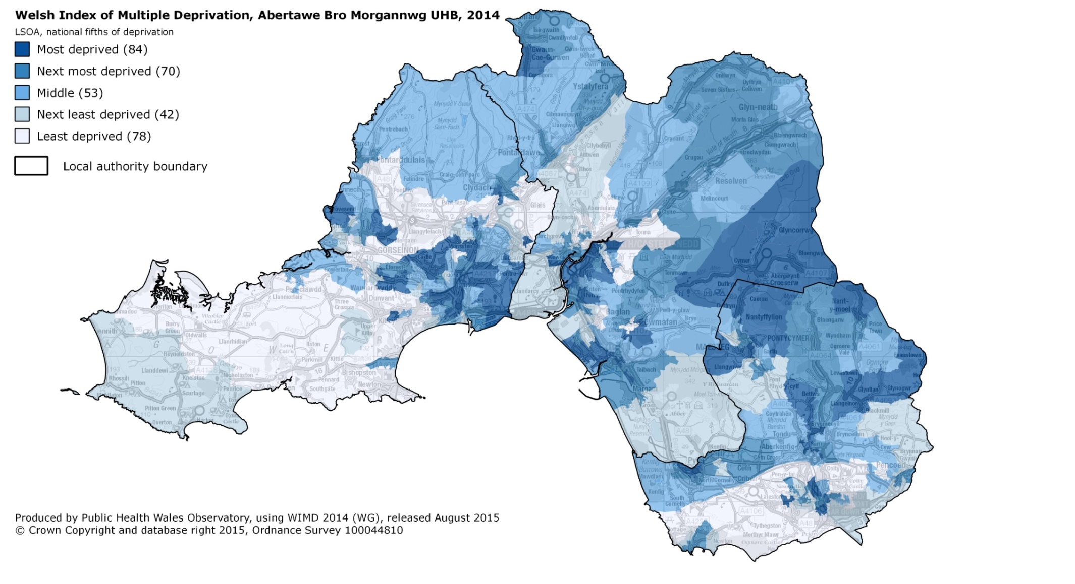
Table 14 and Table 15 show that within the ABMUHB area Neath Port Talbot has the highest levels of multiple deprivation. 60% of Neath Port Talbot’s LSOAs are classed as being in the Most Deprived (0-20%) or Next Most Deprived (20-40%) LSOAs. Bridgend is close behind with 50%, while Swansea has only 38%.

Table 14: LSOAs in ABMU Health Board area ranked as Most Deprived (0-20%), WIMD 2014
Local Authority | LSOAs ranked Most Deprived (0-20%) | LSOAs as %age of all LSOAs in local authority
Bridgend | 20 | 23%
Neath Port Talbot | 27 | 30%
Swansea | 37 | 25%

Table 15: LSOAs in ABMU Health Board area ranked as Next Most Deprived (20-40%), WIMD 2014
Local Authority | LSOAs ranked Most Deprived (20-40%) | LSOAs as %age of all LSOAs in local authority
Bridgend | 24 | 27%
Neath Port Talbot | 27 | 30%
Swansea | 19 | 13%

Appendix A: List of Most deprived LSOAs in ABMUHB Area
Table 16: Most deprived (0-20%) LSOAs in ABMUHB area, WIMD 2014.
Name | Code | LHB Rank (of 327) | Wales rank  (of 1909) | Deprivation
Caerau (Bridgend) 1 | W01000991 | 1 | 6 | 0-10%
Penderry 1 | W01000830 | 2 | 21 | 0-10%
Cymmer (Neath Port Talbot) 2 | W01000921 | 3 | 22 | 0-10%
Castle 2 North | W01001955 | 4 | 27 | 0-10%
Townhill 1 | W01000862 | 5 | 29 | 0-10%
Castle 1 | W01000742 | 6 | 33 | 0-10%
Penderry 3 | W01000832 | 7 | 34 | 0-10%
Townhill 2 | W01000863 | 8 | 41 | 0-10%
Mynyddbach 1 | W01000817 | 9 | 43 | 0-10%
Caerau (Bridgend) 2 | W01000992 | 10 | 44 | 0-10%
Penderry 4 | W01000833 | 11 | 45 | 0-10%
Townhill 3 | W01000864 | 12 | 49 | 0-10%
Townhill 6 | W01000867 | 13 | 50 | 0-10%
Townhill 5 | W01000866 | 14 | 64 | 0-10%
Sandfields West 2 | W01000962 | 15 | 72 | 0-10%
Aberavon 4 | W01000886 | 16 | 79 | 0-10%
Bettws (Bridgend) | W01000975 | 17 | 90 | 0-10%
Sandfields East 2 | W01000958 | 18 | 98 | 0-10%
Bonymaen 1 | W01000738 | 19 | 102 | 0-10%
Neath North 2 | W01000939 | 20 | 112 | 0-10%
Morriston 9 | W01000814 | 21 | 116 | 0-10%
Brackla 3 | W01000981 | 22 | 117 | 0-10%
Morriston 5 | W01000810 | 23 | 119 | 0-10%
Neath East 1 | W01000934 | 24 | 122 | 0-10%
Briton Ferry West 1 | W01000896 | 25 | 123 | 0-10%
Sandfields West 3 | W01000963 | 26 | 133 | 0-10%
Morfa 2 | W01001022 | 27 | 136 | 0-10%
Morriston 7 | W01000812 | 28 | 140 | 0-10%
Sarn 1 | W01001055 | 29 | 141 | 0-10%
Penderry 6 | W01000835 | 30 | 142 | 0-10%
Aberavon 3 | W01000885 | 31 | 145 | 0-10%
Neath East 2 | W01000935 | 32 | 148 | 0-10%
Penderry 7 | W01000836 | 33 | 150 | 0-10%
Aberavon 2 | W01000884 | 34 | 166 | 0-10%
Blackmill 2 | W01000977 | 35 | 171 | 0-10%
St. Thomas 1 | W01000849 | 36 | 176 | 0-10%
Gwynfi | W01000930 | 37 | 177 | 0-10%
Caerau (Bridgend) 3 | W01000993 | 38 | 179 | 0-10%
Cornelly 4 | W01001002 | 39 | 189 | 0-10%
Llansamlet 8 | W01000801 | 40 | 207 | 10-20%
Sandfields West 4 | W01000964 | 41 | 212 | 10-20%
Coedffranc Central 3 | W01000914 | 42 | 216 | 10-20%
Cockett 8 | W01000762 | 43 | 217 | 10-20%
Penderry 5 | W01000834 | 44 | 218 | 10-20%
Cockett 2 | W01000756 | 45 | 224 | 10-20%
Ynysawdre 1 | W01001057 | 46 | 225 | 10-20%
Landore 3 | W01000789 | 47 | 234 | 10-20%
Penderry 2 | W01000831 | 48 | 246 | 10-20%
Pyle 2 | W01001049 | 49 | 248 | 10-20%
Neath South 2 | W01000942 | 50 | 249 | 10-20%
Maesteg West 3 | W01001019 | 51 | 254 | 10-20%
Penyrheol (Swansea) 4 | W01000844 | 52 | 264 | 10-20%
Llansamlet 6 | W01000799 | 53 | 269 | 10-20%
Landore 4 | W01000790 | 54 | 271 | 10-20%
Sandfields East 1 | W01000957 | 55 | 278 | 10-20%
Glyncorrwg | W01000924 | 56 | 284 | 10-20%
Oldcastle 1 | W01001035 | 57 | 287 | 10-20%
Castle 3 | W01000744 | 58 | 292 | 10-20%
Caerau (Bridgend) 4 | W01000994 | 59 | 293 | 10-20%
Sketty 4 | W01000856 | 60 | 295 | 10-20%
Blackmill 1 | W01000976 | 61 | 298 | 10-20%
Landore 2 | W01000788 | 62 | 302 | 10-20%
Maesteg East 2 | W01001015 | 63 | 303 | 10-20%
Bryn and Cwmavon 3 | W01000900 | 64 | 310 | 10-20%
Port Talbot 3 | W01000951 | 65 | 315 | 10-20%
Maesteg West 4 | W01001020 | 66 | 319 | 10-20%
Briton Ferry East 2 | W01000895 | 67 | 323 | 10-20%
Clydach 3 | W01000752 | 68 | 325 | 10-20%
Neath East 3 | W01000936 | 69 | 328 | 10-20%
Bonymaen 2 | W01000739 | 70 | 331 | 10-20%
Mynyddbach 2 | W01000818 | 71 | 332 | 10-20%
Neath North 3 | W01000940 | 72 | 334 | 10-20%
Morriston 6 | W01000811 | 73 | 336 | 10-20%
Neath East 4 | W01000937 | 74 | 340 | 10-20%
Morfa 3 | W01001023 | 75 | 342 | 10-20%
Nant-y-moel 1 | W01001024 | 76 | 347 | 10-20%
Bryntirion Laleston and Merthyr Mawr 3 | W01000990 | 77 | 352 | 10-20%
Sandfields East 4 | W01000960 | 78 | 354 | 10-20%
Gwaun-Cae-Gurwen 2 | W01000929 | 79 | 355 | 10-20%
Castle 4 | W01000745 | 80 | 356 | 10-20%
Tai-bach 2 | W01000967 | 81 | 361 | 10-20%
Penllergaer 2 | W01000838 | 82 | 369 | 10-20%
Cymmer (Neath Port Talbot) 1 | W01000920 | 83 | 372 | 10-20%
Bonymaen 4 | W01000741 | 84 | 380 | 10-20%

https://www.nomisweb.co.uk/query/construct/summary.asp?mode=construct&version=0&dataset=31#
Source: https://www.nomisweb.co.uk/query/construct/summary.asp?mode=construct&version=0&dataset=31#
http://www.publichealthwalesobservatory.wales.nhs.uk/demography-overview
http://www.publichealthwalesobservatory.wales.nhs.uk/demography-overview
https://statswales.gov.wales/Catalogue/Health-and-Social-Care/Life-Expectancy/lifeexpectancyandhealthylifeexpectancyatbirth-by-localhealthboard-localauthority
https://statswales.gov.wales/Catalogue/Health-and-Social-Care/Life-Expectancy/lifeexpectancyandhealthylifeexpectancyatbirth-by-localhealthboard-localauthority
Under the Equality Act 2010 disabled is defined as individuals that have a physical or mental condition/illness lasting or expected to last for 12 months or more, which affects their ability to carry out day-to-day activities either a lot, or a little.
https://www.nomisweb.co.uk/query/construct/summary.asp?mode=construct&version=0&dataset=31
Wales Institute of Social and Economic Research Data and Methods. (2011). An anatomy of economic inequality in Wales. Cardiff: EHRC.
Equality and Human Rights Commission. (2010). How fair is Britain? Equality, Human Rights and Good Relations in 2010. The First Triennial Review. Manchester: Equality and Human Rights Commission.
Whittle, S., Turner, L., and Al-Alami, M. (2007). Engendered Penalties: Transgender and Transsexual People’s Experiences of Inequality and Discrimination. London: Press for Change.
https://statswales.wales.gov.uk/Catalogue/Health-and-Social-Care/Births-Deaths-and-Conceptions/Births/Maternities-by-Area-PlaceOfConfinement
https://statswales.wales.gov.uk/Catalogue/Health-and-Social-Care/Births-Deaths-and-Conceptions/Births/LiveBirthsWithLowBirthWeight-by-Area
https://statswales.wales.gov.uk/Catalogue/Equality-and-Diversity/Sexual-Identity/SexualIdentity-by-Area-IdentityStatus
https://www.carersuk.org/news-and-campaigns/press-releases/facts-and-figures
Wales Institute of Social and Economic Research Data and Methods. (2011). An anatomy of economic inequality in Wales. Cardiff: EHRC.
The analysis by WISERD refers to the DDA 2005 definition of disability rather than the Equality Act 2010 as the data reviewed for the report predates the Equality Act 2010.
World Health Organization. (2004). Commission on social determinants of health. Geneva: World Health Organization.
https://gov.wales/statistics-and-research/welsh-index-multiple-deprivation/?lang=en
See Appendix A for a list of the 84 LSOAs.

