Useful contact information:

Ward M, Morriston Hospital
(01792) 708891 (open 24 hours)

Children’s Physiotherapist
(01792) 530742
(Mon–Fri 8.00am – 4.00pm)

Children’s Orthopaedic Clinic, Hafan Y Mor Children’s Centre, Singleton Hospital
(01792) 703010
(Mon-Fri 8.30am – 4.30pm)

Steps
(01925) 750271
www.steps-charity.org.uk

Developmental Dysplasia of the Hip (DDH)


Information for parents and families

Editorial Board: 568
First Published: February 2012 Version: 2
Reviewed: May 2018
Next Review Date: May 2020 Author: Paediatric Physiotherapy

What is DDH?
Developmental dysplasia of the hip is a problem with the way that the hip joint develops. It is usually present from birth and is more common in girls. When developmental dysplasia of the hip is diagnosed and treated early in a young baby, the outcome is usually excellent.

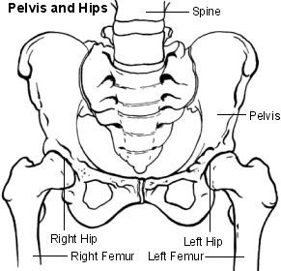
The hip is a ‘ball and socket‘ joint. In a normal hip, the top of the thigh bone (femur) has a ball shape that fits into a cup shaped socket on the pelvis (acetabulum). The head of the femur and the acetabulum fit closely together.
In young babies the shape of the cup is shallow, making the joint more like a cup and saucer. As the baby grows the socket becomes deeper.

What are the treatment options?
If your baby’s hips are immature they will be monitored and reviewed as they grow.

If your baby’s hips are unstable or dislocated they will be secured in a soft harness, a Pavlik harness. This harness holds the legs in a ‘frog’ position which encourages the correct growth of the hip joint. It is worn for 23 hours a day for a few weeks.

In a few cases the orthopedic consultant may decide that your baby needs to be examined with an Arthrogram. This is a special x-ray where dye is injected into the hip joint to get a clearer picture of the hip.

Some babies do not respond to treatment in a harness, or DDH is not detected until they are older. These cases may need an operation and a period of time in plaster (hip spica) covering the hips and legs. After a short time in hospital your baby will be able to return home.

The orthopedic consultant will advise you of the appropriate management for your baby.

A very small percentage of children can be difficult to treat and may require sequential surgery. Fortunately this is rare.

1 6

What tests are done?
If there is a concern it will be discussed with an orthopaedic surgeon who will decide if treatment or monitoring is required.
If there are signs of DDH or any risk factors apply, arrangements will be made for an ultrasound scan of the hips. This is similar to the ultrasound scan used during pregnancy.

Is treatment necessary?
If your baby is born with DDH, treatment is best started as early as possible. Without treatment there is a high risk of problems such as arthritis later in life, perhaps as early as their thirties.
Mild instability may only need to be carefully monitored and your baby may grow out of it. If it is clear that the hip joint is not developing normally on its own, then further treatment may be offered.

5
In DDH the socket may fail to grow deeply enough and in some cases the ball (head of the femur) may be partially or completely displaced out of the socket.

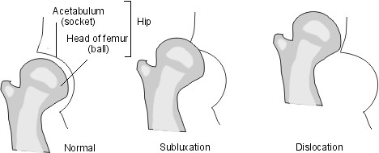

As a result the socket and the ball are not in close contact. In the mildest form of DDH, known as subluxation, there is some contact between them. In the more severe cases the femoral head (ball) may be displaced completely out of the socket and be dislocated.

2

Why does it happen?
The cause of DDH is not clear. Many babies are born with unstable hips that stabilize soon after birth. With DDH, the problem persists but can be treated successfully with early detection.
About two babies in every 1,000 born will have a hip that needs treating. This can be due to various risk factors such as:
- A family history of hip problems.
- Breech position in the last three months of pregnancy.
- Breech birth.
Girls are more often more affected than boys, particularly the first born.

How is DDH detected?

All babies’ hips are examined shortly after birth by a doctor/midwife.
Ideally babies’ hips should be examined within 24 hours of birth, at the six week check, between six and nine months of age and at walking age.

In older babies and children the signs to look for are restricted movement when spreading the legs apart and a limp.

What signs should I look for?
The condition is not painful and there are no definite signs that your child may have a problem with hip development.

The following may be associated with DDH:

  - One leg appears shorter than the other.
  - An extra deep crease is present on the inside of the thigh.

  - One hip joint moves differently from the other and the knee may appear to face outwards.

  - When you change your baby’s nappy one leg does not seem to move outwards as fully as the other one.

  - Your child crawls with one leg dragging behind.

After walking age you may notice:

  - Your child stands and walks with one foot on tiptoes.
  - Your child walks with a limp.

Research has shown that parents are good at detecting hip problems so if you are concerned talk to your health visitor or GP. Treatment is usually less complex the earlier it is started.

3 4

