

Information for Parents and Families Slipped Upper Femoral Epiphysis
What is SUFE?
SUFE (also known as SCFE – Slipped Capital Femoral Epiphysis) is a disorder of the hip involving the top of the thigh bone. For reasons that are not well understood, the ball at the upper end of the femur (thigh bone) slips off in a backwards direction. This is due to weakness of the growth plate. Most often, it develops during periods of accelerated growth, shortly after the onset of puberty.

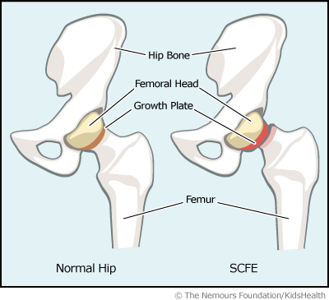

Why does it happen?
The cause of SUFE is unknown and in many cases the slipping of the bone is a slow and gradual process. However, it may occur suddenly and be associated with a minor fall or trauma. It occurs three times more often in males than females.
Symptomatic SUFE, treated early and well, usually allows for good long-term hip function.

Type of SUFE:
Acute slip – Often occurs following significant trauma and produces a sudden onset of pain severe enough to prevent weight- bearing. Patients usually report minimal or no previous symptoms.
Chronic slip – This is the most common form where the slip has been gradually worsening over a long period of time. Referred pain is often reported at the hip, thigh or knee.
Acute on Chronic slip – This is where the slip has been gradually occurring, and then suddenly increases dramatically. The child will have had months of discomfort and then present with an abrupt increase in pain and a pronounced limp.

What are the symptoms?
- Pain in the knee, hip or groin.
- Difficulty with walking.
- A limp may be present.
- Affected leg may be shorter and appear turned outwards.
- Decreased range of movement.
- Decreased muscle power.

What tests are done?
GPs who suspect a child has SUFE will refer the child to a specialist for diagnosis. Then the condition is diagnosed based on a comprehensive history, physical examination and X-rays of the hip.
X-rays will be taken of the hip when the child is lying flat and with the legs in a frog-legged position. The X-rays will help confirm the diagnosis by demonstrating that the upper end of the thigh bone does not line up with the portion called the femoral neck.
An MRI Scan (Magnetic Resonance Imaging) may also be used to confirm the slipping of the femoral head.

Treatment
Surgery:
Once SUFE is diagnosed, your child will be placed under the care of an Orthopaedic Surgeon. Surgery is usually the treatment of choice and it is important to act fast to prevent further slippage and complications.

The most common type of surgery for SUFE is called ‘in-situ
fixation’. With this treatment, the bone is held in place with a single central screw. This screw prevents the head of the thigh bone slipping.

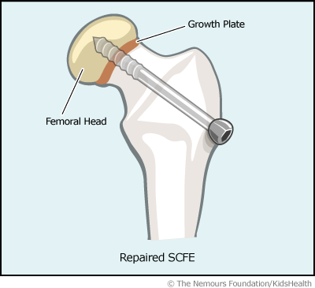

Physiotherapy:
After the operation to stabilise the hip, physiotherapy will provide your child with crutches to mobilise with, usually for 4 to 6 weeks .
General lower limb range of movement and muscle strengthening exercises will also be provided.
Many children who suffer from SUFE attend hydrotherapy (exercises and activity in water) which is a fun and effective way of building strength and improving the range of movement in the affected limb.

What is the longer term prognosis?
How your child does following a SUFE, depends on the severity of the condition. Some children who have had a severe slip at an older age may be predisposed to early ‘wear and tear’ within the hip joint.
Often the prognosis is good, however some more serious problems can occur such as interruption to the blood supply to the head of the thigh bone. SUFE affects the area of growth in the thigh bone therefore there can be long-term effects on leg length which may need addressing.
In approximately 25 to 30% of cases, SUFE may develop in the other hip. Any symptoms need addressing promptly and may also require surgery.

Useful contact information:

Ward M, Morriston Hospital
(01792) 708891 (open 24 hours)

Children’s hospital Physiotherapist
(01792) 503742
(Mon–Fri 8.00am – 4.00pm)

Children’s Orthopaedic Clinic, Hafan Y Mor Children’s Centre, Singleton Hospital
(01792) 703010
(Mon-Fri 8.30am – 4.30pm)

Editorial Board: 535
First Published: September 2011 Version: 3
Reviewed: December 2020
Next Review Date: December 2022 Author: Physiotherapy

Page 4 of 4

