CONTENTS
The Ed Major Critical Care Department Morriston Hospital – Intensive Therapy Unit
Comprehensive Information for Patients, Relatives and Friends
This information Booklet is for patients, family and friends of patients admitted to the Intensive Therapy Unit (ITU). This booklet provides more detailed information about critical care. We hope this helps answer questions you may have. Please feel free to ask staff for further information, we are happy to help.

Frist published 2019
Version No.1. Review Date: 2022

- Map of Morriston Hospital and ITU 3 and 4
- Introduction 6
- What is Critical Care? 7
- Why is my relative/ friend in Intensive Care? 9
- What does your relative being in Intensive Care look like? 10
- Visiting your relative/ friend 11
- Who works in Intensive Care? 14
- The daily routine in Intensive Care 21
- Monitoring your relative in Intensive Care 22
- Equipment and treatments in Intensive Care 25
- Treatments used in Intensive Care 31
- Infection Control 34
- Research & Teaching 35
- Patient Confidentiality 36
- How do I find out how my relative is doing? 36
- Contacting the unit 37
- Making a complaint 38
- Language and communication barriers 39
- Discharge from Intensive Care 40
- Transfer to Other Centers 41
- What if my relative dies? 42
- Organ & Tissue Donation 43
- Facilities at Morriston Hospital 44
- Getting to Us 45
- Useful Resources for Support 47
The Ed Major Critical Care Department is on the first floor of Morriston Hospital in the locations numbered 6 and 7 on the map below.

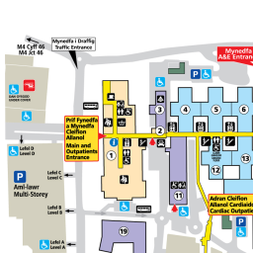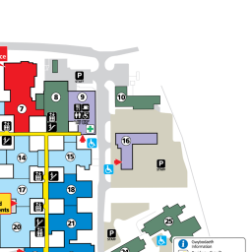
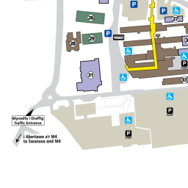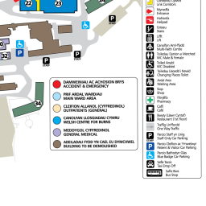


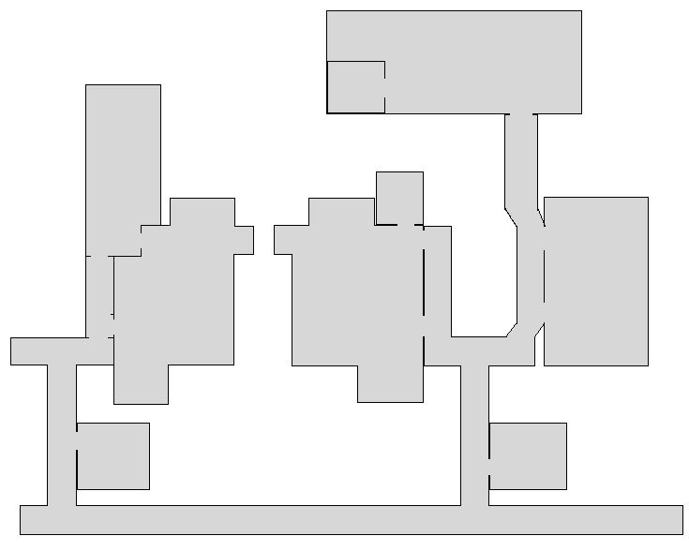


ITU MAP
ITU Map Key

ITU North 1
ITU East 2
ITU West 3
ITU South 4
HDU South or Deep south 5
Relatives and Friends rooms 6
Reception 7
To the main entrance
Main Corridor First floor
To the canteen
7
6
66
5
2
1
[Grab your reader’s attention with a great quote from the document or use this space to emphasize a key point. To place this text box anywhere on the page, just drag it.]

Morriston Hospital Main Entrance

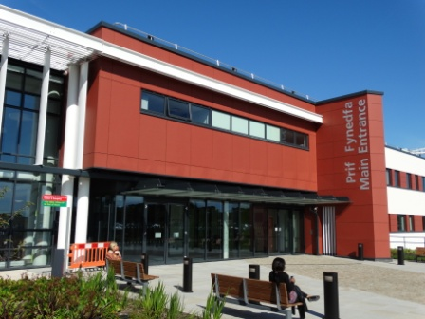

The Ed Major Critical Care Unit is situated In Morriston Hospital
Morriston Hospital
Heol Maes Eglwys
Morriston
Swansea
SA6 6NL
01792 702222

Introduction

Morriston Hospital is a 750-bedded teaching hospital in Swansea and part of Swansea Bay University Health Board. It serves the population of Swansea and its surrounding areas, as well as receiving patients from further afield via the specialist services offered in the Hospital.

The Ed Major Critical Care Unit is a general adult Intensive Therapy Unit (sometimes also called Intensive Care Unit) with 28 beds spread across 5 inter-connected areas. These areas are called North, South, East, West and HDU South (also known as Deep South).

There are also other, separate specialist Intensive Care Units (ICUs) in Morriston Hospital, such as Cardiac and Burns ICUs which cater for the patients of those Specialties, as well as other areas of higher care, such as the Coronary Care Unit, which looks after patients with heart disease. These are not part of this department and are located at different areas within the hospital.

What is critical care?

Intensive care is a term used for the specifically designed area where seriously ill patients are supported and managed, often with specialist treatments. The term is often used interchangeably with Critical Care and Intensive Therapy Unit (ITU). Intensive Care refers to the care and support given to those with life-threatening conditions that require intensive monitoring and support.

This Specialty deals with the diagnosis and management of life-threatening conditions that require the artificial support of organs and invasive monitoring. The staff working in Intensive Care have specialist training in Intensive Care. As well as keeping up-to-date with modern developments in diseases, their management, therapies and technologies relevant to the vast array of conditions seen.

Intensive Care incorporates both the Intensive Care and High Dependency Unit (HDU). There are more nurses on duty in Intensive Care compared with the general wards, which reflects on the increased care and observation critically ill patients require. Usually patients in Intensive Care are nursed by one nurse in a one-to-one ratio, i.e. the nurse generally has no other patients to look after. High Dependency Care is under the umbrella of Intensive Care where your relative requires more support and observation than can be provided on a general ward, but not as much as required in Intensive Care. Usually two high dependency patients are nursed by one nurse.

Sometimes as a patient recovers from a critical illness they “step down” to HDU prior to being discharged to the ward, or sometimes a patient is admitted to HDU because they need more support than on a ward. There are also some patients that it is felt by the Intensive Care teams that the support and observation offered by HDU will be the limit of their treatment. There is no physical space differentiation between ITU and HDU patients they will all be cared for within the five areas of ITU.

Patients are usually admitted to ITU with life threatening conditions. It is important to be aware that unfortunately not everyone that comes to Intensive Care survives. Sometimes, in spite of all the treatment we may give, patients are too sick to survive. There are also occasions where putting patients through certain treatments may be inappropriate and burdensome to their overall condition and wishes.

Why is my relative/ friend in the intensive care?

The majority of patients come to us an Emergency. In these cases, a patient either requires specialist monitoring or has become so ill that one or more of their organs require support in order to maintain their life whilst treatment continues. This can sometimes be as soon as they arrive into hospital, or can sometimes occur during their admission whilst being cared for on the wards. Sometimes a patient comes to us straight from an emergency operation. Any Specialty can refer their patients to Intensive Care at any point during their time in Hospital.

Other admissions to intensive care are elective. This is a planned admission to Intensive Care after a major operation or procedure, where a period of close monitoring or organ support is beneficial to the patient’s recovery. If this is applicable to your relative it is sometimes possible to visit the Unit before their operation to orientate yourselves.

What does your relative / friend being in Intensive Care look like?

Your relative / friend is likely to look different from the last time you saw them. This can be due to several reasons:
- They may be bruised and swollen if they have suffered injuries
- Critical illness can cause the body to become swollen and puffy
- They might have tubes and dressings if they have had operations
- They will have monitoring wires attached to a monitor
- They may have drips in connected to pumps and fluids
- They may be sleepy or unconscious
- They may be connected to equipment supporting their body
- There will be a nurse at the bed space looking after your relative

It is important to remember that even though they may have changed in appearance and attached to lots of machines and monitors, they are still the same person you knew before. The nurse and medical staff will help prepare you for your first visit. They will answer any questions you might have.

Visiting your Relative

Visiting times are 12:30pm till 4:00pm and 5:30pm onwards

Visiting hours can be flexible for close family however, because of patient confidentiality during doctors ward rounds and other clinical activity we ask that you not visit between 08:00am and 12:30pm. For safety reasons we ask that a maximum of two people visit at any time. We will make every effort to ensure you can see your relative or friend as much as possible, however there will be times when visitors are asked to leave the bedside temporarily for clinical procedures and personal care for confidentiality reasons. It is an important part of your relative or friends’ recovery that they have the opportunity to rest. In order to provide patients with some quiet time we have a rest period from 4:00pm till 5:30pm daily, we kindly ask that you do not visit during this period. Thank you.

The mornings are the busiest period on the Unit as many of the multi-disciplinary team members assess and treat your relative, as well as undertaking the daily care of your relative. Sometimes your visit may have to be interrupted to allow treatment or a procedure to be undertaken. In these cases, we will ask you to wait in the waiting room and call you back in once finished.

Visiting can be arranged outside of these hours, so please discuss it with the nurse at your relative’s bedside, or if difficulties are encountered then ask to speak with the Nurse in Charge.

When you arrive at the Unit’s doors there is an intercom system with each of the unit’s names indicated on the system. Press the buzzer, and when someone answers, please say who you are and who you would like to visit. Occasionally, there can be a delay answering the buzzer if the nurses are busy, so please be patient with us. At main reception, during office hours the receptionist will ring the Unit on your behalf.

Sometimes we might have to ask you to wait a little while before visiting, for instance if your relative is receiving treatment or being reviewed by one of the team, but we will come and get you when they are ready.

When a patient is first admitted to the ICU, it is normal to wait for a while being allowed in. We appreciate this can be quite aggravating, however the Doctors and Nurses need time to make their assessments, get your relative comfortable and stable, and get them attached to any equipment required for their care. Someone will be out to let you know what is happening as soon as they can.

Can I touch my relative/ friend?
It is usually possible to touch your relative. However, as they are often surrounded by life-support machines, wires and tubes, it is often prudent to ask their nurse first, who will help you.

Can I talk to my relative/friend?
Definitely Yes. Often during the early days of their time in ITU your relative may be unconscious due to drugs used to keep them sleepy and comfortable. Your relative may be able to hear even if they are unable to respond. Our staff talk to your relative whilst we are looking after them so they know what is happening, so we would also encourage you to talk to them, letting them know you are there with them.

Do I need to bring anything for them?
There is only limited space on ITU for storing belongings. We ask all relatives to take home all property other than toiletries. Patients will need their own toiletries such as soap, toothbrush, shaving kit, comb etc. Valuables and money should not be brought in to ITU. Any electrical equipment brought on to the department is brought in at the families own risk and must be electrically tested by the Estates Department prior to use within the hospital environment.

A bit about the team looking after your relative or friend

The team of staff involved in providing care for each patient includes; doctors, nurses, physiotherapists, pharmacists, radiographers, health care support workers and administrative staff.
A member of the medical staff is always on duty within the department and there is always a consultant on call. The Lead Nurse manages the ITU at Morriston hospital. There is always an experienced Sister or Charge Nurse responsible for each shift. They are assisted by a team of staff nurses and senior staff nurses who care for individual patients.

Who works on the Unit and what do they do…
- Consultant Intensivists
  - These are the most senior doctors working in ICU. They are ultimately responsible for the care of the patients on the Unit. They have trained specifically in Intensive Care Medicine, and many have also trained in other areas, such as Medicine, Anaesthesia and Emergency Medicine. There’s always a consultant on-call 24 hours a day.
- Doctors
  - There are many different grades of doctors. These are Doctors in training, working towards their next grade. These doctors work on a rota to ensure 24-hour presence on the unit. The Junior Doctors working are of varying seniority and come from a variety of backgrounds including Medicine, Anaesthesia and Emergency Medicine. There are some that are training specifically in Intensive Care.

- Advanced Critical Care Practitioners (ACCP’s)
  - These are our team of Specialist senior nurses that have undertaken a training program to take on advanced skills and knowledge related to ITU, and support the Medical staff in looking after your relative.

- Nurse-in-Charge
  - This is a senior Intensive Care nurse that is responsible for coordinating care on ITU and its nursing staff during their shift.
- Nurses
  - The Nurses are the staff who look after your relative’s needs for the duration of their shift. They monitor your relative’s condition, look after their personal care and support and treat them.
- Healthcare Support Workers
  - These are healthcare workers that assist the ITU staff in the day-to-day care of your relative, as well as ensuring the Unit is adequately stocked and our equipment cared for.
- Physiotherapists
  - Our Physiotherapy team assesses our patients in the ICU every day. They have several roles, including:
    - Listening to your relative’s chest and helping clear the lungs, as well as helping wean your relative from the ventilator through strengthening their breathing muscles.
    - Maintaining a good range of limb movements and mobility whilst in bed, through methods such as stretches and the use of splints
    - Strengthening exercises and improving mobility
  - It is vitally important people who are critically ill receive physiotherapy. This is in order to mobilise them, this is an important aspect of your relatives rehabilitation.
  - Not every patient requires the same input from physiotherapy. Some patients will have a daily review, whilst others may receive a review and several treatments a day.
- Radiographers
  - These are allied health professionals who visit the Unit regularly to take x-rays of our patients using a portable x-ray machine. They may also visit your relative to do an Ultrasound scan. They also undertake other types of scan in the Radiology Department that your relative may need.
- Pharmacists and Pharmacy Support Workers
  - Pharmacists are specialists that are involved in the monitoring the drugs we use and their effects on our patients. Pharmacy Support Workers assist the Pharmacists in ensuring our Unit has an adequate supply of the drugs we use.

- Dietitians
  - Assess your relative’s nutritional state and requirement, to ensure that they are receiving the right type of food, as well as enough calories and nutrients.
- Specialist Nurses Organ Donation
- These are specialist nurses who in certain circumstances can inform, advise and facilitate organ donation.
- Parent Teams and Specialties
  - Your relative may have been cared for before their admission by another Doctor in another Specialty. These are referred to as the Parent teams. They will take over your relatives care once discharged from ITU. For instance, they might be the Surgeon who carried out your relative’s operation.
- Microbiology Consultant
  - These are specialist Doctors experienced in managing infections. They often visit the ITU to guide current antibiotic therapies or update us on new findings from the laboratory.
- Radiology Consultant
  - These are specialist Doctors interested in imaging. They sometimes visit the Unit to help identify internal structures we cannot examine and assist with imaging machines such as an ultrasound scanners. They sometimes also help us drain fluid using imaging machines.

- Students (Nurses, Doctors, allied health professionals)
  - Our ITU is a University-affiliated teaching hospital. Integral to training the next generation of staff is the presence of students on the Unit, who may be Medical Students, Nursing Students, Physiotherapy or Pharmacy Students to name a few.
- Speech and Language Therapist
  - These are specialist health professionals who provide support, care and treatment for patients with difficulties with communication, eating, drinking and swallowing. Patients on ITU can develop problems with swallowing due to the tubes needed to treat them when they are very unwell.
- Chaplains or other Religious Figures of Standing.
- Administrative staff
- These staff help co-ordinate patient information and facilitate patient information. In addition to managing the reception desk.
- Stores coordinator and ITU Technicians
- These members of staff manage the specialist stock and equipment needed in the ITU environment.
- Domestic staff
- These staff help maintain the cleanliness of the unit. You will see them on the unit throughout the day.

How to recognize the team?

- Doctors and members of the medical team wear peach or blue tops and bottoms when delivering care.
- Lead Nurses wear navy tunics with red piping.
- Sisters/ Charge nurses and Senior Staff Nurses wear navy blue NHS Wales uniforms.
- Staff Nurses wear hospital blue NHS Wales uniforms.
- Health Care Support Workers wear green NHS Wales uniforms.
- Physiotherapists and radiographers wear white tops.
- Student Nurses wear purple NHS Wales uniforms.
- Administrative staff and receptionists wear either a blue patterned top, a turquoise top or a pale lilac tunic.
- The ITU technician and the stores coordinator wear white tunics.
- Radiographers wear black scrubs.
- Domestic staff wear burgundy NHS Wales uniforms.

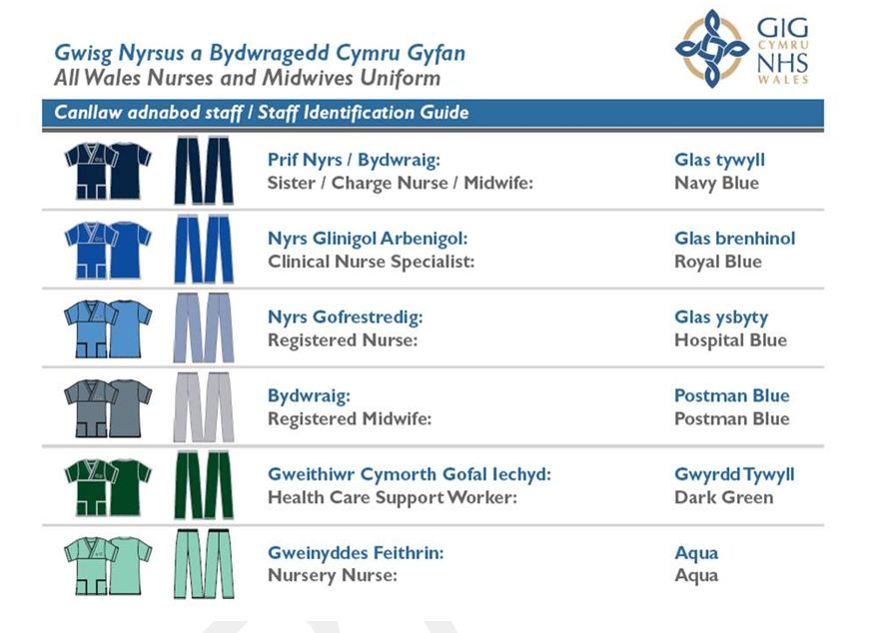

The Daily Routine in Intensive Care

7:00am-8:30am: Handover of nursing, junior medical and Consultants.

9:30am-12:00am: Morning ward round. Your relative will be reviewed by a Consultant Intensivist and supported with the Junior Medical staff. Here they are assessing your relative, reviewing tests and findings in order to guide their treatment.

12:00pm-2:00pm: Lunchtime & Afternoon visiting. During this time our staff continue to carry out your relative’s day-to-day care, as well as undergoing any investigations or procedures they require.

3:00pm-4:30pm: Afternoon ward round. Your relative will be reviewed by the Consultant Intensivist and the Junior Medical staff to review progress from the morning and identify any new issues which require addressing.

4:00pm-5:30pm: Patient rest period – Visitors are asked not to visit during this time. We try to minimize interventions and we reduce the lighting to allow patients time to rest and recuperate.

07:00pm-08:30 pm: Staggered handover of nursing and junior medical staff

Monitoring your Relative in Intensive Care

In Intensive Care we monitor our patients closely in order to assess clinical condition, progress and to quickly identify signs of deterioration warranting intervention.

Monitors may be classed as non-invasive (able to take readings superficially); or more invasive (to measure specific readings). They might measure things continuously or intermittently.

What you might see
- Saturations monitor: probe on fingers, toes or ear lobe which monitors the oxygen levels in the blood
- ECG: sticky dots on the chest that measure the electrical activity in the heart
- Blood pressure cuff
- Temperature probe

Equipment and Treatments in Intensive Care

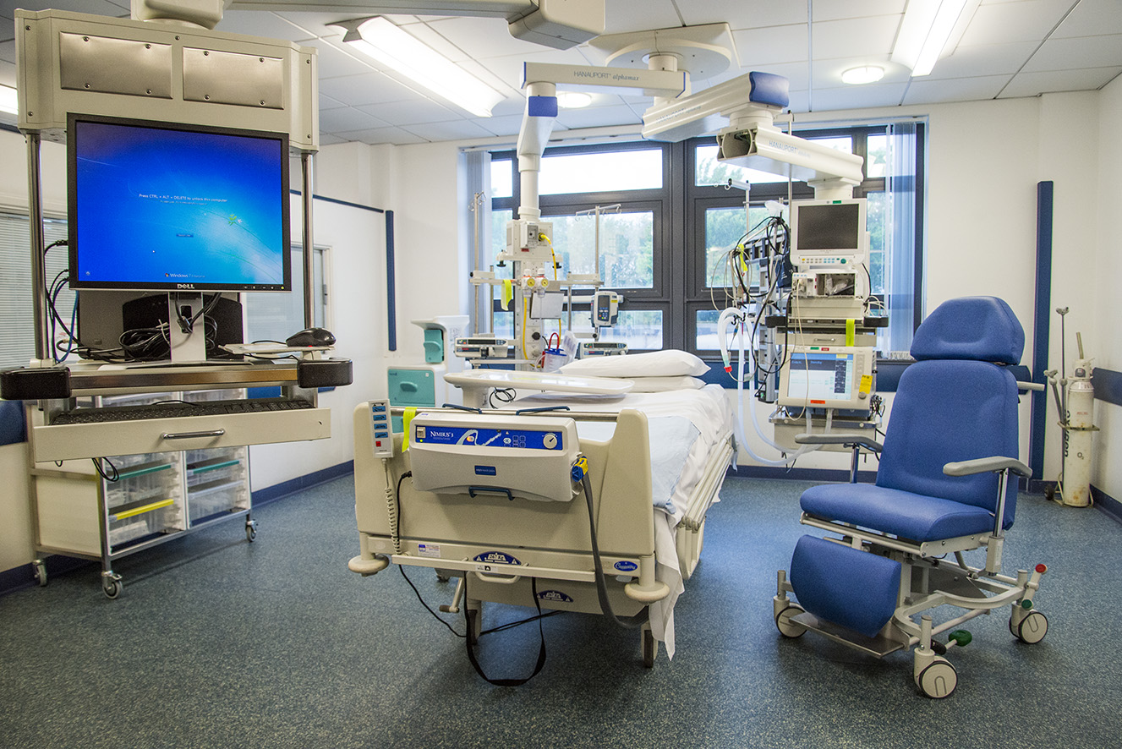

This is an example of a bed area in the ITU. All our bed areas have the same basic equipment. Your relative or friend may need help from some or all of this equipment.

Our intensive care bed areas look similar to this:
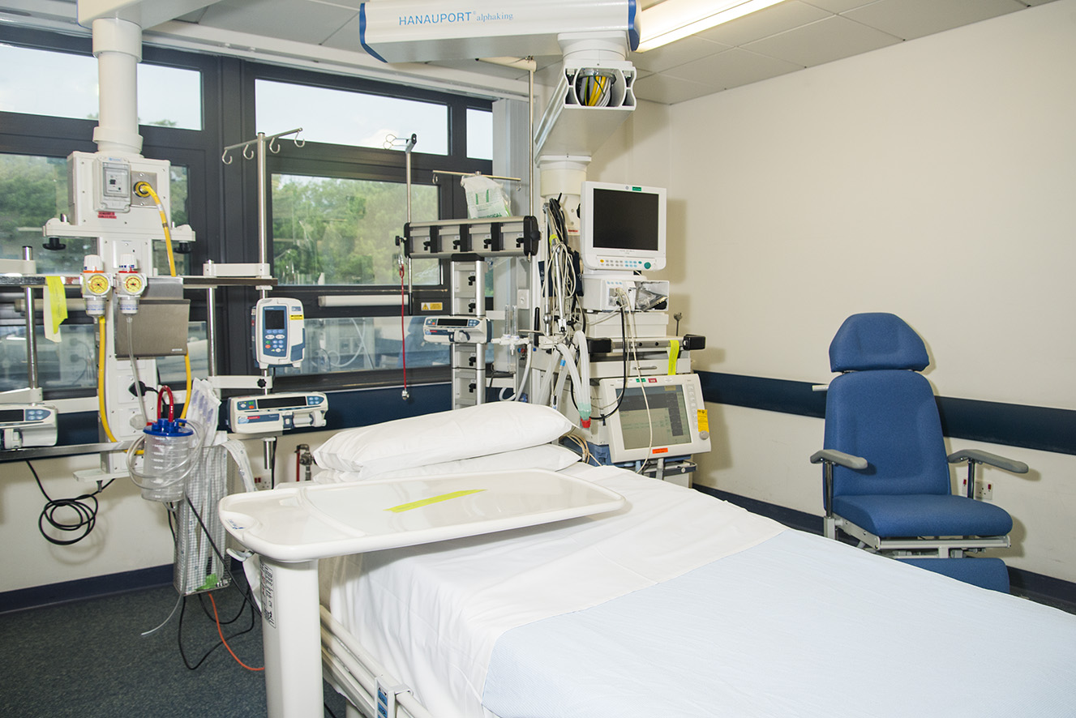
This is a ventilator. It is used to help patients with their breathing.
This is the monitor for patient observations, such as blood pressure and pulse.
These are fluid and medication infusion devices.
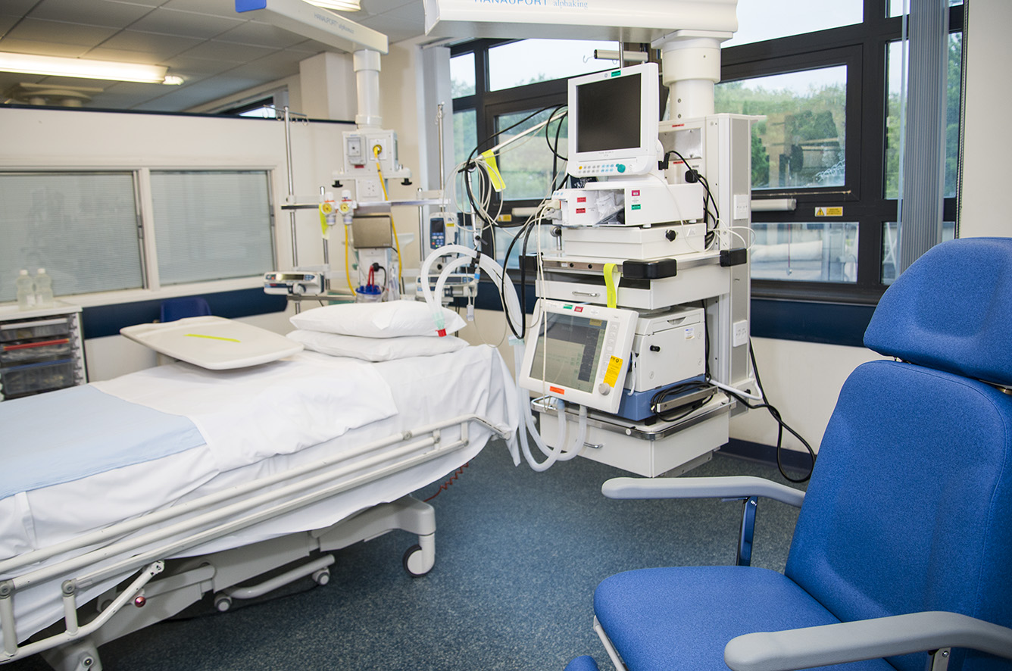
This is the monitor for patient observations, such as blood pressure and pulse.
This is a ventilator. It is used to help patients with their breathing.

Equipment Used in Intensive Care

Breathing Equipment

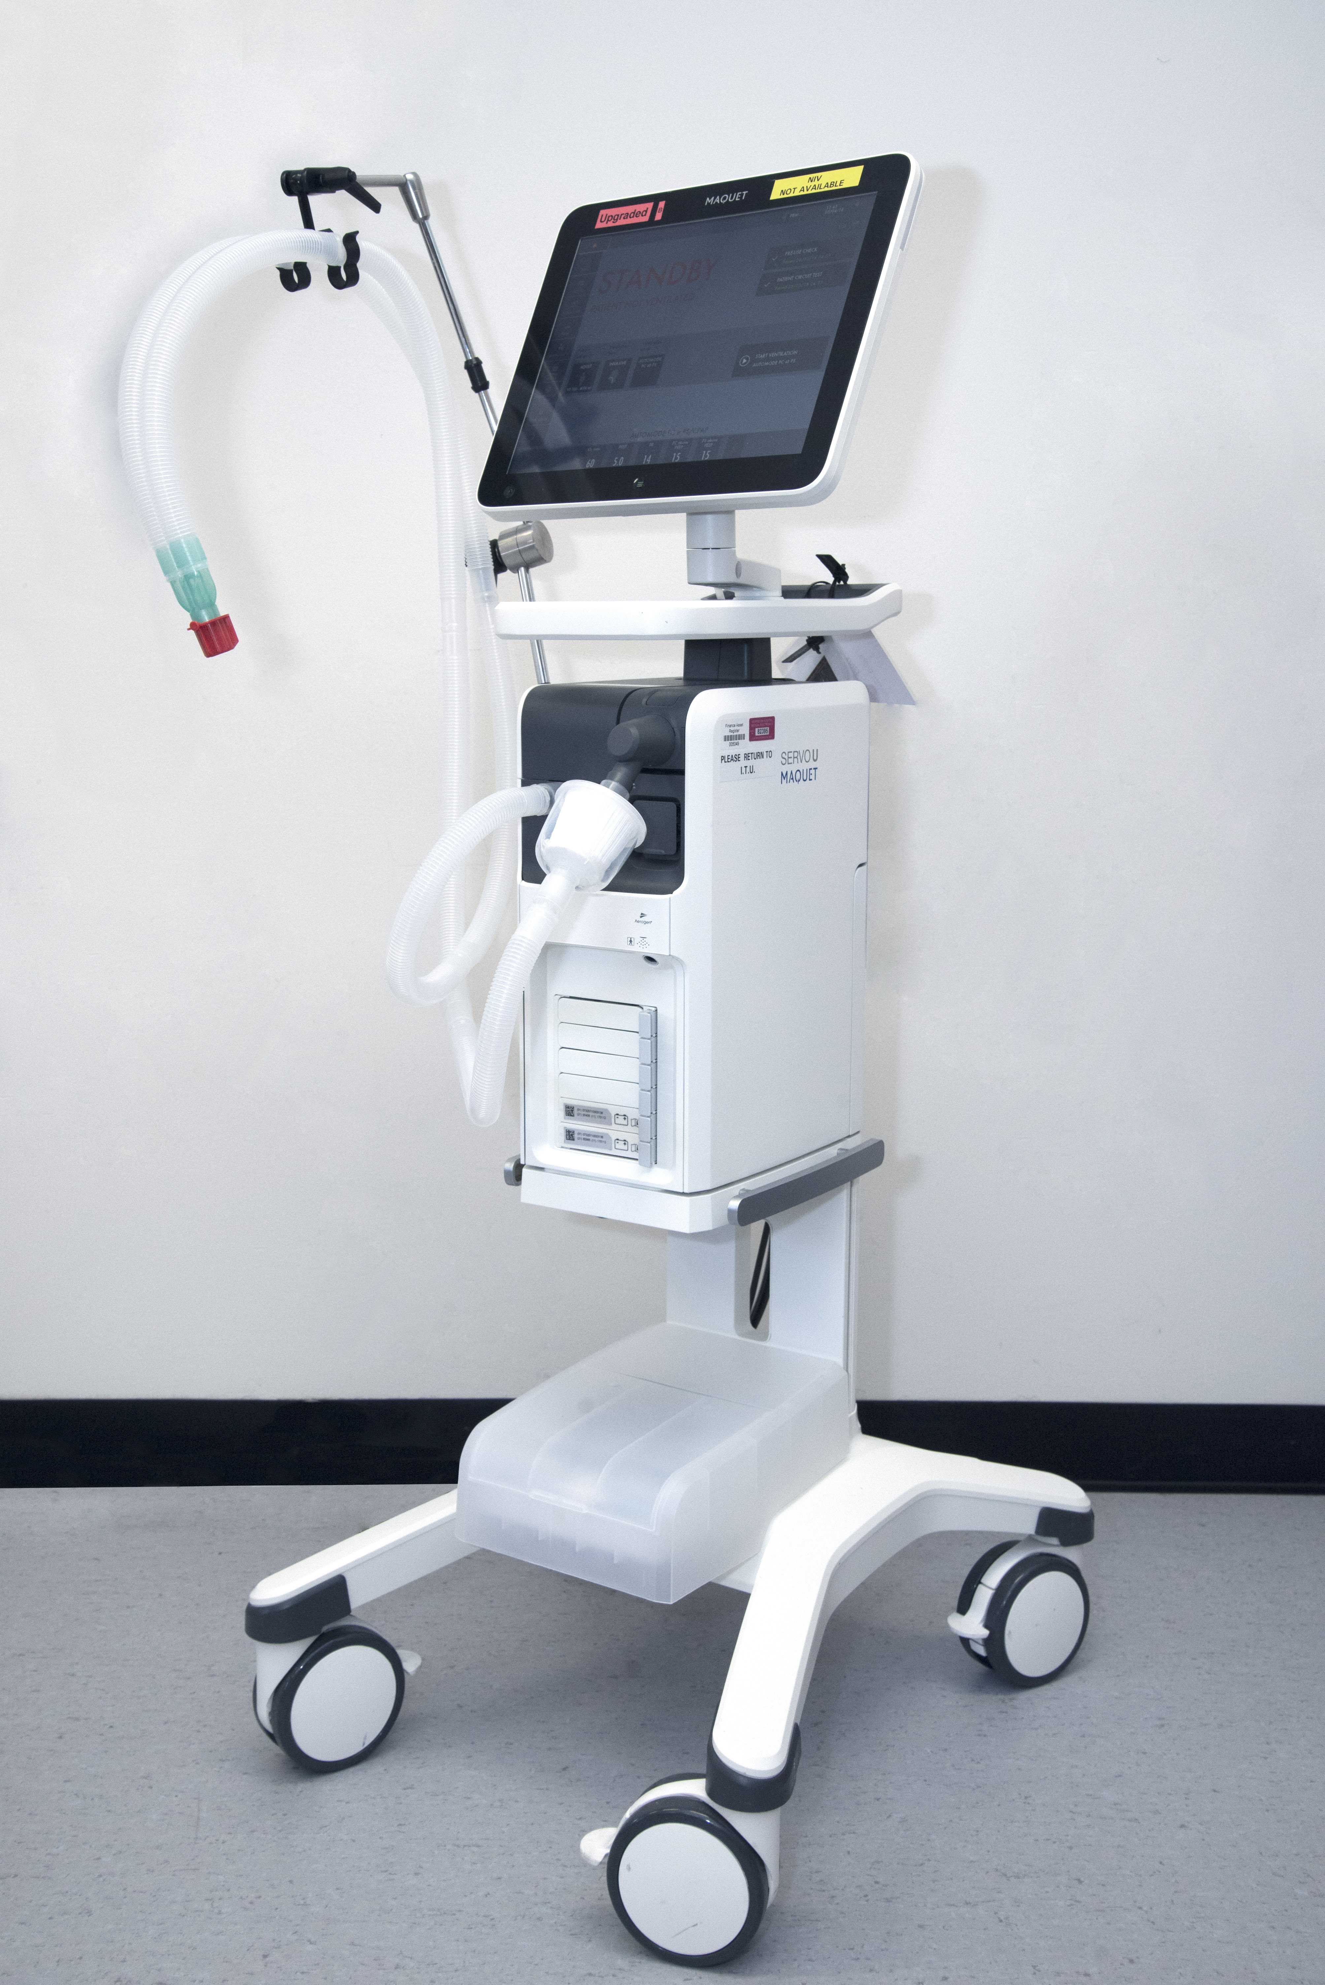
A Ventilator is a machine that artificially supports your relative’s breathing. It is connected to your relative through a tube going into their windpipe. This tube can either be through the nose or the mouth. The Ventilator is a machine that blows additional oxygen and air into the lungs. Depending on need the ventilator can take over your relatives breathing completely or can be set to assist them with their breathing. As your relative’s condition improves, the support they require from the Ventilator is gradually weaned down.
Picture 1: An example of a ventilator
used on the CCD.

If your relative is likely to require the assistance of a Ventilator for a prolonged time, sometimes the tube in to their windpipe is replaced by a tracheostomy tube. This involves an operation to insert a tube into the windpipe via a hole made in the throat. This can either be inserted by one of our Doctors on the Unit, or sometimes needs an operation to site. These tubes are much easier to tolerate than a tube in a nose or mouth.

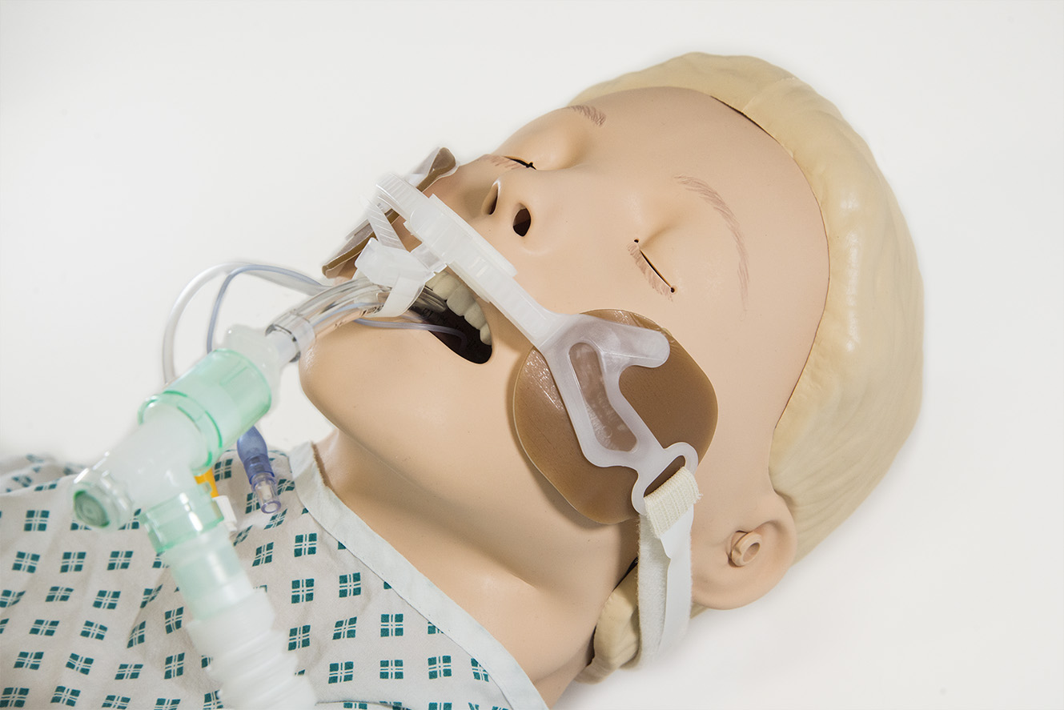
It can be frustrating for our patients as they aren’t usually able to speak to us with a tube in place, even though they may feel they are. Although, occasionally with a tracheostomy in place we can use special equipment to give them a voice as they improve.
Picture 2: An example of an oral breathing tube (also known as an Endotracheal Tube).
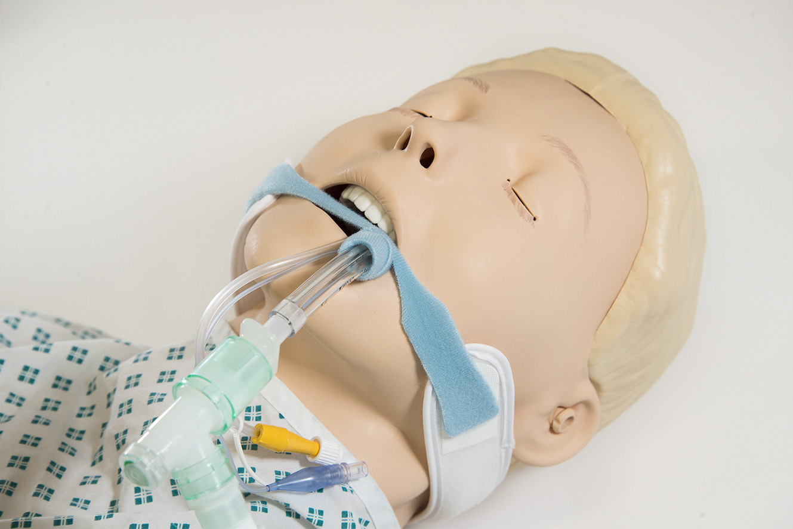
Picture 3: An example of an oral breathing tube with an alternative fastening.

For some of our patients we are able to support their breathing with a breathing machine that does not involve a tube into their lungs. This machine may be connected to your relative either through a tight-fitting mask, nasal prongs or a hood. This machine can give additional oxygen and can help reduce the amount of work your relative is doing to for their breathing.
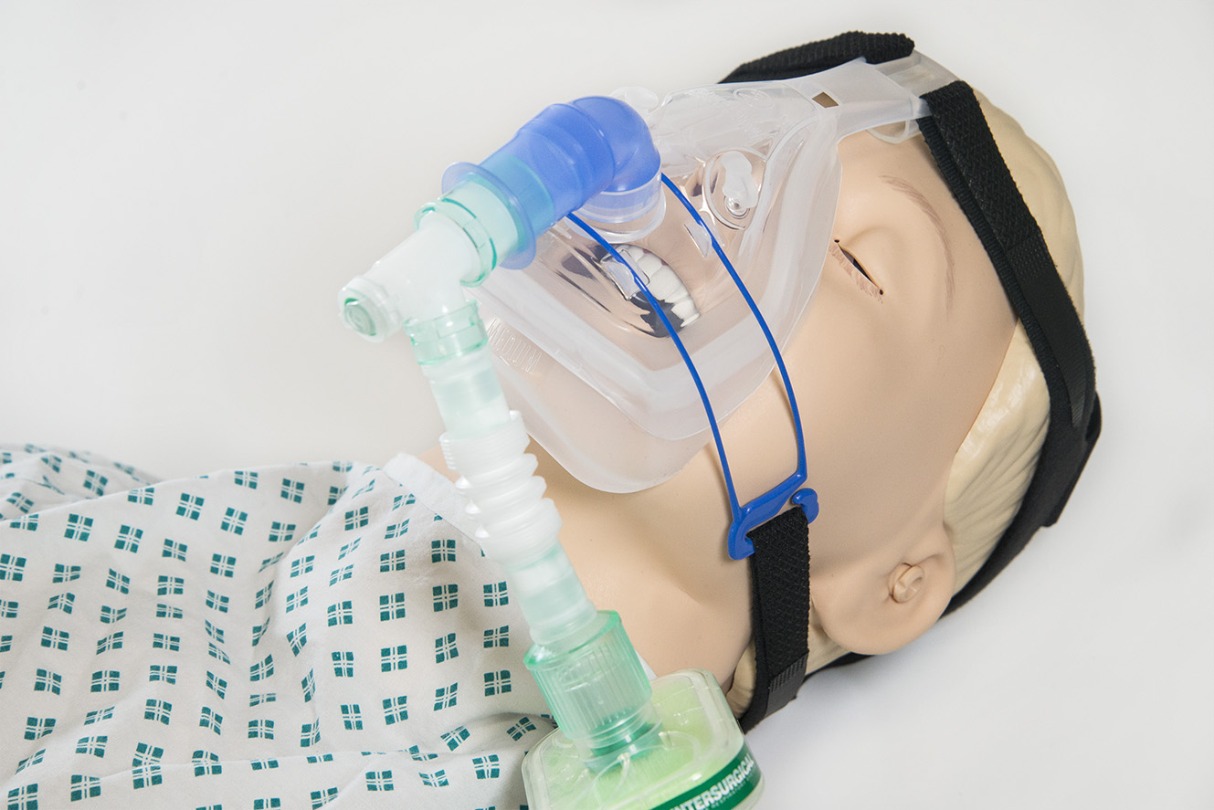
Picture 4: This is an example of a non-invasive ventilation mask. In some cases we use these masks to give a person extra support and oxygen with their breathing.
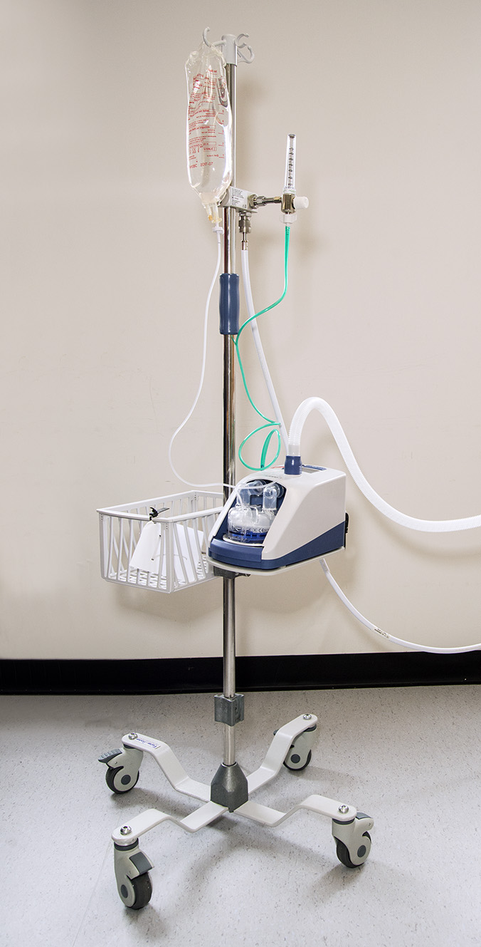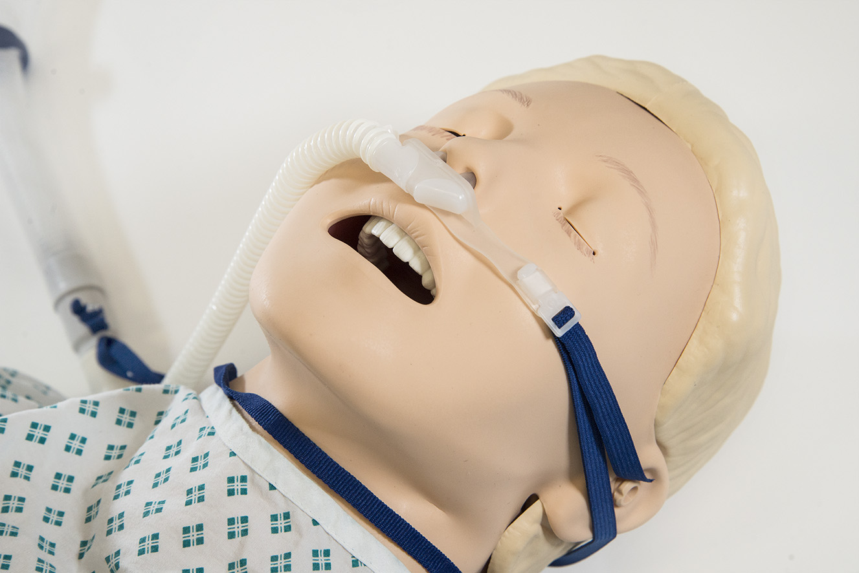

Picture 5: This is an example of an administration device for high flow oxygen. We use this for some people to help with their breathing.
Drug and Fluid Infusion Pumps

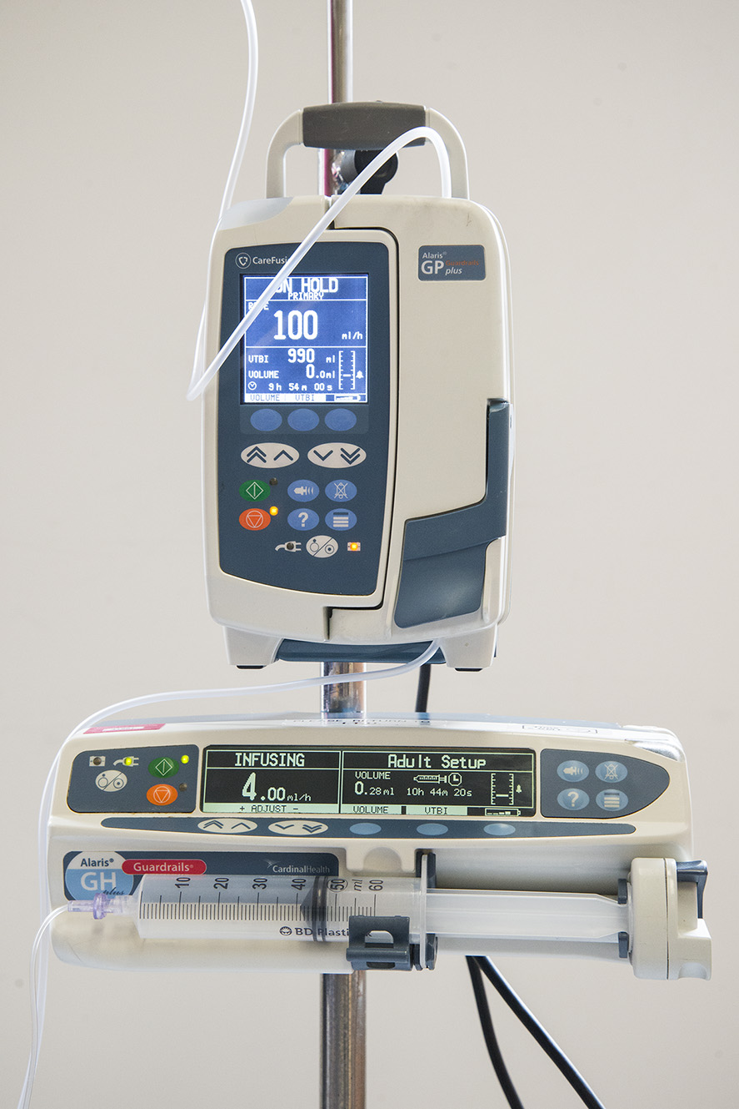
Many of our patients are attached to drips. Drips allow us to administer fluids, drugs, nutrition and blood products to your relative (if needed). Drips run these liquids into your relative via small tubes placed into their veins. Often these tubes are placed in the neck, arm or hand, but may sometimes be put under the collarbone, in the groin or the legs. The liquids in the drips are often run through a pump, in order to carefully monitor the amount and ensure the drip runs at the appropriate rate.
Picture 6: These are commonly used fluid and medication infusion/ pump devices you may see in CCD.

Your relative’s nutrition is given in liquid form, either down a small tube passed via the nose into the stomach, or more rarely directly into the vein.

As your relative’s general health status improves and when the team deems it appropriate, they may be able to start to eat and drink for themselves
There are also tubes that drain the waste (urine/stool) products from different areas of the body of your relative.

Equipment to Support the Kidneys
When the kidneys are working well they produce urine and in Intensive Care we often measure this hourly via a tube passed into your relative’s bladder that drains into bag.
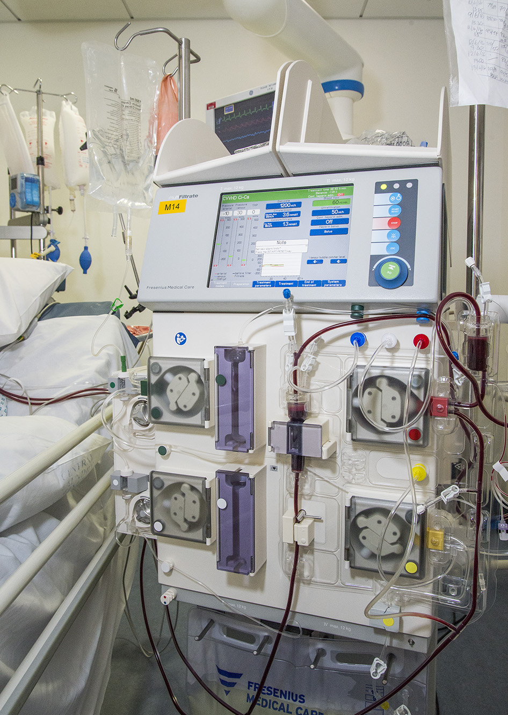
When the kidneys aren’t working properly or if we need to get rid of certain drugs and bodily waste products, a kidney machine or a hemodialysis machine may be used to support them whilst they recover. This may be done either continuously (for a temporary period of days) or for several hours at a time. It is done through a drip either in your relative’s neck, sometimes in their groin or under their collarbone.
Picture 7: This is an example of a hemodialysis machine on ITU.

Specialist and Other Equipment
We also use a variety of other equipment to look after your relative. We have ultrasound machines to assist our Doctors in placing drips. We use electrocardiogram (ECG) machines to make a tracing of the electrical activity of your relative’s heart. We have warming blankets and cooling devices to help us either warm up or cool down, respectively, your relative. To prevent pressure areas we regularly use inflating mattresses, and in some of our patients we also use inflating calf supports to try and prevent blood clots.

Dependent on what has happened to your relative, other more specialist equipment might be used. The staff looking after your relative can tell you about it if needed.

Treatments Used in Intensive Care

Drugs
These are a vital aspect to the care we give to your relative in Intensive Care. The drugs we use and the amount of them will vary depending on what is happening to your relative and how they progress.

Sedatives & Painkillers
We often use sedatives to keep a patient in a deep sleep, especially at the beginning of their admission. We review the need for the sedation every day and also try and give a sedation pause to allow us to assess your relative. Where possible we also use lower doses to make sure your relative is as awake and comfortable to be able to tolerate of all of their treatments and monitoring attached to them. The important side effects of these sedatives are short term memory loss, delirium and confusion. Friendly faces and talking to them often helps orientate them.

We often use painkillers for our patients. The ones we use are potent, which can make your relative comfortable but sometimes makes them drowsy. They are good at relieving pain. They also help reduce anxiety and keep your relative comfortable during their treatment.

Muscle relaxant drugs
Sometimes we may have to give other drugs to a sedated patient that stops their muscles moving, allowing us to co-ordinate them better with the breathing machine. It does not affect the heart muscle but does affect their limbs and face, so they may appear unresponsive.

Heart & Circulation Drugs
We also use two powerful groups of drugs in ICU to support our patients that act on the heart and the blood vessels. Drugs called inotropes help us increase the pumping function of the heart. If a patient’s blood pressure is low we use drugs called vasopressors that squeeze the blood vessels and help raise the pressure.

Others Drugs
Some of the drugs we give will be your relative’s normal medications, either given through the vein or into their stomach via the tube through their nose. Sometimes some of the drugs your relative normally takes might not be appropriate to give your relative while in ITU depending on what is wrong with them.

Other drugs we give will be geared towards treating the problem that brought them to us, for instance antibiotics if it was an infection.

Whilst in ICU we also sometimes give a drug to try and prevent stress ulcers in your relative’s stomach. Many of our patients also receive a blood thinning injection to try and prevent blood clots in deep veins whilst they are not as mobile as normal. We also use a mouthwash to try and keep your relative’s mouth clean.

Nutrition
Nutrition is crucial to the recovery of our patients and we are guided by our Dietitians as to what form of nutrition we give our patients, and how many calories they need. Many of our patients are not able to feed themselves, so we feed them either into their stomach via a tube through their nose. Some critically unwell patients are unable to utilize nutrients and are at risk of malnutrition in these instances we provide nutrition straight into the vein.

If your relative has special dietary requirements or restrictions please let us know, so we can try and address these.

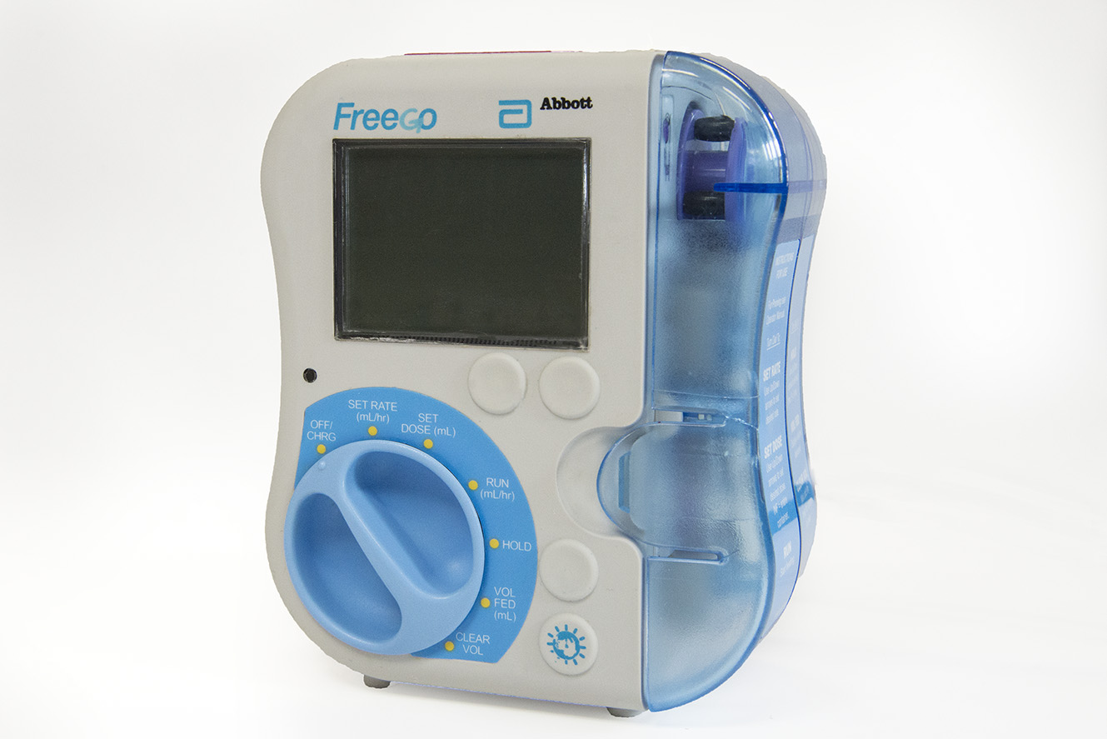
Picture 8: This is a feeding pump used to feed patients through a tube in their nose or mouth. The tube goes to the person’s stomach and feeds nutrition directly to the stomach.
In some cases patients may be admitted to the ITU already having a line coming from their stomach for feeding. If this is the case we would use a feeding pump like the one above to start feeding.

Infection Control

Infection control is important to ITU. We would like you to help us cut down the risk of spreading infection. We ask that you clean your hands with alcohol gel before entering the ITU and again when you leave. Please see a member of staff before entering the department if you have a cold, cough, are feeling generally unwell, have any other infection issues or have had diarrhoea/vomiting recently. Please do not bring flowers from home for your friend or relative. These measures are important for the safety of your relative or friend and other patients, visitors and staff in the department. Thank you for your help.

- Please remember to use the alcohol foam hand wash when entering & leaving the Unit. This helps us with the control and prevention of infection. If it is empty please let one of the staff know.
- Please do not touch the tubes or lines.
- Please do not sit on the beds.
- If your relative is being barrier nursed or isolated, their nurse will guide you on what to do.

Research and Teaching

Morriston Hospital is a teaching hospital. As such its current staff are involved in training the next generation of staff, whether they are Medical, Nursing or Allied Healthcare Professional students. You may see students on the unit, they are supervised at all times. If you have any concerns over the presence of any of the students you see, please inform your relative’s Nurse who can address your concerns.

Our junior doctors are also in training. Often part of the daily ward round run by the consultants involves teaching the junior doctors. They may talk about an aspect of your relative/friends care in order to educate them. However, sometimes they may not be specifically talking about your relatives/ friends case. So if you have any concerns or queries, please ask the Nurse. They may be able to address them, or arrange one of the Medical staff to speak to you. At busy times on the Unit, there may be a delay before someone is available to speak with you.

Patient Confidentiality
In ITU we are governed by the same patient confidentiality agreement as on the wards and in the community. Your relative’s condition and treatment must remain strictly confidential between them and the team caring for them. Any information about your relative will not be disclosed to anyone except his or her next-of-kin. This applies with enquiries over the phone (We are unable to give much information over the phone), as well as in person.

How do I find out how my Relative is doing?
Keeping in mind confidentiality, our staff will endeavor to keep you up to date with your relative’s progress. The first port of call is your relative’s bedside nurse, who will be able to update you with their progress and condition, as well as any changes in treatment or management. They will do their best to address your concerns and answer your queries. If you would like to speak to a consultant caring for your relative/ friend, please ask the nurse who can help arrange it for you. Doctors will endeavor to speak to you at a mutually convenient time. Sometimes the Doctors may want to speak to you about your relative and an aspect of their car. The nurse will usually contact you to arrange a mutually convenient time.

Also, when you first visit your relative, we may ask you to nominate a person as the main point of contact. This is usually the next-of-kin or someone they have delegated this to. They can act as the contact person for updates relating to your relative and are the person that friends and family can contact to enquire about your relative’s condition. This system allows us to focus on caring for your relative whilst ensuring your family is able to keep abreast of progress.

Contacting the Unit
During office hours our reception is staffed by our receptionists who will be able to take telephone calls and direct them to the appropriate Unit. Once you’ve visited your relative for the first time, your relative’s nurse will be able to give you the direct number for the Unit your relative is based on.

The direct dial numbers are listed below:

Morriston Hospital Switch board (ask for CCD) - 01792 702222
ITU reception – 01792 703447
North Unit – 01792 703774 or 01792 703007
South Unit – 01792 618873
South HDU (Deep South) – 01792 618874
East Unit – 01792 703480 or 01792 703481
West Unit – 01792 703472

All we ask is that one of you act as the designated enquirer with regards to phone contact and updates, so as to prevent our staff being overloaded with responding to phone calls.

Making a Complaint
We always aim to give your relative/friend what is best for them. Our aim is that during your relative’s stay in Intensive Care you have no concerns and are happy with the care we give them, and with how we interact with you.
If you feel we have not achieved this you may want to raise your concerns.

For any concerns raised, we are often able to listen to your concerns and address them there and then. The first port of call is usually your relative’s bedside nurse, who will either try and address your worries directly or help find the right person for you to talk to. Any problems or complaints that cannot be solved in this way can be referred to the nurse- in-charge of ITU or the Lead Nurse of the CCD. The Nurse-in-Charge will try and address your complaints and concerns, or escalate them further.

If you want to complain formally about an issue relating to your relative’s care in Intensive Care, then there is an NHS formal complaints process through which you can raise your concerns. The Nurse-in-Charge can talk you through the process should this be required.

Language or Communication Barriers
Sometimes our patient’s don’t have English or Welsh as a first language, which may lead to some difficulties in communication between staff and relatives and vice-a-versa. Please let us know what the patients preferred language is. We may be able to assign members of staff fluent in their preferred language to look after your relative. However, we cannot guarantee this on every shift, so bear with us.

If the patient and relatives are unable to communicate in English we will do our best to arrange an interpreter, this usually requires some preparation. There is also a ‘Language Line’ translation service that can be arranged through the nursing staff if needed.

Being discharged from Intensive Care
Being discharged from Intensive Care is a positive step for your relative, and usually means their condition is improving. Sometimes if your relative has been with us for a long time, patients and their families can become worried and anxious about this transition back to the ward. This may be as a result of the close relationships you may have developed with the nurses and doctors in ITU and the staffing levels and monitoring can make your relative and you feel secure.

The ward staff in our hospital are familiar with caring for patients who have just been discharged from Intensive Care. They will continue the care and monitoring your relative requires as they continue their recovery. Although there are fewer nurses on the ward, there will always be a way to call for one should your relative or you are concerned about them.

Prior to leaving Intensive Care, our doctors handover to the doctors that will be looking after them on the ward. They inform them of the treatments that were required during their time in Intensive Care. And what current treatments and management plans are in place to continue your relative’s recovery. Our nursing staff also hand over to the staff on the ward relating to the details they need to know in order to continue your relative’s care and recovery.

This handover is also put into a written document which is placed into their Medical Notes. Therefore anyone reviewing your relative is able to see what happened to them during their time in Intensive Care, and what the current treatment plans are. The Intensive Care outreach team are also available 24 hours a day, should the ward teams be concerned about your relative’s medical condition.

Patients who have been discharged from ITU are also checked on by the Critical Care Outreach team. This is a team of specialist critical care nurses.

Transfer to Other Centers
Morriston Hospital does not contain all of the different Specialties that look after patients e.g.: for neurology or liver treatment. Sometimes it may be necessary to assess and stabilize your relative before transferring them to another hospital that has a Specialist service necessary for the treatment of your relative. If this is the case you will be informed of where, how and when they will be transferred as well as the contact details for the new Hospital. The most common situation for us is patients being transferred to Cardiff with head injuries, as that is where the neurologists work.

Sometimes for rarer or more specialist treatments your relative may be transferred further afield. We would hope that if this were the case we would be talking to you about it beforehand, so you would know why it was necessary.

What if my relative/friend dies?
Patients are usually admitted to ITU with life threatening conditions. Not everyone that comes to Intensive Care survives. This may be as a result of serious injuries they sustained prior to arrival, or may be sudden and unexpected as a result of their serious illness. More often, however, there are warning signs that a patient is either not responding to the support they are being given. Or are getting worse despite being on the maximal support available in Intensive Care. When this is the case, we are usually able to talk through things and prepare you for the possibility that your relative might not recover. Withdrawal of treatment may also be discussed at this point.

Where it becomes evident that death is inevitable, our focus of care often shifts to that ensuring a patient has dignity and is comfortable in their last period of life. There are various medications we can use to support these goals.

Should your relative be in this situation, you are more than welcome to spend as much time as you want with them. Also, if you fell you would like some religious or spiritual support, please let us know as there is a hospital Chaplin available to come and talk with you if wanted. Religious leaders of other faiths are also most welcome.

After a patient has died, our staff will be able to talk you through the process and procedure that happens in the following hours and days, following this stressful time.

Organ and Tissue Donation
Some patients who pass away on the Intensive Care Unit may have the opportunity to help others through organ and tissue donation. If the gift of organ donation is a possibility, our Specialist Nurses in Organ Donation will check the Organ Donor register. Then the Specialist Organ Donation nurses will talk about the idea of organ donation with you.

For some patients and families, they may already have had discussions about organ donation and made their decisions. For many, however, this may be the first time it has been discussed. Our team will support you through this decision.

Facilities at Morriston Hospital

Facility | Location | Opening times
Cash machine | First floor outside the canteen | 24 Hour
Hospital Dining Room (Canteen) | First floor (open Monday till Sunday) | 7:45am – 10:45am  12:00pm – 2:30pm  5:30pm – 7:30pm
Coffee Shop (Hospital) | Next to canteen | Mon-Fri 9:00am – 5:30pm
Vending machines | First floor at canteen  Main CCD relatives room | 24 Hour
WH Smith  (General shop) | New Main Entrance Lobby | Mon-Fri 7:30am – 8:00pm  Sat-Sun 7:30am – 7:00pm
Costa Coffee  (Coffee and sandwich shop) | New Main Entrance Lobby | Mon-Fri 7:00am – 9:00pm  Sat-Sun 9:00am – 7:30pm
Subway (baguette shop) | New Main Entrance lobby | Mon-Fri  7:00am – 9:00pm  Sat  8:00am – 9:00pm  Sunday  9:00am – 9:00pm
Multi Faith Centre | Just off the new main lobby behind the volunteer desk | Sunday service is at 11:15am

Getting to Us

By Car
Morriston Hospital post code is SA6 6NL
If travelling from the East, take the M4 until Junction 45. Then at the roundabout take the 2nd exit (B4603). The Hospital is signposted, but follow this road, over a mini-roundabout and up the hill. At the next roundabout, take the 3rd exit on to Heol Maes Eglwys. At the next roundabout take the 1st exit. Follow this road. Go straight over the mini-roundabout, and then take the next turning on the right on to the main hospital site. At the mini-roundabout take the 1st exit. Car parking for visitors is signposted on the left.

If travelling from the West, take the M4 until Junction 46 and follow this road round to a roundabout and take the 1st exit (A48 Clasemont Road). At the mini-roundabout, take the 1st exit on to Pant Lasau Road and follow this road to another roundabout. Take the 1st exit, and follow it until another mini-roundabout where you take a right into the main hospital site. Parking for visitors is signposted on the right.

Car parking
This is free at all hospital sites however spaces are limited. Please be aware there are designated areas for visitor and disabled parking.

Public Transport
Morriston hospital has a bus stop located near their main entrance. For more information on bus services and timetables contact Traveline Cymru on:
0871 200 2233 or go to www.traveline.cymru.

Taxi
Morriston hospital has a free phone service for taxis located in the main entrance.

Useful Resources for Support
ICU Steps
www.icusteps.org
Founded by ex-patients and relatives to support those affected by critical illness. Website has links to support groups, as well as online resources relating to Intensive Care.
The Samaritans
Telephone: 116 123 (24hours a day, 365 days a year)
www.samaritans.org
An organization that provides a confidential service either through telephone, e-mail, post or by visiting a branch, that allows you to talk through any stresses , worries or concerns that might be affecting you during this difficult period.
Patient UK
www.patient.info
An independent service providing resources for patients and relatives about a wide variety of diseases in a well written and easy to understand fashion.
Cruse Bereavement Care
www.cruse.org.uk
Service that exists to support those bereaved, and help them understand their grief and cope with their loss. It can offer counselling, as well as advice and information relating to bereavement.
BRAKE- The Road Safety Charity
www.brake.org.uk
BRAKE is a road safety charity dedicated to stopping deaths and injuries on roads, and caring for those bereaved by such events.

The CCD staff are committed to delivering a high standard of care, if you have any suggestions as to how we can improve our service we would like to hear from you. There is a suggestion box on the reception desk for written suggestions.

Acknowledgements.
With thanks to

For the content:
Dr V.Kumar
Dr B.Jones
Senior Staff Nurse S.Martin
Medical Photography SBUHB

For the Design:
Senior Staff Nurse S.Martin

All images copyright of SBU Health Board
Please refer to the Swansea Bay University Health Board website for further information
https://sbuhb.nhs.wales/

