


Tooth brushing

Visual

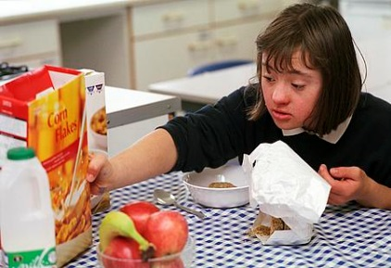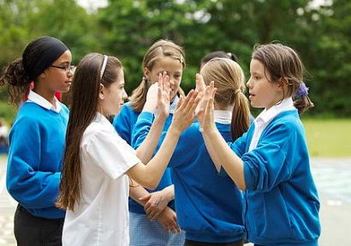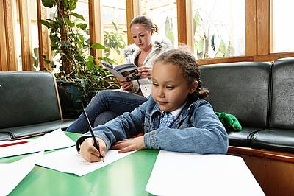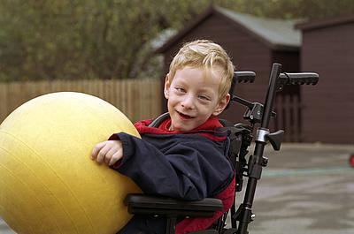
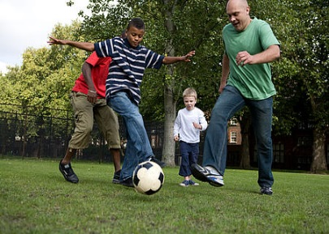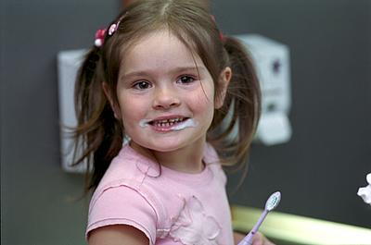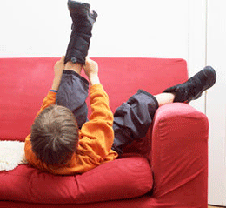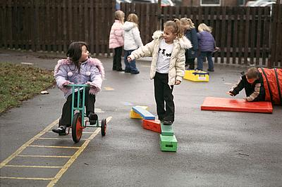

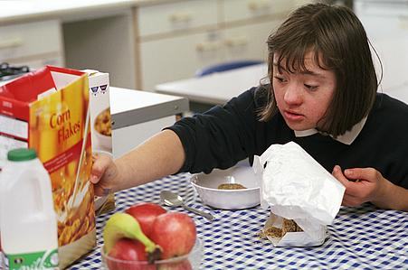
Community Paediatric Occupational Therapy Department


Introduction
Brushing teeth is an essential part of good oral hygiene and good habits should be established as early as possible. Toothbrushing should be part of a routine and take place at set times during the day, for example – bath, pyjamas, brush teeth, story, bed.
It is recommended that children’s brush their teeth twice a day and should be supported with this task until the age of at least 7, by which time they should have developed the coordination to reach all of their teeth.
The visual aid for toothbrushing below might be useful when children begin to carry out this process independently.
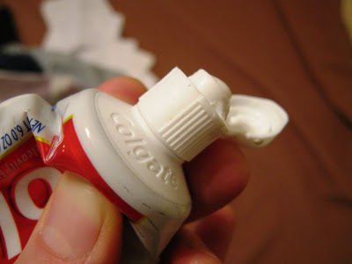
- Take the cap off the toothpaste
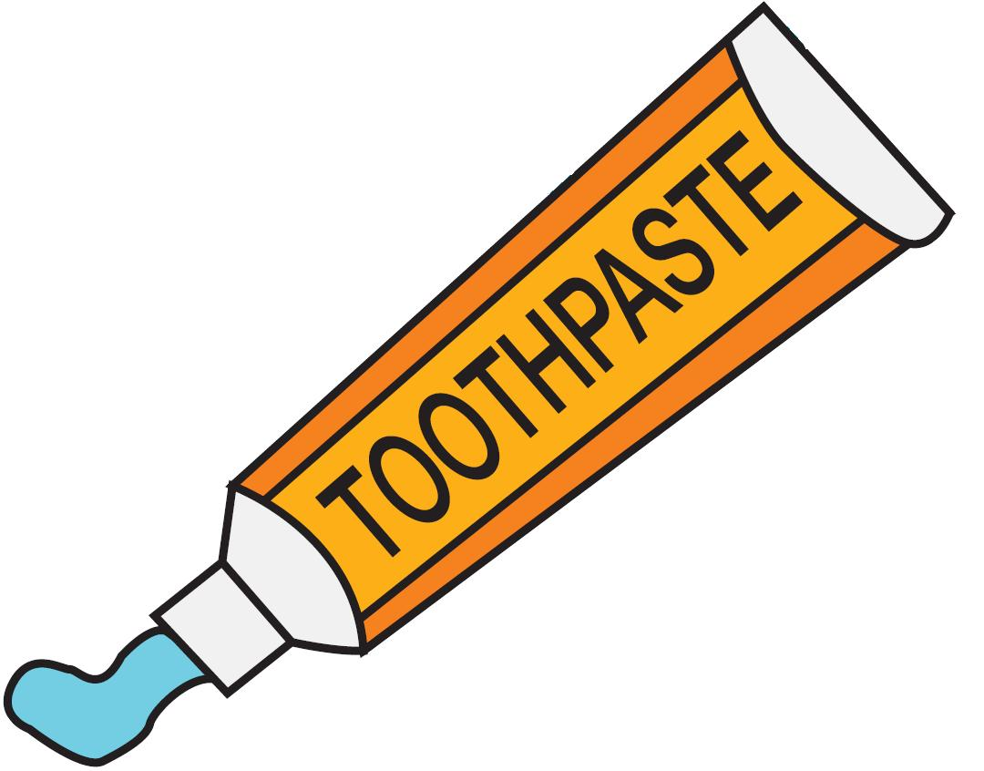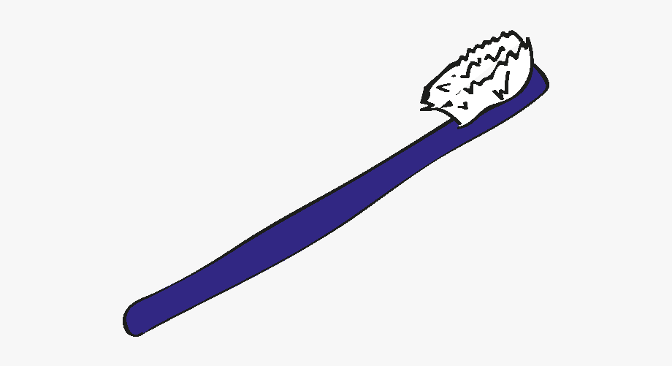
- Get toothbrush and toothpaste

Publication Date: 10/12/2020
Version: 2
Review Date: 2023
Author: Paediatric Occupational Therapy

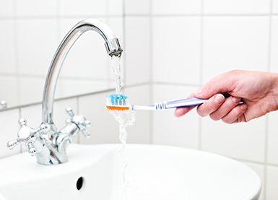
- Turn on tap and wet toothpaste.
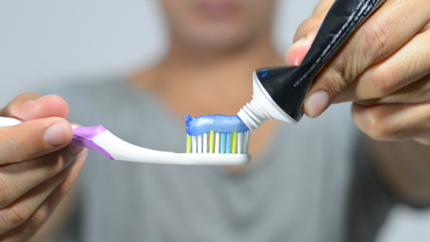
- Put the toothpaste on the toothbrush
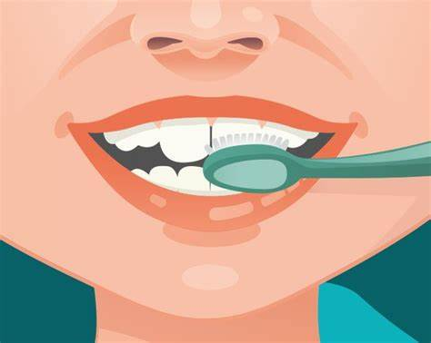
- Brush the front of your teeth.
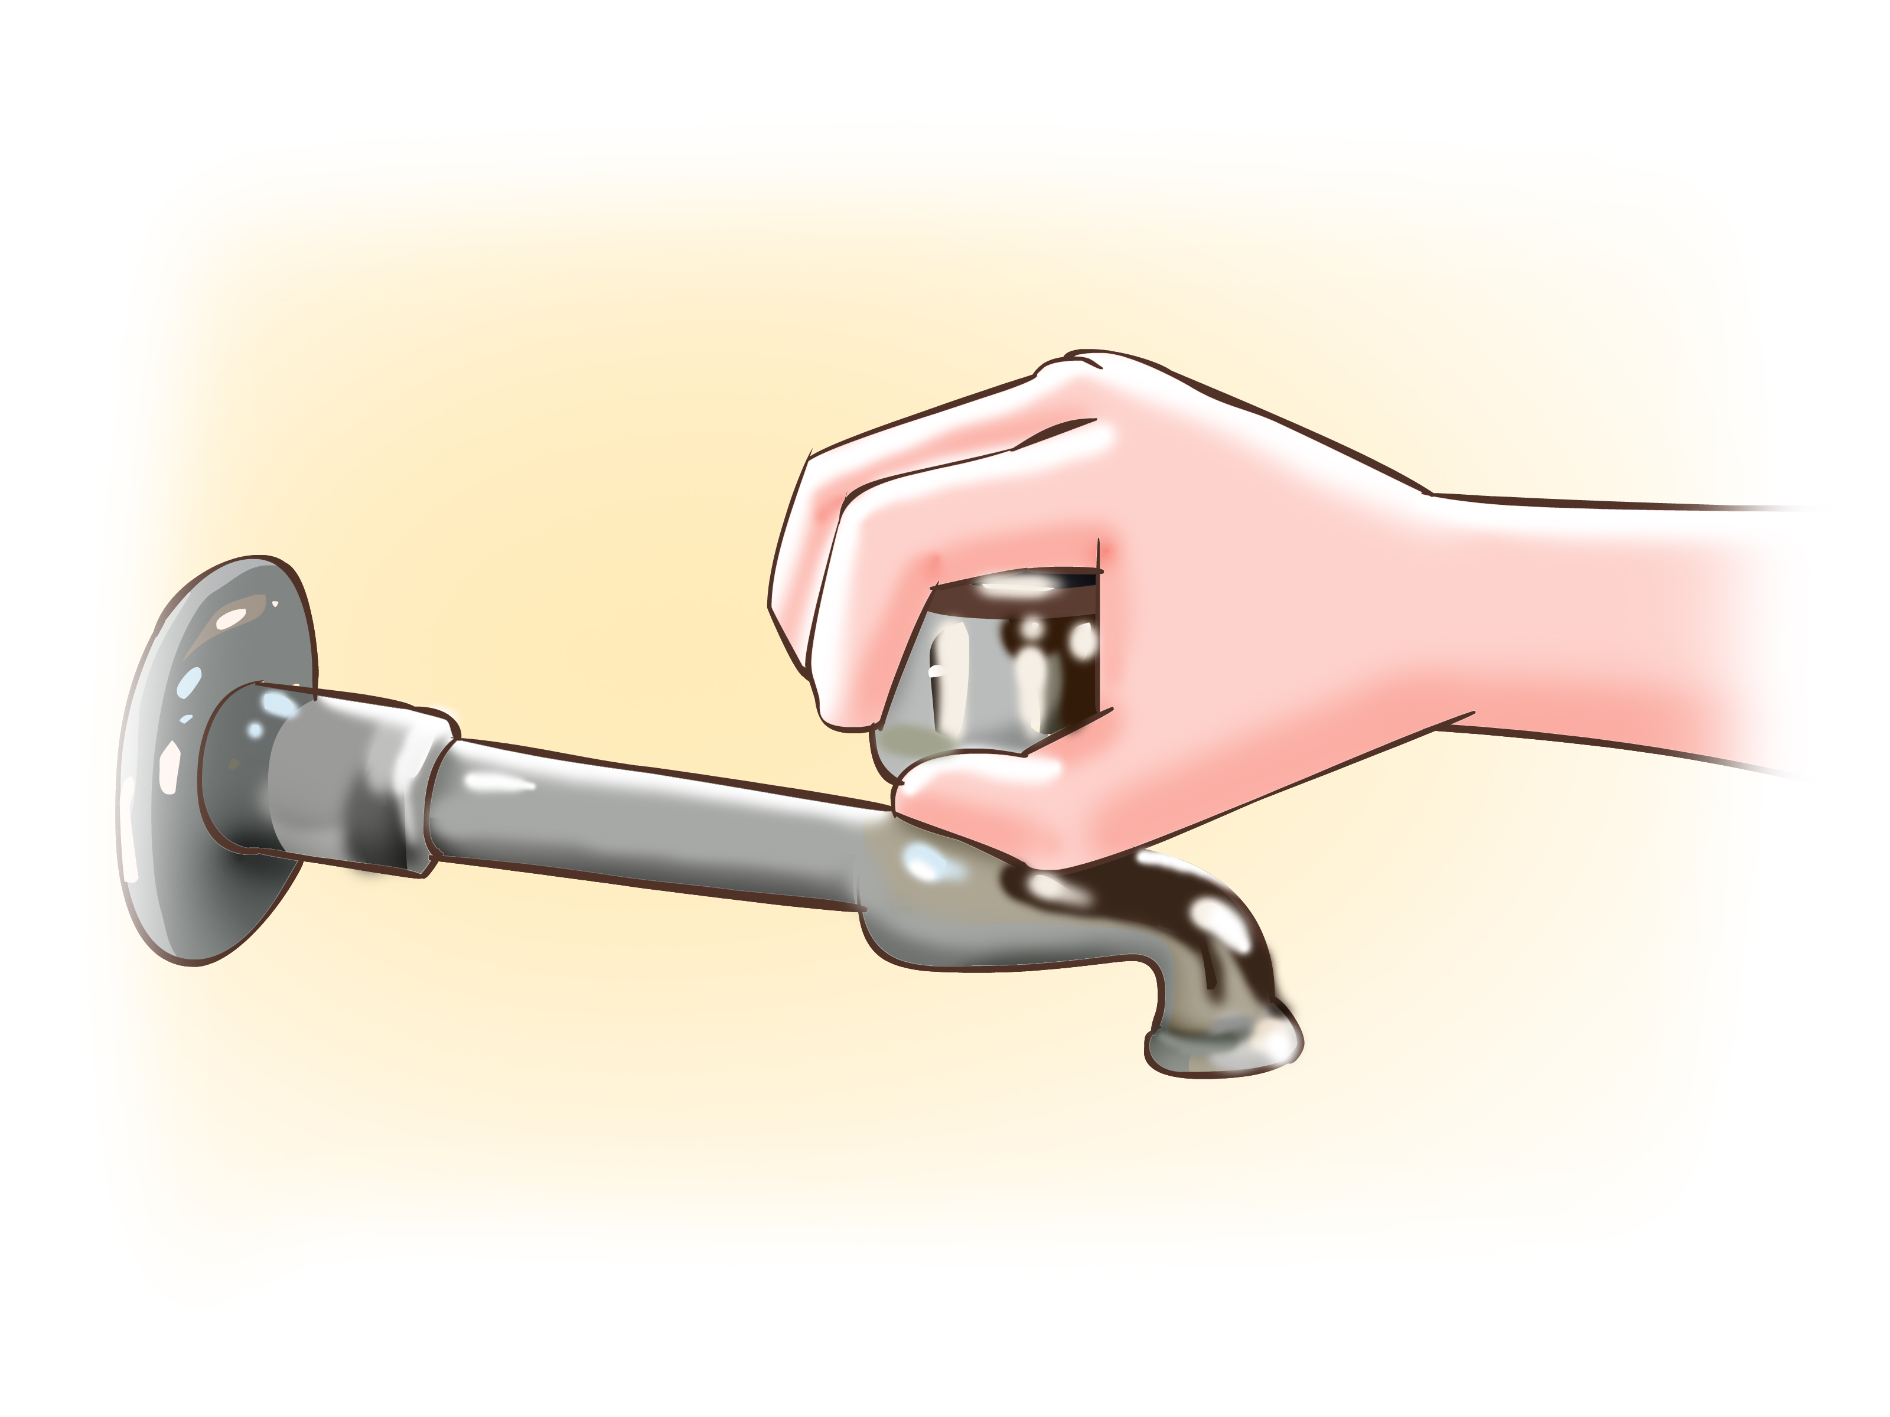
- Turn off the tap.

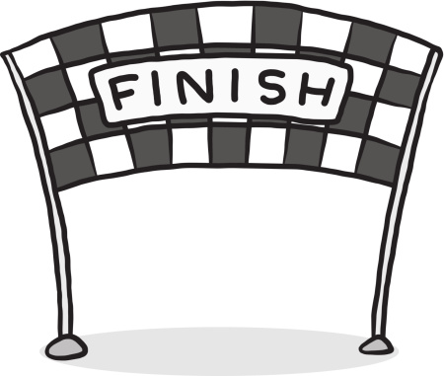
- Finished- WELL DONE!
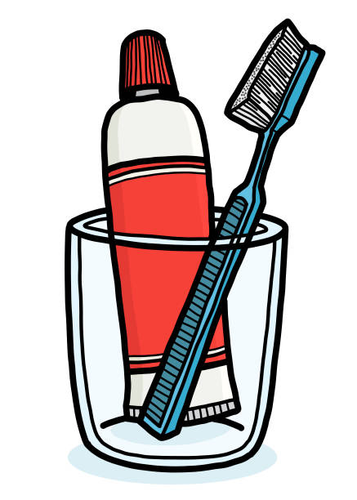
- Put toothbrush and toothpaste away
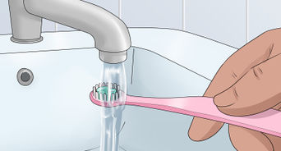
- Rinse the toothbrush under the tap
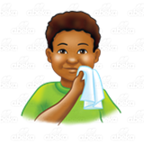
- Wipe mouth and face
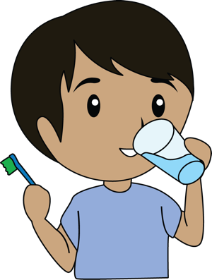
- Rinse mouth with water
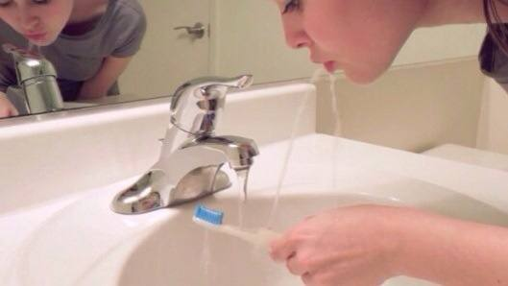
- Spit
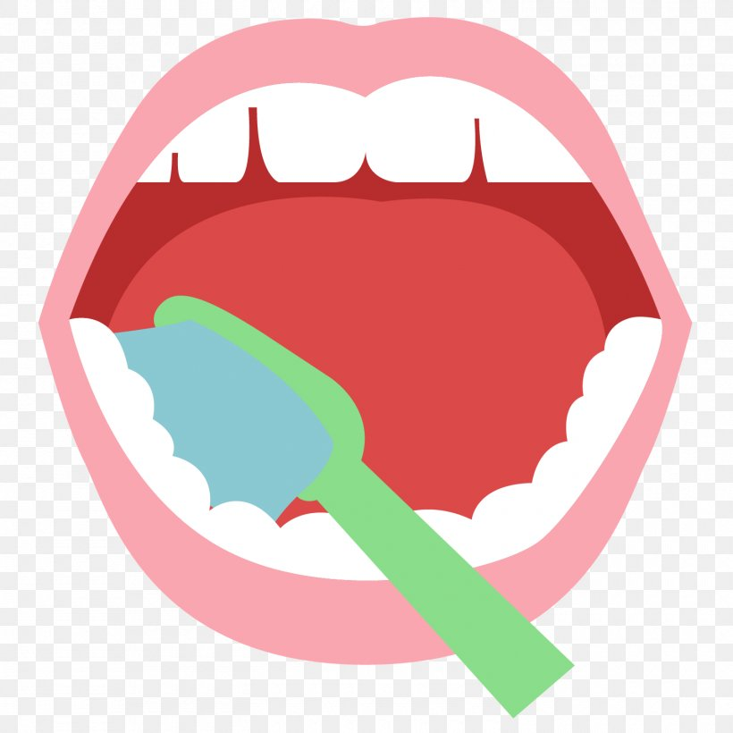
- Brush the bottom of your teeth, left and right.
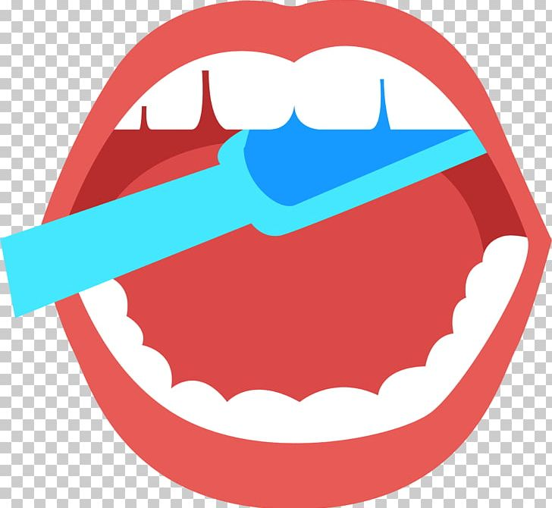
- Brush the top of your teeth, left and right.

Further Information

Some children may display oral hypersensitivity and may want to avoid brushing their teeth altogether.
Some strategies that can help are using a non-foaming, flavourless toothpaste like ORANURSE, or using distractions such as timers.
For more information on this, please see the programme called ‘Oral Desensitisation’.

