

Strategies to Help Manage

Reduced Proprioceptive
Awareness

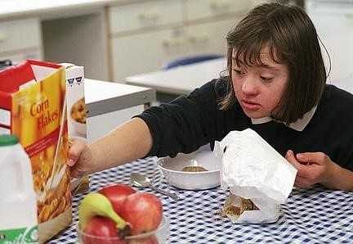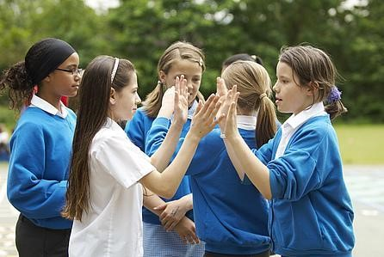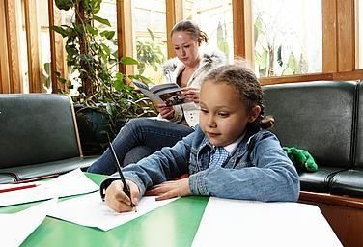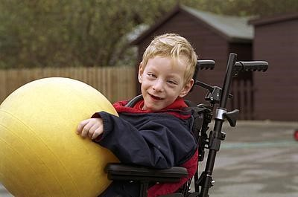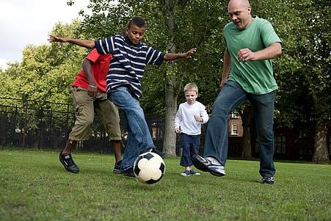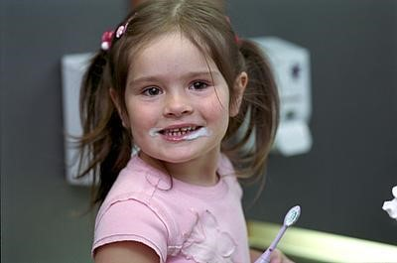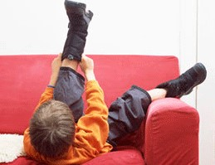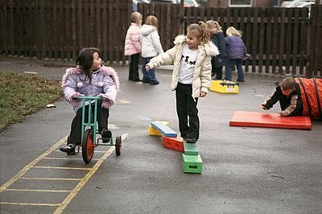

Community Paediatric Occupational Therapy Department
www.abm.wales.nhs.uk/childrensdevelopment

Introduction
This advice sheet provides practical advice for parents/guardians and schools to help children who have difficulties registering where their body is as a result of reduced proprioceptive awareness. Proprioception is the unconscious awareness of sensations from our joints, muscles and ligaments. It provides us with an internal awareness about where our body parts are moving in space. This is necessary so that we do not have to ‘look’ to ‘know’ exactly where our legs or arms are when we move.
Children with poor proprioceptive awareness often have:
- A poor posture when sitting and standing;
- Difficulty learning to swing;
- Difficulty grading movements leading to clumsiness;
- Difficulty applying the correct pressure and so appear rough or heavy handed;
- Frequent falls and regularly bump into things;
- Difficulty writing at speed and apply too much/little pressure through the pencil;
- A heavy reliance on vision to complete fine motor tasks.
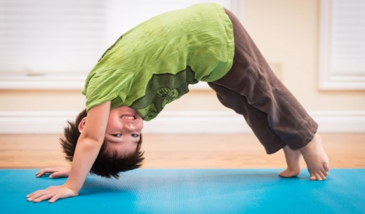

“Heavy Work” Activities
Heavy work activities are important as the pressure through the joints and muscles that they provide give the sensory feedback the child needs to improve their proprioceptive awareness. Doing some of the following types of activities regularly throughout the day, and particularly just before an activity that the child finds difficult, may help calm and focus them.

- Rough and tumble play;
- Monkey bars, trapeze, climbing frames, adventure playgrounds;
- Trampolining;
- Pushing and pulling games such as Row Your Boat in either sitting, kneeling or standing and Tug Of War;
- Catching and throwing heavy sandbags, beanbags and balls;
- Sit the child on a piece of strong fabric on a slippery floor such as tiles, lino or polished wood. With the child holding one end of a piece of rope and you the other, pull them around the floor.
- Everyday activities e.g. vacuuming, pushing the supermarket trolley, digging and raking in the garden, shaking out duvets, cleaning windows etc.
- Wheelbarrow walks;
- Vibrating pens and toys;
- Jumping off something high to land on something soft e.g. from the sofa onto a pile of cushions;
- Squashy Ball: encourage the child to hold a sponge ball between two flat hands in front of the chest (prayer position). Squash the ball hard to try and keep it flattened for 10 seconds and then repeat.

- Squash into The Floor: encourage the child to place the palms of their hands on the top of their head and press down for 10 seconds. Build up to 25 seconds over time.

- Hotdog: roll the child up in a duvet (the child is the ‘sausage’ and the duvet is the ‘bread’!). Put ‘toppings’ on the ‘sausage’ by applying firm pressure with your hands down their back, arms and legs. If your child really enjoys this try varying the type of pressure with the topping e.g. tomato sauce could be firm squeezing, onions could be firm patting. Always stop and ask the child if they want more. This way they get to control the input you are giving to suit their needs.

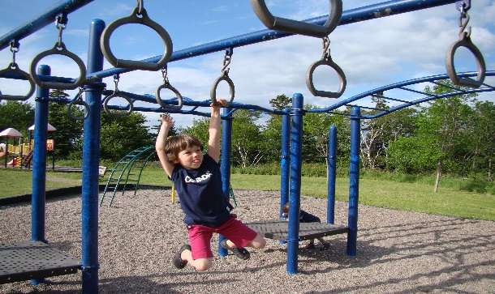
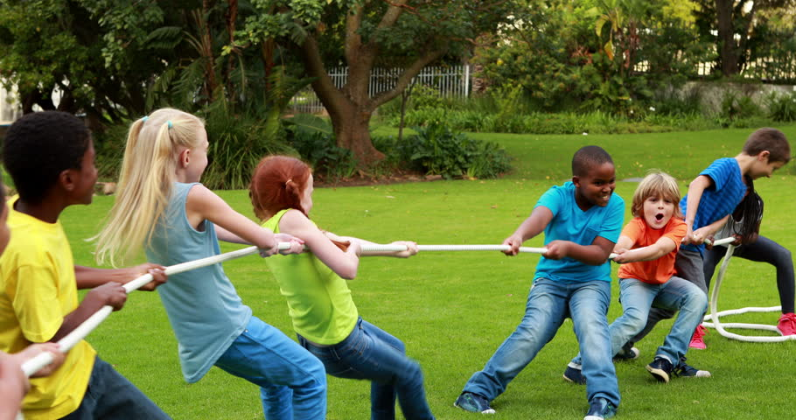
- Strong Man Press Ups: child lies on their tummy on the floor and pushes up through his outstretched arms. Try doing press-ups against the wall or down on a desk.

Considerations for Heavy Work Activities

- For children with poor proprioceptive awareness opportunity to engage in these heavy work activities should be given before focus tasks and not as a reward.

- Some of the more controlled activities can also be used at bedtime to help calm the child as part of a regular bedtime routine.

- If the child struggles with knowing which body part they are moving or needs a prompt to know what to move, give clues during activities by touching or gently tapping the body part.

Deep pressure techniques

Many children respond well to deep pressure as it calms the sensory systems. It also increases proprioceptive feedback. Deep pressure techniques include –
- Wrapping the child up in a blanket and rolling/asking them to roll,
- Giving the child a firm hug,
- Making a sandwich with the child’s body with a mat underneath them and a mat on top. You can try increasing the pressure by pressing gently on top,
- Giving the child a firm massage,
- Using weighted equipment such as a weighted blanket or jacket,

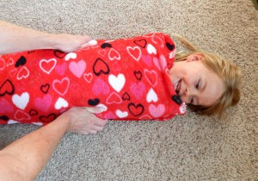

References
Erna, Botticelli and Hallway (1995) Combining Neuro-Development Treatment & Sensory Integration Principles.

Oetter et al (1993) ‘M.O.R.E’ Integrating The Mouth With Sensory and Postural Functions. 2nd edition.

Lane & Murray (2002) ‘Sensory Integration Theory and Practice’. Bundy. 2nd Edition. Case, Smith and Allen Sensory Profile. 3rd Edition. Page 436-439.

Publication Date: 10/12/2020
Version: 2
Review Date: 10/12/2023
Author: Paediatric Occupational Therapy

