


Sensory toys from household objects

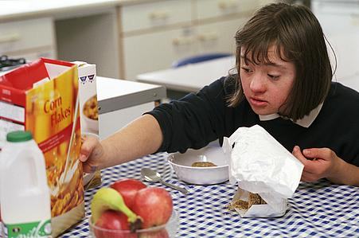
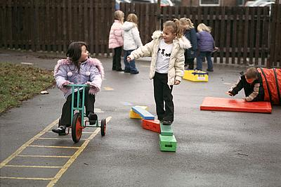
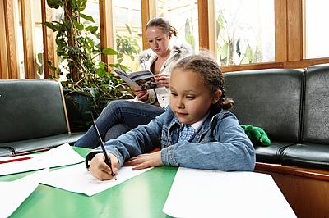
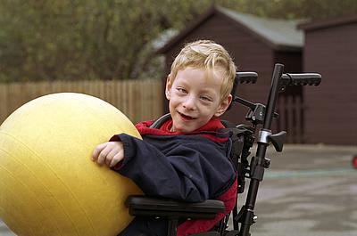
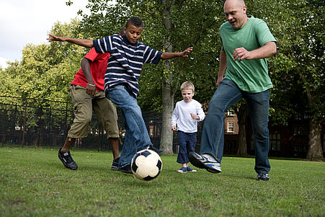
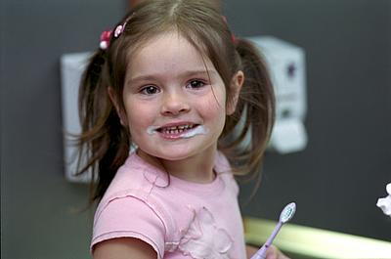
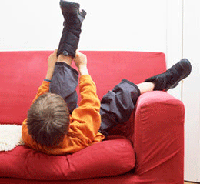
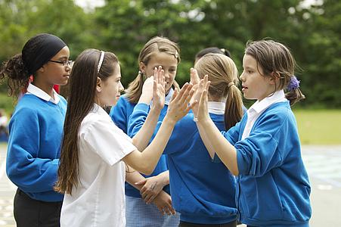


Introduction
Everyday household objects can be used as effective toys. Household objects can provide opportunities for children to explore and experiment with many different types of objects. Giving your child several types of objects to play with could lead to the child discovering an object they find particularly stimulating and interesting.
Experimenting with different objects will give your child a chance to learn about different objects, make comparisons and generalise their skills.

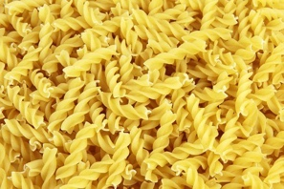
- Objects that have different and interesting textures, shapes, colours and qualities which your child can examine.

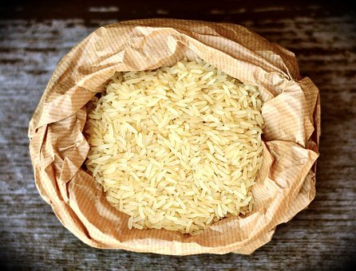
- Everyday objects such as bits of packaging, kitchen utensils, different materials, and different fabrics.

- Use objects that your child can handle easily and then gradually reduce the size.
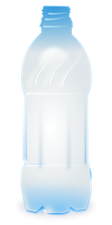
- Make up rattles by filling containers with rice, pasta and pulses.

- Rattles made by filling plastic bottles with coloured pegs, marbles, coins or water
- Fill a box or tray with objects with different qualities such as fabrics (velvet, leather, fun fur, Hessian), wax, metal, sandpaper, bubble wrap, wood and paper. This will provide your child with the opportunity to explore different textures.

- Sensory bottle filled with glitter mixed with water coloured with food dye. Your child can tip the bottle and watch the movement of the glitter.

- Make a lucky dip bin with objects such as candles, inserts from chocolate boxes and biscuit tins, saucepan lids, wooden spoons, tissue paper, sponges, metal spoons, cardboard, cellophane, or fabrics (silk, sequins, leather, fur, carpet, sandpaper or furnishing fabrics)

- Using a tissue box and elastic bands to make a ‘guitar’. Wrap elastic bands around the tissue box and ‘strum’ the bands in the tissue opening.

Many suggestions were taken from ‘Small Steps Forward’ by Sarah Newman, Jessica Kingley Publishers (1999) ISBN 1-85302-643-3

Other suggestions are widely available on the internet and Pinterest.

There are also many outlets where toys/items can be purchased at reasonable prices including ‘cheap disability aids’, pound shops and other high-street shops, Argos.

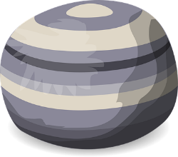
- bubble tubes
- musical toys
- light-up toys
- play mats
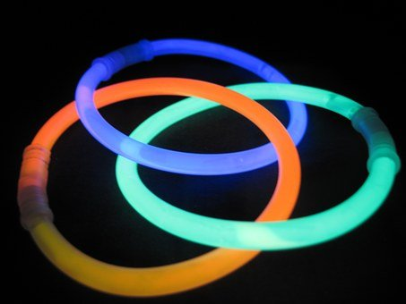
- water features
- fiber optics
- projectors
- kaleidoscopes
- glow in the dark stickers
- bean bags
- water mattresses
- foam wedges
- vibrating toys/ massagers
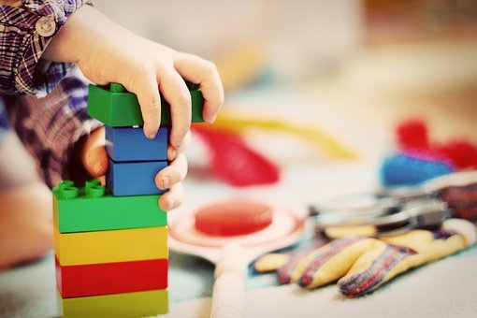
- inset puzzles
- building blocks
- large Lego bricks
- puppets
- threading
- sand & water play
- aromatherapy
- musical instruments
- therapy balls
- mini trampoline
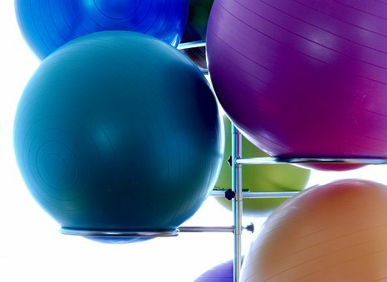
- play tunnels
- therapy balls
- pressure brush
- mobiles
- musical instruments
- craft material
- CDs
- switches and switch toys
- tactile toys (toys that are stimulating to touch)
- swings

Other ideas can also be found on other sites such as Pinterest including Swansea Bay UHB OT for kids.

Editorial Board: Awaiting approval
Publication Date: 13/02/2020
Version:
Review Date:
Author: Paediatric Occupational Therapy

Reference;

Pixabay (2020). Gym ball. Available at; https://pixabay.com/photos/medicine-ball-ball-gymnastics-1575315/ [Accessed: 15 December 2020].

Pixabay (2020). Building blocks. Available at; https://pixabay.com/photos/child-tower-building-blocks-blocks-1864718/ [Accessed: 15 December 2020].

Pixabay (2020). Glow stick . Available at; https://pixabay.com/photos/glow-stick-shining-color-deco-578604/ [Accessed: 15 December 2020].

Pixabay (2020). Bean bag chair. Available at; https://pixabay.com/vectors/bean-bag-seat-seating-bean-bag-576175/ [Accessed: 15 December 2020].

Pixabay (2020). Plastic bottle. Available at; https://pixabay.com/vectors/bottle-pet-drink-plastic-159119/ [Accessed: 15 December 2020].

Pixabay (2020).dry rice . Available at; https://pixabay.com/photos/rice-rice-grains-food-eat-3506194/ [Accessed: 15 December 2020].

Pixabay (2020). Dry pasta . Available at; https://pixabay.com/photos/pasta-rotini-raw-uncooked-2093/ [Accessed: 15 December 2020].

