

Sensory Play for pre-school children

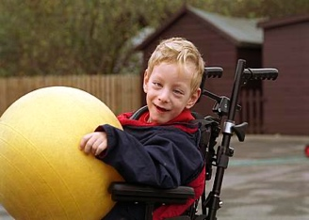
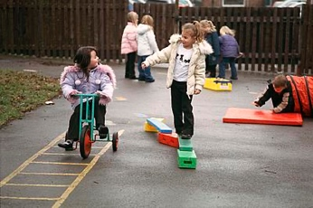

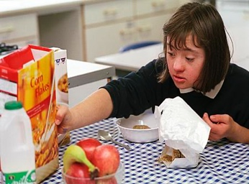
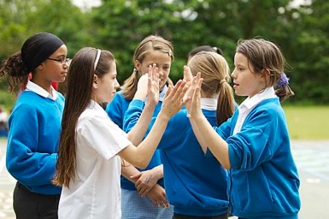
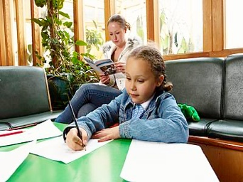
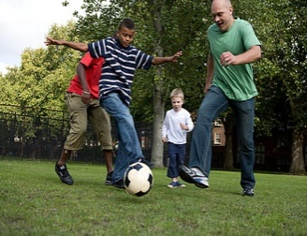
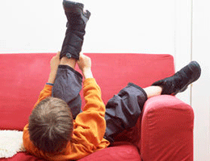
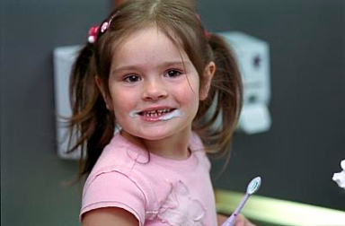

INSTRUCTIONS
Do not force the child to do these activities, as they will be of no benefit if she does not enjoy them. Short sessions incorporated into her daily routine are ideal. Change the sequence and / or vary the activities but be guided by the child. Therapy must be fun!
The activities have been grouped according to the sensory systems. Choose one or two activities from each section for the daily session. If daily sessions are not possible then two or three sessions during the week will be just as beneficial.

- Tactile (touch perception)
- Vestibular (movement sense)
- Proprioception (awareness of body position in space)

Some further activities have also been included to further develop motor planning skills.

Preparation
- Rhythmic movement such as swinging or rocking in one direction i.e. back and forth or side to side.
- Deep pressure to muscles and joints e.g. massage or firm squeezing. This can be done by rubbing hands together or briskly being rubbed down by a towel.
- Heavy work push/pull activities.

TACTILE
Touch is a major source of information to the brain about our environment. It is a feedback system for our body about our movement and position in space. Thus, contributes to our surroundings. The child’s response to tactile stimulation will enable you to know the appropriate type, duration and frequency of stimulation.

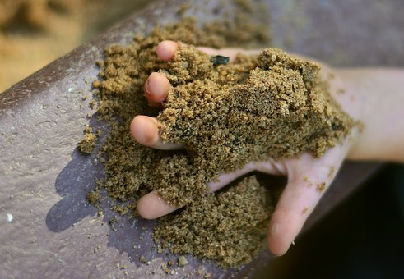
Activity Ideas:

- Sand activities with hands and feet

- Water play: different temperatures, contrasting hot and cold, with / without bubbles / spraying / splashing / squirting.

- Tumbling, rolling games, crawling under blanket, through tunnels, along carpet.
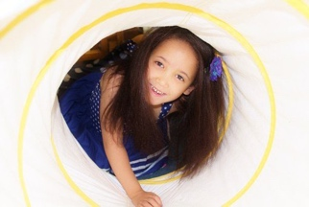
- ‘Hide and seek’ small toys or blocks hidden in rice / sand / macaroni / under blankets / around the home etc

- Play dough activities (this can be home-made): pinching kneading, rolling out, cutting, twisting.

- Finger paint
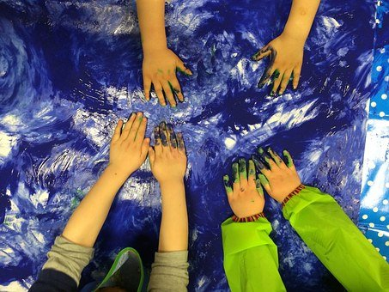
- Messy play with e.g. squirty cream, shaving foam on body etc

- Hand or finger puppets

Tactile input can also have a calming effect. Here are a few ideas:

- Wrapping up in a towel / blanket – this is a good for calming

- Roll up in a blanket and unroll

- Brisk rub with towel after bath, rub down with powder / body lotion
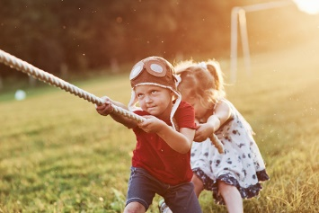
- Row the boat, tug of war

- Bear hugs

VESTIBULAR
Vestibular perception refers to information that is provided by the receptors in our inner ear. This system responds to motion or change or our head position. It integrates our neck, eyes and body adjustments to movement and influences our balance, muscle tone and bilateral integration (the coordinated use of both sides of the body i.e. hands). It has an important effect on regulating our posture and movement in relationship to what we are doing and seeing.

Activity Ideas:
- Swinging on swings, see-saws, in a blanket held by two people
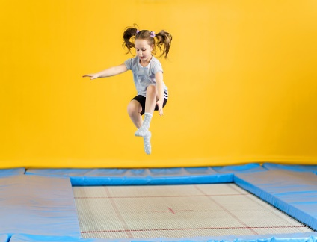
- Spinning e.g. on a swing. As spinning is such a strong vestibular input, it is best done where the child controls the amount of movement and which that you monitor.

- Jumping e.g. on a trampoline, onto soft mats

- Rolling in a blanket
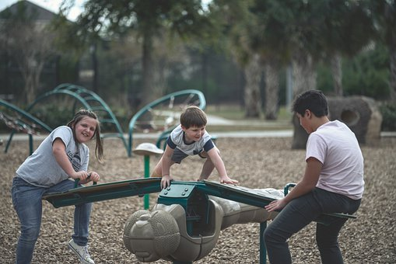
- General rough and tumble play e.g. tip upside down etc

- Adventure playgrounds, bike / trike riding etc

- Soft play areas and ball pools are excellent sources, as are playgrounds

PROPRIOCEPTION
Proprioception is the unconscious awareness of sensations from our joints, muscles and ligaments. It provides information about where our body parts are moving in space. This is necessary so that we do not have to ‘look’ to ‘know’ exactly where our legs or arms are when we move.

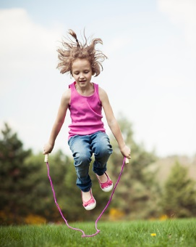
Activity Ideas:
- Jumping on e.g. trampoline, soft mats, over skipping rope

- Lying on back on the floor and kicking a large ball with feet, pushing with hands and other body parts

- Tug of war / pushing and pulling games

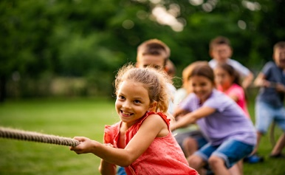
- Hammering activities

- Animal walks e.g. bunny hops (jumping), leap frog, crab walks, elephant walks, lion walks etc

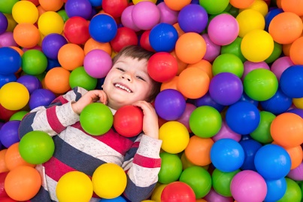
- Soft play areas and ball pools are excellent sources, as are playgrounds

Editorial Board: Awaiting approval
Publication Date: 13/02/2020
Version:
Review Date:
Author: Paediatric Occupational Therapy

References;

Pixabay (2020). Little Boy Playing In The Pool With Plastic Balls In The Nursery. Available at: https://www.istockphoto.com/photo/little-boy-playing-in-the-pool-with-plastic-balls-in-the-nursery-indoors-activities-gm1140002535-304909769?utm_source=pixabay&utm_medium=affiliate&utm_campaign=SRP_image_sponsored&referrer_url=https%3A//pixabay.com/images/search/soft%2520play/%3Forder%3Dlatest&utm_term=soft%20play [Accessed: 15 December 2020].

Pixabay (2020). Its all about team work. Available at https://www.istockphoto.com/photo/its-all-about-teamwork-this-is-tug-of-war-with-dad-on-beautiful-grass-of-sunny-warm-gm1140067496-304940561?utm_source=pixabay&utm_medium=affiliate&utm_campaign=SRP_image_noresults&referrer_url=https%3A//pixabay.com/images/search/tug%2520of%2520war%2520child/%3Forder%3Dlatest&utm_term=tug%20of%20war%20child. [Accessed: 15 December 2020].

Pixabay (2020). Happy kids pulling rope in park. Available at; https://www.istockphoto.com/photo/group-of-kids-pulling-a-rope-gm1006652468-271675709?utm_source=pixabay&utm_medium=affiliate&utm_campaign=SRP_image_noresults&referrer_url=https%3A//pixabay.com/images/search/tug%2520of%2520war%2520child/%3Forder%3Dlatest&utm_term=tug%20of%20war%20child [Accessed: 15 December 2020].

Pixabay (2020). Girl jumping rope. Available at; https://pixabay.com/photos/jump-rope-girl-jump-jumping-5746626/ [Accessed: 15 December 2020].

Pixabay (2020). Seesaw children. Available at; https://pixabay.com/photos/playground-kids-child-kid-play-5057327/ [Accessed: 15 December 2020].

Pixabay (2020). Girl on trampoline outdoor. Available at; https://pixabay.com/photos/girl-jump-trampoline-outdoor-679263/ [Accessed: 15 December 2020].

Pixabay (2020). Blue children colour. Available at; https://pixabay.com/photos/children-blue-child-color-720290/ [Accessed: 15 December 2020].

Pixabay (2020). Child girl crawing tunnel. Available at; https://pixabay.com/photos/child-girl-crawling-tunnel-therapy-587701/ [Accessed: 15 December 2020].

Pixabay (2020). Sand child hand play. Available at; https://pixabay.com/photos/sand-child-s-hand-playground-2630031/ [Accessed: 15 December 2020].

