


Sensory Modulation


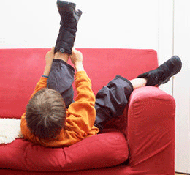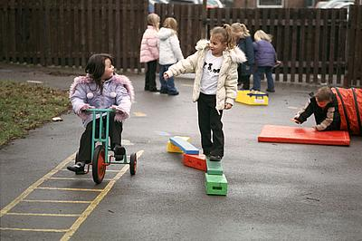


Community Paediatric Occupational Therapy Department

Introduction
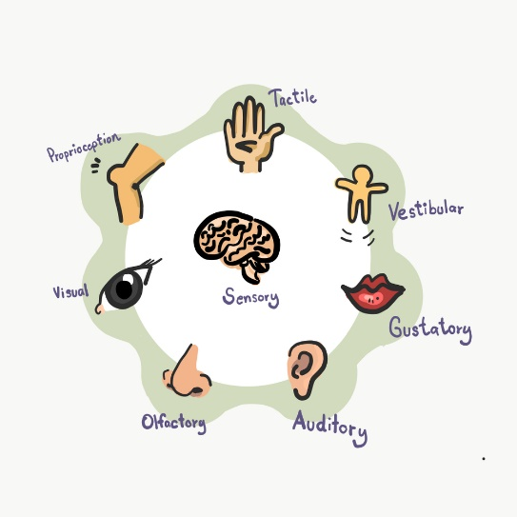
This article provides a brief description of Sensory Modulation for Parents/ Carers/ Teachers of the child identified with Sensory processing difficulties.

What is Sensory Modulation?
Sensory modulation is the ability to respond appropriately to sensory information, and remain in a ‘calm and alert’ state in order to carry out daily activities such as school work. Many different sensory experiences help us to respond appropriately in a given situation. For example, a cup of coffee might make you feel more alert during a long meeting, or a warm bath might help you relax at the end of a hard day. We often develop preferences because certain types of sensory input work better for some people than for others. For example, listening to music helps some people concentrate but is distracting to others.
We are constantly receiving sensory input from many sources including movement and gravity, sounds, vision, touch and smell. Our brains must be able to organise and process this sensory input, and to use that input to respond appropriately to a particular situation. This is what we call sensory integration.

Sensory Integration Difficulties
It is a great challenge to integrate all this information and use it to help us make sense of our world and behave in the right way in a certain situation. For example, sitting still and paying attention in the classroom for an hour is a common expectation in the life of an 8 year old. However, for the child to achieve this, they must be able to take in all the sensory information around them. These can include:
- noises outside the window,
- colourful wall displays,
- teacher’s voice,
- smells from the canteen,
- awareness of their body movement
- the feel of the desk beneath their hands.

They must then be able to sort out what information is important and ignore what is not. Finally, they must use the important information to help them stay still and upright in their chair, listen to the teacher and maintain their attention.

Many children don’t know how to cope with the different sensory input they receive. They have difficulty registering and organising sensory information. This makes it difficult for them to perform the many complex tasks necessary for learning and functioning in the world.


How can you help a child with Sensory Integration Difficulties?

For children with these sensory integration difficulties, it is essential that the people around them have a good understanding of why they behave in a certain way. It is also important that the child’s environment is set up in a way that helps them integrate sensory information and use that input to support their learning and development.

References

- Trott MC (1993) Understanding Sensory Integration, Therapy Skill Builders USA

- Nackley V.L (2001) Sensory Integration, American Occupational Therapy Association. Volume 24

Publication Date: 10/12/2020
Version: 2
Review Date: 2023
Author: Paediatric Occupational Therapy

