


Early sensory and fine motor skills for children with Downs Syndrome

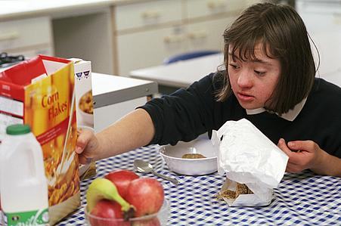
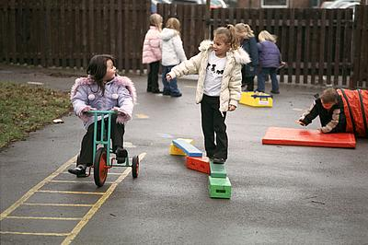
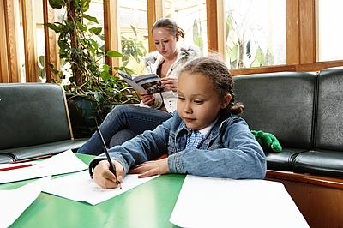
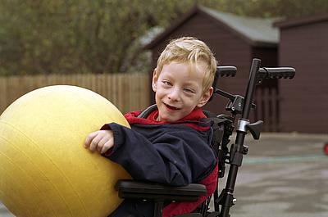
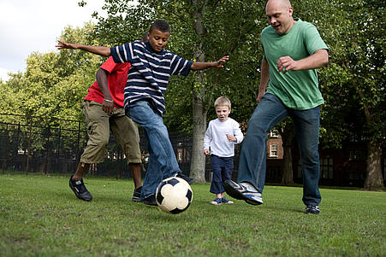
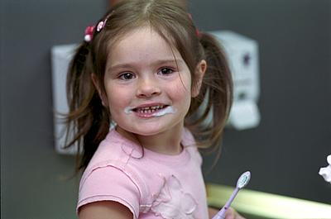
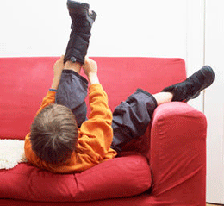
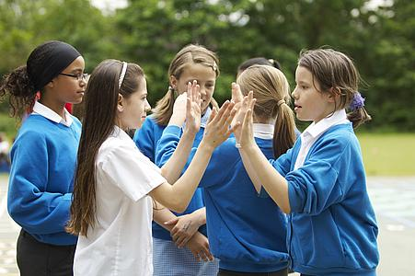

Sensory skills for Function

Sensory Integration is the ability to take in, sort out and make use of information from the world around us. It allows us to make an appropriate adaptive response to meet the demands of the task and environment.
It is important to incorporate sensory elements into everyday activities such as play. Children generally learn using a multi-sensory approach, which allows another sensory system to re-enforce learning. As well as auditory, visual, smell and taste, there are also another three, two of which are lesser known.
It is said that children with Down Syndrome need more time and repetition to learn a new skill. Therefore shorter, more frequent bursts may be more beneficial than longer and less frequent.

Proprioception

The awareness of body position. Messages are received from receptors in the muscles and tendons and help carry out organised movements with appropriate force.

Activity Ideas
- Row the boat
- Shakers
- Hand over hand – clapping game / song, banging on a drum
- General rough and tumble
- The grand old duke of York

Vestibular

Provides feedback regarding balance and movement via receptors in our inner ears. It tells us where our body is in relation to gravity and how fast it is moving.
It is said that stimulation of the vestibular system has an effect on stimulating tone, as well as bilateral integration (the use of two hands together).

Activity Ideas
- Aeroplanes
- Swinging
- Rolling
- General rough and tumble
- Row the boat

Tactile

This is the system where information is received through receptors in the skin.

Activity Ideas

- Hand-over-hand to provide extra tactile input. E.g clapping game
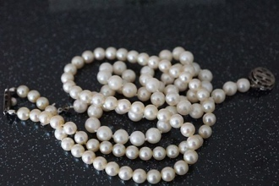
- Messy play e.g. with food (yoghurt, rice crispies, adding water, jelly, etc)

- Different textured balls

- Toys of different textures e.g. soft rubber toys, hard beads, crinkly paper, tinsel and blocks, toys covered in fabric etc

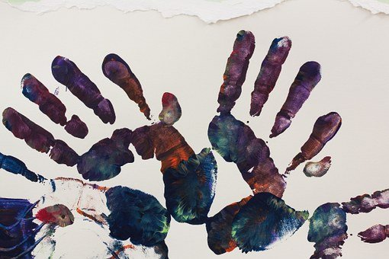
- Row the boat

- Sitting on, crawling and exploring different textures on the floor

- Bubbles

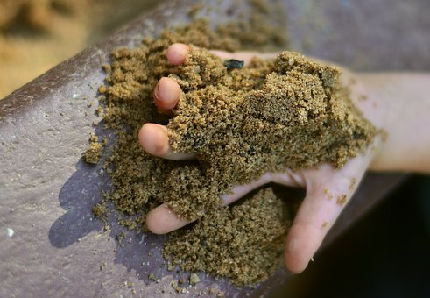
- Hand and footprints

- Rattles

- Sand activities with hands and feet

- Water play: different temperatures, contrasting hot and cold, with / without bubbles / spraying / splashing / squirting.

Fine Motor Skills development

Firstly, the child needs to develop:

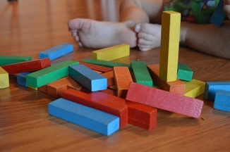
- postural stability e.g. propping on arms, rocking hands and knees with hands open, reaching in sitting shaking toys

- bilateral co-ordination (use of two hands together) e.g. hands together, clapping, passing from one hand to another, pulling toys apart

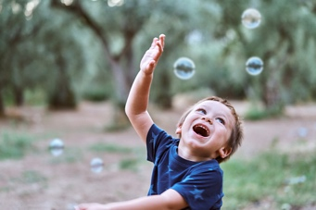
- sensory development e.g. looking at hands, exploring by touch, mouthing.

- before moving onto dexterity (increased control of grasp and release, isolation of fingers, more refined grasps) and tool use (use of spoon), independence skills.

- Sometimes some techniques can be used to compensate for this lack of stability if focusing on fine motor skills e.g. giving increased postural support for periods of play, seating etc.

Grasp – initially involuntary – this tends to take longer to become integrated in babies with Down syndrome. Raking and palmer grasp is prolonged.

Release – initially let’s go of things accidentally without control, then will bring in the other hand which will lead to the development of transferring items (which is the beginning of bilateral co-ordination). They will then let go often against a surface of some sort or throwing randomly, which will allow the wrist to drop and ease release. This is often as a result of reduced control. This can often be a prolonged stage. This will then progress into more precise control such as releasing an object into a container etc.

Activities to encourage fine motor skill development

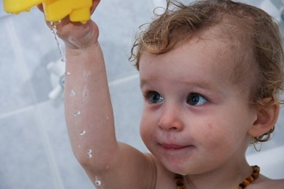
- Toys which are the right size for your child to pick up and hold with one or both hands and take to mouth e.g. rattles, rings etc.

- Activity box with a range of toys, many of which will be sensory in nature, to explore.

- Pee-po games, encouraging them to reach and remove e.g. towel.
- Dropping objects into e.g. a bath to make a splash, noise activated toy onto a tray / floor

- Removing objects from containers / sensory bag etc

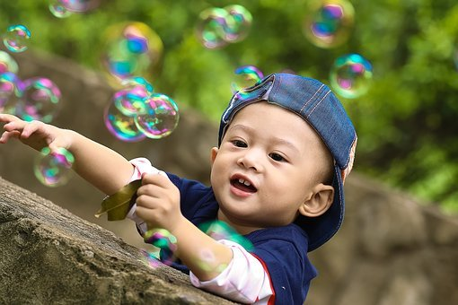
- Action songs e.g. round and round the garden, ten little fingers, twinkle twinkle, two little blackbirds

- Shakers / rainmakers / bells

- bubbles

Preparation


Preparation prior to fine motor tasks is very important, this includes gross motor and sensory. This will help to prepare the body for engagement in fine motor exploration and play. This includes many of the activities already shown to you by the Physiotherapist i.e. tummy time, gym ball activities etc.

Others include:

- Propping on their hands / arms whilst on their tummy – as this helps to build stability around their shoulder girdle and increase their tone and trunk activity and engages their vestibular and proprioceptive systems as well as their tactile system – which can be stimulated further by lying on different types of materials etc.


- Massage – is also an important tool which is used to provide increased feedback as to where their body is in space and can help to desensitise if the child is sensitive to new tactile experiences. This helps to organise movements. This can be such as Baby Massage (which there are many courses available for this) or massage specifically of the arms and hands.

- Rhymes and songs.

Editorial Board: Awaiting approval
Publication Date:
Version:
Review Date:

Reference;

Pixabay (2020). Music note. Available at; https://pixabay.com/vectors/silhouette-musical-note-clef-bass-3275055/ [Accessed: 15 December 2020].

Pixabay (2020). Baby smile newborn . Available at; https://pixabay.com/photos/babe-smile-newborn-small-child-boy-2972221/ [Accessed: 15 December 2020].

Pixabay (2020). Bubbles child . Available at; https://pixabay.com/photos/play-park-kid-ku-shin-child-1679587/ [Accessed: 15 December 2020].

Pixabay (2020). little boy bath water. Available at; https://pixabay.com/photos/baby-boy-little-boy-bath-water-179750/ [Accessed: 15 December 2020].

Pixabay (2020). Child catching bubbles. Available at; https://www.istockphoto.com/photo/cute-child-playing-with-bubbles-gm1164396344-320054979?utm_source=pixabay&utm_medium=affiliate&utm_campaign=SRP_photo_sponsored&referrer_url=https%3A//pixabay.com/photos/search/child%2520catching%2520bubbles/&utm_term=child%20catching%20bubbles [Accessed: 15 December 2020].

Pixabay (2020). Sand child hand play. Available at; https://pixabay.com/photos/sand-child-s-hand-playground-2630031/ [Accessed: 15 December 2020].

Pixabay (2020). Building blocks. Available at; https://pixabay.com/photos/blocks-child-toy-education-game-503109/ [Accessed: 15 December 2020].

Pixabay (2020). Hand painting . Available at; https://pixabay.com/photos/art-therapy-hand-hands-handprint-227585/ [Accessed: 15 December 2020].

Pixabay (2020). Small beads. Available at; https://pixabay.com/photos/beads-jewellery-luxury-chain-697197/ [Accessed: 15 December 2020].

