


Recipe Suggestions

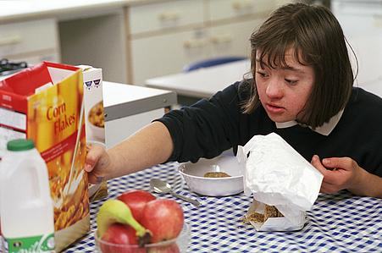
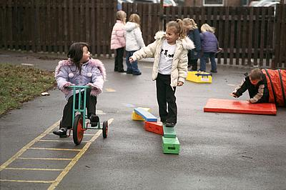
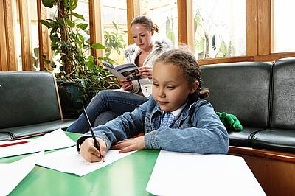
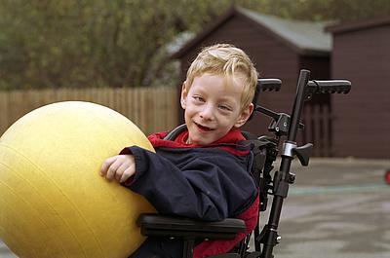
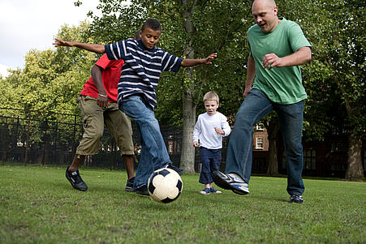
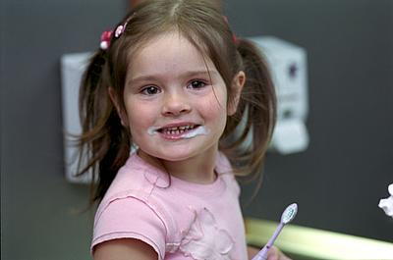
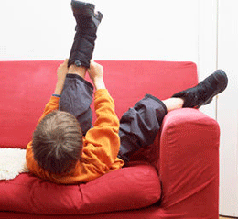
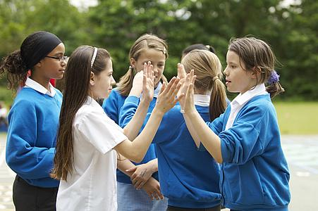


Introduction
This advice sheet is to provide you with ideas of basic recipes that you may find useful when using exploratory play. This helps to develop tactile tolerance and hand function.

It is important that you supervise your child at this time.

Corn Starch Finger Paint
Put 2 cups of corn flour in a pan and add water, while stirring until it is of glue consistency. Cook this mixture, stirring constantly, to a clear gel consistency. Cool. (Optional: add food colouring or flavouring).

Flour/Salt Finger Paint
Combine 1 cup of flour, 4 teaspoons of salt and enough water to make the desired consistency. Add food colouring or paint. Mix well. Store in fridge.
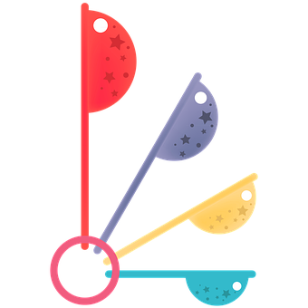

Cooked Play-Dough
- 2 cups plain flour

- 2 cups water
- 2 teaspoons cream of tartar
- 1 cup of salt
- 2 tablespoon of cooking oil
- 1 dessertspoon of powder paint or a few drops of food colouring

Cook mixture in a pan over a medium heat stirring all the time. Remove from heat when mixture comes away from sides of pan. Knead on a floured board. Store in an airtight container. Keeps well especially in fridge. If it gets sticky add flour; if it gets dry add a little water.

Basic Play Dough
- 6oz salt

- 1lb plain flour
- ¼ pt of water
- Mix ingredients together

Strong Dough
Use a strong flour and water to make pliable dough. This is very springy and stretchy, unlike the plain dough which can be easily broken into pieces. The dough is good for stretching between two people. When poked it springs back, unlike normal playdough which holds the mark of the finger.

Gloop
Mix one-part corn flour with one-part water. Add colouring as desired. The mixture becomes firm when pressed and runny when left.

Slime
- 1 cup of soap flakes
- 2 litres of warm water
- Food colouring optional
Dissolve flakes in water and allow mixture to stand until it becomes thick, add more water if necessary. Make sure it does not come into contact with children’s eyes.

Sugar Clay
- 70g butter or margarine
- 75ml golden syrup
- ½ teaspoon salt
- 1 teaspoon of vanilla essence
- 450g icing sugar
- Mix the butter or margarine, golden syrup, salt and vanilla essence in a bowl with hands
- Mix in icing sugar. Knead the dough until smooth
- Add more icing sugar if necessary, to make the clay non-sticky and pliable
- Divide the clay into small portions and mix in food colouring
- Work with bits of coloured clay on a paper towel
Variation: -
Prepare a butter cream icing and decorate a cake, fairy cakes or digestive biscuits and then place the sugar clay designs on their icing background.

Edible Sculpting Dough
- 1 teaspoon of dry yeast
- 345ml very warm water
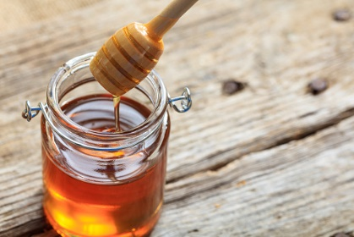
- 1 egg
- 60ml honey
- 50g fat
- 1000g flour
- 1 teaspoon salt
- Mix the yeast and very warm water in a bowl
- Add the egg, honey, fat and salt
- Slowly add the flour until a ball of dough forms. Add a little more flour if the dough is too sticky
- Knead dough by hand on a floured board
- Begin sculpting, making only flat figures as the dough will rise
- Cover the sculptures with a towel and put in a very warm place for about half an hour to rise. For very puffy sculptures, let the dough rise for longer
- Bake for 20mins at 180 ºC or until golden brown
- Eat or save sculptures

Variation: - Insert a paper clip in the dough before baking and the sculpture will have a hook for displaying. Loop some wool or ribbon through the paperclip to hang up the sculpture.

Further recipes can be found on Pinterest and other similar pages e.g. Swansea Bay UHB for kids

HAVE FUN

Editorial Board: Awaiting approval
Publication Date: 13/02/2020
Version:
Review Date:
Author: Paediatric Occupational Therapy

Reference;

Pixabay (2020). Measuring spoons. Available at; https://pixabay.com/illustrations/measure-spoon-measure-baking-5062022/ [Accessed: 15 December 2020].

Pixabay (2020). Runny honey . Available at; https://pixabay.com/photos/honey-yellow-beekeeper-nature-1958464/ [Accessed: 15 December 2020].

