


Preparation for Dressing
and
Foundation Skills for Dressing

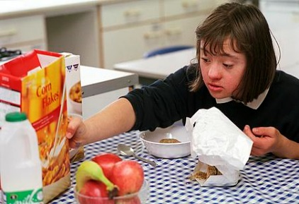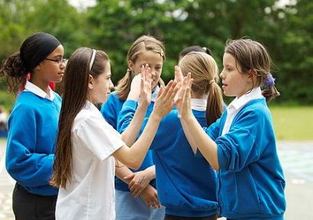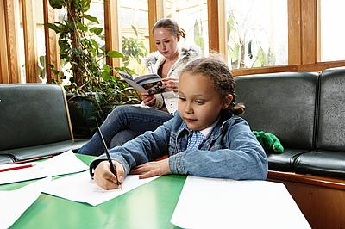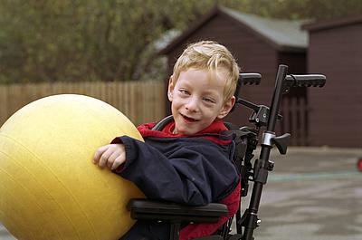
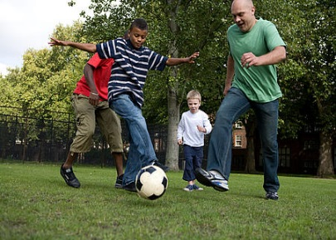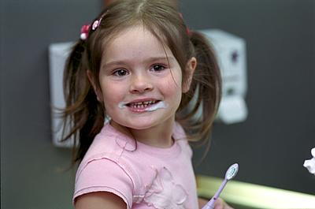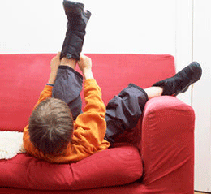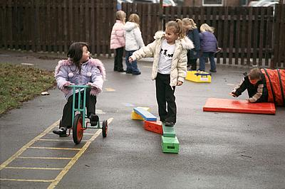

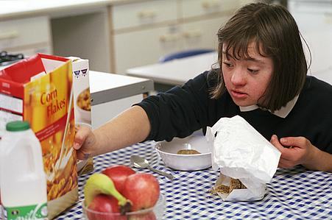

Introduction
This advice sheet provides practical advice for parents/guardians and schools to help children who have specific sensory needs prepare for the sometimes overwhelming task of getting dressed. As the task of dressing requires many foundation skills there is also a list of activities that help develop these skills. By doing one or two of these activities on a daily basis you will be giving the child the best chance of becoming independent in dressing themselves.
It is important that dressing practice is carried out when there is enough time allowed. This will help reduce stress levels for both the child and yourself.
Ensure that the room is warm and well lit and that you have all items required to hand, i.e. relevant clothing, appropriate seating such as small chair or stool and a changing mat etc.

Preparation for Dressing
Proprioception is the unconscious awareness of sensations from our joints, muscles and ligaments. It provides us with an internal awareness about where our body parts are moving in space. This is necessary so that we do not have to ‘look’ to ‘know’ exactly where our legs or arms are when we move. Children with difficulties in this area often find dressing difficult and so tend to rely heavily on vision to complete the tasks.
Some of the following strategies may be helpful prior to dressing as they help to increase your child’s awareness and organization of their body parts:

- Encourage your child to engage in “hard work” activities before getting dressed. These are any activities which require pulling, pushing, lifting, resisting, shifting, jumping, crawling or lying on their tummy. This is important as the pressure through the joints and muscles that your child gets through doing these activities them gives them feedback required to improve their awareness about where their body is i.e. their proprioceptive sense;
- Give verbal clues about which body part is being moved during activities. If your child needs more clues, give them tactile prompts i.e. touch or gently tap the body part;
- Make the preparation fun! Well known action songs such as ‘Row Your Boat’, ‘Head, Shoulders, Knees and Toes’, ‘Simon Says’, ‘The Grand Old Duke of York’, and ‘The Wheels On The Bus’ are all great ways to engage your child in activities that will help them become more aware of their body before dressing;
- Giving firm hugs and/or firm strokes down your child’s arms and legs will also provide proprioceptive input to your child’s body and is a lovely way to prepare for getting dressed;
- Rough and tumble play! This can really stimulate the proprioceptive senses, but be careful that your child doesn’t become over excited as they will struggle to concentrate on dressing afterwards.

Foundation Skills for Dressing
Dressing requires a number of skills which are known as pre-requisite or foundation skills. Examples include reaching, grasping, being able to maintain a stable sitting position, having body awareness and controlled movement, being able to sequence a task and organize themselves and a number of items i.e. clothing. The following activities will help your child to develop these important skills in order to assist them in independent dressing:
Gross Motor Activities:
- Indoor soft play
- Outdoor playground apparatus e.g. climbing frames, swings, slides
- Swimming
- Rough and tumble play
- Action songs
- Trampolining
- Animal walks
- Obstacle courses
- Hula hoops – stepping into it and lifting it up and over their head. This uses the same actions as when taking a top off.
Fine Motor Activities:
- Posting shapes
- Play dough
- Musical instruments
- Threading
- Finger painting
- Cooking, mixing, stirring and kneading
- Arts and Crafts – Collage (ripping & sticking, scrunching up paper), painting.
- Construction toys – Building blocks, Duplo, stickle bricks etc.
- Pull cord toys
- Sorting objects of various sizes, shapes and textures, encouraging the use of a tripod grasp (thumb, index and middle finger) and pincer grasp (thumb and index finger)
- Picking up small objects such as raisins and sweets
- Placing large pegs into a peg board
- Clapping games
- Wind-up toys
- Large jigsaws
- Rolling/throwing and receiving a ball
- Activities, which require one hand to steady, and one hand to carry out the action e.g. colouring and mark making

