


Positions for Play

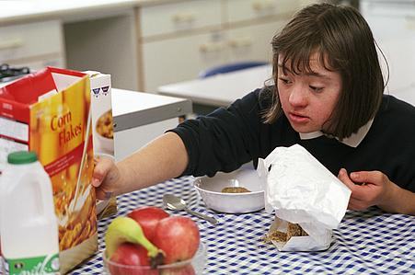
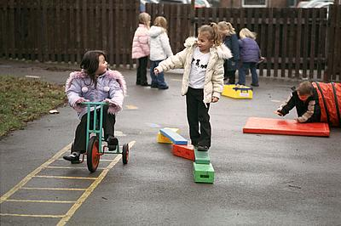
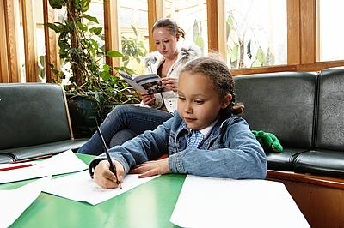
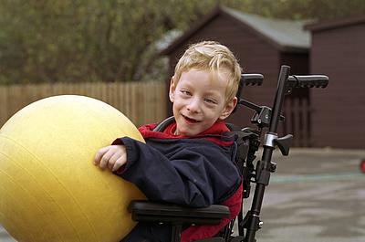
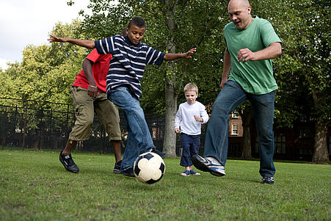
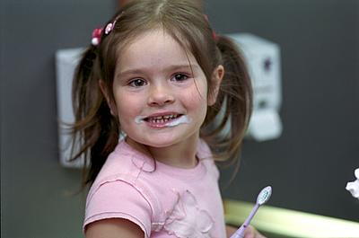
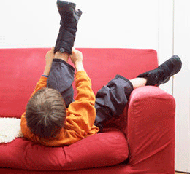
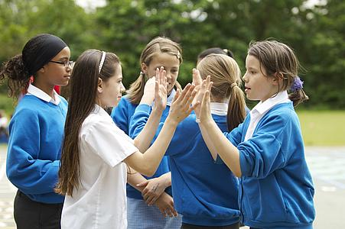


Introduction
The purpose of different positions for play is to develop motor and sensory skills. Different positions for play are important as each position encourages the development of various muscle groups and strength, as well as normal patterns of movement.

Lying on back (supine)
This is usually the least useful position for a child to be in. When on their back, it is difficult for the child to both look at toys and work against gravity to reach and play with them
Can be done on a:
- Wedge / towel at shoulders to give some angle and improve view of surroundings / face-to-face view.
- On your lap

Activities which can be done in this position:
- Hands playing with feet – may need adult facilitation to bring feet up to hands.
- Mobile / baby gym
- Toy placed on chest
- Action songs – with adult hand-over-hand for the actions

Side-lying
This is a good position to encourage the child to see and use both hands together. A rolled-up towel can be placed behind the child’s back to prevent rolling back and a small cushion under the head for comfort.

Activities which can be done in this position:
- Rattles
- Action songs
- Reaching for toys
- Swiping at suspended toys

Lying on tummy (prone)
This will encourage and help the child to hold their head up, to straighten and strengthen their trunk, take weight through the elbows and hands and stretch their hips.

This can be done:

- Over a wedge / rolled-up towel / cushion
- Over knees
- On chest
- Over a therapy ball
- Over a roll
Activities which can be done in this position:
- Reaching
- Looking in a mirror
- Feely mats

Sitting
This is a useful position for self-care, play, and structured activity. It enables the child to be in better contact with the environment, encourages extension of the spine, improves head control and frees the hands for play.
- In a chair
- On lap
- On the floor with / without support – long sitting / side sitting / box sitting
A small box / tray with legs could be used as a surface to play on.

Activities which can be done in this position:
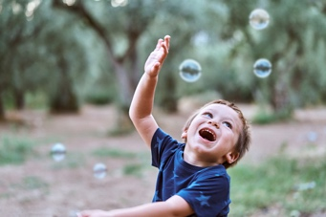
- Action songs
- Bubbles
- Reaching for objects
- Knocking down objects
- Messy play / food play
- Musical instruments

Standing - This contributes to the stability of the child’s hips and knee joints, and provides a different range of visual, sensory and social experiences.
This can be done:
- Against a chair / sofa or table
Activities which can be done in this position:
- Reaching for objects
- Musical instruments
- Moving trucks / cars / ball back and forth

Editorial Board: Awaiting approval
Publication Date: 13/02/2020
Version:
Review Date:
Author: Paediatric Occupational Therapy

Reference;

Pixabay (2020). Bubbles child . Available at; https://pixabay.com/photos/play-park-kid-ku-shin-child-1679587/ [Accessed: 15 December 2020].

Pixabay (2020). Gym ball. Available at; https://pixabay.com/photos/medicine-ball-ball-gymnastics-1575315/ [Accessed: 15 December 2020].

Pixabay (2020). Music note. Available at; https://pixabay.com/vectors/silhouette-musical-note-clef-bass-3275055/ [Accessed: 15 December 2020].

