


Sensory Integration

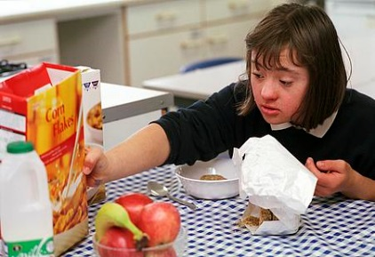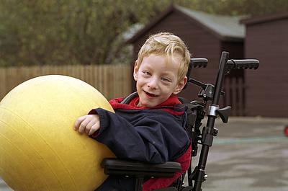
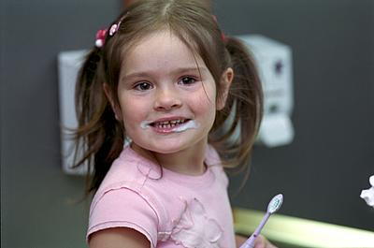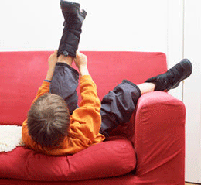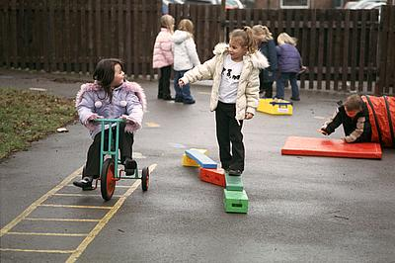

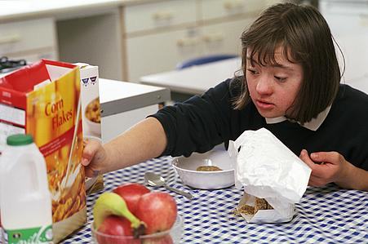
Community Paediatric Occupational Therapy Department
www.abm.wales.nhs.uk/childrensdevelopment

Introduction
This advice sheet provides activities ideas that aim to develop the child’s ability to integrate the sensory information their body receives into an appropriate response to facilitate learning, playing and social interactions.
Sensory Integration is the term that refers to the way that the nervous system receives sensory messages and turns them into responses (Miller 2006).
These senses include sight, sound, touch, hearing, smell and two other systems called the vestibular (balance) and proprioceptive (internal body awareness) systems.

Guidelines
- Never force the child to do these activities, as they will be of no benefit if they don’t enjoy them;
- Short sessions incorporated into their daily routine are ideal;
- Be guided by the child into changing the sequence and/or varying the activities;
- The time must be fun!
The activities have been grouped according to the sensory systems. Choose one or two activities from each section for the daily session. If daily sessions are not possible then two or three sessions during the week will still be beneficial.

The Tactile Sense
The sense of touch is a major source of information to the brain about our environment. It is also a feedback system for our body about our movement and position in space.
If the child is sensitive to tactile stimulation, it is very important that the activities you expose them to be graded accordingly. The child’s response to tactile stimulation will enable you to know the appropriate type, duration and frequency of stimulation e.g. start with dry textures before gradually introducing more wet and varied textures.

Activity Ideas:
- Sand play using hands and feet. This can be graded for children who are sensitive to the texture of sand by providing tools e.g. spades, watering cans, rakes etc;
- Water play: Introduce different temperatures, and vary the activities by playing with and without bubbles, spraying, splashing and squirting;
- Tumbling, rolling games, crawling under blanket, through tunnels, along carpet;
- ‘Hide and seek’. Encourage the child to find small toys or blocks hidden in rice/ sand/macaroni/under blankets/around the home etc;
- Play dough activities including pinching, kneading, rolling out, cutting and twisting.
- Finger painting;
- Messy play with e.g. squirty cream, shaving foam etc;
- Play with hand or finger puppets.
Tactile input can also have a calming effect. Here are a few ideas:
- Wrap the child up tight in a towel or blanket;
- Roll the child up in a blanket and then unroll them;
- Give the child a brisk rub with a towel after the bath or rub them down with talcum powder or body lotion;
- Do actions along to “Row Your Boat” or play “Tug of War”;
- Give the child firm “Bear hugs”.
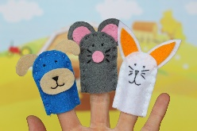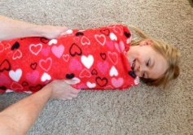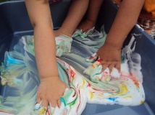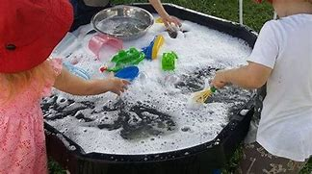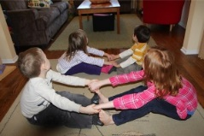

The Vestibular Sense
The vestibular sense refers to information that is provided by the receptors in our inner ear. This system responds to motion or changes in our head position. It integrates our neck, eyes and body adjustments to movement and influences our balance, muscle tone and bilateral integration (the co-ordination of both sides of the body e.g. hands). It has an important effect on regulating our posture and movement in relationship to what we are doing and seeing.
If the child is sensitive to movement, it is very important that this is graded accordingly. The child’s response to movement will enable you to know the appropriate type, duration and frequency of stimulation e.g. start with slow movement back and forth before more challenging rotational movements.
Activity Ideas:
- Swinging on swings or see-saws;
- Spinning e.g. on a swing or an office chair. As spinning provides a high amount of vestibular input it is important to let the child control the amount of movement. Watch carefully for changes in their complexion (i.e. the colour of their face from normal to pale) or distress and stop immediately if these signs are noted;
- Jumping on a trampoline or off something high to land on something soft e.g. from the sofa onto a pile of cushions;
- Rolling in a blanket;
- Rough and tumble play including tipping the child upside down etc;
- Riding bikes, trikes or scooters etc;
- Soft play areas, ball pools and playgrounds all provide excellent sources of vestibular input to help calm and regulate the child’s sensory system.
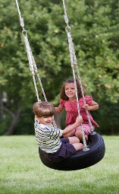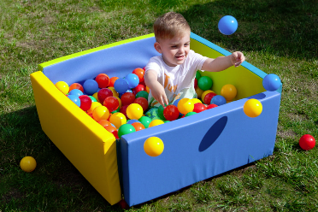
The Proprioceptive Sense
Proprioception is the unconscious awareness of sensations from our joints, muscles and ligaments. It provides us with an internal awareness about where our body parts are moving in space. This is necessary so that we do not have to ‘look’ to ‘know’ exactly where our legs or arms are when we move.
Proprioceptive activities generally have a calming effect and are often combined with activities for tactile and vestibular stimulation.
Activity Ideas:
- Jumping on a trampoline or off something high to land on something soft e.g. from the sofa onto a pile of cushions;
- Action songs such as ‘Row Your Boat’, ‘Head, Shoulders, Knees and Toes’, ‘Simon Says’, ‘The Grand Old Duke of York’, and ‘The Wheels On The Bus’ provide good proprioceptive input;
- Encourage your child to lie on the floor on their back and kick or push a large ball, either helped by you or propped against the wall. For younger children play mats with toys suspended overhead are a good alternative;
- “Tug of War” and other pushing and pulling games;
- Hammering activities;
- Animal walks e.g. bunny hops, leap frog, crab walks, elephant walks, lion walks etc.
- Soft play areas and ball pools are excellent sources of proprioceptive input, as are playgrounds;
- Firm “Bear” hugs;
- Rough and tumble play;
- Hotdog: roll the child up in a duvet (the child is the ‘sausage’ and the duvet is the ‘bread’!). Put ‘toppings’ on the ‘sausage’ by applying firm pressure with your hands down their back, arms and legs. If your child really enjoys this try varying the type of pressure with the topping e.g. tomato sauce could be firm squeezing, onions could be firm patting. Always stop and ask the child if they want more. This way they get to control the input you are giving to suit their needs.

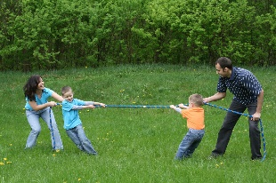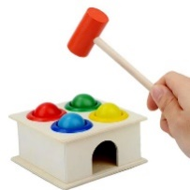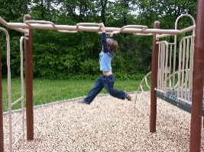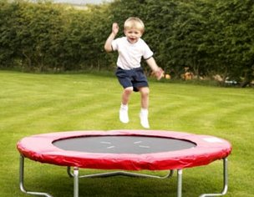

References - Miller L. J. (2006). Sensational Kids: Help and Hope for Children with Sensory Processing Disorder. New York, NY, Putnam
Publication Date: 10/12/2020
Version: 2
Review Date: 2023
Author: Paediatric Occupational Therapy

