


Gravitational Insecurity

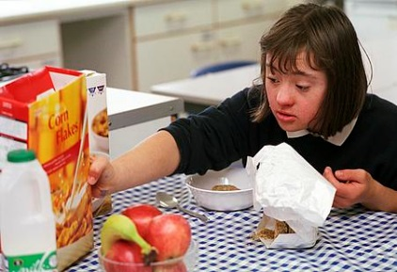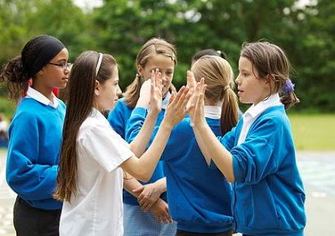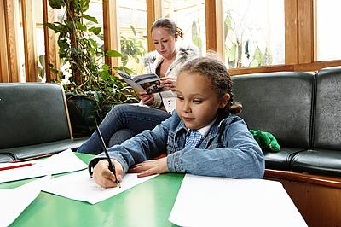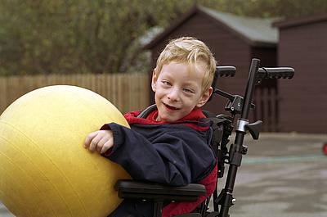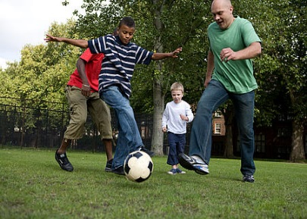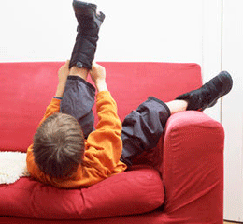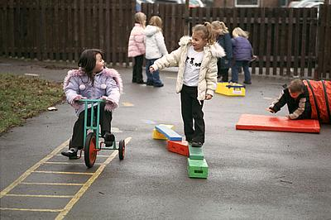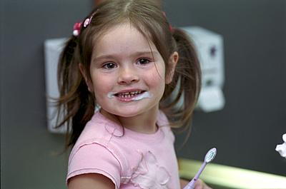

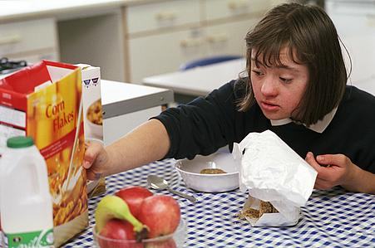
Community Paediatric Occupational Therapy Department


What is gravitational insecurity?
Why is our sense of gravity important?

As part of our vestibular system, we have gravity receptors located within the inner ear. When we hold our head in various different positions, we are working against gravity. As such, we may choose to support ourselves in various ways because when we are not required to work against gravity, we are able to carry out higher-level thinking and we have more energy.

Many daily experiences require us to work with unstable surfaces that may challenge our centre of gravity. For example, walking on gravel, moving up and down over curbs and pavements or walking up steps. These activities are usually automatic with little or no awareness. However, they require us to have a sound, integrated sense of our body position, movement, environment and gravity.
Some children may experience gravitational insecurity. They may feel unsure about their relationship with the earth and lack confidence with movement. This is because they are not sure about their body and head position in relation to their environment.

They may not want to engage in gross motor play because they do not want their feet to leave the ground. Therefore, activities such as swinging or running tend to be avoided.

Unstable surfaces, as previously mentioned, that we may take for granted, can often be extremely frightening and challenging for children who have gravitational insecurity.

Helpful strategies
When working with a child or young person who has gravitational insecurity, it is vitally important that they are given control of the amount of challenging movement experiences they engage in, and they should never be pushed passed their limit.
The strategies explained here can be used in conjunction with techniques to develop body awareness. You should also be aware of sensory strategies that you can use to ensure the child is calm and feels safe and secure. This will be beneficial in preparing the child for the challenging work against gravity, and to comfort and calm them should they feel unsure or unhappy about the activities.

Desktop Strategies
Classroom Strategies
- Using a firm seat that will not tip over will help the child feel secure while sitting at their desk. It is important to ensure their feet remain flat on the ground.
- Using a ‘Move and Sit’ cushion or a ‘Wobble’ cushion can be useful to allow the child to move a little, while still remaining secure in the seat. It will remind the child of their body position which will encourage to feel safe, secure and in control.
- Use your hands to help the child develop body awareness. Always use firm touch and concentrate on the joints of the body. This can also help the child to focus on an activity.
- Visual markers can be useful if the child has difficulty with changing positions such as getting down on the floor or onto a chair. For example, putting a cushion on the spot they are to sit in, so they aim to sit on top of it.
- Thinking about what position the child likes to be in during classroom activities is helpful. As far as possible, let them maintain the position they feel most happy and secure in. As confidence develops, changes in position can be introduced.
- Use every opportunity to practice and reinforce the child’s proprioception/body awareness. This can be done through pushing and pulling games and weight bearing activities. You could trial using backpack weighted with books to further increase sensory feedback.

Snacktime/Food and Drink Strategies
Even certain foods can contribute to our sense of body awareness as they provide a high level of oral sensory feedback.
The best foods for this are those which are chewy, crunchy, sour etc. Thick drinks are also good, for example milkshake. They should be drunk through a straw as sucking provides extra feedback. Similarly, sports bottles are great as they require sucking.

Bus and Car Strategies

It is common for a child who has gravitational insecurity to feel very sick and dizzy when travelling by bus or by car. You can prepare them for this experience by providing lots of calming exercises beforehand.

- Limit the amount of children and space to increase the child’s sense of security. It is important to allow the child to increase exposure to various equipment at their own pace.
- A good place to begin is by using mats, soft play wedges and textured materials (bubble wrap, fur etc) to create uneven surfaces for the child to negotiate their way around.
- When the child is ready, consider moving on to equipment such as smaller therapy balls, rolls, large wedges etc.
- Eventually, the child may develop the confidence to access more challenging equipment such as climbing frames, swings and benches.
- The aim should always be to be child led and to grade your approach very gently.
PE Strategies

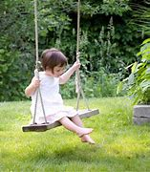
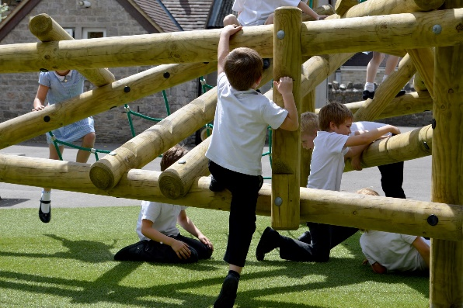

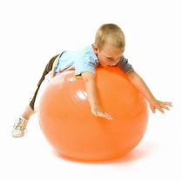

References:
Nackley, V.L. (2001) ‘Sensory Diet Applications and Environmental Modifications: A Winning Combination’, American Journal of OT.

Trott, M.C. (1993) ‘Understanding Sensory Integration’, Therapy Skill Builders USA

