



Calming Strategies Before Bedtime


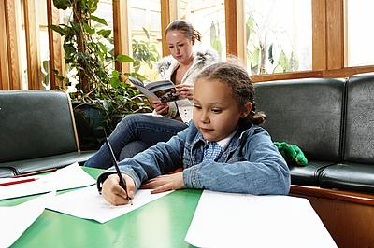
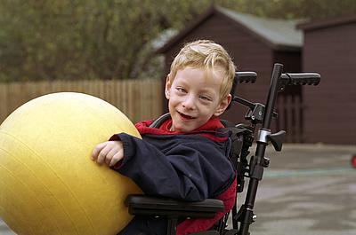

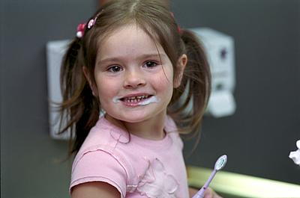
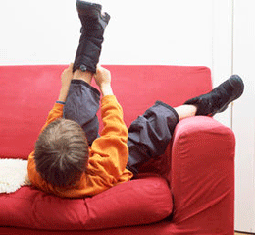

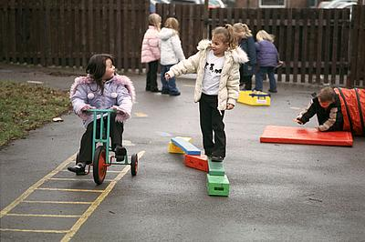

Introduction
Sleep is essential for a child’s health, well-being and development and so it is important that they are encouraged from a young age to develop good sleep routines. For the biggest positive impact, these need to be applied every day in the same way where possible. Some children need help to reach a calmer state ready for bed and so the following advice may helpful in supporting you achieve this.
The following types of sensory input are calming to our systems:
- Slow rhythmic movement such as swinging or rocking in one direction i.e. back and forth or side to side.
- Deep pressure to muscles and joints e.g. massage or firm squeezing.
- Proprioceptive activities i.e. those that include heavy work to muscles, traction or compression through joints, or strong contraction of muscles around joints.

Activities
- “Hotdog” e.g. roll the child up in a duvet and give them pressure with therapy ball (or your hands) down their back, arms and legs.
- Squashing yourself into the floor - encourage your child to place the palms of his hands on the top of his head and press down for 25 seconds.
- Squashy ball - encourage your child to hold the ball between two flat hands in front of the chest. Squash the ball hard to try and keep it flattened.
- Strong Man press-ups - child lies on their tummy on the floor and pushes up through his outstretched arms. Try doing press-ups against the wall or down on a desk.
- Bear Hugs - combine your bear hugs with gentle rocking back and forth for extra calming effect.

Calming Strategy – Womb Space
- Some children can become over-stimulated when in the classroom or a busy environment with lots going on. The child may struggle to cope with all the sensory stimulation around them and become excited, over active or anxious. This then makes it very difficult for the child to focus or concentrate on a specific activity.
- Some children save up the over stimulation they have encountered from earlier in the day and even in a quieter space, can crave activities which help them process the demands of the day in order to help them feel calm and ready for bed.
- When a child struggles to control their arousal (energy) levels, they may need some guidance and support to help them calm down and relax. One method of supporting the child with this is to create a ‘womb space’. The womb space can also be used before bed if your child finds it difficult to calm but can be useful at other times of the day.

What is a womb space?
- It is a small, safe, private and relaxing environment, which the child can retreat to.
- This space enables the child to escape from all the overwhelming stimulation from the outside world and helps them to relax and feel calm and gives them time to regulate.
- The child may use the space alone, or you may want to spend time in the womb space with the child, supporting them to calm or engage them in relaxing activities.



Ideas for creating a womb space:
- Try to create a womb space in a separate quiet room; however, if one is not available then you can use the corner of a room.
- Set up a tent and place cushions and soft blankets on the floor to lie on/under.
- You can drape material over the tent to reduce the amount of light getting into the enclosed space.
- If you don’t have a tent you can use sheets, blankets or cushions to create an enclosed space, or use a tunnel, which the child can climb into and lie down in.
- Make the space comfortable and relaxing:
- Use cushions and blankets to make it soft.
- If the child prefers a dark or dim environment, use darker materials to block out some light. You can drape material over each end of the tunnel or switch off the lights.
- Play gentle humming music if this helps to relax the child.
- You could use a weighted blanket, or sandwich the child between two duvets to help them relax.
- You may want to engage the child in activities that are relaxing and not too stimulating, such as, reading/telling a story, puzzles, cuddling soft toys, quietly singing a song, massage and deep pressure, or gently move in slow linear repetitive movements, such as row-row-row-your boat.

Tips for Bedtime
- A warm bath before bedtime is an excellent way to relax.
- Provide a bath sheet or beach towel to wrap up in after bath.
- Dress for bed while in the bathroom.
- Consider clothing which is comforting to your child.
- Allow a little time to relax and unwind before going to sleep – reading a book or listening to quiet music with a small light that can be turned off without getting out of bed.
- Think about the bedtime environment – low level lighting, minimise distractions of toys or pictures, perhaps try using a sleeping bag or weighted blanket or a bed tent. Consider black out blinds to prevent early morning waking.
- Avoid use of screen time before bed.
- For those sharing rooms, consider a bed tent to create a separate space for each child where they have the option of closing off distractions.
- Avoid placing entertainment equipment directly in the bedroom.

Further bedtime tips can be found in the ‘Sleeping’ handout.

References:
Bundy A C, Lane S J & Murray E A (2002). Sensory Integration Theory and Practice. (2nd Eds.). Philadelphia: F.A. Davis Company.

