Patient information — external disease and corneal services Corneal transplantation: deep anterior lamellar keratoplasty (DALK)

Why do you need a corneal transplant? The cornea is a window of transparent tissue at the front of the eyeball. It allows light to pass into the eye and provides focus so that images can be seen. Various diseases or injury can make the cornea either cloudy or out of shape. This prevents the normal passage of light and
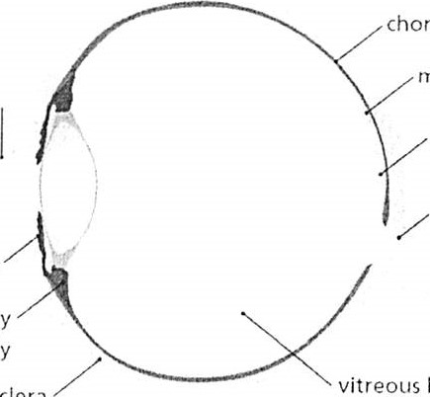
effects vision.
choroid
body
Sclera
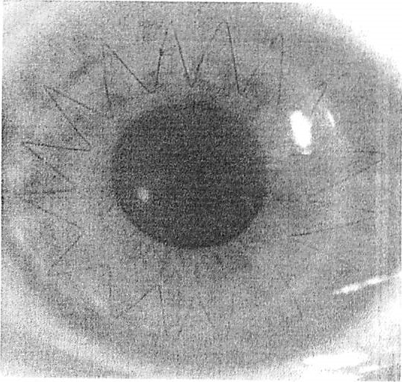

The cornea has three layers (thin outer and inner layers and a thick middle layer). In some diseases, only the middle layer or part of the middle layer is affected (see below).

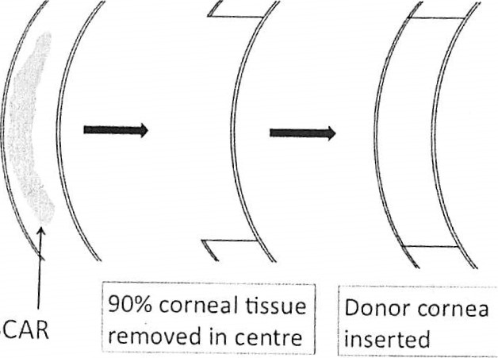
S
DALK is a modern technique whereby the outer two layers of the cornea are removed and replaced with the outer two layers from a donor cornea to give a partial-thickness transplant.

Benefits of deep anterior lamellar keratoplasty (DALK) Improved vision
Approximately 75% of transplant recipients for keratoconus have vision sufficient to drive legally, although they may need glasses or contact lenses or sometimes further surgery for best results. It can take up to 18 months until the full improvement in vision is appreciated.
- Risks of deep anterior lamellar keratoplasty (DALK) Rare but serious complications
- Sight-threatening infection (1 in 1,000) Severe haemorrhage causing loss of vision
- Retinal detachment
- Severe inflammation or other rare causes of loss of vision.

Corneal transplant rejection
A corneal transplant can be identified and attacked by your immune system. This happens in one in six patients in the first two years after transplantation and can cause graft failure. It can often be reversed if anti-rejection medication is started promptly. Rejection remains a possibility for your lifetime.

Graft failure
When a graft fails, your cornea becomes cloudy again and your vision becomes blurred.

Glaucoma
This can usually be controlled by eye drops, but occasionally requires surgery and can damage your sight.

Cataract
This can be removed surgically.

Conversion to penetrating keratoplasty
Occasionally, it is not possible to perform a partial thickness transplant and a full thickness transplant must be performed instead. This happens in 10% of intended DAI-K procedures.

Possible advantages of DALK over full thickness graft
- Lower risk of intraocular (inside the eye) problems such as serious infection or bleeding
- Lower risk of graft rejection
- The corneal wound after DAI-K is stronger than that after a full-thickness graft (PK). This means that stitches can be removed sooner.
Possible disadvantages of DAI-K over full-thickness graft
DAI-K recipients have a slightly lower chance of achieving 6/6 vision (excellent vision) than recipients of full-thickness grafts.

About the operation

The operation
The operation is performed under general or local anaesthetic and is sent to our pathology laboratory for examination under a microscope.

After the operation
You will generally be examined by the surgical team after the surgery and can usually go home the same day. You will be seen again within one week in the out-patient clinic and regularly thereafter (approximately six visits in the first year). We generally recommend that you take two weeks off work, please discuss your specific circumstances with your doctor. You will need to use anti-rejection eye drops for at least six months and in some cases indefinitely. Individual stitches may be removed from three months after the operation, but complete stitch removal is not performed until at least one year after the procedure.

What if my transplant fails?
A failed transplant can be replaced in a procedure known as a re-graft, but the risk of subsequent rejection and failure increases each time for second and subsequent re-grafts.

Corneal transplant rejection
Rejection needs urgent treatment, as this can lead to failure of the transplant and loss of vision.
Symptoms of rejection are:
- Red eye
- Sensitivity to light
- Visual loss
- Pain
If you experience any of these symptoms please contact RACE (number below)
IF YOU NEED ANY ADVICE OR FURTHER INFORMATION PLEASE CONTACT:
Rapid Access Eye clinic - 01792 205666 ext 5850
Or
Mr Saldanha's secretary:
Mrs Helen Clarke, Medical Secretary to:
Mr. Mario Saldanha FRCS FRCOphth DO
Consultant Ophthalmologist,
Cornea, External Diseases and Refractive Surgery,
Singleton Hospital,
ABMU Trust, Swansea
Honorary Senior Lecturer, Cardiff University

Tel: 01792 957627 Ext: 39627

