

Sleep Hygiene
Occupational Therapy

information to improve
the quality of your
sleep
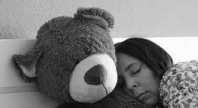
Sleep is one of the most important components of good health, both physical and mental health. A good sleep enables us to think and plan whilst attending to domestic and personal care tasks.

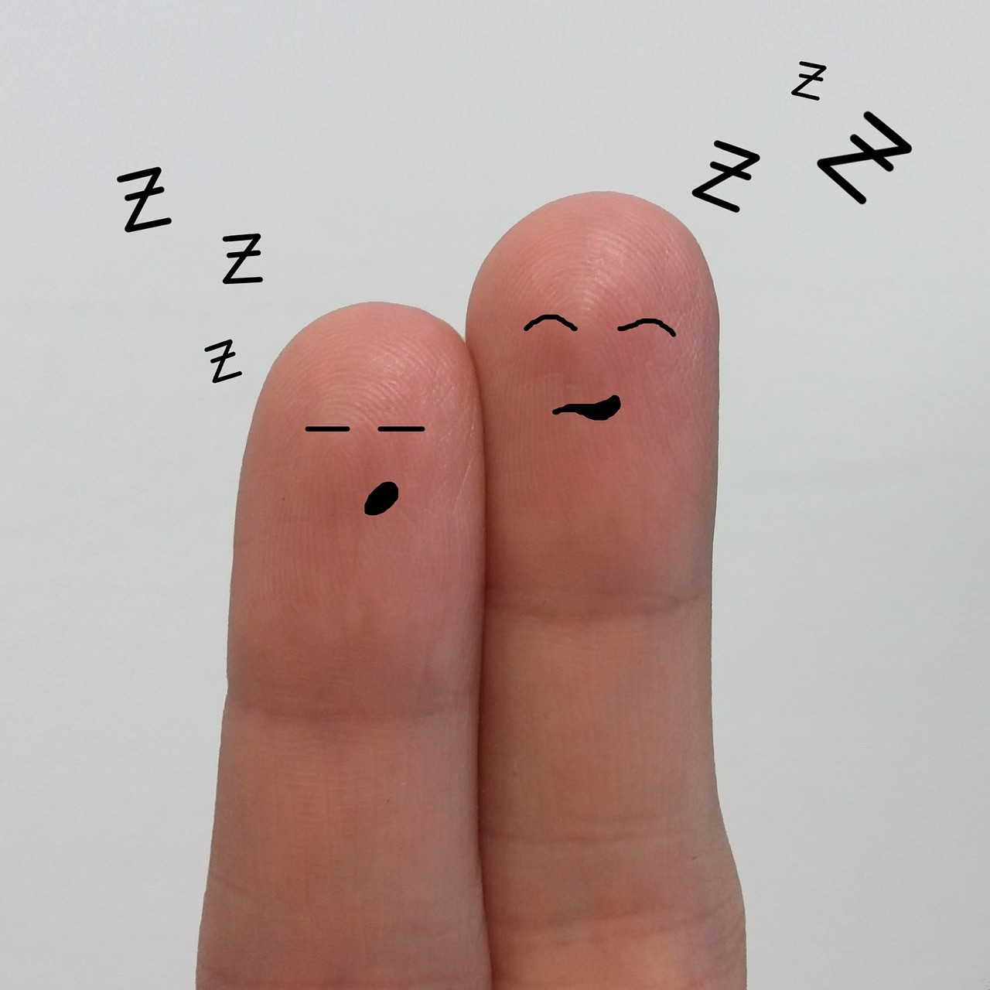
Sleep is particularly important when living with a health condition. Sleep allows our body to repair itself and not getting enough sleep can weaken our immune system.
Everyone, from children to older adults, can benefit from better sleep, and sleep hygiene can play a key part in achieving that goal.
What are signs of poor
sleep:
Having a hard time falling asleep, experiencing frequent sleep disturbances, and suffering daytime sleepiness are the most telling signs of poor sleep hygiene. An overall lack of consistency in sleep quantity or quality can also be a symptom of poor sleep hygiene.
Everyone is different, but most people need between 4 and 8 hours of sleep a night. You need less sleep as you get older or are less active, but you need more sleep if you are unwell, stressed or physically more active. As we age we generally need less sleep and if we are less active this is also true.

Things to
avoid:
Taking alcohol before bedtime (2 hours) keeps you in the lighter stages of sleep from which you can be easily awakened.

Watching TV or using mobile devices in the 2 hours leading up to bedtime as these devices emit a blue light which tricks the brain into thinking it is day time

Eating a large meal close to bedtime, although a light snack may be beneficial e.g. banana, seeds
Avoid caffeine before bedtime as it stimulates the brain and causes insomnia (last caffeinated drink early afternoon) this includes hot chocolate and fizzy drinks as well as tea/coffee

Avoid nicotine - heavy smokers often sleep very lightly and have reduced amounts of REM sleep, they also tend to wake up after 3-4 hours of sleep due to nicotine withdrawal.

Tips to improve your sleep quality:
Worry/depression Effect On Sleep
Worry stimulates the release of the stress hormone adrenalin, which in turn stimulates the activation of many of the body’s functions. This can prevent your body from relaxing and going to sleep. Often, this general worry is then exacerbated by the worry of not sleeping. Be reassured, missing sleep in the short term does not harm you.

Go to bed expecting to sleep …. Positive attitude is helpful

Do not clock watch

Ensure you are in a comfortable position – do not lie flat, experiment with positions and numbers of pillows
Exercise- as little as 10 minutes of aerobic exercises, such as walking or cycling, can drastically improve nighttime sleep quality. For the best night’s sleep, most people should avoid strenuous workouts close to bedtime.

Exposure to sunlight during the day, as well as darkness at night, helps to maintain a healthy sleep-wake cycle.

Routinely practice relaxation/relaxed breathing exercises during the day if necessary to help you drift off in bed

Sleep
Environment:

Keep your bedroom at a comfortable temperature (between 16 and 18 degrees)
Keep the bedroom a calm environment, remove clutter and items/equipment that do not belong in a place of sleep e.g. computers, exercise bikes, TVs Reserve your bed for sleep or sex

Useful Websites:
Sleepio - https://www.sleepio.com
NHS https://www.nhs.uk/live-well/sleep-and-tiredness/how-to-get-to-sleep/ Sleep Council – https://www.sleepcouncil.org.uk
Sleep Foundation - https://www.sleepfoundation.org/

Relaxation/breathing exercises:
https://www.nhs.uk/conditions/stress-anxiety-depression/ways-relieve-stress/ https://www.sleepfoundation.org/shift-work-disorder/shift-work- you/relaxation-exercises-falling-asleep

