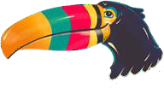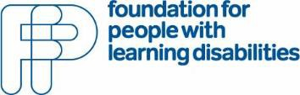Press release

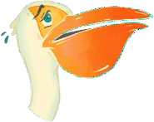
Say hello to Peli and Tou!

The Foundation for People with Learning Disabilities is delighted to launch
PELICAN - Promoting Emotional Literacy In Children with Additional Needs.

PELICAN is a set of free, web-based materials for children and young people with complex learning needs and/or learning disabilities and people who support them.

PELICAN helps staff, parents and carers to develop emotional literacy, wellbeing and resilience in children with learning disabilities and autism. It helps with emotional and behavioural difficulties they have. It can be used alongside other support.

PELICAN can be used in schools, other settings, communities and at home. It is based on over 10 years of action research including collaboration with children, young people and the
adults that support them.

Peli and Tou introduce you to the PELICAN Framework through a simple visual story. Peli is scared to fly but Tou is on hand to help! So, Peli changes from Peli can’t … to Peli can!

Through the story and linked activities, you are guided through the Framework as you introduce:

- I CAN Feel
- I CAN Relax
- I CAN Think
- I CAN Do
 If Peli can and Tou can, then you can! 

Wow, this looks amazing.

Behaviour Intervention Lead/ SENCO Support
What a brilliant name and concept.

Clinical Psychologist
The resources are very young person friendly

Child and Families Therapies Service Staff

To find out more about PELICAN and to access all of the PELICAN resources, go to:
http://www.learningdisabilities.org.uk/pelican

For more information contact the Foundation for People with Learning Disabilities at:
info@learningdisabilities.org.uk

