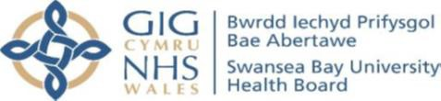

Parental Wellbeing – Virtual Group
Facilitated by Paediatric Occupational Therapy via Teams

These virtual sessions have been developed to offer parents/carers the opportunity, to focus on their emotional and physical wellbeing in a relaxed and informal virtual group setting.

Join us to chat about your self-care needs through group discussion, by exploring a variety of practices and strategies, sharing experiences and finding possible solutions to support each other and achieve better personal & family wellbeing together.


Some of the topics covered will include:
Achieving Self-Care Taking Notice Mindfulness & Meditation
Challenging Negative Thought Patterns Links & Resources to support Wellbeing

Participants will be joining via Teams and the group will include up to 6 attendees. Couples are more than welcome to attend together.

Sessions will be delivered once per week over a 3week period (date & time TBC)

If you would be interested in attending and would like more information, please contact the number below and complete our Request to Attend form.
Swansea: 01792 200400 / Neath & Port Talbot: 01639 862713



Pencadlys BIP Bae Abertawe, Un Porthfa Talbot, Port Talbot, SA12 7BR / Swansea Bay UHB Headquarters, One Talbot Gateway, Port Talbot, SA12 7BR BwrddIechyd Prifysgol Bae Abertawe yw enw gweithredu Bwrdd IechydLleo lPrifysgol Bae Abertawe Swansea Bay University Health Board is the operational name of Swansea Bay University Local Health Board

