What is Occupational Therapy (OT)?
Occupational Therapists (OTs) work with children and young people who have difficulties with daily activities e.g. going to the park, scribbling and drawing, playing with toys, getting dressed, having a bath. We call these ‘occupations’. OTs help children and young people to carry out activities they need or want to do in areas of self-care, school work and play. Our aim is to support children to learn new skills to help them become more independent. We do this together with the parent, child, teacher or other professionals the child may be known to.
What happens if you think your child needs to be assessed by an OT?
SB University Health Board OT service operates an open referral policy. This means that anyone who is affected by a child’s difficulty in managing daily activities can complete a referral form. This could include the parents, another family member, the child’s teacher or another professional that works with them. A referral from anyone other than the person with parental responsibility will not be accepted without consent from that person. Contact your local children’s centre for a referral form.
All the referrals we receive are screened to ensure they are both appropriate and contain enough information for us to make a decision on how to proceed. We may triage the referral with the referrer via phone call if more information is needed to decide if we can help or signpost you to the appropriate service. If the information on the referral is not appropriate the referral might be declined.
Things you will need to consider for the referral:
- How do you think OT can help?
- What things have you already tried to help this child manage better?
- Is this child receiving any additional support, including any other services involved?
- What does this child like to do and what are they good at?
What happens after your referral’s been accepted?
Once accepted, you will receive: a letter with details of a virtual appointment using our ‘attend anywhere’ system. Where possible we want to avoid putting children through any unnecessary assessments.
What happens after our virtual appointment?
Having spoken about the difficulties you or the child is experiencing, we will agree the most appropriate OT input. Our aim will be to help you find possible solutions to assist you in managing the child’s needs.
This may include health promotion through provision of advice, strategies and activity ideas or signposting towards community resources, including our colleagues in social services.
If we agree that the child concerned would benefit from seeing an OT face to face, an appointment will be offered during your virtual appointment or in due course and a letter advising you of this will be sent.
What will happen if we decide you require a face to face appointment with OT?
If we agree that an appointment with an OT is necessary, we will invite you and the child to one of our centres. We will go through our Covid-19 consent form before the appointment to ensure safety for those involved. More information will be given depending on the process the OT feels to be most beneficial. We may also consider seeing the child at home or in school. This could be just OT or with other professionals such as physiotherapists or speech and language therapists, depending on their difficulties.
During these face to face appointments the OTs will be considering:
- What the child is doing? (their occupation)
- Where the child is doing it? (their environment)
- How the child is doing it? (their performance)
This means we may need to watch the child carrying out activities they find difficult and in the different settings.
We sometimes have to use assessments that look in more detail at the skills they need to learn and develop but we will explain what we are doing if we need to do these assessments. This will help us work out with you and the child the best way to make things easier.

What happens next?
If we have not done so already, it is most likely we will give you advice and ways of doings things that will be helpful to use every day. We may also:
- Invite you to attend some therapy sessions.
- Recommend equipment to help you or the child carry out the activity that is difficult.
- Refer on to our specialist splinting clinic.
As OTs we use person centred planning which means we will want to work collaboratively with you to discuss these options and identify the best intervention for you.
For change to happen it is vital that the strategies and advice that we agree on are carried out. This will help you and the child to achieve the goals you have set and may help them achieve their goals in the future.

Covid-19 changes to the service:
- Appointments will be conducted virtually in the first instance.
- Staff will wear full PPE for face to face sessions.
- Covid-19 consent forms will be required to be signed prior to face to face sessions.
- When waiting for an appointment at the centre, wait outside the centre for a member of staff to invite you in.
- All those over 11 years old should wear face masks in the centre.

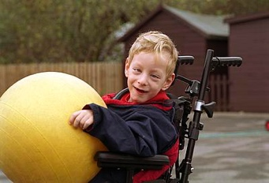
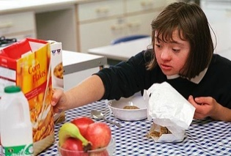
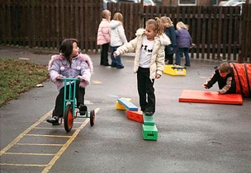
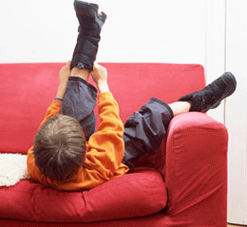

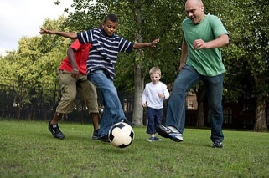
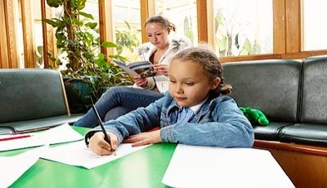
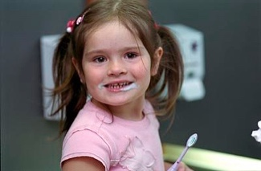
- If you are unwell or showing any Covid-19 symptoms please inform staff prior to appointment. Staff will be obligated to do the same.
Paediatric Occupational Therapy Service

Where to find us?

We work within Swansea Bay University Health Board. The two localities are:

Swansea

Paediatric Occupational Therapy Dept.
Hafan Y Mor
Children’s Development Centre
West Ward Block – Level 2
Singleton Hospital
Sketty Lane
SA2 8QA
Tel: 01792 200400

Neath Port Talbot

Paediatric Occupational Therapy Dept.
The Children’s Centre
NPT Hospital
Baglan Way
Port Talbot
SA12 7BX
Telephone: 01639 862713

If you need any additional information please contact your local centre.

A range of programmes can be found on our website. Type: “Paediatric Occupational Therapy Programmes SBUHB” into google (or your search engine) and click the first link.

Community Paediatric Occupational Therapy Department

