

Fatigue Management
Occupational Therapy

Self Management

Grading:
· Set small, achievable goals
· Change tasks/positioning regularly
· Focus on one thing at a time
Communication:
· Be assertive: tell others how you feel and how your needs can be met
· Delegate when possible

Self-care
· Do things you enjoy
· Engage in hobbies and interests
· Focus on the good things in life
· Have things to look forward to

Healthy living:
· Drink enough water
· Eat regular balanced healthy meals
· Take regular exercise
· Practise regular relaxation or mindfulness
Pacing:
· Do little and often
· Take small regular breaks
· Plan your rest periods in advance
· Balance your day between rest and activity

Be kind to yourself:
- Understand your energy limits and stick to them
· Stick to what you can realistically achieve
· Think of alternative, easier ways to approach tasks - to conserve energy
- If you don’t achieve an activity, try to reschedule it for when you are less fatigued
  - Notice when you have done things well and celebrate your achievements!
  - Be aware and acknowledge your feelings and emotions, try not to dwell on them

Get organised:
  - Plan your time efficiently
· Keep a list or a diary
· Prioritise your tasks in order of importance
Avoid:
· Too much alcohol
· Too much caffeine
· Using electronic devices before bed

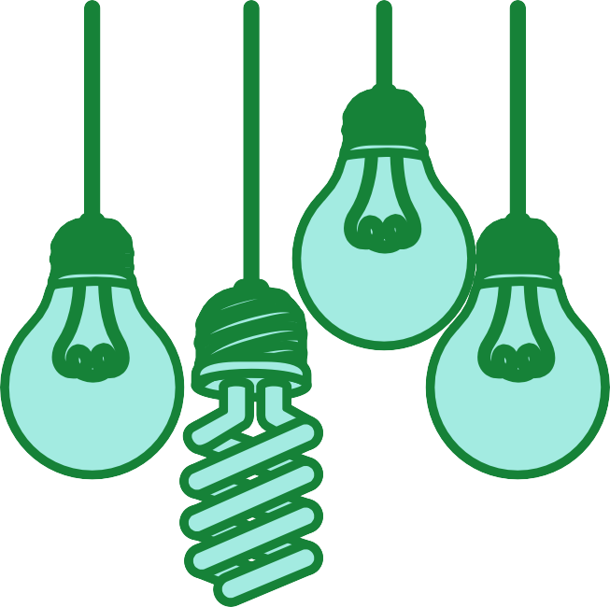Self Management

Try to sleep well:
Stick to a regular bedtime and get uptime Clear your bedroom of clutter and distractions Try to avoid stress and worry at bedtime
Develop sleep rituals before going to bed. For example, have a bath, wind down, listen to gentle music
Create a calm bedroom that is cool, dark and quiet. Use relaxation techniques before bed
Adjusting your environment:
Organise your workspace: keep things in the same place so you don’t waste energy searching
Use good lighting to prevent eye strain
Use signs and labels to help you find things more easily Think about turning off the TV or radio if you’re concentrating on a task

Helping with cognitive fatigue:
Use checklists to help you stay on track
Schedule your time using a diary, calendar or smartphone
Use alarms to prompt you with staying or taking a break from a task
Do one thing at a time to help manage any fatigue
Use post-it notes to help with remembering rather than holding it in your mind.
Instead of letting the thoughts of an entire activity overwhelm you, try to break it down into smaller parts.
Ask for help! Work jointly with family or friends on parts of tasks Make time to do the things you enjoy to help clear your mind if you’re feeling overhwhelmed

