


Anxiety Management

Occupational Therapy

What is Anxiety?

“Anxiety: a feeling of worry, nervousness or unease about something with an uncertain outcome.”
- Dictionary

Anxiety is a natural human response when we perceive that we are under threat. It can be experienced through our thoughts, feelings and physical sensations.
Most people feel anxious at times. It's particularly common to experience some anxiety while coping with stressful events or changes, especially if they could have a big impact on your life.
Like all animals, human beings have evolved ways to help us protect ourselves from danger. When we feel under threat our bodies react by releasing certain hormones, such as adrenaline and cortisol. These hormones:

Makes us Feel More Alert – so we can react faster
Make our hearts beat faster – sending our blood to where it’s needed most.

After we feel the threat has passed, our bodies release other hormones to help our muscles relax. This can sometimes cause us to shake.
This is commonly called the ‘fight, flight or freeze’ response – it’s something that happens automatically in our bodies, and we have no control over it.

Anxiety Becomes a Problem When…

Anxiety can become a mental health problem if it impacts on your ability to live your life as fully as you want to. For example, it may be a problem for you if:
…feelings are out of proportion to the situation
…it lasts for a long time

…it causes you to avoid certain situations
…symptoms of anxiety are a regular occurrence
…it is hard to do everyday activities or things you enjoy
…feelings are very distressing and hard to control

Anxiety symptoms can last for a long time, or come and go. You might find you have difficulty with day-to-day aspects of your life, including:
Holding Down a Job
Looking After Yourself
Enjoying “Leisure” Time
Forming or Maintaining Relationships
Trying New Things

If your symptoms fit a particular set of medical criteria then you might be diagnosed with a particular anxiety disorder. But it's also possible to experience problems with anxiety without having a specific diagnosis. Our pages on self-care and treatment for anxiety

Types of Anxiety Disorders

Panic Disorder:
this means having regular or frequent panic attacks without a clear cause or trigger. Experiencing panic disorder can mean that you feel constantly afraid of having another panic attack, to the point that this fear itself can trigger your panic attacks.
Generalised Anxiety Disorder (GAD):
this means having regular or uncontrollable worries about many different things in your everyday life. Because there are lots of possible symptoms of anxiety this can be quite a broad diagnosis, meaning that the problems you experience with GAD might be quite different from another person's experiences.

Phobias:
a phobia is an extreme fear or anxiety triggered by a particular situation (such as social situations) or a particular object (such as spiders).
Post -Traumatic Stress Disorder (PTSD):
this is a diagnosis you may be given if you develop anxiety problems after going through something you found traumatic. PTSD can cause flashbacks or nightmares which can feel like you’re re-living all the fear and anxiety you experienced during the actual event.

Obsessive Compulsive Disorder (OCD):
you may be given this diagnosis if your anxiety problems involve having repetitive thoughts, behaviours or urges.

Social Anxiety Disorder:
this diagnosis means you experience extreme fear or anxiety triggered by social situations (such as parties, workplaces, or any situation in which you have to talk to another person). It is also known as social phobia.

Body Dysmorphic Disorder (BDD):
this means you experience obsessions and compulsions relating to your physical appearance.

Health Anxiety:
this means you experience obsessions and compulsions relating to illness, including researching symptoms or checking to see if you have them. It is related to OCD.

Perinatal Anxiety (Perinatal OCD):
some women develop anxiety problems during pregnancy or in the first year after giving birth.

You might not have, or want, a diagnosis of a particular anxiety disorder – but it might still be useful to learn more about these different diagnoses to help you think about your own experiences of anxiety, and consider options for support.

How does it make you feel? - Physically
Faster Breathing
Fast, “Thumping” or Irregular Heartbeat
Sweating or Hot Flushes
Change in Your Sex Drive
“Churning Feeling” in Your Stomach
Pins and Needles
Having Panic Attacks
Grinding Teeth
Headaches, Backaches or Other Aches and Pains
Needing Toilet More or Less Often
Restless
Nausea
Light-headed or Dizzy
Problems Sleeping
Physically

How does it make you feel? – Mentally
Can’t Stop Worrying or Bad Things Will Happen if You Stop Worrying
Needing Lots of Reassurance
Worrying About Feeling Anxious
Tense, Nervous or Unable to Relax
Sense of Dread or Fearing the Worst For The Future
Feeling Like the World is Speeding up or Slowing Down
Feeling Like Other People Can See You’re Anxious and Are Looking at You
Worrying You’ve Lost Touch With Reality
Rumination
Derealisation
Depersonalisation
Mentally

Anxiety Cycle
Build Up of Tension
Safety Behaviour e.g. Avoidance
Anxiety & Discomfort
Situation / Thought
Breaking the Anxiety Cycle
Anxiety & Discomfort
Situation / Thought

Nothing Terrible Happens
- Deal with issues causing Anxiety
- Practice Positive Coping Strategies
Stay in the Situation
Focus & Challenge the Anxiety

Unhelpful Thinking Habits
Over time we can get used to thinking in unhelpful ways, such as those described below. We might relate to some of these “habits” more than others, and there might be some that seem far too familiar. Once you can identify your unhelpful thinking styles, you can start to notice them – they very often occur just before and during distressing situations. Once you can notice them, then that can help you to challenge or distance yourself from those thoughts, and see the situation in a different and more helpful way. Red text helps us find alternative, more realistic thoughts.
Mental Filter
When we notice only what the filter allows or wants us to notice, and we dismiss anything that doesn’t ‘fit’. Like looking through our “gloomy specs”, only noticing the negatives and ignoring the positives.
Am I only noticing the bad stuff? Am I filtering out the positives? Am I wearing those ‘gloomy specs’? What would be more realistic?


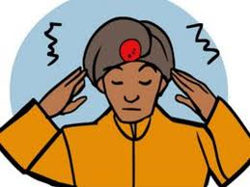

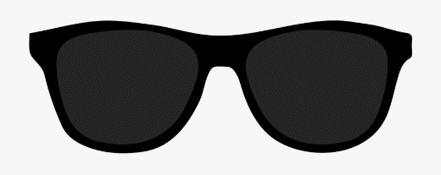
Compare & Despair
Seeing only the good and positive aspects in others, and getting upset when comparing ourselves negatively against them.
Am I doing that ‘compare and despair’ thing? What would be a more balanced and helpful way of looking at it?

Mind-Reading
Assuming we know what others are thinking (usually about us).
Am I assuming I know what others are thinking? What’s the evidence? Those are my own thoughts, not theirs. Is there another more balanced way of looking at it?

Predictions
Believing we know what’s going to happen in the future.
Am I thinking that I can predict the future? How likely is it that that might really happen?

Critical Self
Putting ourselves down, self-criticism, blaming ourselves for events or situations that are not (totally) our responsibility.
There I go, that internal bully at it again. Would most people who really know me say that about me? Is this something that I am totally responsible for?


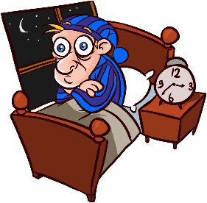
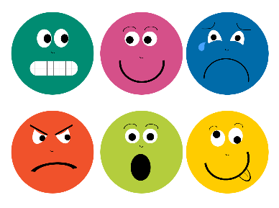

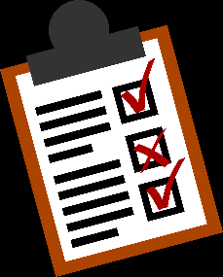

Catastrophising
Imagining and believing that the worst possible thing will happen.
Thinking that the worst possible thing will definitely happen isn’t really helpful right now. What’s most likely to happen?

Mountains & Molehills
Exaggerating the risk of danger, or the negatives. Minimising the odds of how things are most likely to turn out, or minimising positives.
Am I exaggerating the bad stuff? How would someone else see it? What’s the bigger picture?

Emotional Reasoning
This is when we say and think things like: “I feel bad so it must be bad.” “I feel anxious, so I must be in danger.”
Just because it feels bad, doesn’t necessarily mean it is bad. My feelings are just a reaction to my thoughts – and thoughts are just automatic brain reflexes.

Judgements
Making evaluations or judgements about events, ourselves, others, or the world, rather than describing what we actually see and have evidence for.
I’m making an evaluation about the situation or person. It’s how I make sense of the world, but that doesn’t mean my judgements are always right or helpful. Is there another perspective?

Shoulds & Musts
Thinking or saying “I should” (or shouldn’t) and “I must” puts pressure on ourselves, and sets up unrealistic expectations.
Am I putting more pressure on myself, setting up expectations of myself that are almost impossible? What would be more realistic?

Memories
Current situations and events can trigger upsetting memories, leading us to believe that the danger is here and now, rather than in the past, causing us distress right now.
This is just a reminder of the past. That was then, and this is now. Even though this memory makes me feel upset, it’s not actually happening again right now.

Black & White Thinking
Believing that something or someone can be only good or bad, right or wrong, rather than anything in-between or “shades of grey”.
Things aren’t either totally white or totally black – there are shades of grey. Where is this on the spectrum?


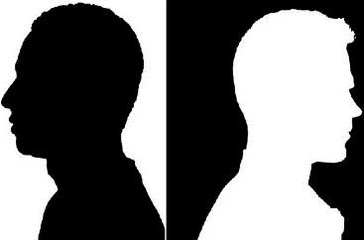

Can you identify your top 3 unhelpful thinking habits?:

It may be helpful to keep a mood diary to help you identify your unhelpful thinking habits and therefore practice challenge these unhelpful thoughts.

STOPP Technique
Stop & Step Back

Stop! Say it to yourself, in your head, as soon as you notice your mind and/or your body is reacting to a trigger.
The Stop step helps to put in the space between the stimulus (the trigger, whatever we are reacting to) and our response.
Take a Breath

Take a Breath. Breathing a little deeper and slower will calm down and reduce the physical reaction of emotion/adrenaline. Breathing is our body’s natural reset mechanism to calm ourselves down.
Focusing on our breathing means we are not so focused on the thoughts and feelings of the distress, so that our minds can start to clear and we can think more logically and rationally.
Observe

Observe. We can notice the thoughts going through our mind, we can notice what we feel in our body, and we can notice the urge to react in an impulsive way. We can notice the vicious cycle of anxiety, sadness or anger (etc.).
Noticing helps us to defuse from those thoughts and feelings and therefore reduce their power and control.
Pull Back

Pull back / Put in some Perspective. This step challenges us to think differently about the situation we find ourselves in. When we step back emotionally from a situation, and start to see the bigger picture, it reduces those distressing beliefs. We can do this by asking ourselves questions like these:
What would a fly on the wall see? / Is there another way of looking at it? / What would someone else see and make of it? / What advice would I give someone else?
Practice What Works

Practise what works. This step challenges us to do things differently. Rather than reacting impulsively with unhelpful consequences, we can CHOOSE our more helpful and positive response. Often practicing things which shift the focus of our attention can be helpful.

Grounding Technique



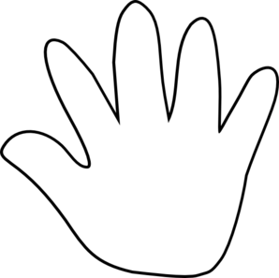


3 Things You Can Hear

2 Things You Can Smell

1 Thing You Can Taste

4 Things You Can Touch

5 Things You Can See

5 Things You Can See

