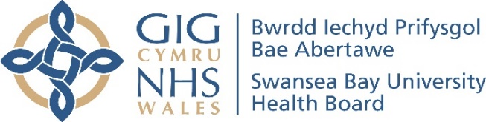


PRIVACY NOTICE

Nutrition Skills for Life, Nutrition and Dietetics Department, SBU Health Board.
This Privacy Notice tells you what to expect when your information is processed by the Nutrition and Dietetic Service. You can contact the Head of Nutrition and Dietetic Service at:
Neath Port Talbot Hospital
Baglan Way
Port Talbot
SA12 7BX
Tel: 01639 862392
E-mail: SBU.DieteticManagement@wales.nhs.uk

The Nutrition Skills for Life, Nutrition and Dietetics Department, SBU Health Board may collect and store your information in line with the NHS guidance and data protection legislation. We obtain your information from your application and registration forms. We collect and process your information in line with data protection legislation in order to provide you with information of training opportunities, accredit the courses you attend and provide ongoing support after the training and to keep accurate, up-to-date records in order to better manage partnership working. We will only collect the data we need such as name, D.O.B., address, employment details, contact details e.g. address, telephone, e-mail.

This information we have will help us provide you with the appropriate training opportunities and support and will lead to a better all-around service for the future.

We are legally able to process your personal information under Article 6 of the General Data Protection Regulation (GDPR) as the processing is necessary for us to perform our official functions as an NHS body. There will be occasions when we will rely on other lawful bases such as when the processing is required for us to comply with the law.

We are legally able to process special category information under Article 9 of the GDPR as the processing is necessary for the provision of health or social care or treatment or the management of health or social care systems and services.

We share your information between relevant departments within the health service. This includes NHS Wales Shared Services Partnership for the purpose of eLearning. This is done in line with data protection legislation.
We will collect your personal and special category information on behalf of Agored Cymru (course awarding body) for the purposes of processing your course registration when applicable. Their privacy information can be found at http://www.agored.cymru/Learners/Privacy-Statement

The Nutrition Skills for Life, Nutrition and Dietetic department will retain your information in line with national and legal guidelines for records management. We will not keep your information for longer than necessary.

You have many rights when it comes to your personal information. For example you have:
- The right to be informed (i.e. this privacy notice)
- The right of access (i.e. getting hold of your own information)
- The right to rectification (i.e. changing any errors)
- To the right to erasure (i.e. if there is a factual error, it should be amended)
- The right to restrict processing (i.e. limit the use of their data while investigation occurs)
- The right to object to processing (in certain circumstances i.e. if it is factually incorrect)
Further guidance on how to exercise your rights is available on the ICO website at: https://ico.org.uk/your-data-matters/

You also have the right to lodge a complaint with a supervisory authority if you are unhappy about how your data is processed.

In the UK, the supervisory authority is the Information Commissioner’s Office whose contact details are provided below:

Information Commissioner’s Office
Wycliffe House
Water Lane
Wilmslow
Cheshire
SK9 5AF

On-line/livechat: https://ico.org.uk/make-a-complaint/your-personal-information-concerns/personal-information-concerns/
Helpline: 0303 123 1113

The contact details for the Data Protection Officer are outlined below:

Data Protection Officer
Headquarters, Swansea Bay University Health Board
1 Talbot Gateway
Port Talbot
SA12 7BR

Tel: 01639 683336
E-mail: SBU.Confidentialityissues@wales.nhs.uk



