

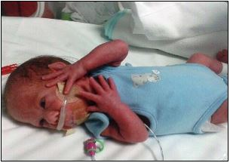
A very warm welcome to the neonatal services for Swansea Bay University Health Board.

Firstly, can we offer you our congratulations on the birth of your baby - or babies!

We'd like to take this opportunity to tell you about our services. The health board provides neonatal services at Singleton Hospital, in Swansea.

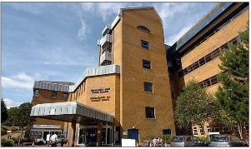
Neonatal services are there for those babies who need support and care after their birth.

The Neonatal Intensive Care Unit (also known as the NICU) is based at Singleton Hospital, Swansea pictured left, and below. It is one of the three large NICUs in South Wales. The NICU provides specialist intensive care for new born babies of all gestations and maturity.

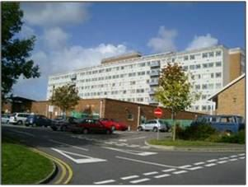
Our newly refurbished NICU unit has been designed to be compliant with latest healthcare standards in the UK and is equipped with modern equipment and advanced monitoring technologies required to care for the sickest and the most vulnerable babies to a very high standard.

We have a team of dedicated and experienced doctors, nurses and support staffs who work very hard to provide quality family centred care. Specialist surgical services for the region are provided at the University Hospital of Wales in Cardiff.

In addition to serving local population in the Swansea area, we routinely receive referrals for the most critically ill neonatal babies from the rest of the South West Wales region including Pembrokeshire, Ceredigion and Carmarthenshire. During busy periods we often accept referrals from other parts of Wales or England.
About this section of our website
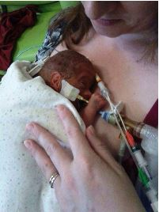
As staff within the Neonatal Services, we recognise that hospitals can be a very frightening place. This section has been created to alleviate some of the worries and answer some questions you may have as parents with a baby or babies on the neonatal unit.

As a parent, it is natural for you to want to be informed and involved in all the decisions, treatment and care your baby receives. It is recognised that the stress and anxiety of having a sick or premature baby may make it difficult for you to take in and rationalise some of the experiences you have and some of the information you receive; it may also make you hesitant in asking further questions.

Away from the intense environment of the clinical area, the section is designed to provide you with easy access to further information about your baby's condition and care needs and thus enabling you to feel more able to be involved in the decisions made on treatments and the care provided. It also provides a variety of support services information for parents and suggests ways you can best help your baby, encouraging active and effective team work between parents and staff.

(Compiled by Dr. Sujoy Banerjee, Dr. Joanna Webb, Mrs. Helen James and the Community Nursing Team with contributions from neonatal unit staff and parents of children looked after on our unit. We are grateful for all your contributions and suggestions).

Meet the team

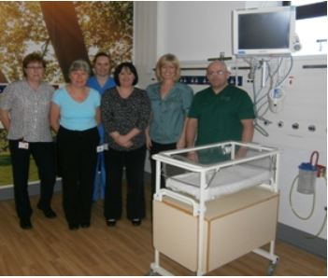
Our Consultants
Dr. Sujoy Banerjee – Clinical Lead for Neonatal Services; Consultant Neonatologist with interest in Neurodevelopment, Clinical governance, Information Technology and Postgraduate Medical Education
Dr. Geraint Morris – Consultant Neonatologist, Clinical Director of Children’s Services with interest in Paediatric Cardiology, Postgraduate Medical Education and Training

Dr. Jean Matthes – Consultant Neonatologist; Lead Clinician, Wales Neonatal network
Dr. Carol Sullivan – Consultant Neonatologist with interest in respiratory medicine and medical education and training
Dr. Maha Mansour – Consultant Neonatologist with interest in Paediatric Cardiology, Cleft Services, Family Integrated Care and Medical Education
Dr. Arun Ramachandran – Consultant Neonatologist with interest in Medical Data Management and Workforce Management
Dr. Joanna Webb – Consultant Neonatologist with interest in Medical Education and Neurodevelopment
Dr Amit Kandhari - Consultant Neonatologist; Clinical Lead for Neonatal Transport (CHANTS) within ABMU
Dr Vanessa Makri - Consultant Neonatologist with an interest in Neurodevelopment, Audit and Data management
Dr Sree Nittur - Consultant Neonatologist with an interest in Cardiology
Dr Lucinda Perkins - Consultant Neonatologist with an interest in Quality Improvement, Education and Training and Neurodevelopment
The medical team also consist of qualified doctors undergoing specialist training

Our nurses
Helen James – Matron for Neonatal Services, HB
Marcia Jordan – Lead Nurse for Neonatal Transport
Gaynor Jones – Breast feeding facilitator and Lead Nurse for Family Integrated Care
Jess Beynon - Lead Nurse for Continuing Professional Development and Nursing Education

Supported by a team of neonatal nurses and nursery nurses

Advanced Neonatal Nurse Practitioners
Kate Richards
Gemma Davies
Susan Edwards
Stephanie Cannell

Healthcare Assistants
Ria Dalling
Denise Brown
Susan Dalling

Receptionists
Alison Forest
Kim Vickers
Susan Stuckey

Neonatal Secretaries
Joanna Morgan
Helen Banks
Emma Mugford
Helen James

Data coordinators
Abigail Porter

Directorate Support Officer

Michelle Weston

Samantha Willis
Bethan Jones

Outreach Community Nursing Team
Cheryl Morgan – Lead for Neonatal Outreach Service
Sarah Owens
Sarah Davies
Cheryl Tobin

Therapy and other services
Amanda Lawes - Neonatal Occupational Therapist
Ceri Selman – Paediatric Physiotherapist
Katherine Willson – Neonatal Pharmacist
Sijbrigje Hood - Paediatric Dietician

How to get here
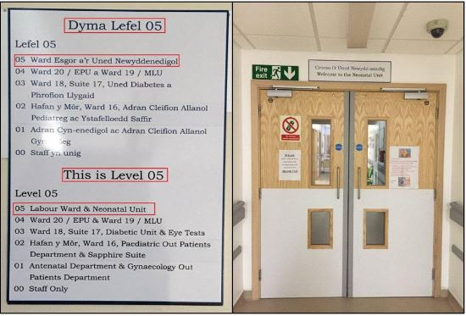
The Neonatal Unit is located on the 5th Floor of the Women and Children’s Block adjacent to the delivery suite.
Address:
Singleton Hospital,
Sketty Lane,
Sketty,
Swansea
SA2 8QA
NICU Reception Tel: 01792285403
SAT NAV users - please use postcode SA2 8QA

