Recognising our staff

Many different types of staff work on the Neonatal Units of the Swansea Bay University Health Board – Doctors, nurses, health care assistants, ward clerks to physiotherapists. This page helps you identify our staff from the uniforms they wear.

All staff members have NHS identity badges with their photographs on the badge - these should be visible at all times.

 | Doctors  All our Doctors wear everyday clothes - their own shirts or blouses, trousers or skirts. You may also see them wearing green or blue surgical gowns.
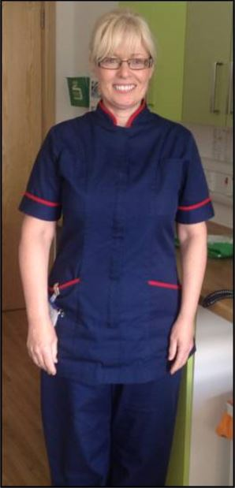 | Lead Nurse  Lead Nurse is responsible for managing nursing and allied staff on the neonatal unit. Lead Nurses wear Navy Blue trousers and tops with a red trim on the collar
 | Ward Manager  A Ward Manager is a senior nurse in charge of all the nurses working on a particular shift. They wear Navy Blue trousers and tops.
 | Staff Nurse  A Staff Nurse is a registered nurse looking after your baby on the neonatal unit. They wear light blue trousers and tops.
 | Nursery Nurse  A Nursery Nurse often looks after your baby in Special care areas, transitional care units and postnatal ward under the supervision of Staff nurses. They are often very experienced in supporting you and your baby before they are ready to go home. They wear light green trousers and tops.
 | Healthcare Support Worker  A Health Care Support Worker contributes to house-keeping and administrative duties on the unit. They wear dark green trousers and tops.
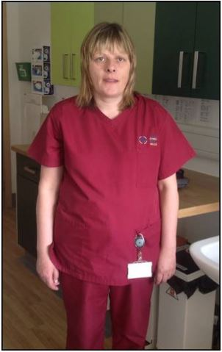 | Domestic Assistant  A Domestic Assistant helps to keep the Neonatal unit clean and tidy. They wear Burgundy trousers and tops.
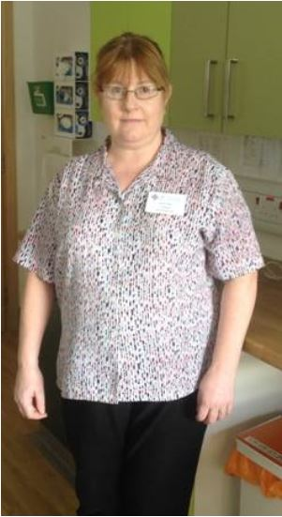 | Receptionists and Ward Clerks  A Ward Clerk / Receptionist provide general administrative, clerical, and support services for the Neonatal Unit. They wear blue patterned tops and navy trousers
 | Physiotherapists  A Physiotherapist has specialist skills and knowledge and helps to develop/restore movement and function through positioning, manual therapy and exercises. They wear white tops and navy blue trousers.
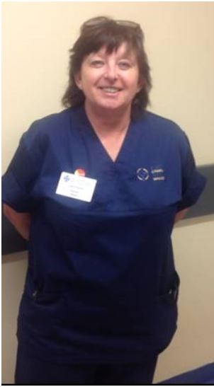 | Midwife Supervisor  A midwife supervisor supports a mother through pregnancy and childbirth including routine postnatal care. They wear dark blue tops and trousers.

