Preparation for Discharge

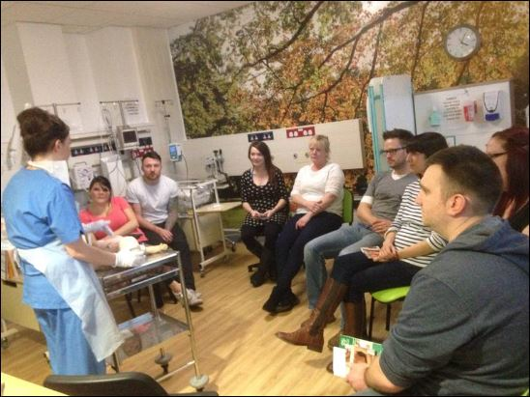
Babies will usually be ready for discharge when they are able to feed by themselves (breast or bottle) and maintain their temperature whilst in a cot – i.e. not requiring an incubator. There are certain exceptions to this but staff will guide you as to your baby’s readiness for discharge. Most premature babies will be ready for discharge shortly before their due date.

If your baby is still requiring oxygen but otherwise ready to go home, arrangement could be made for oxygen to be installed in your house and for you to receive the appropriate training in order to care for your baby at home. The community neonatal nurses will be heavily involved if this is the case and be available to visit you frequently at home to support you and your baby. Please see the Community Neonatal Nurses page for more information.

Before discharge you will have the opportunity to care for your baby on the neonatal unit, either by “rooming in” (being resident in one of our mother and baby rooms in the family unit overnight) or by doing the day-to-day care for your baby during the day if you are unable to be resident. This will enable you to feed, bathe and generally care for your baby whilst having the experienced neonatal nurses on hand to give advice/help if needed. Once you and your baby are ready you will be discharged home. You will have the opportunity to have training in resuscitation (basic life support) and how to manage choking prior to discharge.

If your baby is requiring any medicines you will be given a supply to take home from the hospital. You will then have to get further supplies from your GP on repeat prescription if the medicine is to continue. It is important that you register your baby with your GP before discharge.

Prior to discharge, parents have the opportunity to give feedback about the units in the form of a questionnaire. Please find time to complete this as we value your opinion on what was good about our service and areas that you feel could be developed and improved.

Following discharge you will be given an appointment to see your Consultant in outpatients – this is a good opportunity to review the problems encountered whilst your baby was on the neonatal unit, discuss ongoing medical issues and review growth and development. (Your named Consultant is usually the Consultant who was attending during the week your baby was born). This appointment would usually be around 6 weeks post discharge. If your baby has had other problems during his/her stay they may have other appointments for example for a heart scan, for a hip Ultrasound scan or for blood tests. All babies born less than 30 weeks gestation and all babies that undergo cooling treatment (therapeutic hypothermia) will be offered a developmental assessment appointment at 3 months corrected age, 1 year and 2 years corrected age.

