Neonatal Services – Meet the Patients

Jacob and Isaac
My name is April, and this is our story so far. Me and my husband Martin are parents to 4 children, 3 girls and a boy. So it came as a bit of a surprise to find out we were expecting twins, although a nice surprise when the shock wore off. My pregnancy wasn’t the easiest, very different to my 4 full term normal pregnancies and deliveries. I had spontaneous rupture of membranes around twin 1 at 23 weeks and 6 days, and was transferred to Singleton Hospital from my local hospital for the specialist intensive care cots.

On arrival to Singleton, I was taken to the labour ward. The midwives greeted me and supported me though a very scary time. Myself and husband were also introduced to members of the SCBU team who discussed with us what we could possibly expect if I went on to deliver at this point. Their information and reassurance I cannot underestimate. They gave me and my husband hope when all I felt was fear and hopelessness.

I was given steroids to help develop the babies’ lungs and medication to stop labour at this time. I was admitted to Ward 19, where the midwives were kind and supportive and provided reassurance, which was appreciated in such a difficult, frightening, and emotional time. I remained an inpatient until I went into spontaneous labour at 27+4 weeks. It is hard to describe the mix of emotions, we were going to meet our babies, the uncertainty and fear of what was to come at birth, and what the future was going to hold.

Following a rather quick labour Isaac Asher Davies was born on 17/03/14 at 12:56 AM weighing 830g, the SCBU team were all at hand and took over Isaac’s care, while I prepared for the arrival of our second baby. Jacob Elijah Davies was born on 17/03/14 at 02:25 AM weighing 950g, again the SCBU team were all ready to take over Jacob’s care. My whole trust was put in them, handing over my precious sons to them; our family was now complete with 3 sons and 3 daughters.

Jacob and Isaac both needed a lot of assistance at delivery, and were ventilated at delivery. The midwives and SCBU team kept me and my husband informed of what was happening throughout, and welcomed us on the Unit as soon as I was able to following delivery. The feeling of fear, shock, and pride was overwhelming. The staff on the Unit made us feel very welcome and reassured, not sure if anything could have prepared us for what was ahead of us. People say the experience is like a roller coaster ride, so many ups and downs.

The staff made sure where possible we were involved in the boys’ care, and I was fully supported in expressing breast milk for my boys, which was a great thing to be able to provide as a mother. The care and tenderness the nurses gave to my boys was overwhelming.

Jacob’s Story
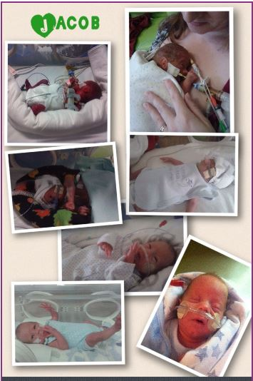
During Jacob’s time at SCBU in Singleton he went through so much, he was intubated at birth and was put on to high frequency oscillation for a period of time, following a pulmonary haemorrhage, Jacob battled through infection, stridor, extremely high blood sugars, metabolic acidosis, oedema, and problems relating to extreme prematurity. Following several attempts at coming off ventilation at day 24 Jacob successfully changed to CPAP which he stayed on until day 32 when he was changed to high flow, which he remains on to date Day 50. We are now at the point of transfer back to our local hospital.

I cannot thank the nursing and medical staff at Singleton enough. Myself and my family will be forever grateful.

Isaac’s Story

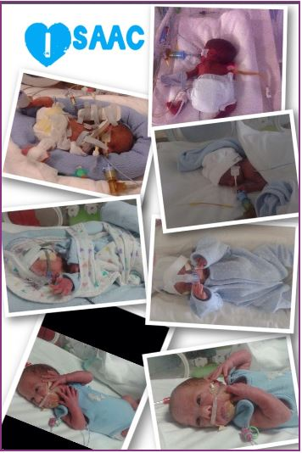
Isaac, like his brother, was ventilated at birth and battled through infection, oedema, and considerable difficulties with his extremely premature lungs, and problems relating to extreme prematurity. Isaac also required high frequency oscillation for a period of time and needed treatment with nitric oxide, which was an extremely frightening time, but the nurses could not have been more supportive and informative involving us as parents at all times. After several attempts of coming off the ventilator, Isaac successfully went onto CPAP followed by high flow which he remains on to date. Isaac is also getting ready for transfer back to our local hospital.

There are no words I can use to express my thanks. I look at my boys now and cannot believe what they have been through, and where they are now, the staff at Singleton truly perform miracles, and our boys are our little miracles. Although still some time to go, we are now able to look forward towards the future and many fun times ahead.

Nobody can really prepare you or understand what it is like to have a baby in NICU, unless you have been there yourself, but the medical and nursing staff are there supporting you all the way. So once again a massive thank you.

