



Swansea Community Learning Disabilities Health Team

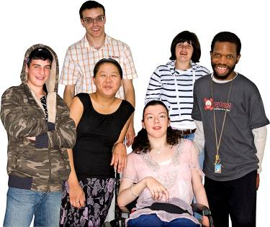 | We work with adults who have a learning disability
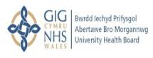  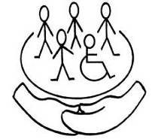 | We are part of the Community Support Team and work with the Care Managers
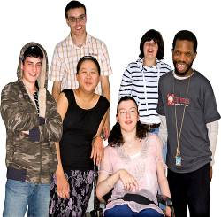  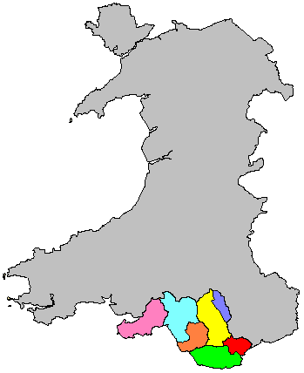 | This team is for people who live in the Swansea area
Who we work with

How to get help

 | Anyone can refer you to the team if you want our help
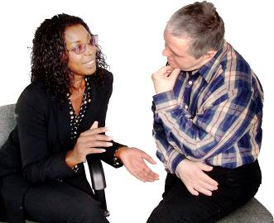 | You can ask your  Care Manager  GP  family or care staff  to refer you
 | You can talk to staff in the Health Team to ask for help

Who is in the team?

 | Consultant Psychiatrist
 | Community Nurses
 | Occupational Therapy
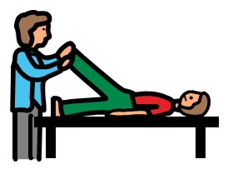 | Physiotherapy

Who is in the team?

 | Psychology
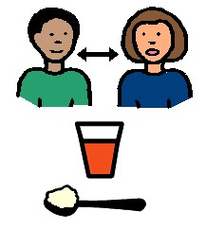 | Speech and Language Therapy
 | Specialist Behaviour Team

These are examples of some of the things we can help you with

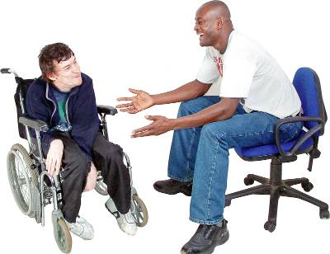 | Communicating well
 | Eating and drinking safely
 | Epilepsy
 | Feeling well and help with your emotions

These are examples of some of the things we can help you with

 | Learning new skills
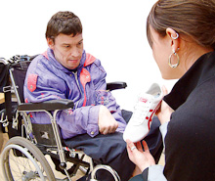 | Being independent
 | Walking and moving
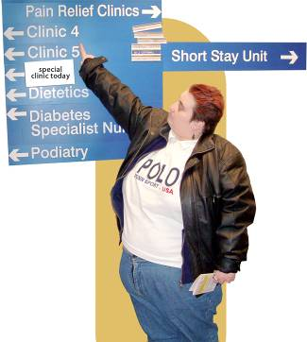 | Support you to see Doctors and going to hospital
What we will do

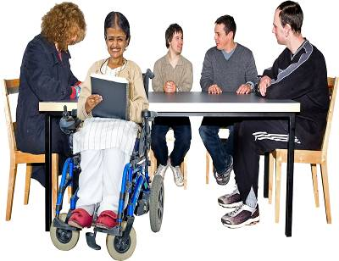 | We will work with you and your carers to plan what help you need
 | We will also talk to your Care Manager if you have one
 | We can also talk to other teams who care for you like your GP or housing association
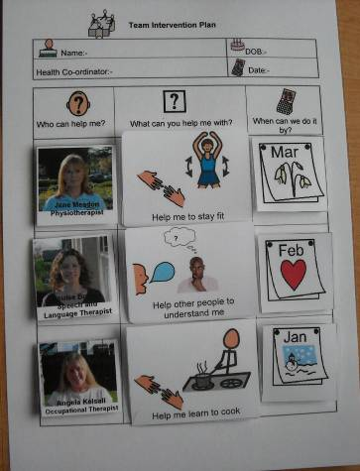 | We will then make a plan about who will help you, when they will help and how they can help.  If you want you can have a copy of your Health Plan

When we are open

The Team is open Monday to Friday

9.00 in the morning to
5.00 in the afternoon
The Team is shut on Saturday and Sunday

How to contact us
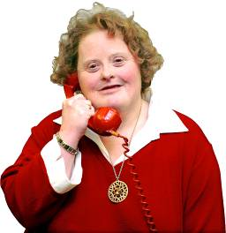 | Our telephone number is  01792 614100
Our address is

Community Support Team
Civic Centre
Oystermouth Road
Swansea
SA1 3SN

