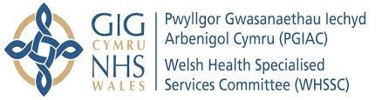 | Welsh Health Specialised Services Committee


Plans For Hearing Implants

- South East Wales
- South West Wales
- South Powys

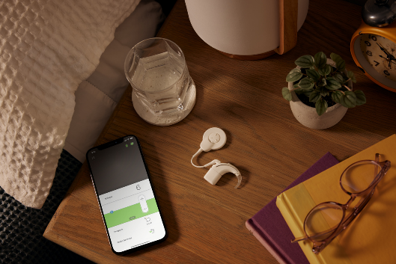

Pictures - Copyright Cochlear Limited

 | This booklet is about plans for the way we give services for people who need ear implants.
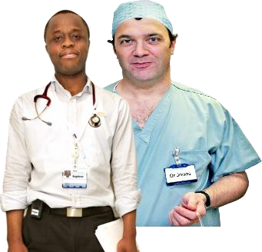 | There are two types of hearing implants, doctors call these:  - Cochlear Implants  - Bone Conduction Hearing Implants (BCHI)  Many people also call a BCHI a Bone Anchored Hearing Aid (BAHA)
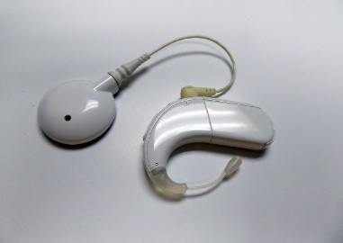 | Someone may need a hearing implant because of:
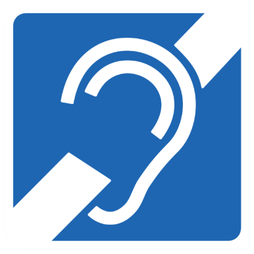 | - deafness in one or both ears
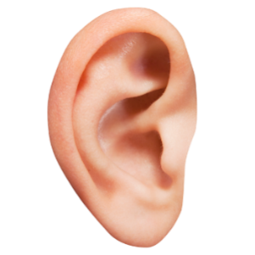 | - hearing loss due to the shape or size of the ear canal
 | - hearing loss due to a medical reason
 | The implant is placed by a team who have a lot of training and experience.
 | This booklet is from Welsh Health Specialised Services Committee.
 | We sort services that are only given by a few centres in Wales or the UK. We make sure people can get an implant if they need it.
Where Are These Services?

 | People needing implants went to:  Cochlear Implants  - Princess of Wales Hospital, Bridgend  - University Hospital Wales, Cardiff
 | Bone Conduction Hearing Implants  - Neath Port Talbot, Swansea  - University Hospital Wales, Cardiff  - Royal Gwent Hospital, Newport
 | In 2019 the Cochlear service in Bridgend closed.
 | All patients needing a Cochlear implant since 2019 are seen in Cardiff.
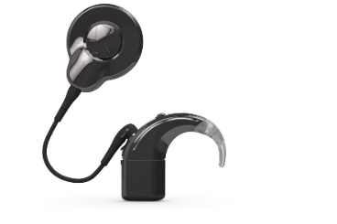 | There was no change for people needing a BCHI.
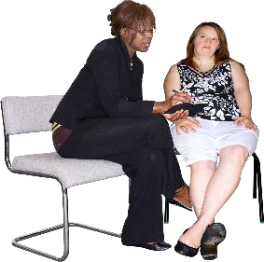 | How Could These Services Be Better?  We talked to experts and patients.
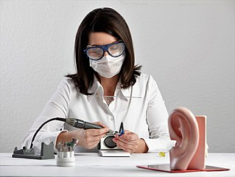 | We talked to the clinical team who give these services.
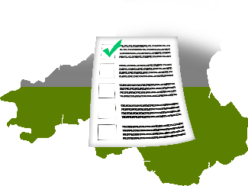 | We looked at information about hearing implant services in:  - South East Wales  - South West Wales  - South Powys
- What Did We Learn?

- Last year
- 48 people had a Cochlear Implant
- 27 people had a Bone Conduction Hearing Implant
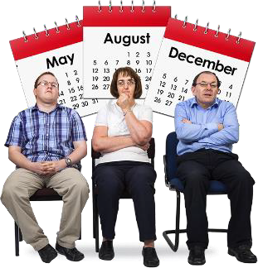 | - Sometimes people have to wait too long to have a hearing implant.
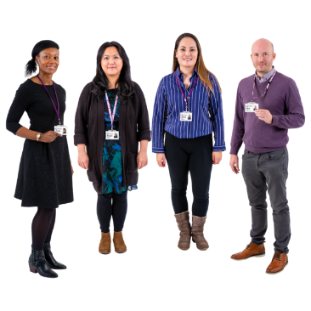 | - Not all hospitals that place hearing implants have all of the right team to do this.
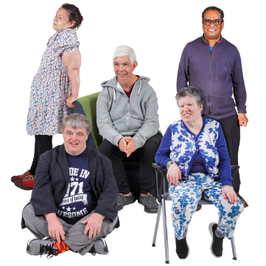 | - The number of Cochlear implant patients is small.  - The number of BCHI patients is smaller.
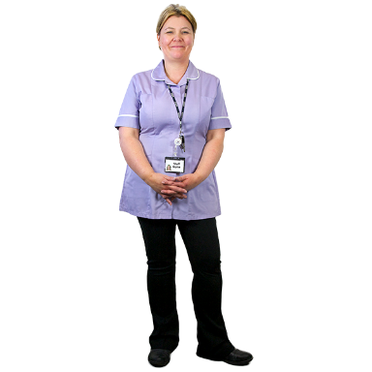 | - There are not enough staff.
 | It is sometimes difficult for services to meet their standards.

Our Ideas For Implant Services
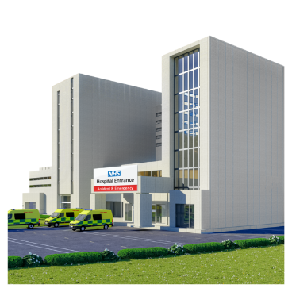 | - We would like to have a single implant centre for South East Wales, South West Wales and South Powys.
 | - A single centre would be able to provide a high quality service for Cochlear and BCHI implants.
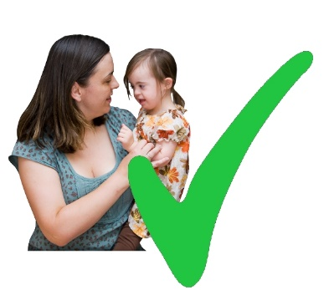 | - We want this centre to be for adults and children.
 | - It will be easier to employ and keep staff in a single centre.
 | - Skills can be kept at the highest level with more implants being done.
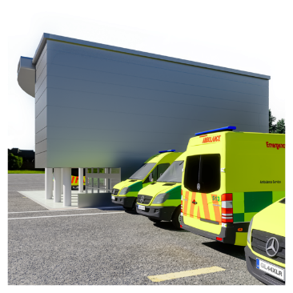 | - It is easier for a bigger centre to cope with emergencies, changes and some staff being ill or leaving.
 | - Moving all the hearing implant operations to one hospital will not change other local services.
 | We Want To Hear What You Think.  Tell us what you think about our ideas?

 | We are also asking:
 | - people who know a lot about hearing implants
 | - staff from health boards
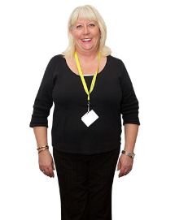 | - people who work for charities
 | - Patients with a hearing implant and their families
 | When we have heard everybody’s thoughts we will look at:
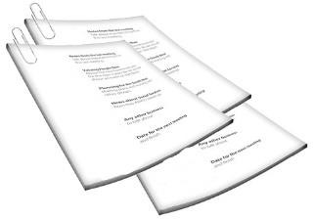 | - what we have found out
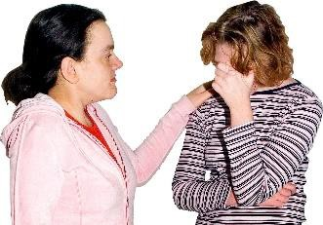 | - if our plans may make life harder for some groups of people
 | - Any extra information
About you.
 | Name:

Tick your answer | 
I am telling you what I think.
I am telling you what an organisation thinks.

 | Please tell us what you or your organisation thinks:

 | Anyone may see your answers.  If you want something kept private, please tell us.
 | Do not put personal medical information.
 | Use full words.
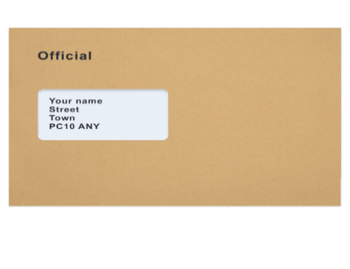 | Do not send us research articles or leaflets.
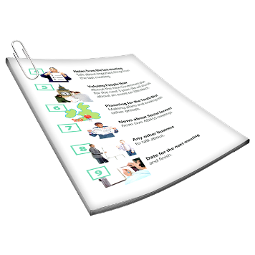 | The full document has more details.
 | You have until 14/02/2023 to tell us what you think.

How do your answers get to us?
Please send your answers in the envelope (you don’t have to pay to buy a stamp):
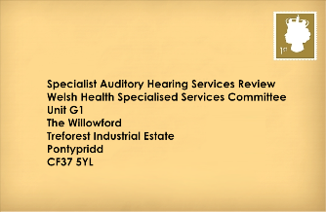 | Specialist Hearing Implant Service Review  Welsh Health Specialised Services Committee  Unit G1  The Willowford  Treforest Industrial Estate  Pontypridd  CF37 5YL
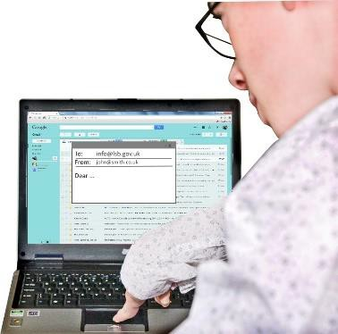 | Email: WHSSC.GeneralEnquiries@wales.nhs.uk
 | Do you want to tell us anything else?
 | Thank you for telling us what you think.

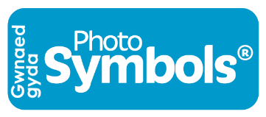 | This easy read was made by  Planet Easy Read  We use Photosymbols

