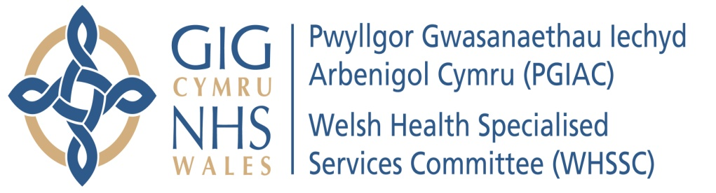

 | 

COCHLEAR IMPLANT AND BONE CONDUCTION HEARING IMPLANT (BCHI) DEVICE SERVICES FOR CHILDREN & ADULTS IN SOUTH EAST WALES, SOUTH WEST WALES AND SOUTH POWYS

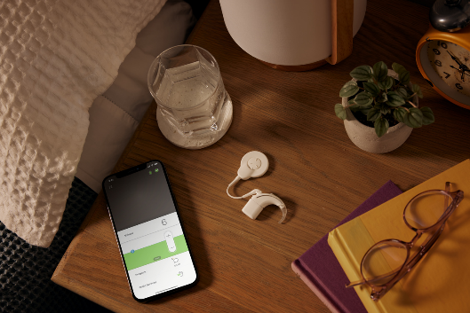

Pictures - Copyright Cochlear Limited
CONTENTS
1. INTRODUCTION 3
2. WHAT ARE COCHLEAR IMPLANTS AND BONE CONDUCTION HEARING IMPLANT (BCHI) SERVICES? 5
3. WHO NEEDS THESE SERVICES? 6
What do we know about hearing loss in Wales? 6
4. HOW ARE COCHLEAR IMPLANT AND BCHI SERVICES CURRENTLY ORGANISED IN SOUTH WALES? 7
National Context 7
5. HOW DOES THE SERVICE PERFORM? 10
Table 1: Referrals 10
Activity 11
6. WHAT ARE THE CHALLENGES FACING COCHLEAR IMPLANT AND BCHI HEARING DEVICE SERVICES IN SOUTH WALES ? 13
• Workforce challenges 13
• Commissioning High Quality Sustainable services 13
• Services spread across the South Wales region 14
• Waiting Times 14
7. WHAT OPTIONS HAVE WE CONSIDERED TO RESPOND TO THE CHALLENGES? 15
• Clinical Option Appraisal 15
• External Assessment 17
• Financial Appraisal 18
In summary of the outcome of the 3 pieces of work: 18
8. IMPACT OF THE CHANGE 20
What is the Impact? 20
9. HOW CAN YOU CONTRIBUTE: ENGAGEMENT AND CONSULTATION 21
Next Steps 21
ANNEX A –Cochlear engagement Questionnaire 23
ANNEX B – GLOSSARY OF TERMS 29

1. INTRODUCTION

Many people in Wales experience hearing loss. Health Boards in South East Wales, South West Wales, and South Powys have been working together to identify the best way to deliver an implantable hearing device service in South Wales. These services currently include the Cochlear Implant service and the Bone Conduction Hearing Implant service (BCHI) (many people also call a BCHI a Bone Anchored Hearing Aid BAHA). The reason we need to talk with you now is that there are temporary arrangements in place for the Cochlear Implant service, and we would like to get them to a more permanent position.

As the commissioner of the services, the Welsh Health Specialised Services Commission (WHSSC) has worked with colleagues from across South East Wales, South West Wales, and South Powys to consider how we deliver a safe and sustainable hearing implant devices service for adults and children that meets published national standards and guidance. Services for patients living in North Wales and North Powys are not included in this work.

This paper will answer the following questions:
- What are Cochlear Implant and Bone Conduction Hearing Implants? (BCHI)?
- Who needs a Cochlear Implant or BCHI?
- How are services in South Wales currently organised?
- What challenges are facing the service?
- What options do we have to respond to the challenges?
- Do we have a preferred option?
- What are the advantages and disadvantages?

We welcome views from all residents and stakeholders in South East Wales, South West Wales and South Powys who may be affected by the preferred option for how this service could be provided in the future.

We have developed a questionnaire that you can use to respond at Annex A. If you have feedback that you would like to comment on that the questionnaire does not cover, please share this in the commentary section at the end.
Consideration has been given to those with protected characteristics through the completion of an Equality Impact Assessment (EQIA). The responses we receive from this engagement exercise will further inform the EQIA.

Due to the nature of the service, we recognise that this document will have some medical terms within it that may not be familiar to all. There is a description of these words is in Annex B.

2. WHAT ARE COCHLEAR IMPLANTS AND BONE CONDUCTION HEARING IMPLANT (BCHI) SERVICES?

Hearing loss affects over 10 million people across the United Kingdom. It can lead to significant health and mental health issues1. It is a very common condition affecting around one in seven of the population. As we get older, the chance of us having hearing loss increases.
Many people with hearing loss wear a hearing aid(s), which make sounds louder in the ears. Not everybody is able to wear hearing aids, as the hearing aid cannot be made loud enough for them to hear clearly. There are many medical conditions that make hearing aids unsuitable for certain, people and an implantable hearing device may therefore be considered.

Cochlear Implant | Bone Conduction Hearing Implant (BCHI)
A Cochlear Implant is for people who gain no benefit from air conduction hearing aids. The implant stimulates the nerves in the inner ear to create sound. | A BCHI is for people who cannot physically wear an air conduction hearing aid. BCHI uses bone conduction to help sound get to the inner ear.
Specialist hearing services that support people needing Cochlear Implants and/or BCHIs aim to:
- Provide a high quality, family focused Cochlear Implant and BCHI programme
- Provide patients with hearing devices with the aim of restoring hearing function and enhancing the listener’s quality of life.
- Provide adults and children with hearing rehabilitation to ensure that patients get the maximum benefit from their devices – this could be through direct input or by providing an advisory service to more local services.
- Promote understanding and the use of the spoken language in children.

3. WHO NEEDS THESE SERVICES?

What Do We Know About Hearing Loss In Wales?

There are approximately 613,000 people over the age of 16 with severe/profound deafness in England and Wales.

Around 370 children in England and 20 children in Wales are born with permanent severe/profound deafness each year. Around 90% of these children live with hearing parents. About 1 in every 1,000 children is severely or profoundly deaf at 3 years old. It is 2 in every 1,000 between the ages of 9 and 16.
Doctors and Audiologists who believe a person could be helped by a hearing implant can refer the person to a specialist hearing centre to be seen by a team of clinical staff, (a multi-disciplinary team). This team will assess whether someone is suitable for a hearing implant. Not all people will benefit from a hearing implant.
It is really important that children who have hearing loss are identified and seen early so that they can learn to speak well, take part in school and learning, make friends and have good conversations.
People who receive a Cochlear Implant or BCHI device may have:
- A chronic ear disease
- Deafness in one or both ears
- Ear canal problems
- Malformations of or absent ear structures

4. HOW ARE COCHLEAR IMPLANT AND BONE CONDUCTION HEARING IMPLANT (BCHI) SERVICES CURRENTLY ORGANISED IN SOUTH WALES?
Hearing Implant Device Services
The Welsh Health Specialised Services Committee is responsible for the commissioning (buying and monitoring) of Cochlear Implant and BCHI Device services for Welsh residents.
Cochlear Implants
There are two specialist centres for Cochlear Implant services in South Wales:
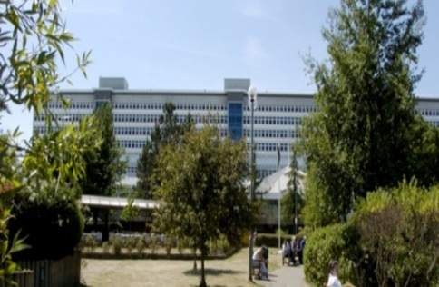
- One at the University Hospital of Wales, Cardiff and Vale University Health Board, and;

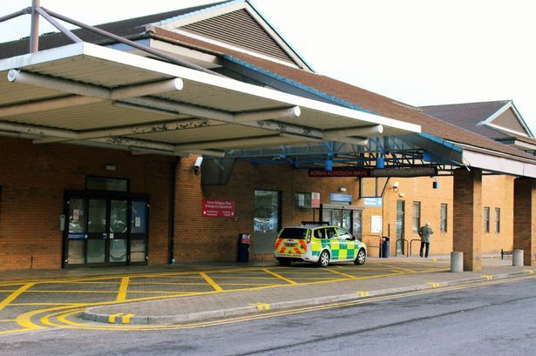
- One at the Princess of Wales Hospital, Cwm Taf Morgannwg, University Health Board

Urgent temporary service change arrangements for the Cochlear Implant service located in the Princess of Wales Hospital, Bridgend have been in place since September 2019. The patients previously seen at the Princess of Wales Hospital in Bridgend are currently seen in the University Hospital of Wales, Cardiff.

Referrals
Prior to August 2019, people living in the following areas were referred to (sent to and seen at) the Princess of Wales Hospital, Bridgend:

Carmarthenshire
Ceredigion
Pembrokeshire
Neath
Bridgend
Swansea
A small number of South Powys patients

People living in the following areas are currently referred to (sent to and seen at) the University Hospital of Wales, Cardiff:

Cardiff and Vale
Gwent
Merthyr Tydfil
Rhondda Cynon Taff
Taff Ely
small number of South Powys patients

Bone Conduction Hearing Implants
There are three centres delivering the Bone Conduction Hearing Implant (BCHI) Service. Services from University Hospital of Wales, Cardiff and the other at Neath Port Talbot Hospital are funded by the Welsh Health Specialised Services Committee (WHSC) on behalf of all Health Boards.

  Neath Port Talbot Hospital, Port Talbot | 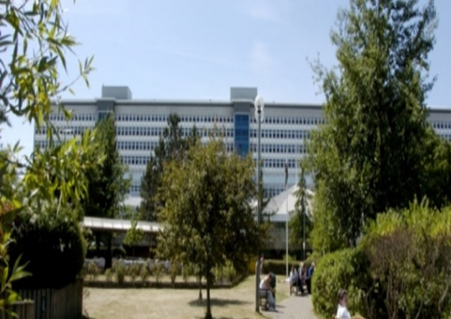  University Hospital of Wales, Cardiff

The service delivered from the Royal Gwent hospital is funded by Aneurin Bevan University Health Board.
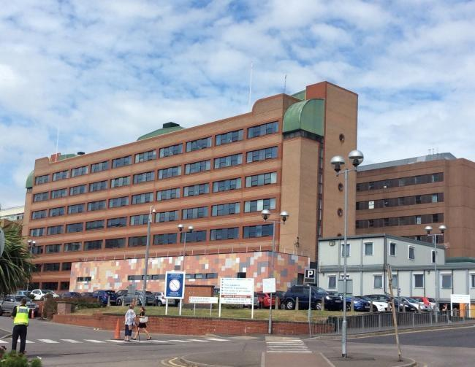
The Royal Gwent
Hospital, Newport
Referrals
People living in the following areas are currently referred to (sent to and seen at) Neath Port Talbot Hospital, Port Talbot:

Carmarthenshire
Ceredigion
Pembrokeshire
Neath
Bridgend
Swansea
A small number of South Powys patients

People living in the following areas are currently referred to (sent to and seen at) University Hospital of Wales, Cardiff:

Cardiff and Vale
Merthyr Tydfil
Rhondda Cynon Valley
Gwent
Taff Ely
small number of South Powys patients

Some adults living in the Gwent area are seen in the Royal Gwent Hospital, Newport, which is not a Welsh Health Specialised Services Committee commissioned service for BCHI.

5. HOW DOES THE SERVICE PERFORM?

There are three pieces of information that are reported by the service which indicate how it performs. These are:
- Referrals – the number of adults and children who need the specialist service and are referred by their doctor or auditory specialists

- Waiting times – length of time adults and children have to wait in weeks or days to be seen for treatment

- Activity – number of adults and children who receive treatment

Table 1 shows the number of adults and children referred to the Cochlear Implant and Bone Conduction Hearing Implant (BCHI) service over the last four years.

Table 1: Referrals

Cochlear  Implant  Referrals | 2017/18 | 2018/19 | 2019/20 | 2020/21
Adults | 56 | 57 | 82 | 31
Children | 20 | 17 | 31 | 12
Bone Conduction Hearing Implant (BCHI) Referrals
Adults | 32 | 37 | 50 | 15
Children | 4 | 2 | 2 | 3

The next table (table 2) shows how long adults and children were waiting to receive treatment for a Cochlear Implant or BCHI during 2019/20.

Table 2: Waiting Times to first assessment 2019/20

Cochlear Implant Waiting time | Cardiff and Vale University Health  Board | Swansea Bay University Health  Board | Aneurin Bevan University Health  Board
New adults | 8 weeks | Not applicable | Not applicable
New children | 4 weeks | Not applicable | Not applicable
BCHI Waiting Time
New BCHI patients | 2-3 weeks | 12 weeks | 24 weeks

Table 3 shows the number of adults and children that were treated in the last four years.
The numbers were much lower in 2020/21 due to the Covid-19 pandemic.

Table 3: Activity

Cochlear Implant Activity | 2017/18 | 2018/19 | 2019/20 | 2020/21
Adults | 14 | 28 | 32 40 | 30
Children | 16 | 15 | 17 | 16
BCHI
Activity
Adults | 25 | 21 | 18 | 4
Children | 0 | 0 | 0 | 0

Outcomes for Cochlear Implant and Bone Conduction Hearing Implant (BCHI)
Hearing Implant services are required to take account of national standards to ensure that treatment is provided in the best possible way. Patients are asked to complete a number of questionnaires asking about their hearing loss, how it is affecting them, and whether the hearing implant has improved their hearing and general quality of life.

There are other tests that can be used to measure how well a person can hear words or words in sentences, without lip-reading. These tests are used to see if the adult or child is suitable for a Cochlear Implant. This is known as a speech test measurement and is performed before surgery and again after surgery to measure the change and whether there has been an improvement in the quality of their hearing.
For those adults or children who have been assessed and may be suitable for a BCHI, speech tests are not usually used. The measure is more around reduction in pain, ear infections, ear mould allergies or how well the BCHI fits compared to an air conduction hearing aid.

6. WHAT ARE THE CHALLENGES FACING COCHLEAR IMPLANT AND BCHI HEARING DEVICE SERVICES IN SOUTH WALES?

Services face a number of current challenges, which are outlined here:

Workforce Challenges
During 2019, it was established that the service provided from the Princess of Wales hospital in Bridgend was facing workforce challenges and had become unsustainable. The Bridgend service was without Audiology support and, as a result of this staffing shortage, was unable to meet some of the quality indicators or achieve the standards as recommended by the British Cochlear Implant Group.
In line with the guidance on ‘Changes to NHS services in Wales’, arrangements were made for the temporary transfer of Cochlear Implant surgery services from Cwm Taf Morgannwg University Health Board to Cardiff and Vale University Health Board. The change means that patients who would have gone to Princess of Wales Hospital Bridgend for surgery and out-patient appointments are temporarily seen at the University Hospital of Wales, Cardiff. Staff from the Bridgend service were also temporarily transferred to support the provision of the service in Cardiff, enabling a level of continuity for patients previously being seen in the Princess of Wales hospital.

Commissioning High Quality Sustainable Services

High quality sustainable services need to have a large number of patients in order to support the development and maintenance of skills across the multi-disciplinary team.

The British Cochlear Implant Group (BCIG) standards recommend:
- That a cochlear implant centre should have a minimum of two experienced ear surgeons who both undertake a minimum of 10 surgeries per year in order to maintain high levels of skill and experience.
Guidance on standards for Bone Conduction Hearing Implant (BCHI) services comes from a consensus statement of experts, which states:
- That BCHI fitting should take place in a specialist auditory implant device centre performing at least 15 implants per year.
With the number of patients needing these services in South East Wales, South West Wales and South Powys, not all centres are able to achieve the quality standards and guidance that are set out in the British Cochlear Implant Group guidelines and NHS England Clinical Commissioning Policy for Bone Anchored Hearing Aid.

These services also need a multi-disciplinary team that is able to discuss and offer access to all types of hearing implants.

Services Spread Across The South Wales Region

The current configuration of services across South Wales means that no service has a high enough number of patients to support a sustainable workforce, and there is not currently a centralised multi-disciplinary team in place.

Waiting Times
Waiting times across the region vary from centre to centre and can lead to some patients in Wales waiting longer than others.

7. WHAT OPTIONS HAVE WE CONSIDERED TO RESPOND TO THE CHALLENGES?

Our aim is to have a safe and sustainable specialist hearing implant device service for children and adults in South East Wales, South West Wales and South Powys that:
- Provides equitable access
- Meets published standards and guidance
- Has staff in the right place with the right specialist skills
- Has a multi-disciplinary team where all patients are discussed and planned for, and able to offer access to all types of commissioned hearing implants
- Facilitates timely access to surgery
To consider the best option, three pieces of work have been undertaken:
- A clinical option appraisal
- An external assessment of the options and how they would deliver against standards set for the service
- A financial option appraisal
Underpinning all three pieces of work were the British Cochlear Implant Group guidelines and the NHS England BCHI Commissioning policy.
Below is a summary of the work:

Clinical Option Appraisal
A series of workshops with clinical teams from Cardiff and Bridgend were held between September 2021 and June 2022 with the aim of discussing the best way of delivering a safe and sustainable specialist hearing implant service for adults and children in South East Wales, South West Wales and South Powys that meets national standards.
The group agreed that a high quality sustainable service needed to be able to meet the criteria in table 4 below, which were developed from the published standards and guidance documents.

Table 4: Criteria developed from published standards and guidance

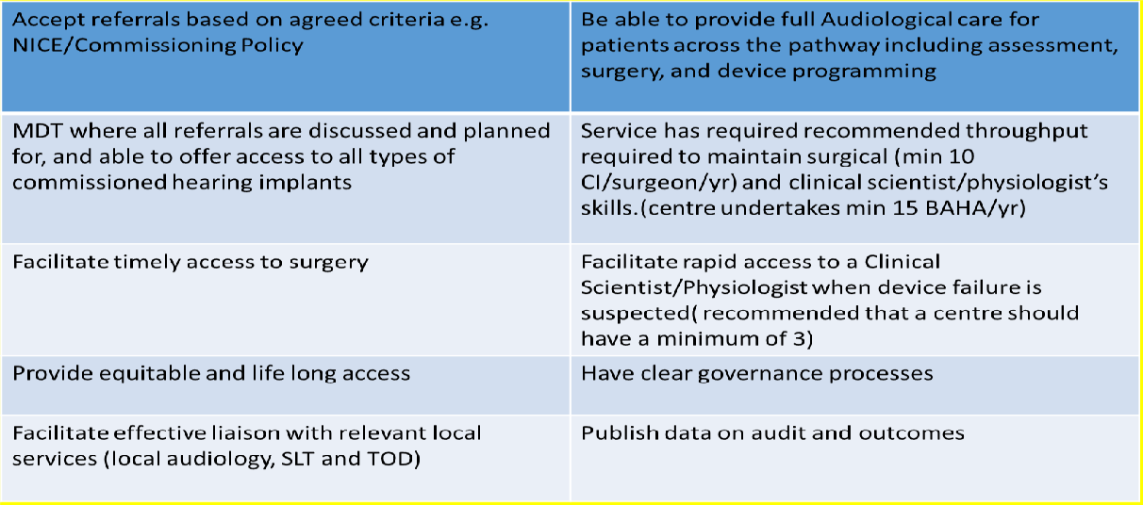

The group considered five options for the delivery of specialist hearing services in the future and scored them against the following criteria:
- Quality and Patient Safety
- Achievability (Staffing, sustainability, and training)
- Accessibility
- Clinical Effectiveness and Efficiency
- Acceptability

The options considered were:

 | Option | Description
A | Do Nothing | 2 Cochlear Implant hubs for adults and children,  3 BCHI hubs for adults and children
B | Central Cochlear Implant/distributed  BCHI | Single Hub (with outreach) for Cochlear Implant 3 BCHI hubs for both adults and  Children
C | Central Cochlear Implant Central Paediatrics  BCHI Distributed adult BCHI | 1 Cochlear Implant hub with Cochlear Implant outreach 1 BCHI hub (Paediatrics)  3 BCHI hubs (adult)
D | Single implantable device hub | 1 single centre for Cochlear Implant and BCHI for both children and adults with an outreach support model
E | 1 Cochlear Implant hub (Children & adults) 1 BCHI hub (Children and  adults) | 1 single centre for BCHI (children and adults)  1 single centre for Cochlear Implant (children and adults)

The clinical team’s assessment of the options against the agreed criteria (developed from published standards and guidance), led them to conclude that Option B was their preferred option.

External Assessment
To consider the options against the same agreed criteria, a panel from a specialist hearing centre from within NHS England was asked to objectively assess the options. In undertaking this assessment, the external assessors arrived at the following ranking of the options:
Option | External specialist hearing implant centre assessment
A | 5
B | 4
C | 3
D | 1
E | 2

The outcome of the external assessment against the standards was Option D being the preferred option.

Financial Appraisal
Finally, each of the options was reviewed financially. It was concluded that none of the options would cost more than the delivery of the current service. Through bringing the services together, there could be opportunity to take forward other service developments.
The outcome of the financial appraisal identified that Option D, a single implantable device hub for both children and adults with an outreach support model, was the most cost-efficient option.

Outcome of the individual work pieces:

Option | Title | Clinical Option Appraisal | External Assessment against of  standards | Financial Appraisal
Option A | Do nothing
Option B | Central Cochlear Implant  /distributed BCHI | √
Option C | Central Cochlear Implant, Central Paediatrics BCHI Distributed adult BCHI
Option D | Single implantable device hub for both children and  adults with an outreach support model |  | √ | √
Option E | 1 Cochlear Implant hub (Children & adults) 1 BCHI hub (Children and adults)

As commissioner of the service, the Welsh Health Specialised Services Committee has the responsibility to consider the most clinically effective and cost effective means of commissioning the service for the future.

Having considered all three assessments, WHSSC has concluded that Option D, a single implantable device hub for both children and adults with an outreach support model, is the model that will achieve the aim of delivering a safe and sustainable hearing implant devices service for adults and children that meets national standards. As such, this is the model that WHSSC would like to commission.

The preferred option will enable the safe and sustainable delivery of services for patients requiring an implantable hearing device which will include:
- Assessment by a multi-disciplinary team that is able to offer access to all types of (commissioned) hearing implants
- Operations at the centre, staffed by a team of 3 surgeons who will have enough patients to maintain their skills
- Device programming at the centre by a team of 3 audiologists who will have enough patients to maintain their skills
- Consideration will be given as to whether some pre-surgical and follow up appointments for the Bone Conduction Hearing Implant service can be delivered through an outreach model closer to home
- Speech and language therapy (SLT), and Teacher of the Deaf (QTOD) support will be provided at a local hospital or in the community, where required.

The service will:
- Support rapid access to a Specialist Audiologist when device failure is suspected at the specialist hearing implant centre and provide equitable and lifelong access
- Ensure equity of access for all patients (i.e. all patients having the same options open to them, and considered for them)
- Support a large number of patients required for the adoption of new technological advances
- Provide remote digital programming (when available and where applicable) and outreach clinics in the local hospitals to improve access to services.

8. IMPACT OF THE CHANGE

The impact of these changes on patients and families is described below:
- Some patients and families may need to travel further to receive some elements of the service, whilst other patients may not need to travel as far as they currently do
- Patients would be treated at a centre carrying out higher numbers of the procedures, which is linked to better outcomes
- Having a single workforce means that service delivery should be consistent and sustainable
- There is the opportunity to use money better, leading to the potential for new developments for the service and for patients, and to have an improved service comparable to other regional specialist hearing implant centres.

9. HOW CAN YOU CONTRIBUTE: ENGAGEMENT AND CONSULTATION

This is the start of our conversation with you about the Cochlear Implant and BCHI Hearing Implant Device service for South East Wales, South West Wales and South Powys. We would like you to share your views about what you have read.
Some of the things we would be interested to learn from you are whether:
- You have an understanding of the Cochlear Implant and BCHI Hearing Implant Device service as a result of reading this document
- You have a better awareness of how the services are currently provided as a result of reading this document
- The challenges facing the service and the options that have been considered for the future delivery of the services are clear
- We are also keen to receive your views on the preferred option.

Next Steps
When the engagement exercise has ended, all information received will be shared with the Community Health Councils (CHC) and Health Boards. We will also make available a report that outlines a summary of what has been received. We will consider all of your comments and decide whether any necessary action is needed as a result. We will also update the Equality Impact Assessment.

On discussing the outcome with Community Health Councils, a further period of consultation may be needed. If this is required we will once again invite your views.
A questionnaire is available at the end of this document to aid your response. It should be returned in the freepost envelope to:

Cochlear Implant and BCHI Engagement
Welsh Health Specialised Services Committee Unit G1 Main Avenue
Treforest Pontypridd CF37 5YL

Or alternately WHSSC.GeneralEnquiries@wales.nhs.uk (please title Cochlear/BCHI Engagement)
We would welcome your feedback by 14/02/2023

ANNEX A – COCHLEAR IMPLANT AND BONE CONDUCTION HEARING IMPLANT (BCHI) DEVICE SERVICES

engagement Questionnaire

The Future of Specialist Hearing Implant Device Services in South Wales Questionnaire

We are seeking the views of patients and other members of the public about how specialist hearing implant device services, such as Cochlear Implants and Bone Conducting Hearing Implant (BCHI) are delivered in South Wales. Your contribution to this is valuable, and helps us shape future discussions. If easier for you, you can complete this questionnaire on-line (at https://forms.office.com/r/s8bSYTaU5K)

Please tick one circle for each question.

Section 1: Please tell us about yourself.

- Are you responding on behalf of a group/organisation or as an individual?

- Group/Organisation (please state which group or organisation and move to question 7)

- Individual

- What is your age?

- Under 16
- 16 - 18
- 19 - 49
- 50 – 69
- 70+
- Prefer not to say

- What is your gender?

- Female
- Male
- Non-binary
- Prefer not to say

- How would you describe your national identity?

- Welsh
- English
- Scottish
- Northern Irish
- British
- Other
- Prefer not to say

- How would you describe your ethnic group?

- White
- Mixed or multiple ethnic groups
- Asian, Asian Welsh, Asian British
- Black, Black Welsh, Black British, Caribbean or African
- Other
- Prefer not to say

- Please tell us the first four characters of your postcode. (This helps us learn where the answers have come from)

- Which Health Board area do you come under?

- Aneurin Bevan University Health Board
- Betsi Cadwaladr University Health Board
- Cardiff & Vale University Health Board
- Cwm Taf Morgannwg University Health Board
- Hywel Dda University Health Board
- Powys Teaching Health Board
- Swansea Bay University Health Board
- NHS England
- Other

Section 2: About the Service

- As a result of reading this information:

- I have a better understanding of how Cochlear Implant and BCHI services are currently organised
- I have no understanding of how Cochlear Implant and BCHI services are currently organised
- My understanding of how services are currently organised is the same

- As a result of reading this information:

- I have a better understanding of the issues facing the service
- I have no understanding of the issues facing the service
- My understanding of the issues is the same
Do you have any comments about the issues facing the service?
- Would you agree/disagree with the following aims for a future Cochlear Implant and Bone Conduction Hearing Implant service:

The service:

- can deliver a safe and sustainable hearing implant device service for the adult and children in South Wales
- has equitable access
- meets national standards
- has staff in the right place with the right specialist skills
- facilitates timely access to surgery

- Agree
- Disagree
- Neither agree or disagree

Please tell us more

- As a result of reading this information:

- I have an understanding of the process that has been followed to arrive at the preferred option
- I have no understanding of the process that has been followed to arrive at the preferred option
- Not applicable

Do you have any comments about the process followed?

- Please tell us what you think about the preferred option of a single implantable device hub for both children and adults with an outreach support model.

- I agree with the preferred option
- I disagree with the preferred option
- I have no particular view on the preferred option

Do you have any comments about the preferred option (i.e. why you agree/disagree)?

- If the preferred option was progressed, what do you think the impact would be?

ANNEX B – GLOSSARY OF TERMS

Audiology | The branch of science and medicine concerned with the sense of hearing.
Specialist Audiologist | A Specialist Audiologist specialises in the diagnosis, analysis and treatment of human auditory disorders such as hearing, tinnitus and audio balance deficiencies.
Bone Conduction Hearing Implant | A Bone Conductor Hearing Implant (BCHI) is a hearing aid which uses bone conduction to help sound get to the inner ear. Note many people also call a BCHI a BAHA.
Clinical Child Psychologist for children | Clinical Child psychologists work with children by assessing, diagnosing and treating children and adolescents with psychological or developmental disorders, and they conduct academic and scientific research
Cochlear Implant System | A Cochlear Implant is an implanted electronic hearing device designed to produce useful hearing sensations to a person with severe to profound nerve deafness by electrically  stimulating nerves inside the inner ear.
Hearing Therapist | A Hearing Therapist offers counselling to help with hearing difficulties
Multi-Disciplinary Team (MDT) | A Multi-disciplinary Team is a mixture of team of named healthcare professionals (eg Doctors, audiologists, nurses etc) who are responsible for discussing and arranging facilitating communication and coordinating care for patients.
National Institute for Health and Care Excellence (NICE) | National Institute of Clinical Excellence – sets standards and guidance for services
Paediatric Anaesthetist | Paediatric Anaesthetists are responsible for the general anaesthesia, sedation, and pain management needs of infants and children
Qualified Teacher of the Deaf (QTOD) | Qualified Teachers of the Deaf (also known as QToDs) are qualified teachers who provide support to D/deaf children, their parents and family and other professionals who are involved with a child's education.
Specialist Nurses | Specialist Nurses are dedicated to a particular area of nursing; caring for patients suffering from long-term conditions and diseases.
Specialist Radiologists | Specialise Radiologists are medical doctors that specialise in diagnosing and treating injuries and diseases using medical imaging (radiology) procedures (exams/tests) such as X-rays, computed tomography (CT), magnetic resonance imaging (MRI), nuclear medicine, positron emission tomography (PET) and ultrasound.
Speech and Language Therapist | A Speech and Language Therapist provides life- changing treatment, support and care for children and adults who have difficulties with communication, eating, drinking and swallowing.

Overview | Cochlear Implant implants for children and adults with severe to profound deafness | Guidance | NICE
https://www.england.nhs.uk/wp-content/uploads/2013/04/d09-p-a.pdf
https://www.bcig.org.uk/sig-quality-standards/
https://www.england.nhs.uk/commissioning/wp-content/uploads/sites/12/2013/05/16041_FINAL.pdf

