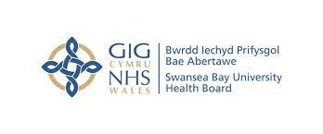
SUBSTANCE MISUSE NEONATAL REFERAL FORM
NAME  DOB:  H/N:  NHS No: | GP

GRAVIDA | PARITY | EDD | CHILDREN WITH MUM

CONSULTANT | MIDWIFE | TEAM
Rob Llewelyn  Robert.Llewelyn@wales.nhs.uk | Ann Saunders  Ann.saunders@wales.nhs.uk | Substance Misuse Specialist Midwife  07891485872  Community Midwife
PARTNER | PPN/MARAC/DV | SOCIAL WORKER
SUBSTANCES USED
HEP C STATUS
CDAT | CDAT NURSE

ADDITIONAL INFORMATION

Any queries please contact: Ann Saunders, Substance Misuse Specialist Midwife
Tel: 07891 485872

Send to Emma.Baddeley@wales.nhs.uk

