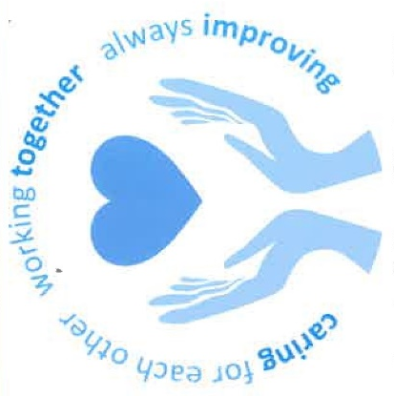

We will make sure we care for you and your loved ones, all the time, in all our communities and hospital.

We will work with you, our patients, families, carers and communities so that we always put our patients first.

We want to keep improving so that we are at our best for everyone.

Please let us know how we are caring for you, your loved ones or if there are things we need to do better.

Not online? Please use the ‘Friends & Family’ cards available throughout all our hospitals and put in the post box provided.
LET’S TALK
Let us know what you think- good or bad

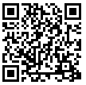
If you would rather speak to someone independent of the Health Board you can contact your local Community Health Council (CHC) on 01639 683490 or email swanseabay@waleschc.org.uk

If you feel able to, tell the Sister/Charge Nurse, Nurse in charge or department head what you think.

Or you can:
Email us at: SBU.LetsTalk@wales.nhs.uk
Leave a voicemail: 01639 684440
Text: 07903591196

Online: If you are at a hospital, you can complete a survey on your smartphone or tablet via our free public WiFi service ‘The Cloud’.
Or you can find more information on our website www.sbuhb.nhs.wales
You can remain anonymous, but if you would like us to reply, please let us have your contact details.

