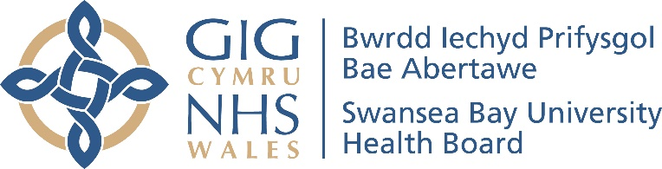

Annual

Equality Report

2020/2021

Contents

Introduction |  | 1
Background |  | 1
Looking back over the last year: |  | 2
 | - Equality Objective 1 - Reduce health inequalities | 2
 | - Equality Objective 2 – Communicate according to individual needs | 6
 | - Equality Objective 3 – Emotional and mental wellbeing | 8
 | - Equality Objective 4 - Mental health services for children and young people | 10
 | - Equality Objective 5 – Staff wellbeing and experience | 10
 | - Equality Objective 6 – Pay differences | 16
 | - Equality Objective 7 – Workforce diversity | 17
 | Looking forward to the next year | 19

Introduction

This is our second Annual Equality Report as Swansea Bay University Health Board. It shares with you our work to progress equality across the Health Board during an incredibly challenging year in 2020/2021.
The report is not designed to cover everything but is an overview highlighting some of our key work. It should be read alongside our Annual Report 2020/2021.

Background

The Equality Act 2010 is about treating everyone in a fair way. This law protects people from being treated less favourably than other people because they are:
- men and women
- disabled people
- young people and older people
- people from different races – who may speak another language
- people who follow a religion or who have no religious beliefs
- people who are gay, lesbian or bisexual
- people who are considering, undergoing or have undergone gender reassignment
- people who are in a civil partnership or married
- women who are pregnant or have recently had a baby.

We have to tell you how we collect and use information to ensure that we are treating people fairly. It is important that our services are meeting the needs of all groups of people who we serve and we treat people fairly at work.

Looking back over the last year:
Taking forward our Equality Objectives

Our Strategic Equality Plan 2020 – 2024 sets out our equality objectives to support the delivery of our strategic aims. We want to be always improving and review progress every year against our equality objectives. Our Annual Report describes our work towards implementing the objectives during 2020/2021. This includes highlighting achievements and identifying areas where further work needs to be done.

Equality Objective 1

Reduce health inequalities
The Chief Executive’s overview in our Annual Report 2020-2021 states that this was an unprecedented year for the health board as its primary focus had to be the response to the Covid-19 pandemic. For significant periods of the year, our focus had to be on managing the health impacts of the pandemic and treating the most urgent healthcare needs. This has had a huge impact on our communities and on all areas of the health board’s business. This is reflected throughout our Annual Report 2020-2021.

Our testing and vaccination programme have been core elements of the response. The health board started the Swansea Bay Covid-19 vaccination programme with frontline healthcare staff at Morriston Hospital on 8 December 2020 before quickly extending to other hospital sites. Once the programme was fully established, a number of facilities started to administer either the Pfizer/BioNtech and Oxford Astra Zeneca vaccines, or both:

- Mass vaccination centres – Bay Field Hospital, Margam Orangery and Canolfan Gorseinon

- A mobile service targeting groups and geographically isolated communities via an ‘Immbulance’

- Primary care centres

- A small number of community pharmacies set up as pathfinders to explore the delivery of vaccine through these settings.

Following feedback, we made a number of improvements to the Mass Vaccination Centre at the Bay Field Hospital and transport access. These were communicated in our Vaccination Newsletters dated 2nd, 9th and 16th February 2021:

- Our partners at Neath Port Talbot Council put up extra directional signs on surrounding roads to make the centre easier to find. We had an extra car park attendant to improve the safety of patients walking from the car park to the entrance door.

- Better organisation within the centre meant queuing drastically reduced. In the event that people had to wait, large indoor seating areas were made available. However, we designed the system to avoid queues where possible, encouraging people to wait in their cars until it is their turn.

- We also resurfaced the walkway from the car park and improved lighting.

- First Cymru Buses run a dedicated free shuttle bus service helping residents in Swansea to get to the Bay Hospital for their vaccinations. The 51 service has been running between Swansea’s main bus station and selected stops along the way to the Mass Vaccination Centre on Fabian Way since the start of February 2020. The service was funded by Swansea Council.

- At the start of the bus service, there was quite a long walk from the bus drop off and pick up point as the bus dropped off at the entrance to the main hospital and not outside the vaccination centre. We worked with the bus company to introduce a new route dropping-off and collecting passengers much closer to the vaccination centre entrance. The route still calls at the blood test clinic at the entrance to the hospital site for those attending blood tests.

- Working with our partners in the local councils for voluntary services and local authorities, we were able to offer free transport to our Mass Vaccination Centres for those with mobility issues who have received appointment letters.

- On arrival at the centres our military colleagues, who have been trained to assist wheelchair users, were on hand to help.

Believed to be the first of its kind in Wales, the Immbulance is designed to reach those who are unable to travel to vaccination centres or GP surgeries, either because of poor transport links or mobility issues.

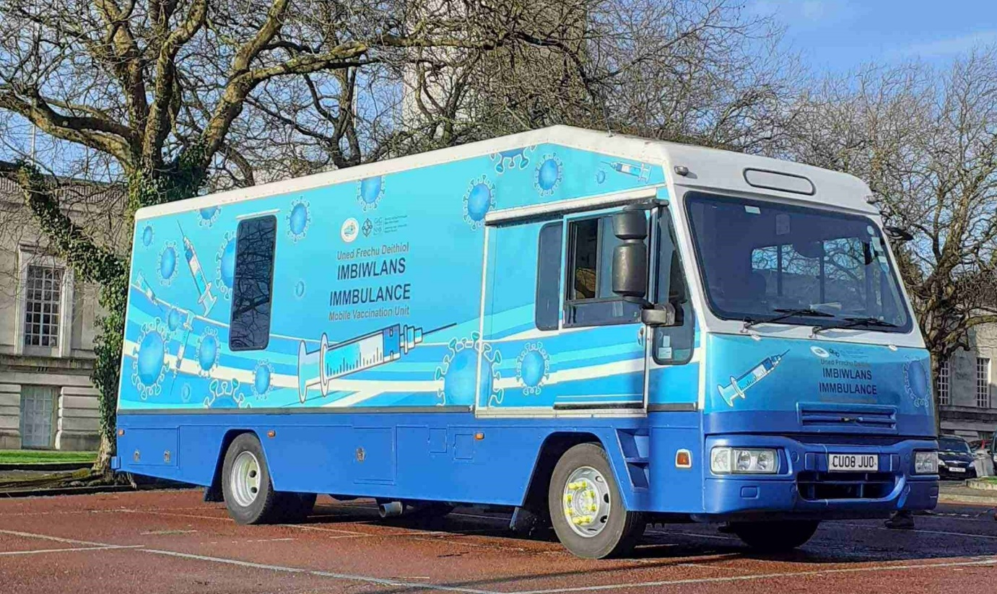

The Immbulance was a mobile library belonging to Neath Port Talbot Council. When it came to the end of its time in that role, the council donated it to the health board and transformed it into a clinical space which would not look out of place in any hospital. A wheelchair lift was retained to maintain easy access and a wireless internet connection installed so patient details can be entered straight onto the immunisation database.

This new vaccination clinic on wheels underwent a trial run late February 2021 at Swansea’s Guildhall. It has been rolled out to reach other areas of Swansea Bay, including more remote communities. The Immbulance helped to bring vaccinations to those areas further from the fixed venues and to those who may be facing mobility or accessibility issues.

The health board’s Vaccination Newsletter dated 2 March 2021 provided information on the vaccination of individuals with a learning disability or severe mental illness as part of priority group 6. Individuals already registered with their GP practice as having a learning disability or severe mental illness were automatically called for vaccination under group 6.

Our community mental health and learning disability teams, partners in local councils and charities and, where appropriate, specialist services such as substance misuse services and families and carers were also asked to identify individuals with learning disabilities and mental illness who should be prioritised for vaccination under group 6.

If individuals live in supported accommodation, they were also contacted for vaccination. Most of the vaccinations were done in GP surgeries for the first doses with the exception of individuals registered with a small number of GP surgeries, who were called to a Mass Vaccination Centre.

The health board’s Vaccination Newsletter dated 10 March 2021 said that we were seeing a lower uptake of the vaccination in Black, Asian and Minority Ethnic communities. Some of our Black, Asian and Minority Ethnic staff and members of the community stepped forward to share their experiences of the pandemic and views on the vaccine in a bid to encourage more people to attend their appointments.
Go to our BAME vaccination page on our website to hear from our staff and to get the answers to other frequently asked questions.

Equality Objective 2

Communicate with patients, families and carers according to their individual needs
Swansea Bay UHB recognises the importance of patients, service users and families being able to receive safe and responsive quality services in a language of their choice.

The Welsh Government provided the health board with a list of links to the latest guidance and services for Covid vaccination in Wales on their website in multiple languages. We promoted awareness through the health board’s Vaccination newsletter dated 2 February 2021. It has also been uploaded to the Covid section on our health board website. Go to this page on our website for the links to the translated information.
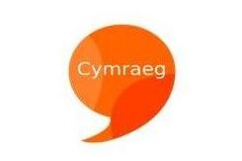
Our Annual Report 2020/2021 highlights the vital part that the Welsh language and culture has to play in the provision of health and social care services to our resident population. Many people choose to receive services in Welsh because that is what they prefer. For others, however, it is more than a matter of choice - it is a matter of need.

It is especially important for many vulnerable people and their families who need to access services in their first language, such as older people with dementia or stroke survivors who may lose their second language and children who speak only Welsh. When discussing mental health, it is important to be able to communicate in your first language to express feelings, thoughts and emotions.

Our Annual Report 2020/2021 identifies that priorities for the health board are the integration of bilingualism and strengthening of our capacity to provide services via the medium of Welsh, ensuring compliance with the Welsh Language (Wales) Measure 2011, and the standards imposed by the Welsh Language Commissioner.

Work undertaken to date includes:

- The development of bilingual patient correspondence;

- Ensuring that an inpatient’s preferred language is established on admission;

- The production of guidance documents for staff covering areas such as translation, signage and the production of marketing materials to promote bilingualism and ensure compliance with the Welsh Language Standards;

- Supplying lanyards and badges to appropriate staff in order to visibly identifying them to patients as being Welsh speakers;

- The production of a protocol for those who answer the telephone on behalf of the organisation, to ensure that people know they can use both Welsh and English when dealing with the health board.

The recruitment of an additional Welsh language translator has allowed the health board to increase the volume of information we are able to provide bilingually, in particular patient-facing information such as posters, leaflets, and the content of our internet site.

The health board has also undertaken a piece of work with a local Welsh language primary school to develop a series of short, simple Welsh conversational skills videos offering support to staff who may wish to develop their everyday ‘meet and greet’ Welsh language skills.

We have a Group with oversight for the implementation of the All Wales Standards for Communication and Information for People with Sensory Loss across the Health Board. The Standards set out the level of service delivery that people with sensory loss should expect when they access healthcare.

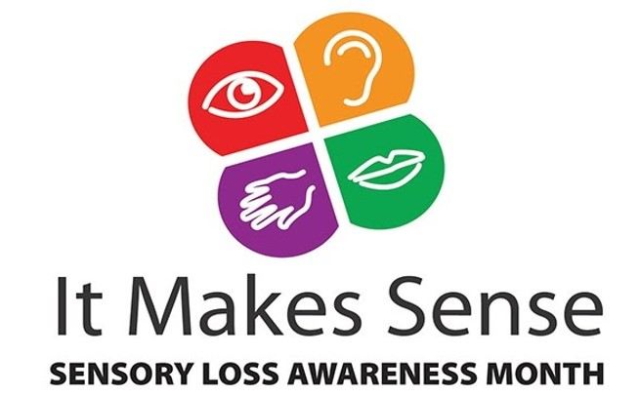
November is Sensory Loss Awareness Month, when NHS Wales would normally run the ‘It Makes Sense’ campaign. Due to the pandemic, the campaign looked a little different in 2020.
NHS Wales arranged a virtual question and answer session with a panel of people with sensory loss to find out about their experience of access to healthcare, particularly during the pandemic. We promoted the opportunity for our staff to join this session on 25 November 2020 via the Intranet. We also shared links to useful resources in a staff bulletin, including:

- A short film on how NHS Wales supports patients and carers living with sensory loss.

- The Wales Council for the Blind’s advice for people with sight loss on safe guiding and social distancing during the coronavirus pandemic.

- The RNIB’s short film on how social distancing can be difficult if you are blind or partially sighted.

Equality Objective 3

Work with partners to improve the emotional and mental well-being of our population
It is well known that the COVID pandemic is having a huge impact on all our lives including our mental health. Levels of anxiety, fear, isolation, social distancing, restrictions, uncertainty and emotional distress experienced have become more widespread.

Local arrangements were established for moving staff between areas to maintain essential mental health services, particularly urgent and inpatient care. Additional equipment was provided across community and inpatient services and arrangements made for increased demand for oxygen as none of our inpatient environments have, nor require in normal circumstances, piped oxygen.

Existing caseloads were risk assessed and red, amber, green rated to identify vulnerability and prioritise allocation of resources to manage risk. This included capturing information on age, physical health issues, mental health issues and whether living alone/with elderly carers.

World Mental Health Day on 10th October 2020 was more important than ever with the year’s theme being; ‘Do one thing’. Our Health Board posted a staff bulletin on the Intranet to raise awareness that ‘Do one thing’ is about taking the first steps to getting support for yourself, or reaching out to someone else by doing just one thing. The bulletin signposted to Mind’s website with a calendar of ideas of ‘One Things’. Their website also included lots of useful resources including advice for key workers going into work during coronavirus and a wellness action plan for those working from home.

This bulletin highlighted the range of wellbeing services available within the Health Board to support staff and volunteer’s wellbeing and how these can be accessed on the Wellbeing page of the Intranet. This included information on ‘Taking Care, Giving Care’ mini rounds, which invited staff to spend time thinking about how they can take better care of themselves and care for others, which helps promote compassion.

To mark World Mental Health Day 2020, our mental health and learning disabilities staff produced a newsletter to showcase the work of their teams and organised a virtual wellbeing event – a lunchtime singing session. Staff from across the Health Board were invited to join them for the event on Friday, 9 October, which was led by Swansea Bay UHB’s Music in Health Facilitator.

Equality Objective 4

Work in partnership to improve emotional and mental health services for children and young people in the Swansea Bay area
Child and Adolescent Mental Health Services (CAMHS) are provided for the Swansea Bay area by Cwm Taf Morgannwg University Health Board. They continued to work with us during 2020-21 to deliver the agreed strategic vision for young people living in Swansea Bay including the implementation of a Single Point of Access and the roll-out of emotional health & wellbeing roles in schools.
The Health Board is the lead agency for the Children & Young People’s Emotional & Mental Health multi-agency Delivery Plan. There are a number of shared priorities across agencies, including improving access to universal services.
One of the projects initiated during 2020/21 was the development of a website for children & young people called tidyMinds. The site is a one-stop-shop for information and signposting for emotional and mental health support for young people who live in Swansea and Neath Port Talbot, and was co-produced with young people.

Equality Objective 5

Improve the wellbeing and experience of our staff

We appreciate the continued hard work and dedication of our staff, especially over the past year. Their health and wellbeing is really important and has been a key part of our response to the pandemic.

At the peak of the pandemic, there were 1,700 staff not in work due to Covid-19 related absences out of 13,499. This was in addition to those shielding.
Staff absence had a very significant effect on the running of our services. Our Annual Report explains how we continued to comply with Nurse Staffing Levels (Wales) Act 2016 by deploying staff and using bank/agency.

Risk assessments have been undertaken throughout the pandemic to ensure staff are working as safely as possible. All staff were encouraged to complete the All Wales COVID-19 risk assessment tool, particularly colleagues from Black, Asian and Minority Ethnic backgrounds who were being disproportionately affected by the coronavirus pandemic.

For those staff for whom it was not safe to work closely with patients, alternatives were initially considered and where possible they were redeployed to support other non-clinical areas of business. Otherwise they were asked to work from home if possible.

There was a 78% increase in management referrals to occupational health relating to Covid-19. As a result, a nurse-based team was established with allied health professional and medical support. The pathway has also been extended to include trauma and bereavement services. Nearly 400 wellbeing champions are now in place to support teams as well as learning and development coaches based within each of the service groups.

Swansea Bay’s Occupational Health and Wellbeing teams were rewarded for their work during the Covid-19 crisis through major awards in the ‘National 2020 Personnel Today, Occupational Health and Wellbeing Awards’. The health board’s wellbeing service won ‘Best Multidisciplinary Initiative’ and the occupational health team was awarded ‘Occupational Health Team of the Year (public sector)’. The health board is the first organisation to win two awards in one year.
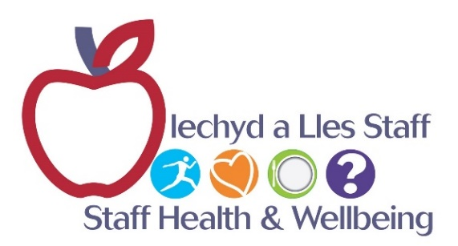
Dedicated health and wellbeing services have been put in place to support staff as they work through the pandemic, including psychologists, meditation and dedicated trauma support as well access to spiritual support and recovery rooms.

Some of the developments made to support, develop and recognise staff during the year include:

- Introduction of an updated wellbeing package for staff to support psychological, emotional and social welfare and health and wellbeing. A number of additional resources were offered including:

  - REACTMH® Training, to help leaders have ‘psychological savvy’ conversations to support their staff;
  - A new virtual wellbeing course ‘Resilient Caring the Swansea Bay Way’, open to all staff and volunteers;
  - ‘Taking Care Giving Care’ is a facilitated psychological approach that serves to centre ‘compassion’ through everything that we do. The focus is on the role and impact of care for staff in any service and helps staff to reflect on working relationships, job demands and self-care and well-being.

- Implementation of a trauma management model (TRiM) within the health board. The TRiM Model aims to keep employees, mentally well, resilient and functioning by providing support and information and identify those who were not coping early enough to signpost them on to specialist support. It helps to break the stigma of mental health and needing to ‘plough on’ regardless and reduces the numbers of front line staff taking time on sick leave due to stress related illness.

- Provision of hotel accommodation for staff who were worried about transmitting the virus to family at home.

- Our first ever pre-recorded ‘Virtual Living Our Values Awards’, providing a well needed boost for staff morale. 151 nominations were received for the awards, 663 individual staff voted for those shortlisted with a total overall of 5,058 votes. The recording was available to all staff to watch afterwards for a month. The English version of the event was viewed 570 times and the Welsh version 83 times.

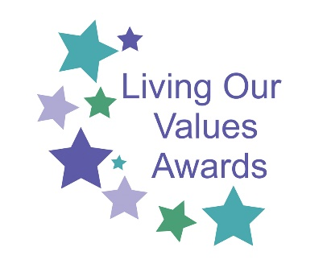
One of our award categories is the Excellence in Equality & Inclusion Award. This was awarded in 2020 to Celia Davies and the Vocational Training Team, who demonstrated over many years how working with diverse communities can benefit both individuals and organisations. They have supported over 3000 individuals from the area to get experience in the work place with over 60% of these going into employment.
- A virtual package commenced in March 2021 for the long-service awards. This recognised 604 staff who had more than 25 and more than 40 years’ service for last and this year.

Kay Myatt, Head of Learning and Organisational Development, was one of the winners of the national Healthcare People Management Association (HPMA) Rising Star Award 2020. This award recognised her leadership and tremendous support for the creation of an inclusive working environment and the development of staff networks.

Staff networks are a vital part of support for our staff and staff are encouraged to get involved where they can. It was the National Day for Staff Networks 2020 when our former Chief Executive Officer met with our Black, Asian and Minority Ethnic Staff Network on 13 May 2020. The CEO was a supporter of our LGBT+ & Allies Staff Network for some time.

Swansea Bay’s Black, Asian and Minority Ethnic network was set up to raise cultural understanding, improve staff support and boost patient care across Swansea Bay health board. It was launched at Morriston Hospital during a 2019 Black History Month event to celebrate ethnic and cultural diversity.

The network launched an Intranet page for staff in January 2021, a logo and introduced our Swansea Bay Black, Asian and Minority Ethnic Champions to staff. The network supports staff at work and always welcomes all members, including allies. You can join by e-mail:
SBU.BMEStaffNetwork@wales.nhs.uk
Our Executive Team is determined to help make a difference and have already pledged to be the Black, Asian and Minority Ethnic Network allies. Their role as an ally is to support the Network, raising positive awareness within their workplace on having equality for Black, Asian and Minority Ethnic representation within our Health Board including senior leadership roles – respecting diversity, differing cultures /backgrounds. The Medical Director is the executive sponsor for the Network.

The role of our Champions is to promote race equality and raise awareness of the issues facing people. Our Champions are a contact person for any colleagues from Black, Asian and Minority Ethnic communities who wants to get involved in the Network, or who may be experiencing discrimination at work, and to signpost to any additional resources that may help.
This is particularly important for overseas staff who may want support to help them integrate within their communities.
Calon, our LGBT+ & Allies Staff Network, have supported our Black and Minority Ethnic Network in their development as a newly established network.
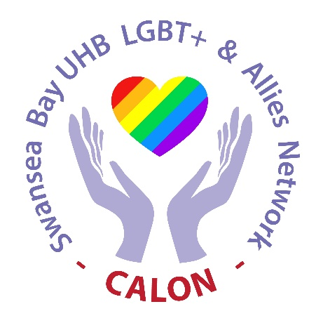

Calon continues to increase its membership. New members are always welcome and you can join by e-mailing:

Calon.LGBTStaffNetwork@wales.nhs.uk

On International Day Against Homophobia, Biphobia and Transphobia (IDAHOBIT) 2020, Calon launched a safe space for LGBT+ staff to support colleagues across the health board during COVID-19. Staff were invited to have a virtual coffee and chat with like-minded people.

Calon varied the days and times of their ‘This is Me with Tea’ sessions so that people with different working patterns did not miss out on the opportunity to drop in for a chat and be their authentic selves. The sessions were created to support LGBT+ colleagues although they were open to allies who may find benefit and want to join in.

Calon marked the National Day for Staff Networks by hosting a virtual drop-in session for anyone who wanted to chat and connect with likeminded people in a safe space and by highlighting anything Calon could do to support colleagues through the current situation. Staff were invited to contact the leads of our Black, Asian and Minority Ethnic Staff Network with the same offer of support.

At the end of August each year, organisations from across NHS Wales usually get together and parade through Cardiff as part of Pride Cymru, celebrating and raising awareness of LGBT+ inclusivity and diversity. With COVID-19 impacting events throughout the country, NHS Wales joined Pride Cymru and went virtual.

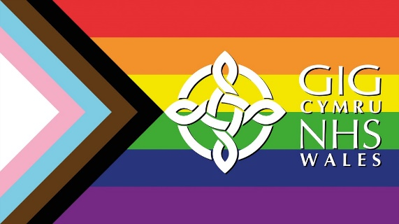
NHS Virtual Pride week took place in August when we celebrated with colleagues from across NHS Wales as part of Pride Cymru. There were plenty of different activities and events for everyone to get virtually involved with. This included a Film Festival, LGBT+ Quiz, and a Gender Identity Panel Discussion.
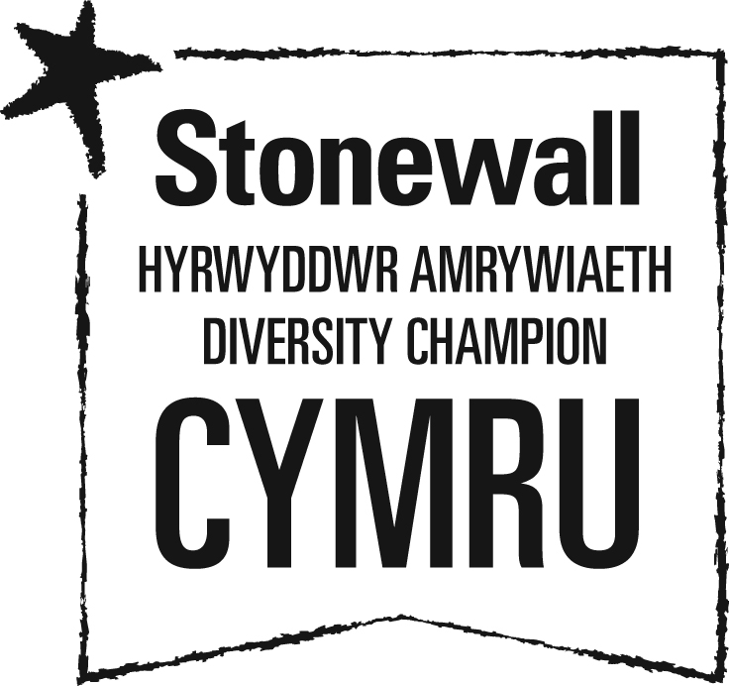
Swansea Bay UHB is a proud member of Stonewall Cymru’s Diversity Champions Programme. Stonewall is Europe’s largest LGBT charity. Diversity Champions is the leading employers’ programme for ensuring all LGBT staff are accepted without exception.

The first Leadership Touchpoint event led by our new Chief Executive focused on inclusion. Staff were invited to join the event and share their experiences of inclusion as well as reflect on their daily practice and how inclusion plays a part in this.

Swansea Bay UHB’s Black, Asian and Minority Ethnic Staff Network and LGBT+ & Allies Staff Network contributed to the Health Board’s Leadership Touchpoint Inclusion event on 29 January 2021.

Equality Objective 6

Identify and take action to address gender, ethnicity and disability pay differences

We have produced gender pay reports and these are available on our website. Swansea Bay UHB’s Employment Data Report 2020/2021 highlights the improvement in the overall completion rates of workforce equality data over the past year.
Further collaborative work needs to be undertaken to improve data quality. This will include working with staff to explain the importance of recording diversity information and how we use this in our work.

We will also work with staff networks and trade union colleagues to help promote an increase in the staff declaration of their personal data on ESR. This is important to enable the health board to report on ethnicity and disability pay differences.

We will research the best practice work of other organisations to learn how improvements can be made to the workforce and pay data analysis.

A Working Group has been progressing the development of an Agile Working Policy. This has many benefits for diversity and inclusion, including broadening access to our workforce and increased opportunities to recruit and retain the diverse talent we need.

Equality Objective 7

Increase diversity in our workforce to reflect the communities we serve
Through our Vocational Training Team, we offer a range of work-based training opportunities and work experience for unemployed people from the local communities. This is in partnership with local lead providers, working closely with Job Centre Plus to help reduce unemployment within the Swansea Bay area.

Through liaising with the Job Centre, the team supported some of those hit economically by the pandemic. The team used the Vocational Training Contract to support the recruitment process for approximately 150 roles in the Mass Vaccination Centres.

From April 2020 until January 2021, the Vocational Training team placed 134 participants with 80 securing employment with the health board and 22 securing jobs with external organisations. 15 additional participants were planned for March 2021.

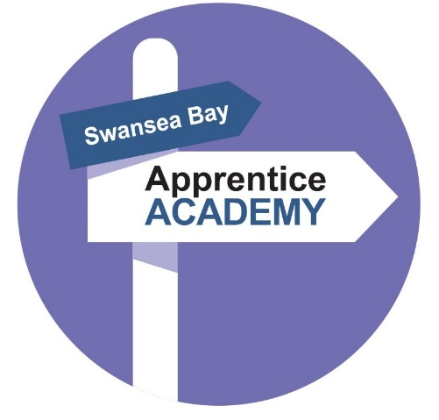
Our Apprentice Academy has grown from strength to strength since it was created in late 2016. The Academy regularly works with local schools, colleges and advice and guidance centres to promote opportunities to groups, including single parents, students not progressing to higher education and others.
The Apprenticeship Academy was a finalist in the category of ‘Large and Macro Employer of the Year’ from Apprenticeship Awards Cymru. At the end of January 2021, the health board had 31 apprentices in post, 11 individuals awaiting a start date, three adverts, three apprenticeships in the pipeline. 104 apprentices were successful in gaining permanent posts.
The Apprenticeship Academy celebrated National Apprenticeship Week by hosting a virtual visit with the First Minister. It was the perfect opportunity to highlight the benefits and successes of the programme in our organisation.
When the timing is appropriate, our career development team plans to resume the promotion of apprenticeships and NHS careers at job fairs, careers and community events to encourage people to apply to work for us. We monitor the protected characteristics of people through the recruitment process.
We launched Project SEARCH Supported Internships in September 2019 at Morriston Hospital, in partnership with Gower College Swansea and Better Jobs Better Futures. It was the first time Swansea Bay UHB had run the scheme.

Eight teenagers with additional learning needs began internships that saw them take on a variety of roles. The pharmacy, library and domestic services at Morriston Hospital are just some of the areas that the Gower College Swansea students were assigned to. As well as gaining practical experience, they also take part in classroom sessions in the hospital as they work towards a BTEC qualification in work skills. The internships were provided under Project SEARCH, an international initiative which began in the US.
Due to the restricted footfall on sites and duty to care, Swansea Bay UHB has paused the programme during the pandemic. The health board is keen to host a second cohort, once the timing to run the programme is appropriate - potentially September 2022.

Looking forward to the next year

No one could have foreseen how the coronavirus (COVID-19) pandemic has drastically changed the way we live our lives. Everyone has been affected by the virus or the restrictions imposed in response to it. The negative impacts of the pandemic have been more severe for some groups than others.

The Equality and Human Rights Commission (EHRC) published a report ‘How coronavirus has affected equality and human rights’ in October 2020. This summarises the emerging evidence to help us understand the effects of the pandemic on different groups in society and the risks to equality and human rights in the longer term. The report sets out targeted recommendations for the UK, Scottish and Welsh Governments to ensure equality and human rights considerations are integrated into the policy response to the pandemic.

We will take the opportunity to learn from the pandemic and make improvements where we can. A central part of responding to COVID-19 and restoring services must be to increase the scale and pace of NHS action to tackle health inequalities to protect those at greatest risk. High quality data is crucial in addressing health inequalities and comprehensive, accurate data on patients and populations will be a priority for the NHS.
We will be reviewing our Strategic Equality Plan 2020-2024 to identify the key inequalities exacerbated by the Coronavirus pandemic and refreshing our action plan to support our recovery from the crisis.

