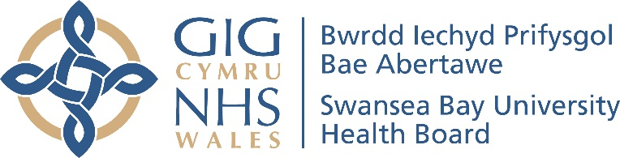

Annual

Equality Report

2019/2020

Contents

Introduction |  | 1
Background |  | 1
Looking back over the last year: |  | 2
 | - Equality Objective 1 - Reduce health inequalities | 2
 | - Equality Objective 2 - Accessible advice and information | 5
 | - Equality Objective 3 - Communicate according to individual needs | 6
 | - Equality Objective 4 - Mental wellbeing | 8
 | - Equality Objective 5 - Mental health services for children and young people | 10
 | - Equality Objective 6 - Staff wellbeing and experience | 11
 | - Equality Objective 7 - Pay differences | 17
 | Covid-19 | 19
 | Looking forward to the next year | 19

Introduction

This is our first Annual Equality Report as Swansea Bay University Health Board. It shares with you our work to progress equality across the Health Board during 2019/2020.
The report is not designed to cover everything but is an overview highlighting some of our key work. It should be read alongside our Annual Report 2019/2020 and Annual Quality Statement 2019/2020.

Background

The Equality Act 2010 is about treating everyone in a fair way. This law protects people from being treating less favourably than other people because they are:
- men and women
- disabled people
- young people and older people
- people from different races – who may speak another language
- people who follow a religion or who have no religious beliefs
- people who are gay, lesbian or bisexual
- people who are considering, undergoing or have undergone gender reassignment
- people who are in a civil partnership or married
- women who are pregnant or have recently had a baby.

We have to tell you how we collect and use information to ensure that we are treating people fairly. It is important that our services are meeting the needs of all groups of people who we serve and we treat people fairly at work.

Looking back over the last year:
Taking forward our Equality Objectives

Our Strategic Equality Plan sets out our equality objectives to support the delivery of our strategic aims. During 2019/2020, we reviewed our strategic equality objectives to meet our legal requirement to do this every four years.
Our equality objectives were refreshed through engagement and consultation with staff, third sector organisations, patient groups, staff networks and equality forums and using other evidence available. This included the strong evidence base within ‘Is Wales Fairer (Equality and Human Rights Commission, 2018). We are grateful to everyone who participated in our engagement and consultation.
We want to be always improving and review progress every year against our equality objectives. Our Annual Report describes our work towards implementing the objectives during 2019/2020. This includes highlighting achievements and identifying areas where further work needs to be done.

Equality Objective 1

Reduce health inequalities through ensuring access to services for people according to their individual needs
Our Annual Quality Statement looks back over 2019/2020 at Swansea Bay UHB’s work programmes to promote good health. This includes:
- uptake of the flu vaccination - including plans to improve the uptake in child immunisations and provide more accessible information to groups who currently do not immunise
- improving access to dental services for the most vulnerable patients in our population
- working to reduce health inequalities for people with learning disabilities through the consolidation of specialist pathways, including autism
- Making Every Contact Count (MECC) training to enable staff to have the confidence, knowledge, skills and tools to have conversations with patients and colleagues about their wellbeing.
- the promotion of World Mental Health Day.
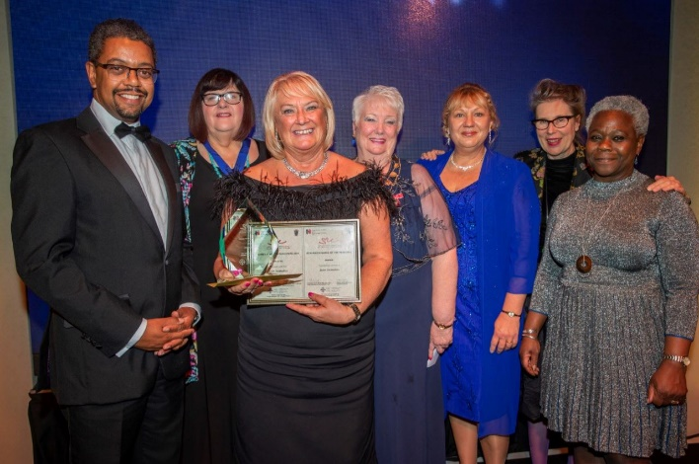

Jean Saunders was crowned as the Royal College of Nursing Wales Nurse of the Year for her work helping asylum seekers access healthcare.
Jean Saunders (centre, with her awards) at the
2019 RCN Nurse of the Year Awards

Leading a team of five, Jean has been helping adult and child asylum seekers get the support and treatment they need in Swansea Bay for 15 years. She has continually fought for equality in their care and contributed to research to improve services for asylum seekers.

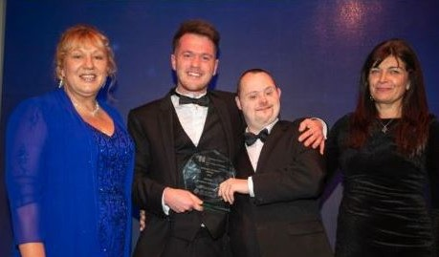
Mitchell Richards, a staff nurse at Hafod y Wennol, won the Nursing Student prize at the RCN Nurse of the Year awards for his work as a champion for people with learning disabilities.
Mitchell with his brother Nathan at the awards evening

Since he started as a nursing student in 2016, Mitchell has worked with the Paul Ridd Foundation and organised numerous fundraising events across Wales. He has also developed e-materials to promote greater understanding of individuals with learning disabilities. As a direct result of his work, Swansea University has pledged to train every nursing student as a learning disability champion.

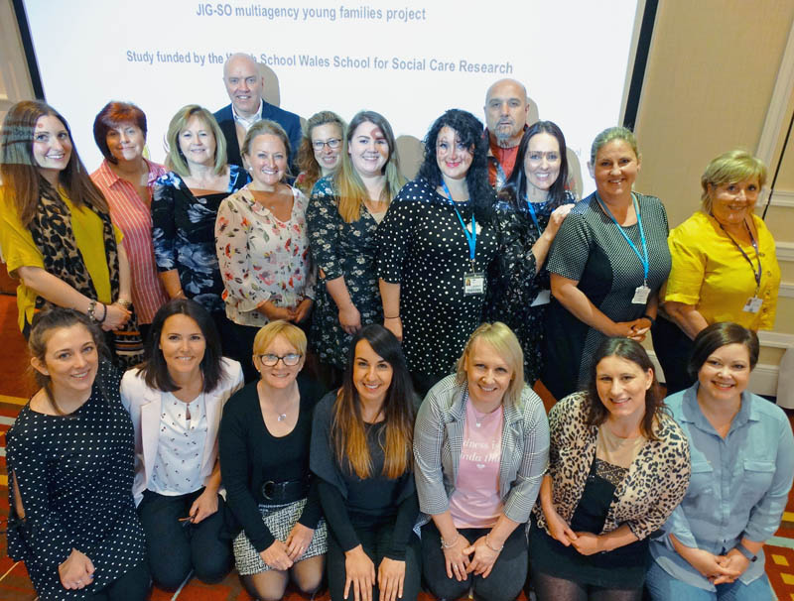
Jig-So, a collaborative project between Swansea Bay UHB and Swansea Council, is part of the Welsh Government’s Flying Start and Families First programmes. It was launched in May 2016 as the successor to Teen Start, which was mainly for pregnant teenagers and only available in parts of Swansea.
The Jig-So team

As part of the service’s ongoing evaluation, a year-long study by a Swansea University team was commissioned, funded by the Wales School for Social Care Research.

The researchers found the close collaborative working led to a high level of communication to meet the sometimes complex needs of service users – creating a team or “family” around the young parents.
This led to better outcomes. For example, many of those referred by the local authority no longer needed social services involvement or were removed from the ‘at risk’ register. After engaging with the team, these young parents were also more likely to remain with their children.

There were also health improvements: high levels of smoking cessation, alcohol abstention, longer breastfeeding duration and better diets.
Programmes of support included healthcare information and support through one-on-one work, family group classes and forums.
Staff also took the young parents to food banks, provided advice on employment, education, housing or universal credit issues, leaving them feeling more supported and better prepared to be a parent.
Safe space was also provided to discuss healthy relationships between parents and challenging topics such as abusive behaviour, stressful situations, arguments and disagreements, and exercises specifically for young fathers to challenge gender stereotypes and negative behavior.
The findings were presented at an event in Swansea’s Marriott Hotel, attended by representatives of the partner agencies, Jig-So staff, and dozens of young parents and their families. Some of them also featured in videos highlighting the difference the team has made to their lives, which were screened on the day.

Equality Objective 2

Provide accessible advice and information to enable people to understand and make informed choices
Our Annual Quality Statement 2019/2020 describes how patients waiting for treatment for a cardiac condition are getting healthy life lessons through a pioneering course run at Morriston Hospital.
Atrial fibrillation is one of the most common forms of arrhythmia or abnormal heart rhythm. This cardiac condition is more common in the over-60s but can affect all ages. A number of treatments are available but there is now increasing evidence that controlling cardiac risk factors such as weight, blood pressure and diabetes can have a huge impact on managing symptoms and improving quality of life.
Morriston Hospital offers a course which educates people with AF about these risk factors so they can take care of their own care. The programme was run as a pilot project and the specialist nurses hope the benefits to patients will lead to it continuing in the longer term.

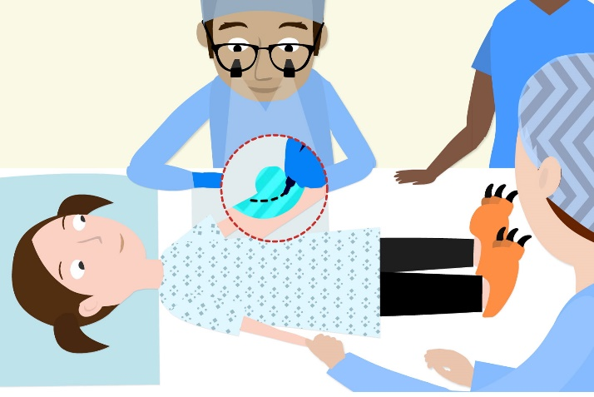
Plastic surgeons in Swansea have joined forces with a BAFTA winning animator to help children recover faster from minor surgery. They have produced a cartoon called Numb and Numb-er, which shows young patients the benefits of opting for a local anaesthetic over a general anaesthetic where suitable. These include being able to watch cartoons, listen to music and even ask the surgeon questions while they are on the operating table. Most importantly, children who have a local anaesthetic recover and leave hospital quicker.

Equality Objective 3

Communicate with patients, families and carers according to their individual needs
Swansea Bay UHB recognises the importance of patients, service users and families being able to receive safe and responsive quality services in a language of their choice.

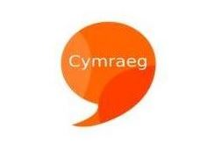
The Health Board is committed to ensuring Welsh and English languages are treated equally in the services provided to the public and other organisations. This is in line with the Welsh Language Scheme and statutory legislation including the Welsh Language Standards (No 7) Regulations 2018.

A Welsh Language delivery group was re-introduced in May 2019. The purpose of the group is to support the Board in discharging its responsibilities for compliance with the Welsh Language Standards as described in our 2019/2020 Annual Report. Progress includes:

- Bi-lingual website and social media accounts

- Welsh language publication protocol implemented to support staff publish bi-lingual documentation

- A bi-lingual clinical appointment reminder texting service has been launched in phases across all of the main specialities. The default first text is bi-lingual and from that point forward the patient may specify whether they wish to receive further texts in Welsh or English.

- All patient letters are available bilingually. These include referral acknowledgment, day case and inpatient and outpatient appointment confirmations.

We have a Group overseeing the implementation of the All Wales Standards for Communication and Information for People with Sensory Loss across the Health Board. The Standards set out the level of service delivery that people with sensory loss should expect when they access healthcare.

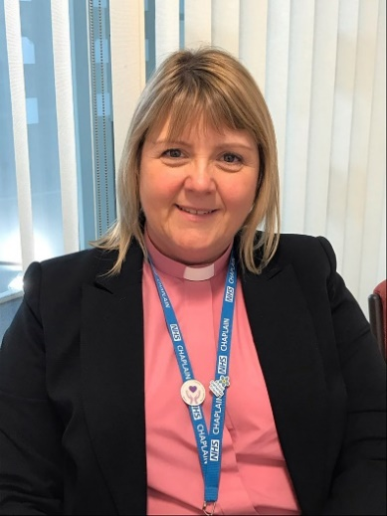
We welcomed on board our new Head of Chaplaincy Tracey Pycroft. Tracey is fluent in British Sign Language and leads ten staff members and 25 volunteers across our five hospital sites. Tracey is based at Morriston opposite the Multi-faith room if you wish to find out more about how Tracey and her team are helping to support our patients and staff.
Tracey Pycroft

Equality Objective 4

Work with partners to promote mental wellbeing and improve access to mental health services for people who are most in need of support
The Strategic Framework for Adult Mental Health was developed with stakeholders and service users. During 2018, the Strategic Framework was further revised to include the findings of a report commissioned by Western Bay on unmet mental health needs in our area.

Our Annual Quality Framework 2019-2020 shares an update on a workshop event held in spring 2019 to start a conversation around suicide locally. The event was attended by 75 people and brought together a wide range of agencies, stakeholders and people with lived experience.
The aim was to establish what was already taking place across the region, what further work was required and where collective action should be focused across Swansea Bay. After the workshop, Swansea and Neath Port Talbot Public Service Boards have endorsed the work and have provided their commitment to support the progression of the suicide and self-harm prevention strategy.
The work has been further supported at a Joint Public Services Board meeting between Swansea and Neath Port Talbot and was discussed by the West Glamorgan Mental Health and Wellbeing Board. This highlights the commitment from a wide range of agencies to progress this agenda and achieve positive outcomes for people in our communities.

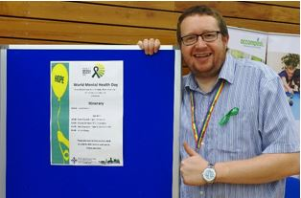
To mark World Mental Health Day on 10 October 2019, Swansea Bay staff organised a special public event at the LC Swansea. The free event was part of a wider campaign by the World Health Organisation focussing on suicide prevention and mental health.

Guest speakers included the Samaritans, Time To Change Campaign and a speaker focusing on men’s mental health. More than 60 groups and organisations were represented at the event demonstrating the range of services available for people needing support. These included the Senior Nursing Team for Mental Health and Learning Disabilities, the Samaritans, Calon (Swansea Bay’s LGBT+ support network), Cariad Pet Therapy, which provides therapy dogs for care homes and schools, and the Bulldogs Boxing Club for those aged 16-24 and currently not in employment, education or training.

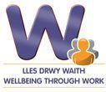
The Health Board continues to deliver the European social funded ‘In Work Support Service’ which delivers mental health and musculoskeletal support to local employees working in small to medium size enterprises. 1,072 local employees have been assisted to return to work or remain in work whilst experiencing health conditions. More than 227 local companies have received support to help manage the health and wellbeing of their staff.

Equality Objective 5

Work in partnership to improve emotional and mental health services for children and young people
Swansea Bay UHB leads the Children and Young People Emotional and Mental Health Planning Group. The Group has been set up to deliver the key actions related to the well-being of our population and mental health services for children, young people and their families from the national Together for Children and Young People’s Mental Health programme. This planning group has representation from Swansea Bay and Cwm Taf Morgannwg University Health Boards, parents, Local Authorities and the voluntary sector.
The Group has a Delivery Plan and the strategic aims are as follows:
- Improved accessibility to child and adolescent mental health services and specialist advice and support

- Sustainable and accessible local services

- Further develop and sustain the Neuro Development Delay Service

- Develop a better range of services for all children with emotional difficulties and wellbeing or mental health issues including transition and single point of access to services

- Develop robust multi-agency arrangements for children with complex needs.

A sub group of the Children and Young Emotional and Mental Health Planning Group has been set up to specifically focus on CAMHS prevention and wellbeing. It is through this group that a new Emotional Health and Wellbeing Service has been set up.

Equality Objective 6

Improve the wellbeing and experience of our staff

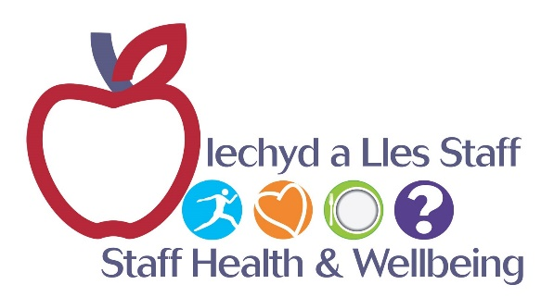
The delivery of Mindfulness based groups and ‘Managing your Wellbeing’ courses have supported the health and wellbeing of staff and a return to work after sickness. Managers have been supported to understand mental health in the workplace. The team has delivered training on the use of the stress standards to enable early support for staff experiencing stress in the workplace.
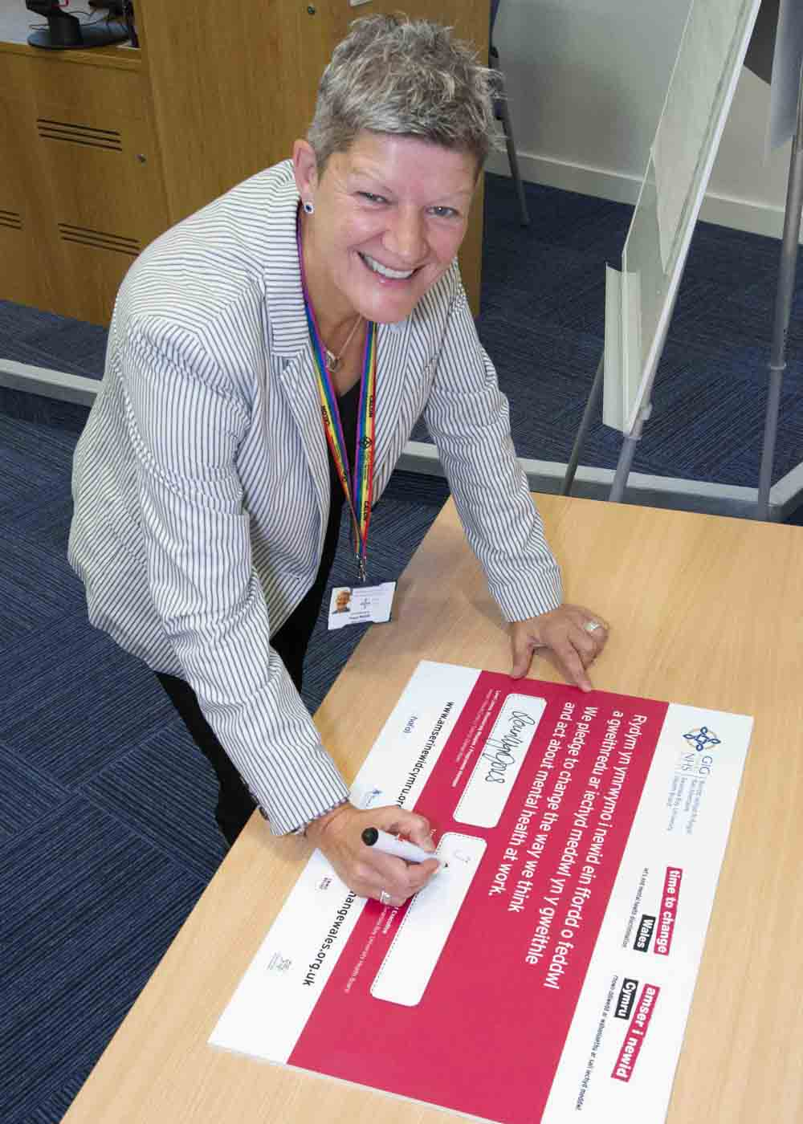

There has been increased partnership working with Time to Change Wales to reduce stigma and discrimination associated with mental health in the workplace. Volunteers have shared their personal stories of overcoming mental health issues and remaining or returning to work. The Chief Executive signed the Time to Change Wales pledge on behalf of the Health Board in September 2019, demonstrating the commitment to this campaign.
Chief Executive Tracy Myhill re-signing the
Time to Change Wales pledge

A successful ‘Wellbeing Week’ was held in September 2019. Staff took advantage of a variety of informative and interactive resources provided by the smoking cessation team, nutrition and dietetics and the living life well programme.

Health checks by the occupational health team and podiatry department proved to be a big hit with staff members as did the ‘Mindful Menopause’ workshops. This year, the events were supported by the wellbeing team.

The #LivingOurValues campaign was launched in July 2019 at a leadership summit and invites staff to sign a pledge card which describes how they live the organisational values. To date there have been more than 800 pledges signed by a combination of teams and individuals.
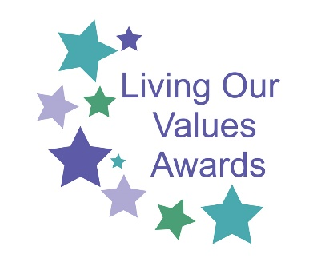
In December 2019, the ‘Living Our Values Awards: Celebrating the Swansea Bay Way’ were launched as part of a programme of recognition and reward, with 151 nominations received. The awards have 13 categories and included the Excellence in Equality & Inclusion Award.
The health board aims to create a culture of openness, honesty and respect which goes hand in hand with the values. A number of actions have been taken to accompany the #LivingOurValues campaign to respond to staff feedback and support healthy workplaces and wellbeing. These include the commissioning of ACAS (Advisory, Conciliation and Arbitration Service) to run workshops for managers, workforce and trade unions in addressing inappropriate behaviours at work, including bullying and the introduction of the Guardian Service in May 2019 as a one-year pilot.
The Guardian Service provides independent, confidential and non-judgemental support to staff raising concerns and focuses on working with individuals and the organisation to reach a resolution on a 24/7 365 basis. Our Annual Report 2019-2020 provides further information.
The long service recognition and patient choice awards continued in 2019-20. This year, the qualifying criteria for long service recognition was reviewed and amended to cumulative years NHS service, rather than continuous, in order to make it more inclusive.
In addition to recognising 25 years or more NHS service, a special recognition was introduced for those reaching 40 years or more.

Muslim staff hosted the Eid ul-Fitr celebration in the Multi-Faith Centre at Morriston Hospital on 11 June 2019. This free event was open to everyone with food and drink included. It was organised by the hospital’s Muslim Chaplain and Muslim staff. The event celebrated the end of Ramandam and helped people learn and understand Islam.

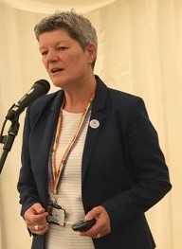
We held a joint diversity and inclusion event with Hywel Dda UHB on 4 July 2019 at the National Botanic Garden of Wales in Llanarthne, Carmarthenshire. Tracy Myhill chaired jointly with Steve Moore CEO at Hywel Dda UHB and they shared their personal stories. This event was called ‘This is me!’. It celebrated the diversity of our workforce and delegates heard personal stories from our staff across Swansea Bay, Hywel Dda, and further afield. The feedback from this event was very positive. It will help shape an inclusive workplace for everyone.

A new Black and Minority Ethnic network was set up to raise cultural understanding, improve staff support and boost patient care across Swansea Bay health board. It was launched at Morriston Hospital during a Black History Month event to celebrate ethnic and cultural diversity.

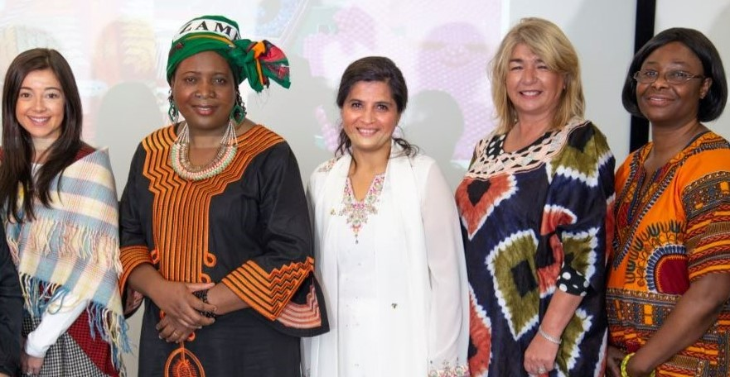
Graduate trainee manager Nia Leather, recovery nurse Rose Nasinda, Head of Value-Based Health Care Navjot Kalra, Director of Workforce and OD Hazel Robinson and theatre nurse Rosina Boglo.

Morriston Hospital theatre nurse Rosina Boglo and recovery staff nurse Rose Nasinda, along with Navjot Kalra, Head of Value-Based Health Care, have played key roles in getting the network started. The network will support BAME staff at work and help employees deal with any cultural changes that come with moving to a new country. The network welcomes all members, including allies, please email SBU.BMEStaffNetwork@wales.nhs.uk
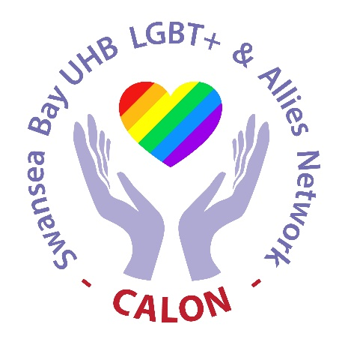
Calon, our LGBT+ & Allies Staff Network, goes from strength to strength with an increased profile and membership. New members are always welcome and you can join by e-mailing:
Calon.LGBTStaffNetwork@wales.nhs.uk

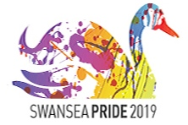
On Saturday, 4 May 2019, Calon, family, friends and colleagues from Swansea Bay UHB marched at Swansea Pride in Swansea City Centre. They came together with other organisations in the area in a celebration of LGBT+ equality and diversity.

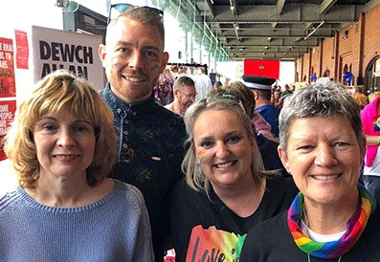
The festival began with a parade leaving Wind Street and finished at the Waterfront Museum where there were a variety of stalls and family friendly activities. Swansea UHB had stalls at the event supported by Calon, the Apprentice Academy and the Sexual Health Department.

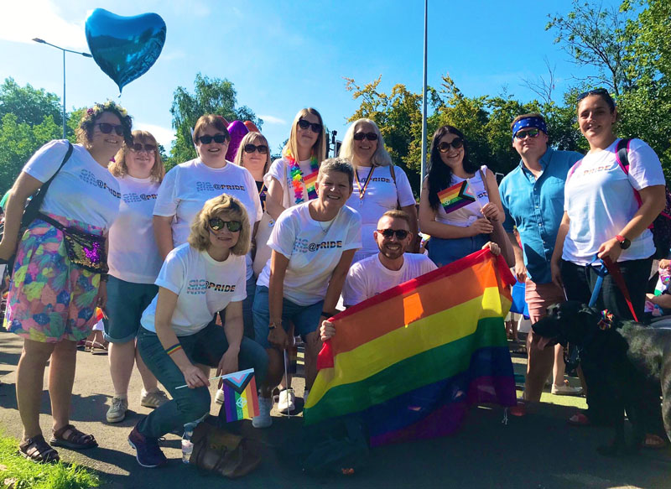

At Pride Cymru 2019, Swansea Bay staff came together with colleagues from across NHS Wales and other organisations throughout the country in a celebration of LGBT+ equality, diversity and culture. Cardiff city centre was painted the colour of the rainbow when over 50,000 people descended on the city as part of the Pride Cymru celebrations.
SBUHB colleagues represented us as inclusive employers and health care providers. We were amongst the one-mile 15,000 strong parade through the capital. We had a fabulous time singing and dancing our way along the streets to the sound of overwhelming cheers from the crowds of people turning out to show their support.
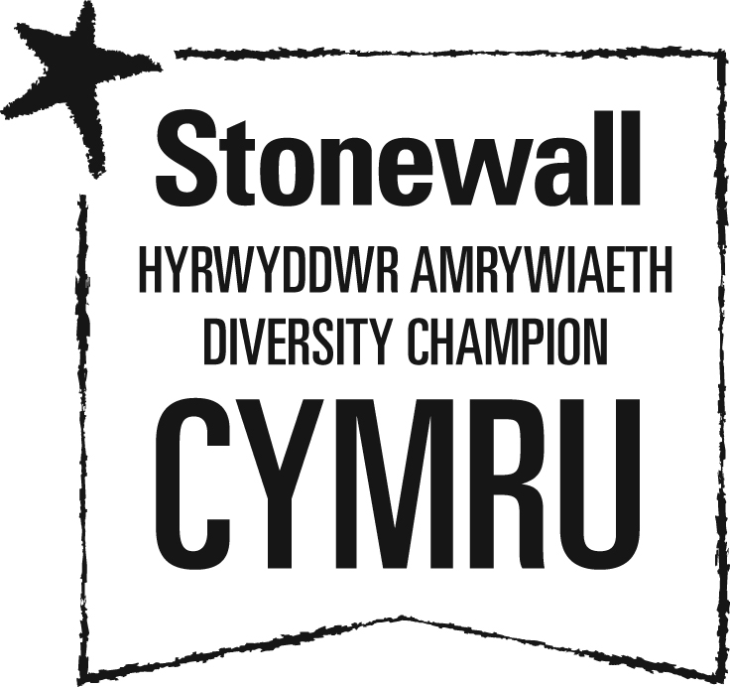
Swansea Bay UHB is a proud member of Stonewall Cymru’s Diversity Champions Programme. Stonewall is Europe’s largest LGBT charity. Diversity Champions is the leading employers’ programme for ensuring all LGBT staff are accepted without exception.

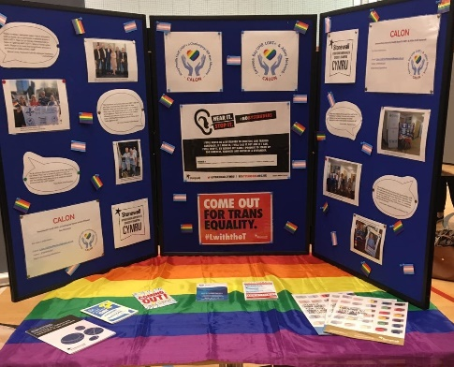
Trans awareness training sessions were delivered across the health board by Stonewall Cymru. The sessions were designed to help staff gain an understanding of gender identity and terminology. The sessions received excellent feedback from staff who attended.

Equality Objective 7

Develop a fuller understanding of the reasons for any pay differences

We have produced pay reports and these are available on our website.
We recognise that there is more work to be done to analyse pay differences. This includes improving the collection of equality data for staff and raising awareness of the reasons why the information is collected. We will be researching the best practice work of other organisations to learn how improvements can be made to the workforce and pay data analysis.

Our Apprentice Academy grows from strength to strength with over 250 apprentices recruited since the Academy was created in late 2016. 70% have progressed to a higher level apprenticeship with us or gained a substantive NHS post.

The Apprentice Academy regularly works with local schools, colleges and advice and guidance centres to promote opportunities to specific groups, including single parents, students not progressing to higher education and others.
The Academy also promote apprenticeships and NHS careers at job fairs, careers and community events to encourage people from diverse backgrounds to apply to work for us. This included the Swansea Pride on 4 May 2019. We monitor the protected characteristics of people through the recruitment process.
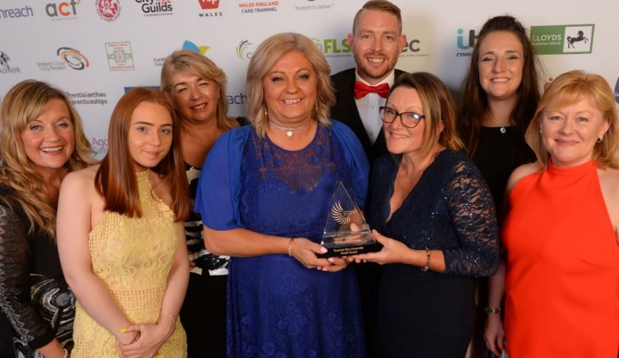
Swansea Bay UHB Apprentice Academy has been recognised with a national award. The health board was named Macro Employer of the Year at the Apprenticeship Awards Cymru, the annual celebration of outstanding achievement in traineeships and apprenticeships, held at the International Convention Centre Wales, Newport.
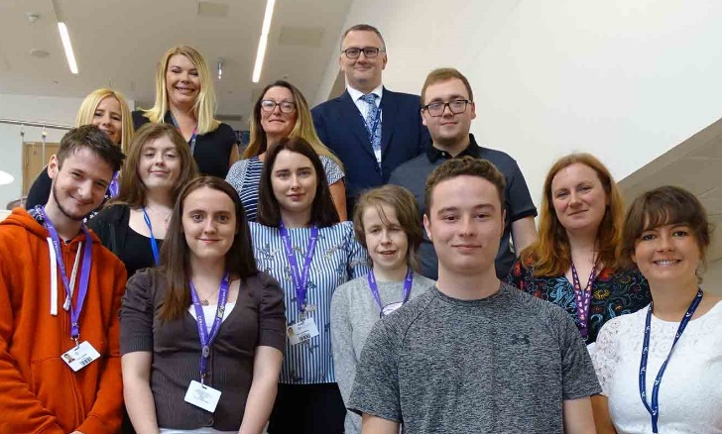
We launched Project SEARCH Supported Internships in September 2019 at Morriston Hospital, in partnership with Gower College Swansea and Better Jobs Better Futures. It is the first time Swansea Bay UHB has run the scheme.

Eight teenagers with additional learning needs began internships that saw them take on a variety of roles. The pharmacy, library and domestic service at Morriston Hospital are just some of the areas that the Gower College Swansea students were assigned to. As well as gaining practical experience, they also take part in classroom sessions in the hospital as they work towards a BTEC qualification in work skills. The internships are being provided under Project SEARCH, an international initiative which began in the US.

Through our Vocational Training Team, we offer a range of work-based training opportunities for unemployed people. These include Employability Skills Programme for adults and Engagement programmes for 16 – 19 year olds.

Covid-19
No one could have foreseen that we would end the year at such a challenging time for not just us but the world. The coronavirus (COVID-19) pandemic has drastically changed the way we live our lives. Everyone has been affected by the virus or the restrictions imposed in response to it. The negative impacts of the pandemic have been more severe for some groups than others.
The Equality and Human Rights Commission (EHRC) published a report ‘How coronavirus has affected equality and human rights’ in October 2020. This summarises the emerging evidence to help us understand the effects of the pandemic on different groups in society and the risks to equality and human rights in the longer term. The report sets out targeted recommendations for the UK, Scottish and Welsh Governments to ensure equality and human rights considerations are integrated into the policy response to the pandemic.

Looking forward to the next year

We will take the opportunity to learn from the pandemic and make improvements where we can. We will be reviewing our Strategic Equality Plan 2020-2024 to identify the key inequalities exacerbated by the Coronavirus pandemic and refreshing our action plan to support our recovery from the crisis.

