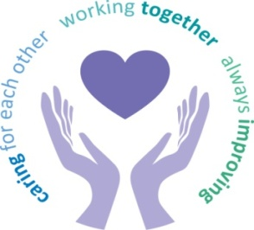
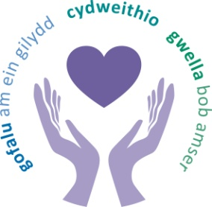

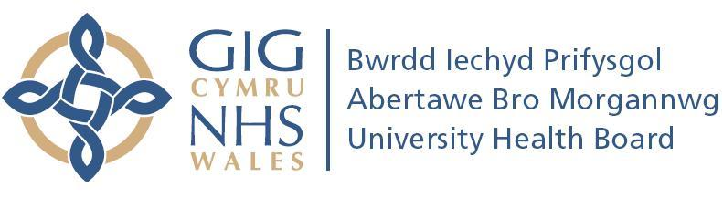

Annual

Equality Report

2017/2018

This document can be made available in

alternative formats and other languages

on request

Contents

Introduction |  | 1
How are we doing? |  | 1
Looking back over the last year: |  | 2
 | - Equality Objective 1 - Reduce health inequalities | 3
 | - Equality Objective 2 - Accessible advice and information | 8
 | - Equality Objective 3 - Communicate according to individual needs | 10
 | - Equality Objective 4 - Mental wellbeing | 12
 | - Equality Objective 5 - Mental health services for children and young people | 14
 | - Equality Objective 6 - Staff wellbeing and experience | 15
 | - Equality Objective 7 - Pay differences | 20
 | Looking forward to the next year | 22

Introduction

This is our seventh Annual Equality Report. It describes what we did to progress equality across the Health Board during 2017/2018. Equality is about making sure people are treated fairly and given fair chances. It is not about treating everyone the same, but seeing people as individuals and being sensitive, thoughtful and flexible about how to meet the needs of each person.
2017/2018 was a year of change in terms of our Board membership. We wished Alex Howells, Acting Chief Executive, well as she left at the end of January 2018 to take up the role of Chief Executive of a brand new health authority, Health Education and Improvement Wales. In February 2018, we welcomed Tracy Myhill as the new Chief Executive. Tracy is an experienced Chief Executive who has brought a wealth of leadership experience to the organisation.
The report is not designed to cover everything but is an overview highlighting some of our key work. It should be read alongside our Annual Report 2017/2018, Annual Quality Statement and Accountability Report 2017/2018

How we are doing?

The Equality Act 2010 is about treating everyone in a fair way. This law protects people from being treating less favourably than other people because they are:
- men and women
- disabled people
- young people and older people
- people from different races – who may speak another language
- people who follow a religion or who have no religious beliefs
- people who are gay, lesbian or bisexual
- people who are considering, undergoing or have undergone gender reassignment
- people who are in a civil partnership or married
- women who are pregnant or have recently had a baby.

We have to tell you how we collect and use information to ensure that we are treating people fairly. It is important that our services are meeting the needs of all groups of people who we serve and we treat people fairly at work.
Our values and behaviours framework was launched in 2015 by involving staff and service users. Our Annual Quality Statement shows the impact our values are having on the services our staff provide.

Looking back over the last year:
Taking forward our Equality Objectives

We have a plan of the work that we are doing to help ensure that everyone is treated fairly. This is known as our Strategic Equality Plan.
We have equality objectives set out within our plan. Our equality objectives have been integrated into our corporate plan to support the delivery of its strategic aims. We want to be always improving and review progress every year against our equality objectives. In this section, we have described what we did to work towards implementing the objectives during 2017/2018. This includes highlighting achievements and identifying areas where further work needs to be done.

Equality Objective 1

Reduce health inequalities through ensuring access to services for people according to their individual needs
Our Annual Quality Statement looks back over 2017/2018 at ABMU’s work programmes to promote good health. This includes:
- the uptake of the flu vaccination in target groups
- the delivery of nutrition and dietetics training in nursing homes
- easier access to education programmes for people with Type 2 Diabetes to help them manage their condition
- the introduction of ‘Help Me Quit’ – the new single brand for all smoking cessation services in Wales. Supporting ‘mums to be’ has been a priority for our midwives and services. Work has progressed to support people with mental ill health with our secure mental health unit becoming smoke-free this year. We have worked with the local authority to roll out the smoke free gates to all our primary schools.
A Morriston ward sister was named RCN Nurse of the Year 2017. Melanie Davies, sister on Ward G, has worked to improve the care of people with learning disabilities not only in Morriston Hospital but across ABMU. Melanie also won the Learning and Disability Practice Award.
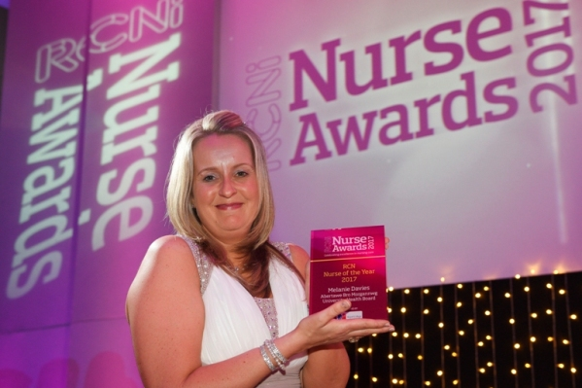
She said: “I am shocked, honoured and amazed – I just can’t believe it. This is the highlight of my nursing career. I’ve got a fantastic team behind me and work with fantastic people but ultimately this award is for Paul Ridd and his family.”
RCN Nurse of the Year 2017 – ABMU’s Melanie Davies
Mr Ridd, who had learning disabilities, died at the hospital in 2009 after receiving very poor care. Since then Melanie has been committed to helping change the way in which vulnerable patients are looked after, working closely with his sister and brother, Jayne Nicholls and Jonathan Ridd.
Since joining the ward in 2010, Melanie has advised colleagues, developed information packs, delivered training and developed a network of champions.
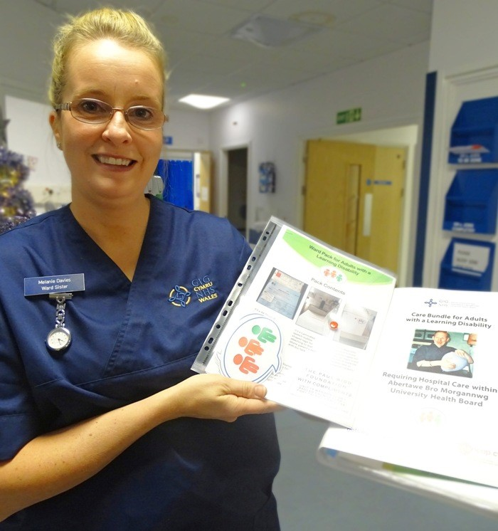
Melanie developed an information pack, with communication tools, magnets, stickers and advice, to make it easier for staff to meet the needs of people with learning disabilities.
Melanie with one of the packs which are now in use across ABMU.
She started delivering informal training sessions on wards to explain the packs and established herself as the hospital’s go-to person for advice when a patient with learning disabilities arrives on the ward.
The packs and training have now been rolled out across the hospital and ABMU and are now used as the foundation for the care bundle developed as part of the Welsh Assembly’s 1,000 Lives campaign.
There is now a network of 170 trained learning disabilities champions across the health board’s four sites. The champions’ names are on ward noticeboards so staff know who to turn to with any questions or issues about learning disabilities care.

The Soothing Patient Anxiety – SPA – experience won another top award for the Princess of Wales Hospital anaesthetic team. The initiative takes the fear out of the operating theatre for patients with a learning disability who need dental work but cannot be treated in a traditional dentist’s surgery.
Instead they are treated under general anaesthetic in hospital – where the anaesthetic team has gone to extraordinary lengths to make sure they feel at ease. This includes letting them play their favourite film, music or video game as they go to sleep.

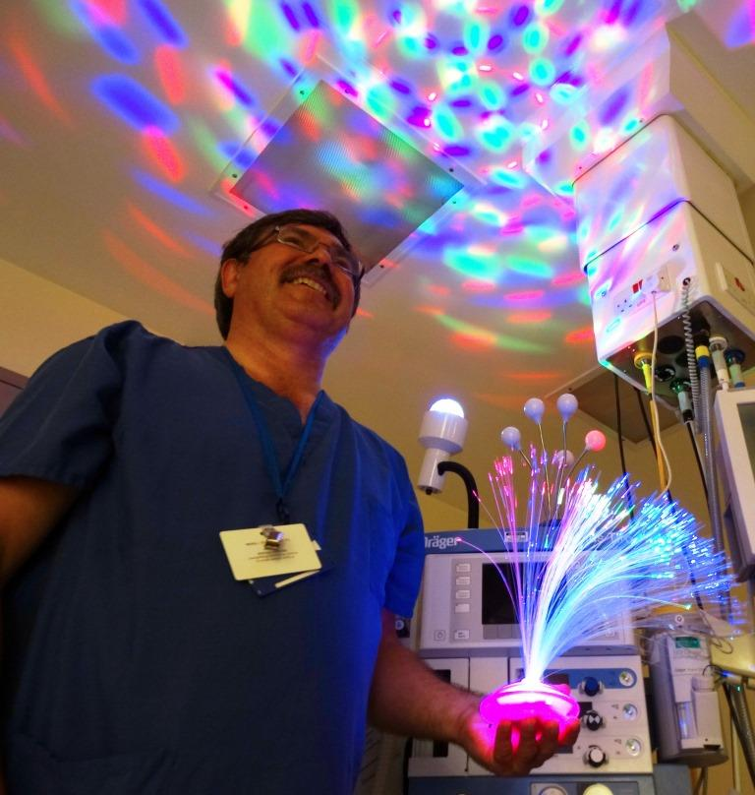
Operating department practitioner Paul Harris has also sourced an array of props ranging from disco lights to children’s character toys.
Paul with some of the lighting effects used as part of the SPA experience.

The initiative has won several awards, including an NHS Wales Award 2016. It won the Anaesthesia Team of the Year Award in the 2017 national BMJ Awards. A video about the SPA experience can be seen here.

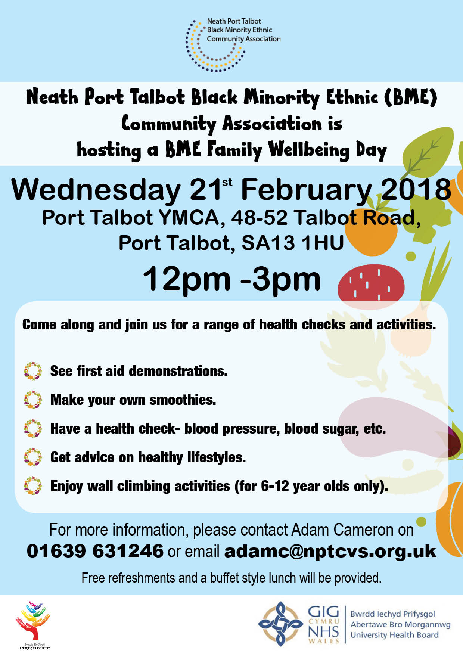
ABMU Health Board supported the newly established Neath Port Talbot Black Minority Ethnic (BME) Community Association to host a health event for the BME community at Port Talbot YMCA on 21 February 2018. Funding was provided to run the event from the ABMU Changing for the Better Grant Scheme. ABMU health staff provided health checks at the event and gave advice in relation to health and wellbeing.

JIG-SO is a joint ABMU and Swansea Council project which has been running since May 2016. The team of Families First midwives, community nursery nurses, family facilitators and early language development workers offer additional support to young women aged up to 25 years and their partners.
It aims to improve care throughout pregnancy and afterwards with family facilitators and early development workers able to provide support up to the child’s third birthday. This means a better experience of pregnancy for the woman and the best possible start in life for the baby.
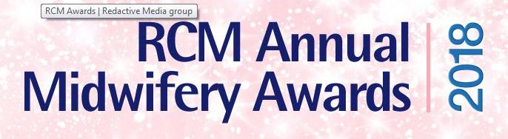
The JIG-SO team won the Reducing Inequalities category at the 2018 Royal College of Midwives (RCM) Awards.
The award judges were impressed with the way in which the project brings together professionals from different disciplines to offer a rounded and long-term approach to care. This fits well with the Well-Being of Future Generations (Wales) Act 2015.
The project has been very successful. Breastfeeding rates for women participating are impressive and the number who have stopped smoking in pregnancy is well above the average for the health board area.
It has also had major personal benefits for these young families. A significant number of mothers who went through the JIG-SO team have had their children removed from the Child Protection Register. A similar number of families no longer require the support of social services.

Equality Objective 2

Provide accessible advice and information to enable people to understand and make informed choices
Morriston Hospital became the first hospital in Wales to launch an online access guide in partnership with DisabledGo on 8 May 2017. This tells people everything from how far the car park is from the main entrance to where the lifts and disabled toilets can be found. It means that disabled people can find their way around Morriston Hospital before they have set off from home. The guides use icons to denote site-specific details such as ramps, disabled toilets, hearing systems as well as wider accessibility information. It includes photographs of the features covered.
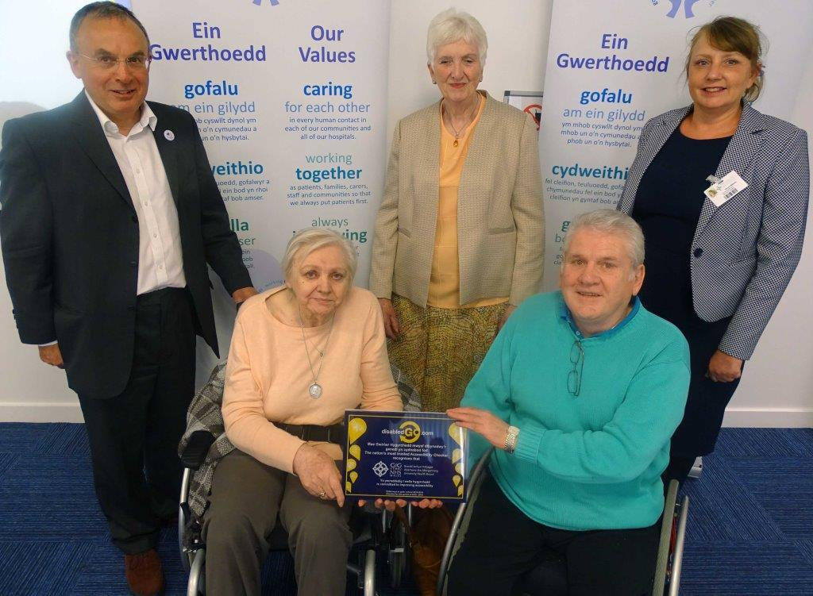
With the DisabledGo plaque are (l-r): ABMU Chairman Andrew Davies; Jean Williams, Catherine Coombs and Brendan Campbell from the Disability Reference Group; and Morriston Nurse Director Nicola Williams

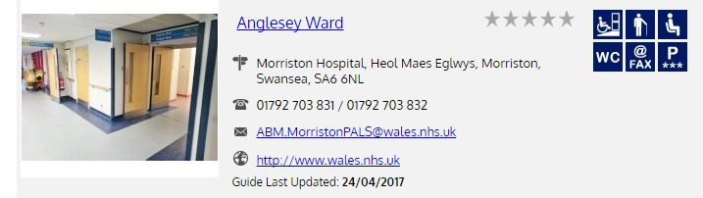

The access guides will be particularly helpful to disabled people, their carers, family and friends. The guides will also be useful to anyone who wants to find out more about the place they will be visiting.

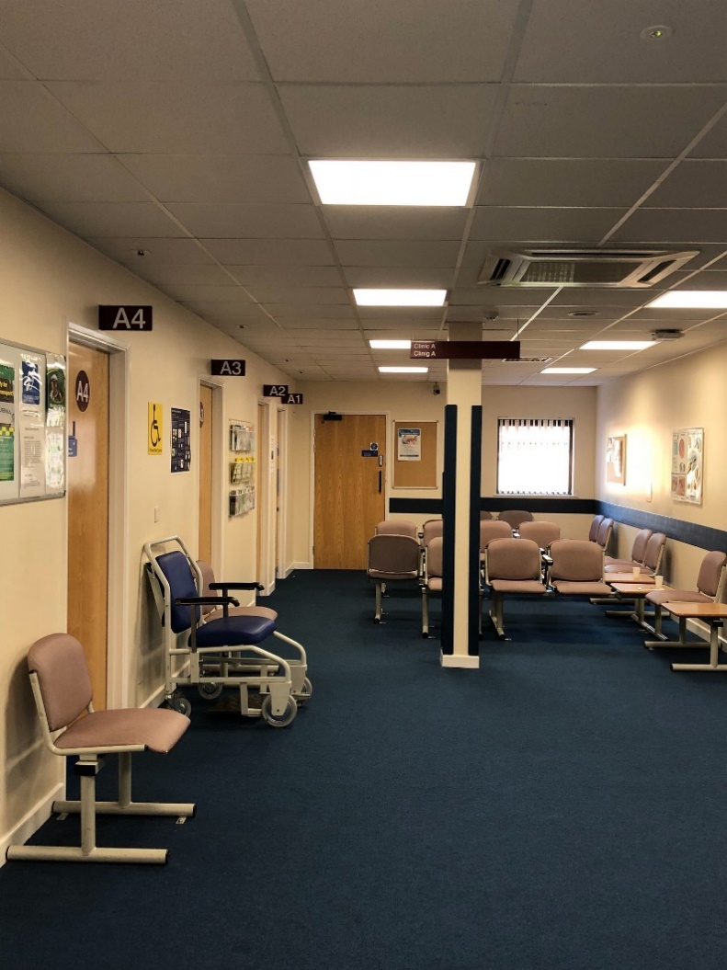
Members of ABMU’s Disability Reference Group (DRG) advised on making improvements to the accessibility of the Eye Clinic at the Princess of Wales Hospital, Bridgend. This included replacing the lighting and carpet within the department. The DRG agreed the use of the funding allocation from the Capital Programme 2017/2018 to undertake this work. A DRG representative visited the department with Capital Planning staff on completion of the scheme.
Improvements made to Eye Clinic, Princess of Wales Hospital

Three young patients had a starring role in a new video produced by the paediatric respiratory team at Morriston Hospital. It teaches children who are being treated for asthma and wheezy episodes the correct way of using their inhalers. The short film shows three young children being given a demonstration in using inhalers, peak flow meters and volumatic spacers by a paediatric respiratory nurse.
The equipment is vital in helping patients to manage their condition by getting the correct amount of medicine into the lungs where it can work to reduce symptoms.
Children with respiratory conditions often need to attend specialist clinics regularly for help managing their treatment. The video will help act as a reminder to young patients and their parents in between their clinic appointments. The video can be viewed here.

Equality Objective 3

Communicate with patients, families and carers according to their individual needs
We have a Group overseeing the implementation of the All Wales Standards for Communication and Information for People with Sensory Loss across the Health Board. The Standards set out the level of service delivery that people with sensory loss should expect when they access healthcare.
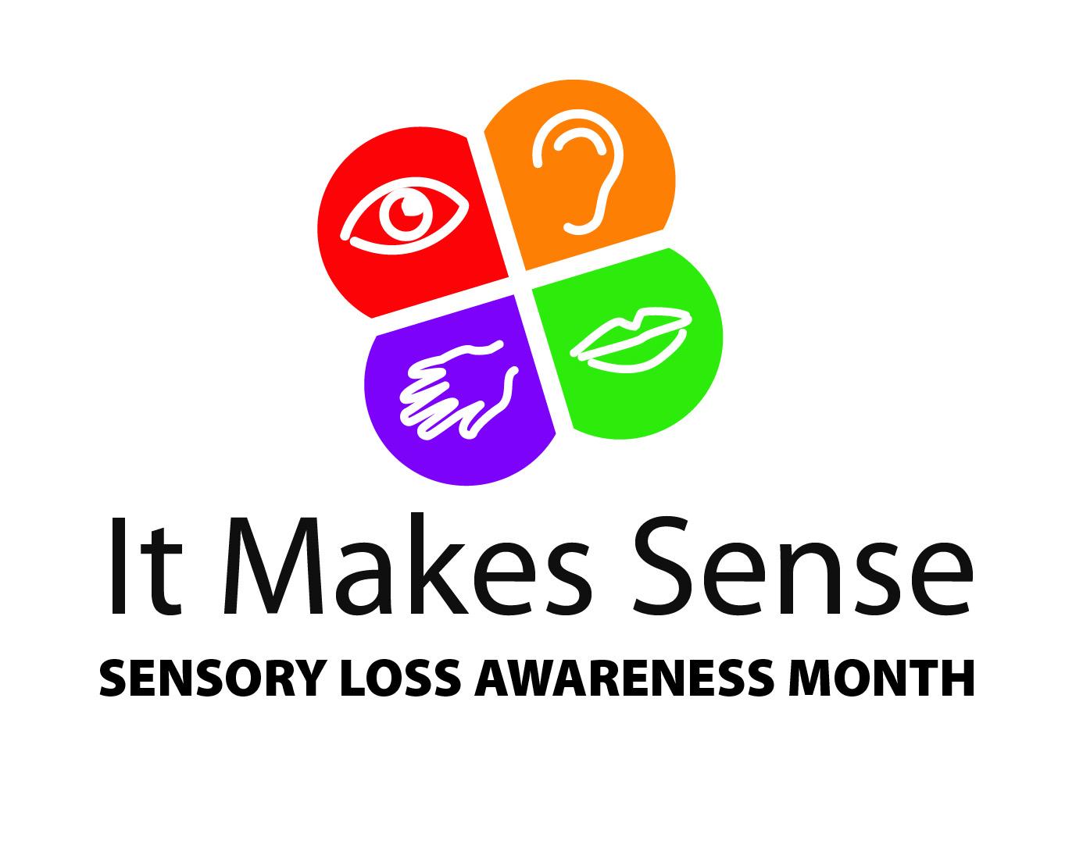
ABMU Health Board celebrated the national campaign ‘It Makes Sense – Sensory Loss Awareness Month 2017’ by hosting the third anniversary campaign launch at Port Talbot Resource Centre on 23 November 2017. Our Director of Therapies and Health Sciences was delighted to welcome staff and members from the RNIB Cymru, Swansea and Bridgend Deaf Clubs, Deafblind Cymru and Swansea Hard of Hearing Group. The programme included:
- Betws Primary School Choir singing and signing songs
- Speeches from the Cabinet Secretary for Health and Social Services and a Deaf Blind Cymru representative
- Sketch around accessibility performed by UCAN Productions - a group of young people with vision impairments
- Screening of the campaign film to show how to remove communication and information barriers for people with sensory loss. The video can be viewed here.

Patients on a Morriston Hospital ward were given a helping hand to hear thanks to a donation of new equipment. Ward F received an induction loop amplifier system from an audio expert who also trained up staff to help patients use it.

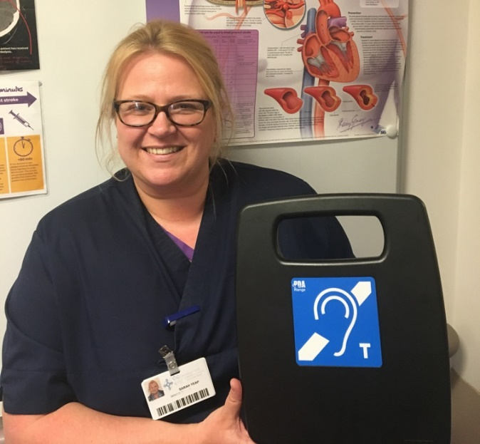
The induction loop is a special type of sound system that helps people with hearing aids pick up on specific sounds.
It is now benefiting patients who are hard of hearing with day-to-day communication on the ward as staff carry out patient capacity and occupational therapy assessments as well as doctors’ rounds.
Sister Sarah Yeap with the loop amplifier system

The Western Bay Carers Partnership Board continues to work together to raise awareness of unpaid carers and to support them by providing information and services. This year, additional funding has been made available and used to:
- further develop identification and support of young carers in schools in the area
- expand the work undertaken by Swansea and Bridgend Carers Centres and Neath Port Talbot Carers Service in providing information at local hospitals and at other health settings.
In February 2018, the Bridgend and District branch of the Alzheimer’s Society started a new service at the Princess of Wales Hospital offering advice regarding looking after someone with dementia. A support worker from the charity visits the hospital every month to talk to carers looking after a loved one with dementia. They offer personal advice and practical support.

Equality Objective 4

Work with partners to promote mental wellbeing and improve access to mental health services for people who are most in need of support
Our Annual Quality Statement 2017/2018 shows that suicide prevention was one of our top 10 quality and safety priorities. Pages 6 - 8 of the Annual Quality Statement outlines some of the actions that have been undertaken against the priorities.
To mark mental health awareness week, a variety of events took place around Swansea. They were aimed at reminding the public that mental health problems can affect anyone, regardless of background and offering information about how to get help and advice.
The Patient’s Council based at Cefn Coed Hospital worked with the community group, Think Again, which is made up of people who have experienced mental health issues. Together they planned a programme of events for the week going to places like supermarkets and day centres. The week was brought to a close with a walk from the Junction Café at Blackpill, along the seafront, ending at Verdi’s in Mumbles.
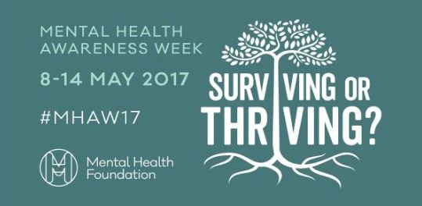
The theme for the week was ‘Surviving or Thriving’. People who had experienced mental health problems themselves were there to offer advice and support at the events.
In May 2017, ABMU Health Board, Bridgend County Borough Council, Neath Port Talbot County Borough Council and Swansea Council agreed that they would develop a strategic framework for mental health services for adults. Engagement with service users and their carers/ families was crucial to ensure that this framework addressed the issues our population face when trying to get support from our services.
The new model of care is based on what service users and their carers told us needed to be different in future. Key to the new model is that anyone who has mental health problems has the right to receive help and support which aims to prevent problems and intervene earlier to stop problems escalating. Our Annual Quality Statement outlines what these services will include and what is needed for the new model to become a reality.
To mark World Mental Health Day on 10 October 2017, a special event supported by ABMU took place in the Grand Theatre Arts Wing in Swansea. It featured local consultants presenting talks on various aspects of mental health, including depression in older adults and dementia. It was open to the general public and free of charge. The Swansea event has been organised for more than 10 years by the Patient’s Council based at Cefn Coed Hospital.
The theme for Mental Health Day was ‘Mental Health in the Workplace’. Information was made available at the event on 60 projects involving the health service, local authority, universities, the Third Sector and service user and carer groups.
ABMU has a number of projects and campaigns in place to improve the health and wellbeing of its own workforce.
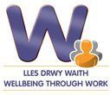
It also runs the Wellbeing through Work In-Work Support Service, which is open to anyone who is struggling in work or on sickness absence due to mild or moderate mental health issues – such as stress, anxiety or low mood.
The initiative provides rapid access to a team of locally-based NHS occupational therapists, who specialise in emotional health issues, and physiotherapists. They provide tailored support to help people manage their health condition in work, or to successfully return to work. The confidential service is open to people who are employed or self-employed, and live or work in the Bridgend, Neath Port Talbot or Swansea areas.

Equality Objective 5

Work in partnership to improve emotional and mental health services for children and young people
Our Annual Quality Statement 2017/2018 highlights that the purpose of the ABMU Health Board Children and Young People’s Strategy Board is to ensure the delivery of safe, effective and family or carer centred care for children and young people. This will be across all levels of care from the promotion of health and wellbeing to referral for specialist care.
The terms of reference have been reviewed and agreed to ensure there is representation from all key service providers across ABMU, the Local Authority and Third Sector organisations.
The Board will develop and agree a work plan for the year, which includes the Health Board wide Children’s Strategy.
Our Annual Report 2017/2018 explains that we have regular meetings with Cwm Taf University Health Board to review and discuss performance and the quality of care in Child and Adolescent Mental Health Services which they are commissioned to provide on our behalf.

Equality Objective 6

Improve the wellbeing and experience of our staff

Staff wellbeing was a continued priority over the past year with a focus on early intervention to increase resilience and emotional health. 256 Wellbeing champions have undertaken training to deliver the role in their service area and are supporting our approach to early intervention.
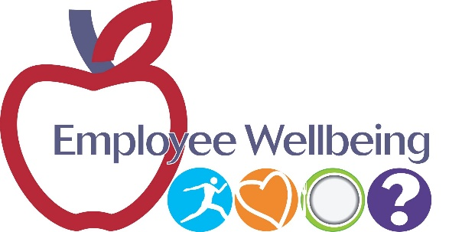
Staff can access support within 7 days of self-referring to the new Staff Wellbeing Advice and Support Service. Early evidence shows 67% of staff are referring for mental health problems and 33% for physical health.
78 managers have undertaken the Work Related Stress Risk Assessment Training. A rolling programme of courses has been planned to enable managers to better manage stress in the workplace. 48 managers have attended Mental Health Awareness Training. A rolling training programme has been planned.
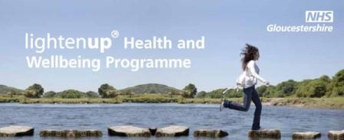
Staff health and wellbeing courses (Managing Your Wellbeing and Lighten Up) continue to be delivered.
We continue to engage with ‘Time to Change Wales’, which aims to reduce stigma and discrimination associated with mental health in the workplace. Ten presentations have been made to staff and Managers.

We have continued to work to embed the ‘Living our Values’ programme which has included workshops and staff shadowing listening events. Following the launch of our Staff Experience Strategy, a Reward and Recognition Programme took place during 2017/18. This included the launch of ABMU Long Service Awards programme and the continuation of the Patient Choice Awards and the Chairman’s Awards.

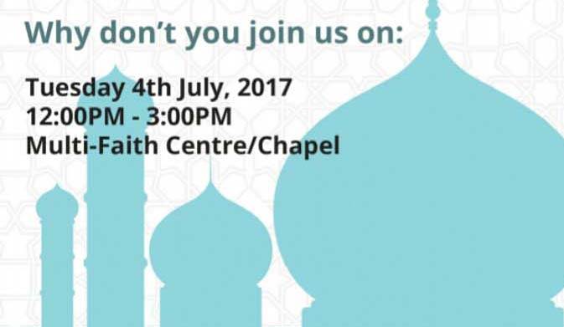
Muslim staff hosted the first Eid Al-Fitr celebration in the Multi-Faith Centre at Morriston Hospital on 4 July 2017. This free event was open to staff and the public, with food and drink included. It was organised by the hospital’s Muslim Chaplain and Muslim staff. The event celebrated the end of Ramandam and helped people learn and understand Islam.
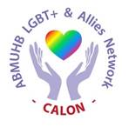
ABMU’s Lesbian, Gay, Bi and Trans (LGBT+) & Allies Staff Network, Calon, is going from strength to strength with an increased profile. The network provides networking opportunities and peer support between staff. It is open to LGBT+ employees and allies. Calon’s membership is continually increasing and new members are always welcome. Just drop an e-mail to Calon.LGBTStaffNetwork@wales.nhs.uk if you want to find out more.
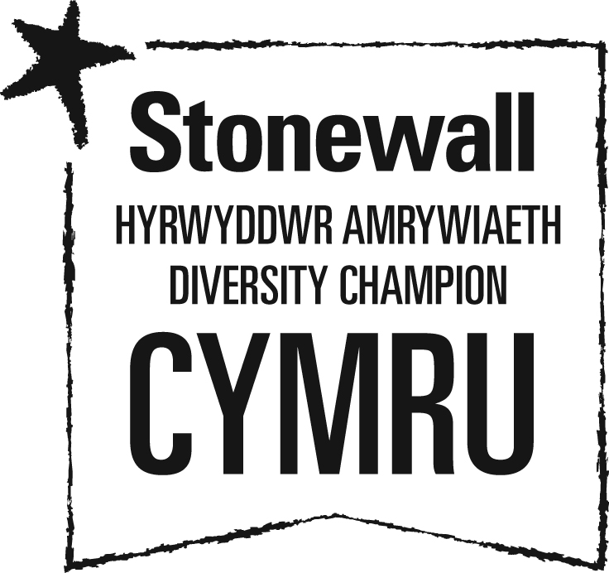
ABMU is a proud member of Stonewall Cymru’s Diversity Champions Programme. Stonewall is Europe’s largest lesbian, gay, bi and trans (LGBT) charity. Diversity Champions is the leading employers’ programme for ensuring all LGBT staff are accepted without exception.

We were one of the 434 organisations that took part in Stonewall’s Workplace Equality Index (WEI) 2018. This is a bench marking tool for employers to measure their progress on lesbian, gay, bi and trans inclusion in the workplace. ABMU moved up 93 places in the Stonewall WEI to be ranked number 154 in 2018. We are edging closer to the Top 100 Employers list after only a short amount of time as this was only our second year of entry.
ABMU successfully launched Stonewall’s No Bystanders campaign in August 2017 to encourage staff to speak out and challenge all forms of hateful language and abuse. This campaign was a huge success with dozens of teams across ABMU signed pledges in support of this anti-discrimination campaign in the workplace. The campaign was run by Calon with support from ABMU’s Graduate Trainee Managers and the health board’s full backing.

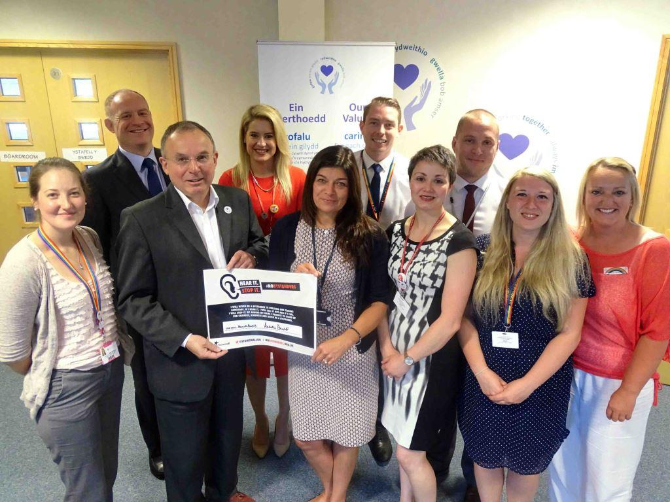

Chairman Andrew Davies and interim Chief Executive Alex Howells are holding the signed pledge with Calon’s founders and the Graduate Trainee Managers

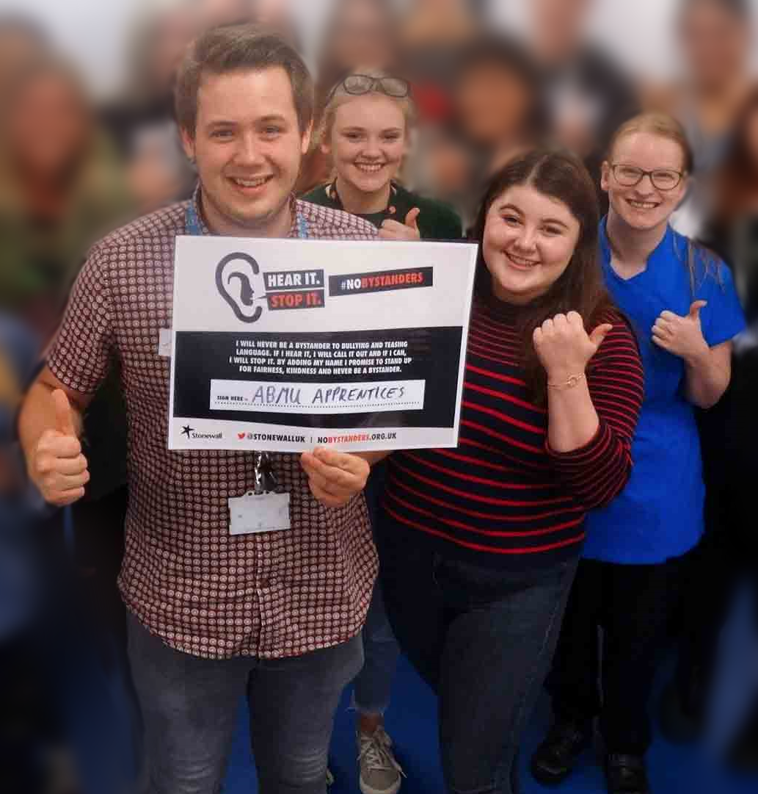

Left: No Bystanders gets the thumbs-up from ABMU apprentices

ABMU staff supported the Pride Cymru parade in Cardiff on Saturday, 26 August 2017. It was important for us to join Wales’s largest celebration of equality and diversity to show our commitment to sexual orientation and gender identity equality. Members of Calon were joined by colleagues, family and friends for the parade through the city centre.

Calon members joined colleagues from across NHS Wales on a health information stand hosted by Aneurin Bevan University Health Board at an event afterwards in Cardiff civic centre. People were encouraged to visit the stand to describe their experiences of using NHS services in Wales. They told stories of good care, as well as how services could be improved for the LGBT+ community.

LGBT History Month takes place every February and celebrates the lives and achievements of the LGBT community. It was founded by School’s Out UK, the LGBT Education Charity, and 2018 was its 14th year.

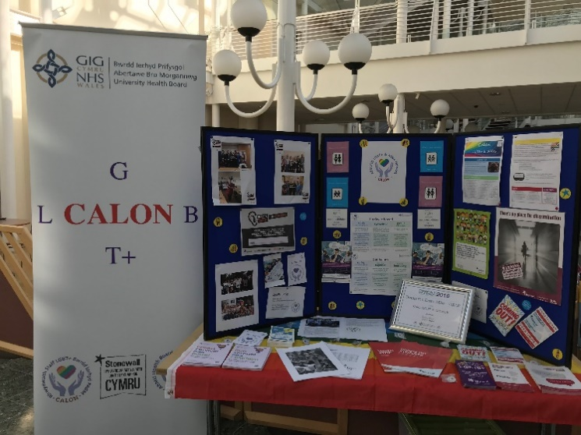
Calon marked LGBT history month by running information stalls at the Princess of Wales, Neath Port Talbot, Morriston and Singleton Hospitals during lunchtimes for staff to learn about the Network. They advertised the dates and times of the stalls and invited staff to come along for a chat.
Calon collaborated with Cinema and Co, an independent cinema in Swansea, with the screening of the heartwarming and funny film ‘Beautiful Thing’. This feel good, positive movie is about self-discovery and first love set in working class 90s London. The film was screened on the evening of Friday, 16th February 2018 and was open to the general public.

Equality Objective 7

Develop a fuller understanding of the reasons for any pay differences

We have produced pay reports and these are available on our website: http://www.wales.nhs.uk/sitesplus/863/page/59057
We recognise that there is more work to be done to analyse pay differences. This includes improving the collection of equality data for staff and raising awareness of the reasons why the information is collected. We will be researching the best practice work of other organisations to learn how improvements can be made to the workforce and pay data analysis.

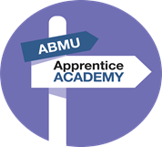
Our Apprenticeship Academy is going from strength to strength with 100 apprentices having joined us in a range of clinical and non-clinical roles. NPTC Group of Colleges works in partnership with the Academy to identify suitable candidates for apprenticeships and to support them throughout their training. Many of our apprentices have now completed their apprenticeship programme and are employed by ABMU on a permanent basis.

The Minister for Lifelong Learning and the Welsh Language dropped in to attend one of the regular workshops held at Morriston Hospital by the Health Board’s Apprentice Academy on 26 February 2018. The Academy brings together new recruits for training and support. The Minister heard from both current apprentices and their line managers about what they have gained from taking up the training opportunities.
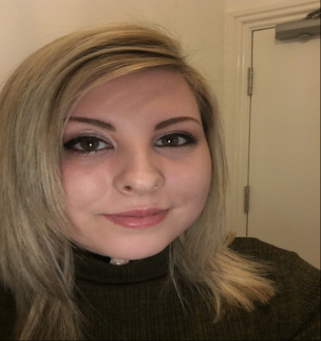
Shannon Rees joined ABMU as an apprentice in October 2016, hoping to establish a career within the NHS. Shannon was successful in finding permanent employment as a Band 4 within the Informatics Department in October 2017.
Shannon said: “Without the apprentice academy and my team, I would not have been able to have experienced such a positive way into work which allowed me demonstrate my potential and passion and now because of this I’ve got a permanent position in the health board.”

The Apprenticeship Academy promote apprenticeships and NHS careers at job fairs, careers and community events to encourage people from diverse backgrounds to apply to work for us. This included the South Wales Indian Society Careers event and Pride. We monitor the protected characteristics of people through the recruitment process.
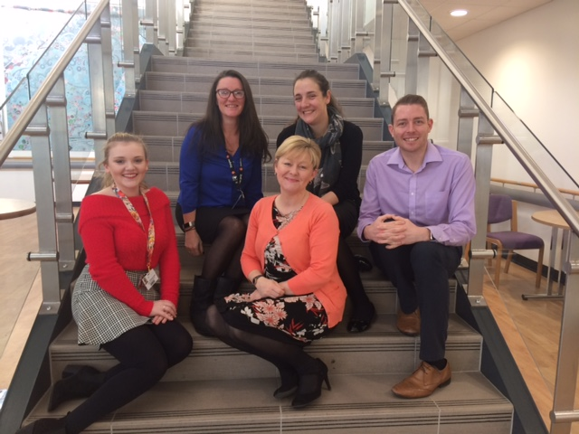
Pictured left to right are Giorgia-May Towns, Ruth Gates, Ruth Harding, Kay Myatt and Mitchell Jones

Through our Vocational Training Team, we offer a range of work-based training opportunities for unemployed people. These include Employability Skills Programme for adults and Engagement programmes for 16 – 19 year olds.
ABMU promoted Independent Member vacancies on the Health Board with the aim of increasing the diversity of public appointments. We publicised the links to these adverts on the Welsh Government website as they managed the recruitment process on our behalf. We sent the links to the adverts to stakeholders, local third sector organisations, local councils, colleges and universities and equality forums to raise awareness of the roles.

Looking forward to the next year

Our Strategic Equality Plan is published on our website: http://www.wales.nhs.uk/sitesplus/863/page/59057

The objectives help us to continue to make equality and diversity an integral part of all our work and focus on the areas of inequality. We will be tackling the inequalities through actions to take forward our equality objectives.

We will have the health board’s full backing going forward as they are committed to ensuring that we continue to shape the future of equality and human rights within the Health Board.

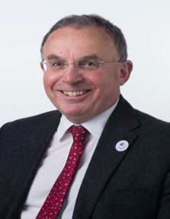
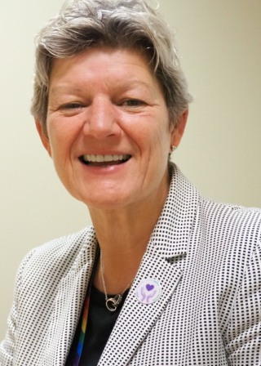

Chairman: Andrew Davies Chief Executive: Tracy Myhill

