


Swansea Bay University Health Board

Standard Operating Procedures
Best Interest Decision
in Supporting Discharge for a Person Lacking in Capacity

Equality Impact Statement
This policy has been screened for relevance to equality. No potential negative impact has been identified so a full equality impact assessment is not required

Document Authors: Sharon Jackson – Interim Integrated Community Services Manager
Sarah Morse – Clinical Lead OT, UEC; Laura Thompson – Lead OT, MGH; Andrea Preddy – Principal Officer, Swansea Council
Approved By:
Approver | Date | Version
Mental Capacity Delay Task & Finish Group | 05/03/2025 | 1.0
Combined: Regional Operational Assurance Group/Pathway of Care Delays Group | 28/08/2026 | 2.0
Unscheduled Emergency Care Board
RPB - Older People Board
Review Date:

- Introduction
Ensuring timely and safe discharge of patients who lack capacity to make decisions about their care is critical in maintaining their well-being and preventing unnecessary hospital stays. This SOP outlines the process for conducting and documenting a Best Interest Decision when a person is unable.
This SOP supports the Mental Capacity and discharge requirements contained within the Overarching Discharge Policy. Overarching Discharge Policy DRAFT v1.2.docx
- Definitions and Abbreviations
- Mental Capacity Act (MCA): A legal framework governing decision-making for individuals lacking capacity
- Integrated Discharge Hub (IDH): A multi-disciplinary team coordinating patient discharges from hospital settings.
- Reablement: Short-term support designed to help individuals regain independence following a hospital stay.
- Lasting Power of Attorney (LPA): A legal representative authorised to make decisions on behalf of an individual who lacks capacity.
- Purpose
- To support staff to undertake and document a Best Interest decision for a person lacking capacity, to achieve timely discharge to minimise risks of hospital admission or prolonged hospital stay (Home First ethos).
- To improve patient experience and outcomes
- To reduce length of stay
- To prevent or reduce deconditioning
- To reduce or avoid hospital borne infections
- Scope
- Patients aged 18years and older who have been assessed on the probable basis of lacking capacity, specific to the discharge decision at that time.
- Discharges without disagreement, conflict or complexity or a financial charge.
- If a discharge has a new financial charge or cost for the individual, then it is not within scope of health staff to complete a best interest decision. An MCA would be required in these circumstances for discharge planning.
- Returning to usual home/care home, with or without temporary arrangements i.e. Reablement Support/District Nursing/Acute Clinical Team/Virtual Wards
- Responsibilities
- Any registered health or social care professional involved in the care of a person in relation to discharge can support and undertake the best interest decision.
- This includes (but is not exhaustive of): Ward Nursing Staff, Medical Staff, All Health Professionals, Patient Flow, Clinical Nurse Specialists, Social Workers, Discharge Liaison Nurses, Pharmacists, Acute Clinical Team, Virtual Wards.

- Procedure
- All staff should read and follow the SOP.
- All health board staff should be compliant with MCA and DoLs Level 3 Training. Band 5 registrant or higher can complete the best interest decision.
- Following assessment indicating a lack of capacity to make a decision in relation to discharge, at that specific time, proceed with the Best Interest decision.
- Follow the Best Interest Template: refer to Appendix A.
- Document patient name, DOB, NHS Number, Date, Time of Assessment, name, profession & signature of person leading on Best Interest Decision. Include names, roles of any other persons present.
- State decision to be made.
- Why you believe the person is unable to make the decision? Consider the following four questions:
  - Can they understand?
  - Can they retain?
  - Can they weigh up information?
  - Can they communicate expression of choice at the time of the assessment?
- What is the impairment of the mind or brain? (Formal diagnosis not required. It does not matter if the impairment or disturbance is permanent or temporary).
- Document, based on the above, the probability of not having capacity to make the decision in relation to discharge.
- Consider all available options, starting with least restrictive.
Discharge options should be considered in line with the Choice Policy. Choice Policy v2.0.docx
- Every effort should be made to consult with the individual in addition to consulting with any person involved in the individual’s care such as family, other hospital, health and social care staff, Lasting Power of Attorney, Deputy, Care Home Manager/Lead Nurse etc.
- Consider current and past preferences of the person, including beliefs and values in the discharge outcome decision.
- Store Best Interest Form in Medical Notes.
- Copy of form to be placed in professional specific documentation, if required.
- Good practice to provide a copy to patient, family, informal carer etc.
- As the Best Interest is time and decision/task specific, Best Interest decision will be reviewed by the receiving service, profession, care home etc.
- If referring on to Integrated Discharge Hub (IDH) for discharge pathway, document Best Interest decision outcome only e.g. Best Interest decision completed for Reablement in ‘reason for referral’ text box, along with other information relevant for safe discharge.
- DO NOT TICK Social Worker or Mental Capacity Assessment on IDH SIGNAL referral, this should only be used where formal MCA, complex discharge planning is required, such as permanent change in discharge destination or disagreement on discharge plan.
Where disagreement remains unresolved following the best interest decision, the Reluctant Discharge SOP should be followed. Standard Operating Procedure - Reluctant Patient Discharge.docx
- Appendices
Appendix A: Blank – Best Interest Form
Example
Name | DOB | NHS No
Capacity
What is the decision to be made?
Why do you believe the person is unable to make the decision? (Document rationale considering all 4 of the following questions:
- Understand?
- Retain?
- Use or weigh up?
- Communicate expression of choice?
What is the impairment in the functioning of the mind or brain? (DO NOT have to have a formal diagnosis). And link to why they can’t make the decision.
I have reason to believe, on the balance of probabilities, the person named above did not have capacity to make this decision at the time I spoke to them and so a best interest decision has been made on their behalf.

Best Interest Decision
What are the available options?
Who has been consulted with? | Date spoken to
Decision made:
- All person’s consulted with agree that this decision is the least restrictive option and in this person’s best interests:
- Yes ☐
- No ☐. If anyone is objecting seek line management/colleague advice, consider referral to other appropriate professionals

Balance of Decision
Decision (delete not applicable) | Pro (delete not applicable or add | Cons
Discharge from hospital as no further medical care requiring an inpatient stay identified | Reduce risk of harm  Reduce risk of hospital borne infection  Improvement in patient experience returning home  Improved potential of reablement within home environment  Reduced risk of deconditioning  Improved access to nutrition and hydration with foods/drinks of choice  Home environment enhances sleep quality aiding in recovery | Possibility of medical condition reoccurring
Not to admit to hospital as no medical intervention identified that requires inpatient treatment | Reduce risk of harm  Reduce risk of hospital borne infection  Improvement in patient experience returning home  Improved potential of reablement within home environment  Reduced risk of deconditioning  Improved access to nutrition and hydration with foods/drinks of choice  Home environment enhances sleep quality aiding in recovery | Possibility of medical condition reoccurring

Name & Role | Date | Signature

Appendix B: Example - Best Interest Form
Example
Name | DOB | NHS No
Joe Bloggs | 01/01/1941 | 12343546675
Capacity
What is the decision to be made?
Can Mr Bloggs decide what level of care he currently needs?
Why do you believe the person is unable to make the decision? (Document rationale considering all 4 of the following questions
- Understand?
- Retain?
- Use or weigh up?
- Communicate expression of choice?.
I have explained to Mr Bloggs several times what support he currently needs but although he understands what I am saying to him, his memory is so poor he will forget what we are talking about after a few minutes. At present Mr Bloggs is unable to retain information about the benefits of reablement or the risks to him going home without a reablement care package.
What is the impairment in the functioning of the mind or brain? (DO NOT have to have a formal diagnosis). And link to why they can’t make the decision.
Mr Bloggs is currently being treated for a UTI, has some residual delirium and so is currently unable to retain information for long enough about his care and support needs to make this decision.
I have reason to believe, on the balance of probabilities, the person named above didn’t have capacity to make this decision at the time I spoke to them and so a best interest decision has been made on their behalf.

Best Interest Decision
Consult with the patient. What are the patient’s views/expression? (consider previous choices, wishes, beliefs and values)
Mr Bloggs repeatedly stated he wants to go home.
. When Mr. Bloggs had capacity last year his family recall he told them he didn’t want to go into hospital

What are the available options?
Returning home with no care.
Returning home with a package of reablement for up to 6 weeks.

Who has been consulted with? | Date spoken to
Mrs Bloggs – agrees her husband is confused so can’t make the decision and that it is in his best interests to have reablement so he can go home safely.  DLN – Colin Collins - agrees Mr Bloggs is confused so can’t make the decision and that it’s in his best interests to have reablement as staring in hospital would be a risk to further infection. | 1.1.24 on phone  31.12.23 on ward

Decision made:
For Mr Bloggs to return home with reablement for up to 6 weeks.

- All person’s consulted with agree that this decision is the least restrictive option and in this person’s best interests:
- Yes ☒
- No ☐. If anyone is objecting seek line management/colleague advice, consider referral to other appropriate professionals

Balance of Decision
Decision (delete not applicable) | Pro (delete not applicable or add | Cons
Discharge from hospital as no further medical care requiring an inpatient stay identified | Reduce risk of harm  Reduce risk of hospital borne infection  Improvement in patient experience returning home  Improved potential of reablement within home environment  Reduced risk of deconditioning  Improved access to nutrition and hydration with foods/drinks of choice  Home environment enhances sleep quality aiding in recovery | Possibility of medical condition reoccurring
Not to admit to hospital as no medical intervention identified that requires inpatient treatment | Reduce risk of harm  Reduce risk of hospital borne infection  Improvement in patient experience returning home  Improved potential of reablement within home environment  Reduced risk of deconditioning  Improved access to nutrition and hydration with foods/drinks of choice  Home environment enhances sleep quality aiding in recovery | Possibility of medical condition reoccurring

Name & Role | Date | Signature
David Davies | 1.1.2024 | D Davies

Appendix C: Assessing Capacity Flowchart
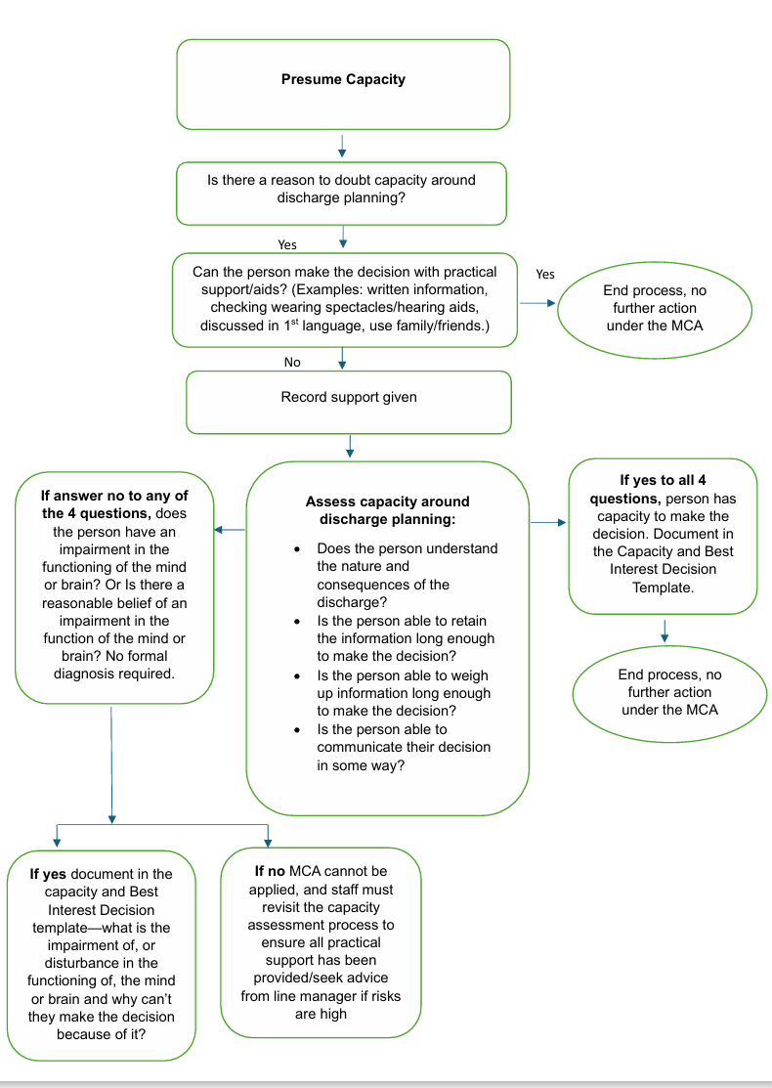

Appendix D: Best Interest Checklist
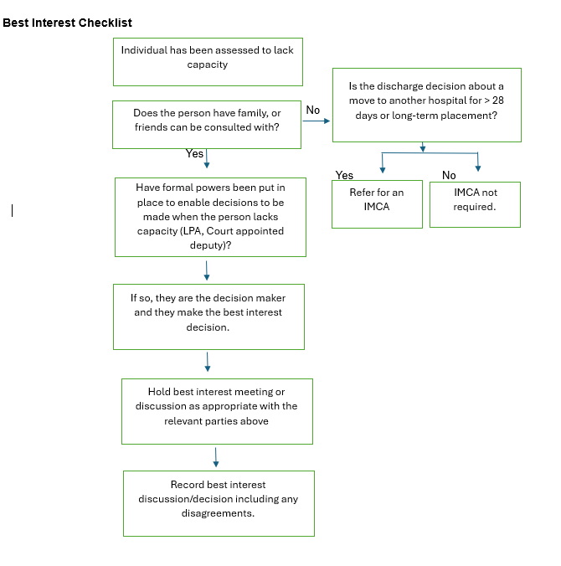

Appendix E: Best Interest Decision Pathway
