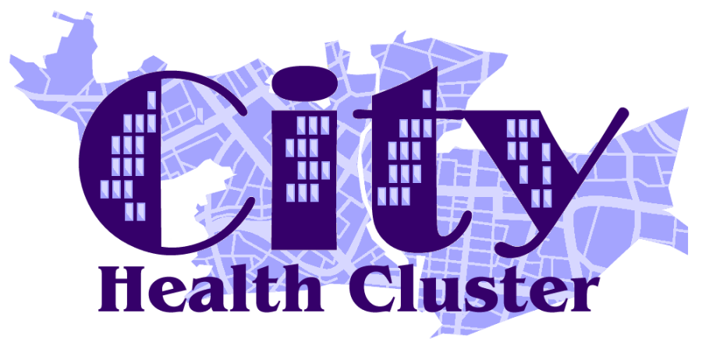

City Health Cluster
Integrated Medium Term Plan
(IMTP)

Annual Plan 2022 – 2023

Contents
1. CLUSTER OVERVIEW – PLAN ON A PAGE 1
2. FORWARD LOOK 2
2a. SWOT ANALYSIS 3
3. VISION/MISSION STATEMENT 4
4. STRATEGIC BACKGROUND & PRIORITY AREAS 5
STRATEGIC BACKGROUND 5
CLUSTER IMTP STRATEGIC PRIORITY AREAS 8
5. CLUSTER NEEDS HIGHLIGHTS 10
SUMMARY 10
LOCALITY KEY FACTS 17
6. ACTION PLAN 19
7. GOVERNANCE ARRANGEMENTS 27
MEMBERS 27
8. CLUSTER ASSETS PROFILE 28
Key Community Assets 28
9. CLUSTER WORKFORCE PROFILE 29
10. CLUSTER FINANCIAL PROFILE 30

1. CLUSTER OVERVIEW – PLAN ON A PAGE

The following provides an at a glance summary of key actions planned by the cluster:
IMPROVING PLANNED CARE | IMPROVING CANCER & PALLIATIVE CARE | IMPROVING UNSCHEDULED CARE
- Decrease long waiting times for persistent pain clinic through pilot project  - Introduce a cluster based spirometry project  - Maximise use of consultant connect  - Increase referrals to long covid service | - Promote screening uptake  - Implement 2 new pathways to expand referrals into rapid diagnostic centre  - Increase uptake into Help me quit  - Plan, secure and deliver co-ordinated 24/7 palliative and end of life care | - Deliver a comprehensive cluster flu programme  - Improve connections and referrals through optometrists for emergency eye care patients through the EHEW scheme  - Reduce inappropriate attendances at GP surgeries by dental patients  - Increase uptake of common ailment scheme
IMPROVING MENTAL HEALTH & LEARNING DIFFICULTIES | CHILDREN, YOUNG PEOPLE & MATERNITY | PREVENTION & REDUCING HEALTH INEQUALITIES
- Further develop, implement and evaluate the Alcohol related brain disease project  - Offer all patients on Learning disability register annual health check  - Commissioning cluster based mental health services | - Maximise the number of schools participating in healthy eating projects  - Commissioning of a project to provide mental health and well-being for young people  - Increase flu vaccine uptake in pregnant women | - Increasing uptake of e-learning for understanding of injecting drug users  - Reduce deaths from overdose through improving both access to and services available for substance misuse  - Implement plan to reduce antibiotic prescribing  - Identification of barriers to access for some patients and support in overcoming these  - Participate in the 2 year All Wales Diabetes prevention programme

The plan is actioned using enablers; technological, workforce, communication and engagement, financial. Click here

2. FORWARD LOOK

Welcome to the City Cluster Annual Delivery Plan 2022-2023. The Plan highlights our Cluster vision and priorities and details how we will achieve these over the next year.
The City Cluster covers an area of Swansea with high levels of deprivation, homelessness, ethnic diversity and unplanned emergency inpatient admissions. Our Cluster Plan has developed over the last few years to adapt and meet the changing needs of our diverse and growing population. We have fostered new and innovative ways of working that support practice sustainability and help ensure we have the right people in place to deliver safe and effective healthcare. This multidisciplinary approach has maximised the opportunities for cross-practice working and ensured better access for patients in conjunction with partner organisations. City Health Cluster has considered throughout its approach to the delivery of services how it can work to develop and promote net-zero health care in the future, we began our approach with supporting the introduction of an electric vehicle for one of our MDT members.
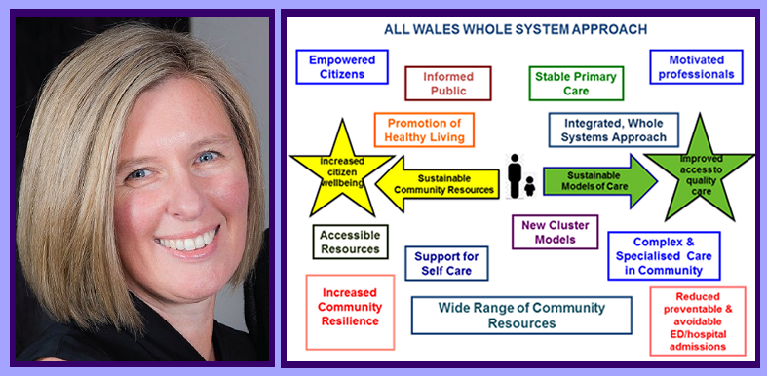
During the last eighteen months, Covid-19 has had a significant impact on service delivery. All contractors have had to change their ways of working, putting in place safer models of care that comply with the operational requirements associated with Covid-19. A number of the Cluster’s planned initiatives have been delayed over this time, including the Transformation Agenda, which was intended to encourage and fund new innovative ways of working with partners across the Cluster. During the last twelve months, our GP practices have had an important and significant role in helping to deliver both the first and second Covid-19 vaccinations, at the time of writing Covid-19 Boosters are being delivered through the Mass Vaccination Centres and by our Cluster community pharmacy colleagues.
The next twelve months will undoubtedly present the Cluster with a range of new opportunities and challenges. The City Health Cluster intends to develop methods of improving patient engagement, further strengthen our links with local schools and continue to work with partner agencies on a range of initiatives aimed at improving the health and wellbeing of its population. Next year we will have the additional challenge of beginning to implement the Accelerated Cluster Development programme, which aims to align cluster work with regional priorities of all our partners
The Integrated Medium Term Plan (IMTP) will continue to be the vehicle by which the Cluster will drive change and continue working towards meeting the Quadruple Aims outlined in the Welsh Government’s - A Healthier Wales.
Dr Ceri Todd, City Cluster Lead

2a. SWOT ANALYSIS

STRENGTHS  - Recognising Cluster population needs and working to support  - Building on relationships with Secondary Care, Third Sector, Local Authority and other partners  - Self-assessing and acknowledging gaps in provision and acting to fill i.e. Paramedic, Pharmacist  - Strong, committed leadership from Cluster Lead  - Funding secured for Non-responder Screening project  - Implementation and Business Development Manager  - Access external funding sources | WEAKNESSES  - Lack of time to develop initiatives  - Staff working at full capacity  - Difficulty regarding recruitment and retention of Health Care Professionals  - Lack of/Increasing cost of locums  - Need to have drive – Participation from all partners  - Consistency in ensuring that the Cluster message is relayed back to GP's within the practice and that their thoughts are fed into the Cluster  - Operational implications and Constraints associated with Covid-19
OPPORTUNITIES  - Tailor Protected Learning Time Sessions to attract and inform staff in order for primary care teams to engage with new ways of working and direction of travel for the Cluster  - Strengthen links with Secondary Care, Third Sector, Local Authority and other partners • Digitalisation/Modernisation  - Links established with two neighbouring Clusters for mutual benefit  - Tailor the IMTP further to the needs of the Network population  - Increased Cluster membership bringing new ideas and opportunities | THREATS  - Demand greater than capacity  - Contractual changes with commissioned services  - Health Care Professionals retirement/ recruitment issues  - Staff shortages in other areas  - Staff morale/wellbeing  - Practice sustainability  - Finance beyond the Transformation Fund  - Change in policy regarding Clusters  - Mainstreaming of Cluster Innovative Roles / Projects  - Operational constraints caused by Covid-19

3. VISION/MISSION STATEMENT

In 2018, City Cluster jointly agreed a Cluster Vision for the coming years. The Vision sets out how our Cluster sees its role in providing Health, Social Care and Wellbeing, with and for, the population of the City Cluster area and its practices.

“City Health Cluster has a vision to improve its patient’s health and wellbeing outcomes alongside focusing on the future sustainability of General Practice. We will achieve this by embracing and encouraging multi-agency and peer collaborative working, participating in and promoting education;
sharing our skills and resources across our Cluster efficiently and effectively.”

The Swansea Bay University Health Board (UHB) Clinical Services Plan sets out a list of key facets for the roles of Clusters:

- Delivery of primary, community and integrated services
- Planning and management of services best delivered at the Cluster level
- Delivery of Care Closer to Home where this is safe to do so and adds value to patient outcomes and experience
- Providing innovative alternatives to traditional outpatient or inpatient models of care
- Support whole populations to develop healthy lifestyles, through preventative programmes, self-care and out of hospital care.
- Integrating primary and community based services between health, social and voluntary sectors, physical and mental health services, with our partners
- Supporting the transition of care out of hospital into the community
- Promoting University Research and Undergraduate and Postgraduate Education in a vibrant community setting

4. STRATEGIC BACKGROUND & PRIORITY AREAS

STRATEGIC BACKGROUND

The Primary Care Model for Wales sets out how primary care will work within the whole system to deliver a place based approach. Our Cluster working is at the core of this to ensure care is better co-ordinated to promote the wellbeing of individuals and communities and will continue to be taken forward through the multi-disciplinary, multi-agency cluster planning teams reflecting all partner contributions.
The Cluster continues to focus resources on delivering the aims and aspirations of the Primary Care Model for Wales and to accommodate the delivery of improvements, our plan is flexible and will be underpinned by ongoing work to develop implementation and performance plans against the stated Goals, Methods and Outcomes Action Plan.
The 2022/23 Cluster IMTP is developed in alignment with national, regional and local strategic context and to address:
- COVID 19 Resilience
- Ministerial Delivery Milestones
- Local Primary Care Cluster Priorities
- Local Priorities influenced by Health Board IMTP, Regional Partnership Board, National Strategic Programmes and the Primary Care Model for Wales
- NHS Wales Planning Framework
- Framed within the context of the Well-being of Future Generations Act
- Social Services and Wellbeing Act 2014
- NHS Wales Decarbonisation Strategic Delivery Plan 2021-2030

As part of the process to develop this IMTP we have worked closely with Health Board colleagues to integrate with the Health Board IMTPs and planning arrangements, such as delivery plans for Cancer and Mental Health services, and under the context of The Clinical Services Plan (CSP) The CSP remains the primary roadmap for the long-term delivery of services for our communities and Cluster planning and delivery remains aligned to the four CSP principles:

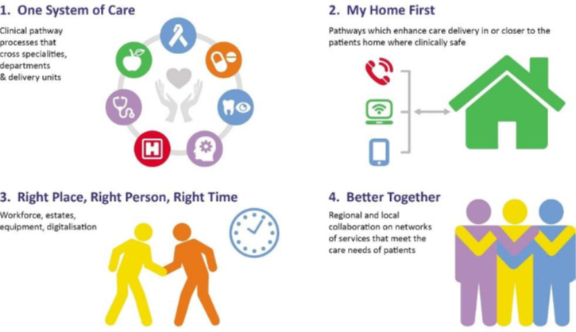

In Swansea Bay, Primary Care Clusters aim to:
- Work towards the Primary Care Model for Wales
- Prevent ill health
- Develop a range and quality of services in the community
- Ensure services in the community are better co-ordinated
- Improve communication and information sharing between professionals
- Facilitate closer working between community based and hospital services
- Support sustainability of primary care

Additionally, Cluster work is structured to encompass the Health Board’s overall Organisational Strategy as set out below in summary
The organisational strategies and priorities of a number of key regional partnerships are also accounted in our planning including:
- Swansea & Neath Port Talbot Wellbeing Plans
- The West Glamorgan Regional Partnership
- The Adult’s Transformation Board
- The Children and Young Adults’ Transformation Board
- The Integrated Transformation Board

CLUSTER IMTP STRATEGIC PRIORITY AREAS

During the planning process, SBUHB Cluster leads considered the range of Health Board strategic priority areas, and agreed to focus their Cluster planning on a key range of six priority areas from those:
Improving Unscheduled Care
Improving Planned Care
Improving Cancer and Palliative Care
Prevention and Reducing Health Inequalities
Children, Young People and Maternity
Improving Mental Health and Learning Disabilities and the 7 goals
In addition the Cluster has mapped throughout its GMO Action Plan where work is undertaken which overlaps with the remaining HB Strategic Priority Areas, Ministerial Priorities (July 2021) and addressing the Four Harms of Covid.
Other SBUHB Strategic Priority Areas
- Responding to Covid (including addressing the four harms of Covid)
- Improving Patient Quality and the 5 Q&S goals
- Improving Planned Care
- Increasing Digital Capability
- Improving primary, community and therapy services

Ministerial priorities refreshed in July 2021:
- A Healthier Wales - as the overarching policy context
- Population health
- Covid - response
- NHS recovery
- Mental Health and emotional wellbeing
- Supporting the health and care workforce
- NHS Finance and managing within resources
- Working alongside Social Care

Clusters have also given consideration to the enablers and programmes in place which will support facilitation of the plan and wider priorities set out above and have set these out at the end of the GMO action plan in section 6 below.
Finally, Clusters have also taken account of the Four Strategic Programme priorities and will continue to address these throughout the year:
- Accelerated Cluster Development;
- Urgent Primary Care;
- Community Infrastructure and
- Mental Well-being
Taking account of these priority areas ensures a robust approach to delivering safe, quality services and improving health population whilst maintaining the lighter touch approach requested for the development of the IMTPs in the annual delivery period prior to the implementation of the national Accelerated Cluster Development Programme. The ACD outline specification discussed nationally is currently being considered by Cluster Leads to identify key requirements and constraints into 2022-23 as an ongoing process, alongside Health Board and Local Authority discussions in the region.

5. CLUSTER NEEDS HIGHLIGHTS

An extensive cluster needs profile has been developed for all 8 clusters within the SBUHB. This document is available separately, the content of the needs profile was considered for City Health Cluster with highlights set out below:

SUMMARY
Carers:
There are 8501 carers in Swansea providing 50 or more unpaid hours of care. Of those 5873 are aged over 50. The projected number of carers is expected to continue to rise
Disability:
Data from the 2011 census highlighted that percentage of people in Swansea whose day to day activities were limited as 11% or limited a lot as 13%. In 2019 the Swansea Bay area has on average 26.6% of working age people who are EA core or work-limiting disabled, 2% above the Welsh average
Obesity:
9% of the Cluster population in 2018 was recorded by GP’s as obese –this was the lowest in Swansea.
Alcohol:
Swansea Bay UHB has the highest proportion of population that drink over the recommended guidelines (21.1%) Swansea 20.8% and the Wales average is 19%.
Alcohol specific admissions by men (655) were more than double that of women (303) in Swansea in 2017/18 as were alcohol specific mortality at 8.9% and 8.2% respectively.
Whilst adolescent alcohol related admissions in Swansea Bay UHB (35 per 100 thousand) are below the Wales average (43 per 100 thousand) there is a higher rate for young women (50 per 100 thousand)) compared to young men (22 per 100 thousand). Although both are below the Wales average (54 and 32 respectively).
Alcohol related mortality in Swansea Bay UHB (14.6% or 58.9 deaths per 100 thousand) is higher than Wales average (12.5% per 100 thousand) and second highest after Cwm Taf Morgannwg (16.8% per 100 thousand).
Screening:
In 2017/18 the City Health Cluster is below the bowel screening target of 60% at 47.5%.
It is below the Cervical screening target of 80% at 64.7% and is below the Abdominal Aortic Aneurysm target of 80% at 73.6%.
Vaccinations:
The summary uptake identifies City Health Cluster as underperforming in all areas of take up. There are no identified area categories that achieve the target up take of 95%.
Category areas with less than 90% of the target achieved include:
2 years – MenB 88.7%
4 years – 4 in 1 pre-school booster 86%
4 years- MMR (2 doses) 84.6%
4 years – up to date 83.2%
5 years – 4 in 1 Pre-school booster 87.7%
5 years – MMR 2 doses 87.3%
15 years – 3 in 1 teenage booster 81%
15 years – MMR 2 doses 85.7%
15 years – 3 in 1 teenage booster 87.7%
16 years – MMR 2 doses 86.7%
Diabetes:
Diabetes diagnosis and registrations, in the former Abertawe Bro-Morgannwg University Health Board (ABM UHB) 2018, area was slightly above the Wales average; 6.21 and 6.03 respectively. City Health Cluster is on target with 6.2%

Sexual Health:
In 2018/19 The Sexual Health in Wales Surveillance Scheme reports a compares the 6-month period October 2018 to March 2019 (Q4 2018-Q1 2019) with (Q4 2017 -Q1 2018) highlights:
- More syphilis (22% increase), gonorrhoea (14%), and first episode herpes (7%)
- Of concern, 76% increase in syphilis diagnoses in people aged less than 25 years
- Fewer new diagnoses of HIV (43%)

Increase was seen in Chlamydia diagnoses in ABM UHB, compared to a Wales decrease of 3%. The biggest increase observed in men (+20%) and men who have sex with men (+83%).

The percentage change in chlamydia diagnoses made in ISH clinics from Q4 2017- Q1 2018 to Q4 2018-Q1 2019, by LHB of residence, gender and sexuality identified a 58% overall increase in Gonorrhoea diagnoses in ABM UHB, compared to a Wales increase of 13%. The majority of Health Boards observed an increase in Gonorrhoea diagnoses but none as steep as ABM UHB. The biggest increase observed in men who have sex with men (105%).
Asylum seekers, refugees and migrants:

In June 2018, Wales was home to 3148 asylum seekers dispersed among the four Welsh dispersal areas of Cardiff (1,458), Newport (571), Swansea (957) and Wrexham (162). Since the inception of the Syrian Vulnerable Persons Resettlement Scheme in late 2015, Wales had also become home to 854 Syrian refugees, dispersed among every local authority.

Whilst the COVID-19 pandemic has seen the advancement in technology a benefit to a lot of patients to access services (for example; Ask My GP) it has created a barrier for migrants and asylum seekers which in turn has placed additional pressure on support services such as the Health Access Team. Migrants and asylum seekers usually have very little or no English language speaking skills which has meant the lack of face to face contact due to the pandemic has created an impact on accessing health services.

Students:
Mental health problems. 94% of universities in the UK have experienced a sharp increase in the number of people trying to access support services, with some institutions noticing a threefold increase. According to Unite Students Insight report 2019, the percentage of students who consider that they have a mental health condition has risen, and now stands at 17%. This has risen from 12% in 2016 when the question was first asked. As in previous years, anxiety and depression – often both – were the most commonly reported conditions.

Adult prisoners:
When it comes to considering health needs and pharmaceutical needs, the length of stay is often more relevant than the length of sentence. 79% of current residents have been in HMP Swansea for under six months. This places the main emphasis of healthcare on the identification and management of immediate health needs. Stays of a short length make it more difficult to pick up on hidden and long-term conditions, particularly those where screening may be infrequent.
The equalities team provided some more detailed information about the types of disability recorded. The most common types were mental health problems and unspecified disabilities.
Antibiotic prescribing:
Whilst Swansea Bay UHB is making good progress and is on target to meet the 25% reduction, as a Health Board we remain an outlier in terms of overall antibiotic usage when compared to Wales and England
City Health Cluster has seen an increase in the prescription of Pregablin and Protein Pump inhibitors.
Mental Health:
The Public Health Wales Mental Wellbeing in Wales tool in 2018 identified that in Swansea respondents reported the highest level of low wellbeing. Adults aged 65 and over reported higher levels of wellbeing than younger age groups.
Sense of worthwhile- Swansea local authority had one of the lowest overall rating scores at 81.5.
Low Sense of Anxiety: Swansea being the lowest (60.0) and lower than Wales (62.8). Age groups 55-64, 65-74 and 75+ were more likely to have a low sense of anxiety
High Sense of Happiness – Swansea Bay UHB showed the lowest percentage (72.0) than the rest of Wales and the Wales average (74.7).
Suicide:
Between 2014 and 2018 the suicide rate for Swansea Bay UHB was 12.3 per 100,000 population, equating to 208 recorded deaths by suicide. This is in line with the Wales average at 12.3 per 100,000. Additional analysis undertaken in early 2019 showed that during 2008-17 suicide rates were higher in males than females in both Swansea and Neath Port Talbot, which is in line with the national average. Among males, the rates were highest in the 35 – 64 year age group in Neath Port Talbot and the 25 – 54 years age group in Swansea.
Suicides in within Swansea Cluster April 2020 - March 2021 were 28.
Dementia:
In Swansea Bay UHB around 5,607 individuals are registered with dementia which is likely to be an underestimate due to symptoms not being recognised and delays in diagnosis. From a public health perspective, it is important to remember that while dementia usually affects older people it is not an inevitable part of the ageing process (WHO; 2012. Dementia: a public health priority). It may therefore, be amenable to primary prevention, awareness raising to reduce stigma and reducing barriers to early diagnosis and support for cares to reduce the economic burden and improve quality of life.

Smoking:
The City Health Cluster contacts to the Help Me Quit service. Recorded smoking rates within City Health Cluster are the highest in the SBUHB area. Smoking attributable admissions, EASR per 100,000 Swansea Bay UHB had 1488 admissions which was above the Welsh average (1427) during 2016/17 to 2018/19, the second highest in Wales. Nearly 6% of all hospital admissions for males and nearly 4% of females were attributable to smoking during this period in SBUHB.

Sexual Identity:
Amongst LGB people, there are a range of health related behaviours and mental health issues significantly higher or at higher risk than the general population averages. General population, including for alcohol dependency, smoking, mental disorder, suicidal ideation and attempted suicide, substance misuse and deliberate self-harm. 41% of transgender people reported attempting suicide compared to 1.6% of the general population.
Flu:

Data showcased practices in the City Cluster achieved SBUHB for patients aged 65 years and older of 64.10% in 2020-21.this was not the case for children aged 2/3 years (37.60%) or those at clinical risk 6m-64 years (30.60%) both of which were lower than the Welsh Average of 56.3% and 51.0% respectively.

Heart Failure:
In the period, 2016-17 to 2018-19 the prevalence rate of heart failure across the former ABM UHB region have continued to increase in line with the Wales average. In the 3-year period, ABM UHB saw a slight increase from a 1.054% prevalence rate to 1.073% similarly to Wales which also observed a slight increase from 1.013% to 1.062%. City Cluster are achieving target at 0.9%.
COPD:
Respiratory health remains to be a key priority area to the NHS in Wales, with 1 in 12 people having a respiratory illness. Among the most common are chronic obstructive pulmonary disease (COPD), asthma, occupational lung diseases such as coal miners’ pneumoconiosis, pneumonia and pulmonary hypertension. Prevalence of COPD (%) in the City Cluster is amongst the highest at 2.5%
Stroke:
The prevalence of Stroke and TIA across Wales for 2018 was 2.1%. The City Cluster are in line with the Welsh Average achieving a rate of 2.1%

Learning Disabilities:
A 2010 study by the Improving Health and Lives Learning Disabilities Observatory noted that people with learning disabilities have poorer health than their non-disabled peers, differences in health status that are, to an extent, avoidable. It also noted that health inequalities faced by people with a learning disability began in childhood and that they were often caused as a result of lack of access to timely, appropriate and effective healthcare.
People with a learning disability are 58 times more likely to die aged under 50 years than other people. 4 times as many people with a learning disability die of preventable causes compared to people in the general population.
People with a learning disability are 10 times more likely to have serious sight problems and 6 out of 10 people with a learning disability need to wear glasses.
Life expectancy:
Swansea Bay UHB follows the all-Wales trend for life-expectancy and is stalling. For males living in Swansea, life expectancy is 77 years of age which is slightly lower than the Welsh average at 78 whereas for females it is the same as the Welsh average at 82 years of age
Mortality:

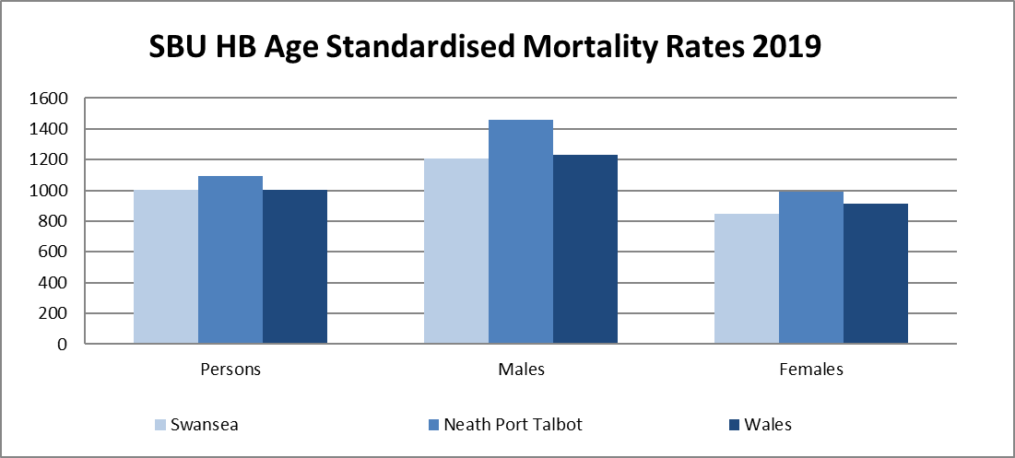
COVID Vaccine Uptake:
Data as of August 2021
GP Cluster | Cohort total | Total First Vaccination | Total Second Vaccination | % Vaccinated (1st Dose) | % Vaccinated (2 Doses) | % of Population Vaccinated (2 Dose) | Who is left(1st Dose) | Who is left(2nd Dose) | Future Booked
City Health | 42218 | 32594 | 29194 | 77.20% | 89.57% | 69.15% | 9624 | 13024 | 981

LOCALITY KEY FACTS

- The City Health Cluster servers a (GP registered) population of 51,082 (as at 01.04.2021) and is the third largest cluster by registered population in the Health Board Area. (Source – NHS Wales Shared Services Partnership)
- It is 1 of 5 clusters within the county of Swansea.
- Of the 20% most deprived LSOAs in Wales, 17 are within Swansea, with 12 found within the City Cluster
- This area consists of 22 LSOAs in the city centre area and adjacent urban areas to the north, west and east; across both sides of the River Tawe. (Source - https://www.swansea.gov.uk/communityareaprofiles / IMTP 2020-2023)
- The Cluster geographically covers wards: Castle (part), Cockett (part), Landore (part), St Thomas, Townhill, Uplands (part) (Source - https://www.swansea.gov.uk/communityareaprofiles)
- A journey from Brunswick to Swansea SA1 by road would take 9 minutes and cover a distance of 2 miles. (Source – Google Maps)
- The largest area within the cluster is around the city centre, the adjacent wards of Cwmbwrla and Uplands (6,800 people per square km, the highest density in the county) and also in Townhill and Penderi. (Source – IMTP)
- Based on the projected population growth in Swansea, provided in section 2, there is a forecast of 6.94% increase in population between 2018 – 2043. Based on the resident population in the City health cluster area of 39,179 (Population projections by local authority and year (gov.wales)) this could increase to 41,898
- The City Health Cluster has approximately 5,065 people over the age of 65 years and over (12.9%) which is lower than the Welsh average of 21%. (Primary Source – Mid 2018 Population estimates (Source: Small area population estimates (2018), ONS) Secondary Source - Cluster IMTP
- The Cluster area has 13 GP practices (5 of which operate branch practices).
- The cluster has 15 community pharmacies. (Source – Cluster IMPT 2020 – 2023)
- There are 6 dental practices that offer NHS treatment and 6 optometric practices. (Source – Cluster IMPT 2020 – 2023)
- There are;
  - 4 Dual Registered Care Homes
  - 2 Local Authority Homes
- There are no pharmacies in the City Cluster who are able to offer pharmaceutical services through the medium of Welsh.
- According to the 2011 Census 11.4% of people aged 3 years and above in Swansea are able to speak Welsh
- According to Swansea Council Local Development Plan (2010-2025) it is estimated that a minimum of 2,010 homes will be built in the City Cluster.

6. ACTION PLAN

How we developed this plan
Our plan is a flexible plan, informed by the strategic background and range of priorities, together with consideration of local needs highlighted above. It will be underpinned by ongoing work to develop implementation and performance plans against the stated Goals, Methods and Outcomes Action Plan. Future programmes of work such as those around Obesity Prevention, Diabetes prevention and Cancer, among others will be considered as the programme details evolve
Key:

Strategic Priority Areas
Responding to Covid
Improving Patient Quality and the 5 Q&S goals
Improving Staff Experience
Improving Unscheduled Care
Improving Planned Care
Increasing Digital Capability
Improving Cancer and Palliative Care
Prevention and Reducing Health Inequalities
Children, Young People and Maternity
Improving primary, community and therapy services and the 6 priorities Primary and Community
Improving Mental Health and Learning Disabilities and the 7 goals

Addressing Ministerial Priorities
A Healthier Wales – as the overarching policy context
Population Health
Covid Response
NHS Recovery
Mental Health and Emotional Wellbeing
Supporting the Health and Care Workforce
NHS Finance and Managing within Resources
Working Alongside Social Care

- IMPROVING PLANNED CARE
 | GOALS | METHODS | OUTCOMES
 | To address long term waits for persistent pain service   | Pilot provision of persistent pain service | Decrease existing waiting list for First appointments by 50%  Reduced waiting times for future referrals  Decrease in re-referrals  Reduction in GP appointments
 | Improve outcomes for patients experiencing long covid | Maximise use of the Long Covid pathway within Primary Care | Read codes for long covid defined  Increase in number of referrals to long covid service.
 | To address backlog of COPD patients | Introduction of a Cluster based spirometry project | Reduction in backlog of patients currently waiting for Spirometry
 | To reduce referral demand and face to face attendances where appropriate | Maximise usage of Consultant Connect across service areas for City Practices | To increase Consultant Connect targets by 10%

- IMPROVING CANCER & PALLIATIVE CARE
 | GOALS | METHODS | OUTCOMES
 | Improve Health of Cluster through increased uptake of  Screening projects | - Promote bowel, cervical and breast screening uptake  - Review Outcome of 2021/22 cancer non responder project | Increase in levels of uptake from most recent baselines with the aim of achieving uptake of:  Cervical - 70%  Breast - 70%  Bowel - 55%
 | To expand referrals into Rapid Diagnostic Centre | Implement two new pathways for excluding colorectal cancer in the young and to provide rapid access and assessment for suspicious neck lumps | Rapid diagnosis/reassurance for those moving through the pathways
 | Reduce Smoking rates | Help me quit – provide support patient to quit smoking through advice and education, promotion through communications  Liaise with pharmacy colleagues to consider future action, increasing engagement with level 3 service | Increase patient contacts by a further 10% by the end of March 2023.
 | Improve EOL for patients and patient’s family | Plan, secure and deliver well-co-ordinated 24/7 palliative and end of life care in line with published standards | Patients and their families experience better EOLC services  All practices engaging in regular in house Palliative care meetings

- IMPROVING UNSCHEDULED CARE
 | GOALS | METHODS | OUTCOMES
 | Increase uptake rates of the flu vaccine | Deliver cluster plan of action to address Flu to compliment individual practice plans including, promotion of self care, vaccination clinics, communications, Healthy living hub, flu champions for 22/23, practices to share best practice, flu plan for 2022/23; practices to share “best practice” | Increased uptake in target groups.to:  65+over - 75%  Under 65 at risk - 50%  2+3 year olds - 50%  Reduced variation in vaccination rates across cluster
 | Deliver the new model of Primary care for optometry services in the Cluster | Deliver a plan to streamline referrals within the Cluster, including maximising referral pathway, developing pro forma and upskilling workforce as well as educating GP’s /Cluster members regarding what is an appropriate referral | Increased number of direct referrals to Optometrists across the Cluster.  Backlog of patients awaiting retinopathy screening cleared
 | Reduce inappropriate attendance of dental patients at GP Practices | Increase GP/Cluster member awareness of pathway for unregistered patients requiring emergency dental care.  Put in place clear signposting arrangements in all GP Practices | Reduction in number of dental patients inappropriately attending GP Practices.
 | Enable Patients to access most appropriate care | Signposting of patients to Common Ailment Schemes  Working closely with individual community pharmacies to increase uptake into common ailment schemes | Increase in number of patients accessing the Common Ailment Scheme by 10%

- IMPROVING MENTAL HEALTH & LEARNING DISABILITIES
 | To improve treatment outcomes of patients suffering from Alcohol Related Brain Disease  (ARBD) | ARBD Project established and operational until end of March 2023.  Identify and refer to the Project patients with a history of heavy alcohol use who may be suffering from ARBD. | A range of measures to include  Number of assessments undertaken by MH Nurse  Number of patients referred to Secondary Care  Number of patients seen and number of interventions undertaken by Alcohol Worker.
 | To reduce gaps in Health Outcomes with those with Learning Disabilities | Annual Health Checks for those with learning disabilities. All Cluster Practices currently participate in the Directed Enhanced Service for Learning Disabilities. | All patients on Learning Disability Registers received the offer of an annual health check.
 | Develop a Mental Health Cluster Model to Support Mental Health | Commissioning of Mental Health/Wellbeing/ Counselling Services  Mapping of Mental Health based Cluster Services | Better reported patient experience/outcome measures  Rapid access to psychological therapies

- CHILDREN, YOUNG PEOPLE & MATERNITY
 | GOALS | METHODS | OUTCOMES
 | To promote Nutrition in schools | Cluster to explore the provision of nutritional/Healthy eating classes in schools  Support/fund a coordinated programme of classes | Maximise the number of schools participating in the Healthy Eating Project
 | To improve the Mental Health and Well being of young people | To commission a project related to the mental health and wellbeing of younger people | Project commissioned to refer young people into
 | Improve Health of pregnant women and their unborn child | Increase vaccination uptake in pregnant women | Increase uptake of flu vaccine in pregnant women by 10%
 | Mental Health | Please see 4.3 above

- PREVENTION & REDUCING HEALTH INEQUALITIES
 | GOALS | METHODS | OUTCOMES
 | Alcohol related brain damage | Please see 4.1
 | To increase awareness of GP and Practice Nurse understanding of injecting drug users | Raise awareness through accredited e learning and education through local services | Increase Completion of accredited e learning by 30%  Attendance by all surgeries to training offered  Clear management plans in place
 | To increase awareness of substance misuse services | Sharing knowledge across the cluster of services available  Explore possibility of dedicated cluster substance misuse support worker | Improved access to services available  Reduce deaths from overdose  Improve harm minimisation
 | Reduce the volume of overall antibiotic prescribing across the Cluster | Work closely with Medicines Management with Quality Improvement work to deliver a plan of action | Reduction in the overall level of antibiotic prescribing across the Cluster  Variation in levels of Antibiotic prescribing between Practices reduced to a justifiable level.
 | To consider inequalities to access of service for patients | Identification of issues around access  Scope out possibility of voluntary services that can support  Continue to work towards building relationships with all communities within the Cluster | Identification of possible options to improve access collated
 | To reduce Type 2 diabetes within the Cluster population | Delivery of the two year All Wales Diabetes Prevention Programme | National evaluation based on a core set of patient clinical outcomes to be finalised

- ACTION PLAN ENABLERS
Technological | Workforce | Communication & Engagement | Finance
Blue stream E learning platform | Continued employment of Business Manager to provide the Cluster with the resources to achieve its goals | Primary and community communications officer delivering e-media, and press advertising campaigns | Income generation by the Cluster  Possible access to funds via Charity Linked to the Healthy Living Hub
Ask My GP | Continued employment of Cluster paramedic |  | WG funding
My Health Online | Cluster Pharmacist |  | Mental health and learning disability delivery group funding for social prescriber and for mental health triage post
First Practice Management | Social Prescriber
 | Local area co Ordinator
 | Primary Mental Health triage
 | Emergency Planning Response and Resilience Plan
 | Induction Pack for New Cluster staff
 | Cluster Members

7. GOVERNANCE ARRANGMENTS
The Cluster members meet 5 times a year at formal Cluster Board meetings, to plan and review progress and strategic direction related to the Cluster IMTP and to routinely address: Cluster Plan, Cluster Spending Plan, Risk Register Update, Sustainability and Finance. Declarations of interest are addressed as standing items.
Welsh Government and Health Board allocated Cluster Funds are spent and allocated in accordance with Swansea Bay UHB Standing Financial Instructions. Non-Welsh Government funds are administered on behalf of the Cluster by Swansea Council for Voluntary Services in accordance with agreed Cluster and funding body policies and procedures.

MEMBERS
The core membership of the Primary Care Cluster shall comprise of representation from all local services involved in health and social care within the cluster area and shall include:

- Cluster Lead (Chair)
- Representation for each GP Practice In City Health Cluster there will be representation from 8 GP Practices. This will include as a minimum a GP and will also extend to Practice Manager.
- One representative from Community Pharmacy - to represent all community pharmacies within the cluster
- One representative from Dental - to represent dental services within the cluster
- One representative from Optometry - to represent optometry services within the cluster
- Primary, Community & Therapies Services Senior Manager
- Cluster Development Manager
- Nominated representative for Adult Nursing and Children’s Nursing
- Medicines Management Representation
- Nominated representative for Therapies; two members to represent the breadth of therapies services
- Representation from Mental Health
- Third Sector / Community Voluntary Service

8. CLUSTER ASSETS PROFILE

Primary Care Estate is used to support the development and implementation to community based clinics e.g. spirometry and counselling clinics

Key Community Assets

Active Community and Voluntary Organisations.
Leisure centres
Entertainment venues
Libraries
Community Hubs
Beach access
Football and Rugby stadiums
University
Kilvey Country Park
Access to the River Tawe and the Marina
City regeneration, together with the development of continuous cycle routes along the bay and road improvements to reduce congestion along Fabian Way have facilitated easier and safer access to the city.

9. CLUSTER WORKFORCE PROFILE
One of the most effective ways identified to deliver services to meet Cluster priorities is through the employment of Cluster based MDT. This includes a huge range of professions and areas of expertise, with some working closely together to achieve the demands and capacity of the Cluster needs.
Role | WTE | Outcomes / Impact
Clinical Pharmacist | 1.0 | More prudent model of healthcare shift towards new primary care model for Wales.  Benefits whole Cluster population circa 50,809 patients  GP time saved – reviews, admin/recall, queries from practice staff members  Reduced patient contact time with practice when switched to less intensively monitored medication  Reduced GP appointments and hospital admissions with a particular focus on those patients who have been discharged from hospital or are residing in a care home
Paramedic | 1.0 | Estimated to support 1,500 patients in the upcoming year  Support all GP practices in the City Health Cluster with a Cluster population total of 50,809  Supporting the Cluster GP practices with patient general assessment, observation and history, phlebotomy,12 lead Ecg, vaccinations, respond to and triage house calls during urgent and routine situations.  To provide assessment of patients, planning and implementing their care and treatment.
Business Manager | 1.0 | The 33 Cluster members are supported.  Increased resources available to cluster  Implementation of Cluster IMTP  Cluster projects developed and implemented (as determined by the cluster) effectively with robust monitoring, evaluation and reporting  Clear feedback to Cluster members and Health Board  Timely access for cluster to relevant information to inform improvements for health population and service delivery  Increased partnership working and partnership projects
Social Prescriber | 0.5 | Provides support to patients with:  long-term conditions  Mental health  lonely or isolated  Complex social needs which affect their wellbeing

10. CLUSTER FINANCIAL PROFILE
