Our Partner Organisations

Children and Young People’s Therapy Services recognise the importance of working in partnership with the child, parents and carers to maximise a child’s physical and functional abilities and to promote independence and effective communication. We are committed to multi professional and multi-agency working.

Here you will find links to a number of organisations that you may find useful. External links are included on this website to provide users with additional information.

Please click on the organisation logo in order to be directed to their official websites.

Voluntary Sector Organisations

Disclaimer: Swansea Bay University Health Board cannot guarantee that such links will always work, and make no representations as to the quality and accuracy of the sites linked to. SB UHB does not endorse any external sites and is not responsible for their content.

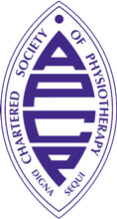 | Association of Chartered Paediatric Physiotherapists  The official website of the Association of Paediatric Chartered Physiotherapists.
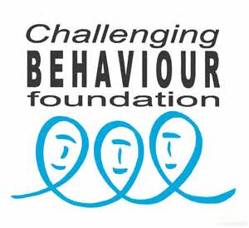 | The Challenging Behaviour Foundation.  Working to improve understanding of challenging behaviour, empower families with information and support, and help others to provide better services and more opportunities.
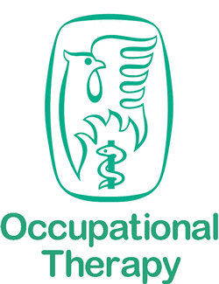 | College of Occupational Therapists  The official website of the College of Occupational Therapists.
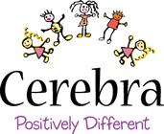 | Cerebra  Cerebra is a unique charity set up to help improve the lives of children with brain related conditions through research, education and directly supporting the children and their carers.
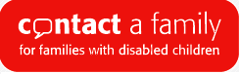 | Contact a Family  Contact a Family is the only national charity that exists to support the families of disabled children whatever their condition or disability. You can sign up for their free monthly e-newsletter via their website.
 | Dogs for Good  Dogs for Good is a life-transforming charity, creating exceptional partnerships between people living with disability and specially trained assistance dogs.
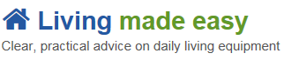 | Living made easy  Providing independent advice about independent living for disabled adults and children, older people, their carers and families. Includes advice on seeking charitable funding.
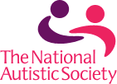 | National Autistic society  The leading UK charity for people with autism (including Asperger syndrome) and their families. Providing information, support and pioneering services, and campaign for a better world for people with autism.
 | Pedal power  Pedal Power is the working name of The Friends of Pedal Power Project. We are a charity whose Mission is "to make cycling accessible to all".
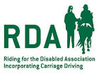 | Riding for the Disabled Association  At RDA, our horses and ponies provide therapy, achievement and enjoyment to people with disabilities all over the UK. Our network of 500 volunteer groups organise activities such as riding, carriage driving, vaulting and show jumping to up to 28,000 people each year.
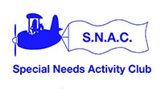 | Special Needs Activity Club (SNAC)  SNAC is a parent-led organisation, providing play and leisure facilities to children and young adults with special needs from all over the South Wales area on four days of the week.
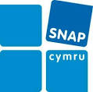 | SNAP Cymru  Education for All Since 1986 SNAP Cymru has worked with families and professionals in schools, education, health and social care to help ensure that children and young people’s needs are identified, assessed and provision made to help them reach their potential and be fully included.
 | Tŷ Hafan  Tŷ Hafan offers comfort, care and support for life-limited children and young people and is dedicated to improving the quality of life for the whole family. This comfort and support extends out of the hospice and reaches right into the heart of the family home, and is completely free of charge to the families in Wales who need it.
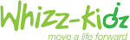 | Whizz-Kidz  There are an estimated 70,000 disabled children in the UK who are waiting for the right wheelchair that will mean they can get up to all the things that kids like to do. And that’s where Whizz-Kidz comes in. We give disabled kids the equipment, support and life skills they need to be just like any other kid.
 | ASD Info Wales  ASD Info Wales, the national site for Autistic Spectrum Disorders (ASD). Here you will find information about Autistic Spectrum Disorders (including Autism and Asperger Syndrome), service details, training opportunities and updates on the implementation of the ASD Strategic action Plan for Wales.
 | MindEd  Free online education to help adults to identify and understand children and young people with mental health issues.
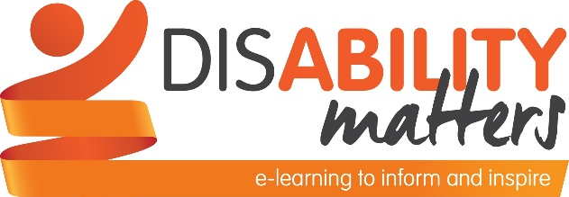 | Disability Matters  Offers free e-learning for anyone who works or volunteers with disabled children and young people. Designed to improve staff confidence and promote effective communication, Disability Matters supports collaborative working to ensure disabled young people can achieve the outcomes that matter to them.
 | Affinity Hub  Aims to provide emotional support to parents and carers of children with special needs. The website is run by Joanna Griffin, a Chartered Counselling Psychologist who also has her own child with a disability.
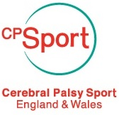 | Cerebral Palsy Sport  CP Sport is the country’s leading national disability sports organisation supporting people with cerebral palsy to reach their life potential through sport and putting people with cerebral palsy and their families at the heart of everything we do.
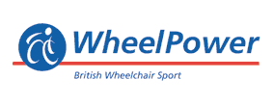 | WheelPower  WheelPower are dedicated to providing opportunities for disabled people to find a sport they enjoy and provide opportunities throughout the year to introduce people to wheelchair sport.
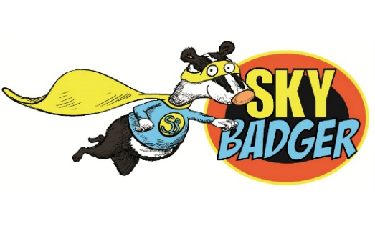 | Sky Badger  Sky Badger is a charity that finds help and adventure for disabled children and their families all over the UK. This is achieved by building bridges between disabled children and the charities and services available to help.

Disclaimer: Swansea Bay University Health Board cannot guarantee that such links will always work, and make no representations as to the quality or accuracy of the sites linked to. SB UHB does not endorse any external sites and is not responsible for their content.

