

Oral Sensitivity

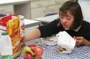
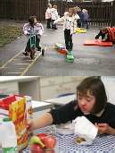
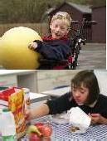


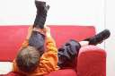
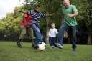
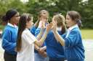

Community Paediatric Occupational Therapy Department

Introduction
The following programme is designed to assist a child to develop tolerance of oral sensations; the mouth is the most sensitive area of the body and is used at an early stage of development to increase knowledge of different textures. This exploratory stage is also important for developing oral motor control i.e. the ability to suck, blow, chew etc. The tongue and lip movements used during feeding and speaking depend on adequate sensitivity in the oral area.

When a child presents with sensitivity to touch it is not uncommon for the area within and around the mouth to be most problematic. This can result in frustration for parents at meal times, dental hygiene activities etc.
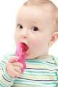
Oral motor skills are developed in the following sequence: -

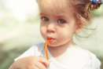
- Suck

- Blow

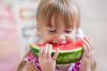
- Biting


- Crunching

- Chewing

It is important that you consider this sequence when presenting activities to a
child. If the child has good sucking skills then activities can be centred on blowing. The activities within the programme follow this sequence of development.

There are no set rules with regards to how quickly a child progresses through the programme. It is important that tolerance and skills are developed at a comfortable pace for you both.

Begin the programme by placing the child in front of you in front of a mirror. Start to apply deep touch pressure around the area outside the mouth, encourage the child to do the same, this is beneficial in desensitising.
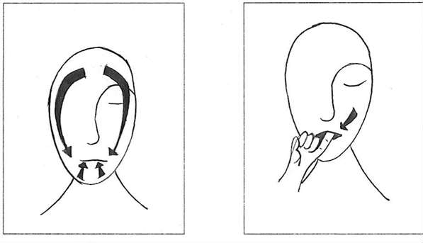
Next encourage the child to apply deep touch pressure to the roof of their mouth or gums by using a finger or another soft, round object.
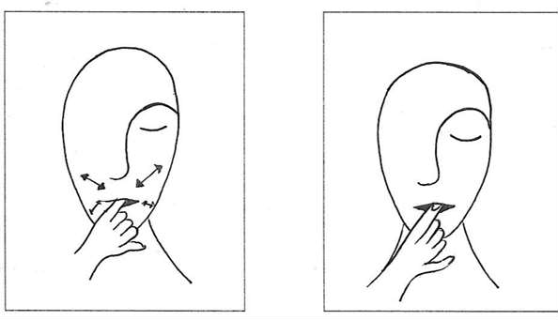

Introduce this method to the child when brushing teeth, pour about 1cm of flavoured water into a small cup, dip the end of the toothbrush into the cup. Encourage the child to hold the toothbrush and brush their tongue, teeth, inside of the cheeks and roof of the mouth. An electric toothbrush may be used to provide additional sensory information. Please ensure a very soft brush is used.

These activities will assist in:

- Decreasing tactile sensitivity
- Increase awareness of the mouth structure
- Improve tongue movements
- Increase the ability and willingness to brush teeth Other activities that may be of benefit are: -
- Drinking through a straw (Note: if sucking through a straw is difficult the activity can be graded by sucking food from a finger). Grade this activity by changing the size and length of straw.


- Drinking through a straw can be further graded by firstly drinking soft drinks such as squash or pop progressing onto thicker drinks such as milkshakes. (Note: if your child has any swallowing difficulties please seek advice from your Speech

and Language Therapist before attempting this task).

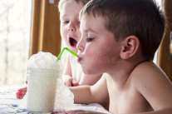
- Blowing activities such as blowing through straw, again similar to the sucking activities
these interventions can be graded by blowing into water with soapsuds, whistles and balloons. The child can progress onto activities that require more controlled blowing e.g. blow football, blowing bubbles etc.
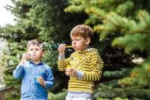
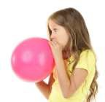
These activities will assist in:

- Teaching the child how to force air through their mouth
- Improve muscle control of their lips

Activities that provide opportunities to experience different temperatures will improve sensory awareness.

Other activities should include opportunities to develop biting, crunching and chewing skills. Examples of activities may include:

- Biting and tugging on tubing, pieces of liquorice, fruit etc.

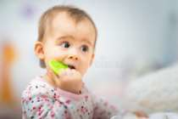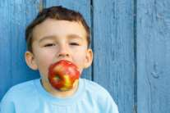
- Chewing crunchy food such as crisps and crackers, carrot sticks, bagels or apples.

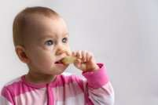

- Finally, licking activities: for example, licking lollipops, ice cream, peanut butter on a spoon may be introduced to the child, as they require the most fine-tuned oral skill.



Many of the activities provide enhanced proprioceptive (information from muscles, joints and ligaments enabling the brain to know where each part of the body is and how it is moving – in this instance proprioceptive information relates to the mouth area) and tactile sensation to the mouth.

Aim to carry out activities on a daily basis, this will assist the child in maximising their potential to develop oral sensations.

As the child begins to tolerate and explore different textures orally it is important that they are provided with opportunities to explore textures with their hands.

