

Bike Skills

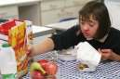
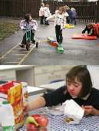
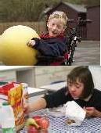
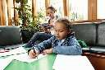

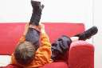
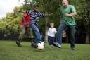
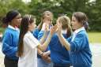

Community Paediatric Occupational Therapy Department

Introduction
The following strategy may help if your child is having difficulty learning how to ride their bike. The following technique takes time, but the idea is that your child gets a sense of achievement from mastering each step one at a time.

General Advice

- Always follow general bike safety rules when teaching your child how to ride e.g. practicing in a quiet area, wearing a helmet, bike reflectors etc.
- Ensure your child has totally mastered one step before moving onto the next.
- Grass is not good as it is too soft and makes pushing harder.
- Take time to help the child practice and reinforce the skills.

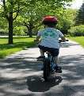
You will need:

- A bike
- A helmet

- Lower the seat so the child can sit comfortably with both feet flat on the ground.
- Remove both pedals.

- Using a flat surface in a safe area e.g. a playground, get your child to propel themselves forward using a walking movement with their feet.

- Tell them to keep their arms fairly rigid and to look where they are going.
- When your child has mastered steps 3 and 4, get them to propel themselves forward using both feet at the same time (whooshing along like a skier!)
- When the child is competent, practice on a safe hill or a slope in a park. As they achieve, gradually increase the distance the child goes down the slope. Encourage them to rest their feet on the frame of the bike.
- Get your child to practice stopping the bike by braking and putting their feet down at the same time.
- When the child is freewheeling down the slope and stopping in a controlled manner, put the pedals back on.
- Repeat steps 6 and 7, with the child resting their feet on the pedals this time.
- Introduce the pedalling action. If the child has difficulty with moving one foot then the other (reciprocal movement), try taking the pedals off and repeat step 5, but moving one foot then the other rather than both together.
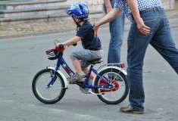
Information adapted from https://www.nhsggc.org.uk/kids

