

Waking Up the Sensory System


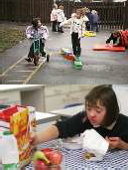
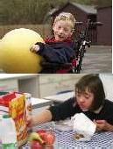


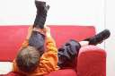
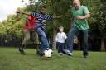
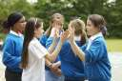

- This activity is used to wake-up the child/young persons hand muscles and joints. It is also used to give the brain sensory feedback, waking up the sensory processes.

- This will wake the child/young person up and make them more alert to carry out activities.

- This activity works better if carried out by the whole class.

- The movements should be carried out as a sequence of events. For example, it could also be called ‘The storm’ to give meaning to each of the movements being performed.

- The sequence requires a narrator for the sequence to give cues and prompts when changing movements.

- To go from movement to movement – go around class/circle as a progressive change of movements (point to each child if possible).

First Movement
- Rubbing hands together (gradually increase intensity)
This activity produces a quiet rustling sound and so could be interpreted as the wind (at beginning of the storm).

Second Movement
- Clicking of fingers
Producing a louder sound which can be interpreted as rain on a window etc.

Third Movement
- Patting thighs alternate hands (gradually increasing force and speed) This makes a louder noise e.g. hailstones / heavier rain etc

Fourth Movement
- Stamping feet simultaneously on the floor (gradually increasing force and speed)
Louder noise – like thunder.

Then go back through movements in reverse order.

They should now feel more alert and ready to work!

