

Pre-Writing Learning Through Gross Motor Movement Activities

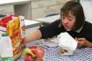
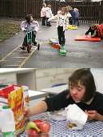
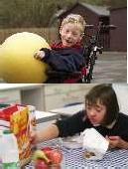
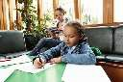

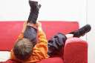
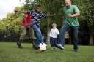
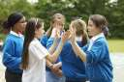

Drawing in the Air
Purpose: To teach the child to imitate or copy vertical, horizontal, or circular scribble movement, using gross motor activity.

Skill Stage: Imitation of basic pre-writing shapes

Materials:
- An empty paper towel roll
- Crepe paper streamers or cut out paper stars

Position: Standing, kneeling or half kneeling

Procedure: Attach crepe paper streamers or stars to the end of the paper towel roll to make a “magic wand”. Stand facing or next to the children. Alternate holding the wand with both hands or either hand. Wave the wand in the air in a vertical, horizontal or circular direction. Have the student imitate the movement.
Reverse the lead so that sometimes you are imitating the child and sometimes they are imitating you.

Variations
- “Draw” shapes or letters in the air.
- Combine sounds with the movements.
- Have the children walk while doing the imitation. This makes the movement more difficult.

Table Wipe Drawing

Purpose: To teach pre-writing scribble imitation through gross motor activity.

Skill Stage: Vertical, horizontal or circular scribble imitation.

Materials:
- Washcloth
- Table

Position: Standing.

Procedure: Have the child imitate wiping the table up and down, back and forth or in a circular direction. You do it, then have the child do it.

Variations: Have the child wipe a low chalkboard with an eraser or wipe a window with cloths and cleaner in a particular scribble direction.

Stencil Drawing

Purpose: To teach imitation of basic pre-writing shapes.

Skill Stage: Imitation of basic shapes

Materials:
- Stencils
- Crayons, markers or finger paints

Position: Sitting, prone, kneeling, half kneeling, on all fours, standing

Procedure: Give the child a stencil cut out of Plexiglas, cardboard, or fibreboard. Have them feel the shape with their fingers. Have them feel it again with their eyes closed. Then have them draw inside the stencil with crayons, markers or finger paints.

Remove the stencil so they can see what they have done. With the stencil removed, have them follow along the mark with a finger. Then have them try to repeat the shape without the stencil.

Variations: Stencils can be made of felt, sandpaper or cloth of strong texture glued to a board.

