
Bwrdd lechyd Prlfysgol Bae Abertawe

Swansea Bay University
Health Board

Left-Right Reversal in Handwriting



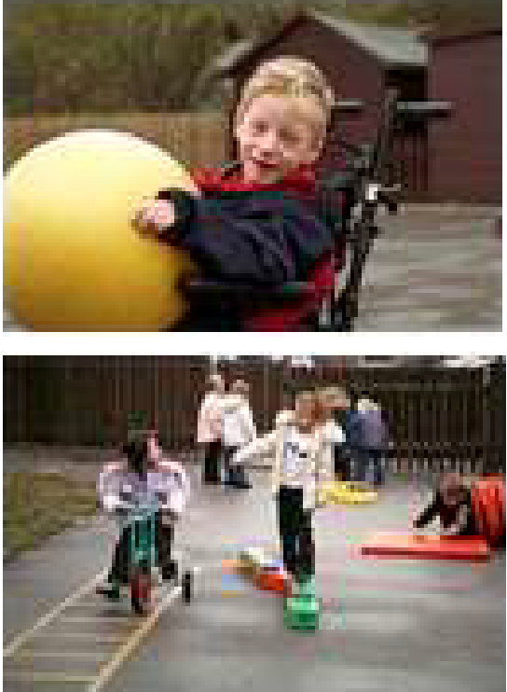

TREATMENT AIMS:

- To enhance the spatial directionality and left right orientation in the formation of letters and numbers.

- To provide guidance and suggestions of remedial activities to correct written reversal.

Introduction

Reversing letters and numbers in writing is one of the most commonly observed problems among children with different Specific Developmental Disorders.
Numerous theories to account for reversals exist. They are all based on the idea of spatial orientation and its development.

It is not uncommon for a child aged 4 to 6 years old to reverse formation of numbers/letters when he/she first starts writing with a pencil. However, if a child after the age of 7 years old still has a high degree of written reversals, it may be related to different underlying developmental problems which need to be evaluated and properly remediated.

Developmental Functions

There are four different levels of developmental functions which contribute to the acquisition of left-to-right orientations in the formation of letters and numbers:

  - Body Parts and Spatial Directionality i.e. understanding that the body has different dimensions, especially the concept that the body has two sides.

  - Left-Right Orientation i.e. the ability to maintain consistent orientation of left- to-right in the processing of writing, reading and spelling.

  - Visual Form Perception i.e. the ability to recognise and differentiate different configuration in letters and numbers. If a child has difficulty in this area, it will cause Visual Reversals.

  - Visual-Motor Integration i.e. the ability to transfer perceived visual information into motor output. If a child difficulty in this area, it will cause Written Reversals.

Remediation Programmes

The following four levels or remediation programmes have found to be effective to make changes:

Remediation of Poor Spatial Directionality

The ages at which children normally pass the items are given below. If a child makes a directionality error, demonstrate the answer by pointing and saying the correct response. Then have the child repeat the answer three times before proceeding.

    - Ages 5 and above normally pass item 1.
    - Ages 7 and above normally pass item 1 and 2.
    - Ages 8 and above normally pass item 1 through 4.

      - (Ask the child)
        - Show me your right hand
        - Show me your left hand
        - Show me your right leg
        - Show me your left leg

      - (Face the child)
        - Show me your right hand
        - Show me your left hand

      - (Place a coin on the table to the right of a pencil relative to the child)
        - Is the pencil to the right or to the left?
        - Is the coin to the right or to the left?

(Have the child move to the opposite side of the material)
        - Is the pencil to the right or to the left?
        - Is the coin to the right or to the left?

(Face the child)
        - Do you see this coin? Have I got it in my right hand or left hand?
        - Do you see this watch? Is it on my right wrist or left wrist?

      - (Face the child)
        - Touch your left ear with your right hand
        - Point to your right eye with your right hand
        - Touch your left leg with your right hand
        - Touch your right ear with your left hand

Remediation of Poor Left-Right Orientation

- Draw an arrow pointing to the right under words that are often reversed.

- Slide a pencil/finger along the text to keep the eyes moving towards the right.

- Draw lines under text with a pencil while reading, particularly in reading workbooks or mimeograph materials that can be discarded.

- Show the child how to print words quickly with rubber stamps and give him/her the experience of printing words. This demonstrates the direction that must be followed from the left to right.

Remediation of Visual Reversals

- Use A4 paper, write a letter/numbers in correct orientation and reversed pattern. Ask the child to scan from left to right line by line and to cross out those reversed ones. Gradually increase the complexity by adding more letters/numbers.
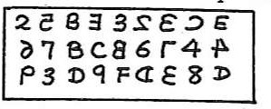

- Purchase sheets of coarse sandpaper. Cut letters and numbers that are about four inches in width and about eight inches in height. Let the child trace over these letters, very gently, with the index and middles fingers used together. As the child traces each letter he/she should vocalise the sound/name of that letter, making the sound last as long as it takes to write the letter. If the child is not properly making the strokes, then put their hand in yours and guide their fingers in the proper direction. This is a tried and true aid for children who need tactile reinforcement for learning.

- Write on a child’s back. Use the child’s entire back. Print a letter or numeral and ask the child to tell you what you wrote. To simplify this task, trace the letter on the child’s back and place three letters in front of them to choose from, including the letter that you wrote on their back.

- Have the child draw and then cut out large case letters and numbers on paper. Then have the child display the individual letters and numbers in their correct left- right position. Repeat this with the child using the cut out letters to make words that cause reversals.

- Use a package of 3 x 5 index cards. Print or write according to the child’s age and grade level, one word to a card. Purposely miswrite a letter in some of the words e.g. for the word ‘find’ you might print ‘finb’. The child is to tell you whether the word looks right or wrong.

- Use cards to write some commonly reversed words (no/on). Then use one of the words in a sentence and have child indicate the same word on a paired word card.

- Make up paired flash cards for commonly reversed words. Present the paired words until the child can make correct responses at least 4 times without errors.

After going through a series of paired cards go back and present any pair again that caused initial difficulty.

- For an exercise in discrimination, first show the child that ‘b’ has a hump on its right side, the ‘d’ has a hump on its left side, and the ’p’ has trail that goes down. Make the following exercise on a A4 paper:

b d p p d p b d b p b p d d p b b d b d b p d p b d
p d p b p d p d b d p b d

Choose one letter and say, “Remember the ‘p’ has a tail that goes down. Now take your pencil and mark each ‘p’, saying “p” each time you come to it. Then do the same for ‘b’ and ‘d’ with fresh paper”.

- Print the letter ‘b’ on a card and the letter ‘d’ in identical size on tracing paper. Place the tracing paper on the card and have a child point out the difference. Remove the tracing paper and show the letter ‘b’ again. The same technique may be used with sets of words beginning with confusing letters, such as ‘big’ and ‘dig’ etc.

Remediation of Written Reversals

  - Write those letters and numbers that are confusing to the child on a whiteboard or a large piece of paper. Have the child trace over that image, as many as five or ten times. Watch the child so that he/she starts and completes the strokes at the proper places.

  - Have the child make cards with printed words/letters/numbers that cause reversals. Then have the child finger trace the writing while also saying it. Next remove the card and have the child write it from memory. Repeat this procedure until the child can read and write it several times without errors.

  - Have the child draw and then cut out large case letters and numbers on paper. Then have the child display the individual letters and numbers in their correct right-left position. Repeat this with the child using the cut out letters to make words that cause reversals. Repeat this exercise until the child can organise letters, numbers and words several times without errors.

  - Have the child mark the letter and number that are incorrect. Then have the child write the correct letter to number under it four times. Make up additional examples as necessary.

References:
Jordan, B.T. (1974). Jordan Left – Right Reversal Test Manual. Novato, C.A. : Academic Therapy Publications.
Sidney Chu, SROT, OTR February 1994

