

Bwrdd lechyd Prifysgol
Bae Aberta we
Swansea Bay University
Health Board

Develop Letter Formation Using Multi-Sensory Technique - Programme 1

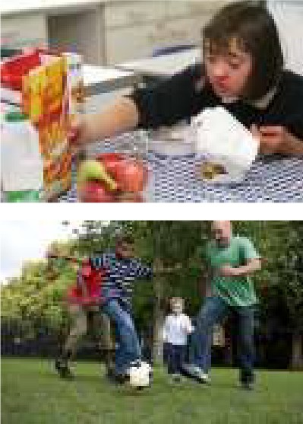

Aim – To Develop Multisensory Skills for Letter Formation

THIS PROGRAMME SHOULD BE PRACTISED FOR 10 MINUTES ON A DAILY BASIS

Week 1

TASK | ACTIVITIES
Letters | Practice ‘round letters’ e.g. o, a, d, g, q using the following methods:  - Practice letters in shaving foam or squirty cream.  - Practice letters using chalks on carpet squares.  - Draw letters in a sand tray.  At end of week practice the above letters on lined paper to help the child transfer  and consolidate information into context.
Motor  Planning Pincer Grip | Game of Connect 4

Week 2

TASK | ACTIVITIES
Letters | Practice ‘round letters’ e.g. o, a, d, g, q using the following methods:  - Practice letters using finger paint.  - Practice letters using marble and template  - Cut out letters in sandpaper or emboss wallpaper – encourage the child to trace around with his finger.  - Draw letter in the air (see attached for details)
Motor  Planning Pincer Grip | - Cube design (copy block design pattern with cubes).  - Simon says and mirror copying.

Week 3

TASK | ACTIVITIES
Letters | Practice ‘curvy letters’ e.g. c, s, f.  - Practice letters in sand tray, shaving foam, carpet squares,  blackboard, roughened templates.
Motor Planning | - obstacle course. Start with just 3 stages.

Week 4

TASK | ACTIVITIES
Letters | Practice ‘curvy letters’ e.g. c, s, f.  - Using marble and template (if available)  - Practice letter with crayons/chalks on wall hung paper – using large movements  or use pens on whiteboard.
Motor Planning | See attached hand strengthening programme.

Week 5

TASK | ACTIVITIES
Letters | Practice ‘Down, Up and Over letters’ e.g. r, p, b, h, n, m.  - Practice letters in shaving cream or foam, add resistance by  adding e.g. sand, glitter, rice etc.
Motor  Planning | See attached hand strengthening  programme.

Week 6

TASK | ACTIVITIES
Letters | Practice ‘Down, Up and Over letters’ e.g. r, p, b, h, n, m.  - Practice letters using chalks on carpet squares.  - Practice letters using finger paints.
Motor Planning | Ball Games (Bouncing, Throwing, Catching)

Week 7

TASK | ACTIVITIES
Letters | Practice ‘Straight – down letters’ e.g. t, i, l, j.  - Practice letters using a Rice Tray  - Sentence on paper using these letters. E.g. Jenny opened the till.
Motor Planning | - Angels in the snow.  - Simon Says

Week 8

TASK | ACTIVITIES
Letters | Practice ‘Straight – down letters’ e.g. t, i, l, j.  - Practice letters with pencils on emboss paper.  - Sentence on paper using these letters. E.g. Little John Jumped over the Ledge.
Motor Planning | Star Tracking (see attached)

Week 9

TASK | ACTIVITIES
Letters | Practice ‘U Family letters’ e.g. u, y, w, v.  - Practice letters with finger paints.  - Sentence on paper using these letters. E.g. You and your friend won the yellow umbrella.
Motor Planning | - Game of Dominoes  - Jig Saws

Week 10

TASK | ACTIVITIES
Letters | Practice ‘U Family letters’ e.g. u, y, w, v.  - Practice letters on chalkboard.  - Practice letters in shaving foam.  - Sentence on paper using these letters. E.g. Yellow flowers cover the wall.
Motor Planning | - Jumping over moving rope on floor.  - Obstacle course – 5 stages.

Week 11

TASK | ACTIVITIES
Letters | Practice ‘Strange letters’ e.g. e, x, z.  - Draw letters in a sand tray.  - Table – wipe drawing (see attached).
Motor Planning | Hop Scotch

Week 12

TASK | ACTIVITIES
Letters | Practice ‘Strange letters’ e.g. e, x, z.  - Practice letter with felt pens.  - Stencil drawing (see attached)  - Sentence on paper using these letters. E.g. My excellent pet zebra.
Motor Planning | - Puzzles  - Therapy Ball

